Exercise 1: Creating a Basic CTE

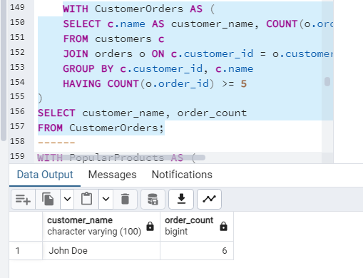

Exercise 2: Multi-CTE Query

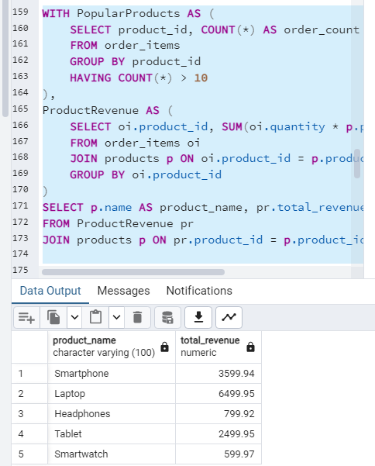

Exercise 3: Using CTEs to Cleanse Data

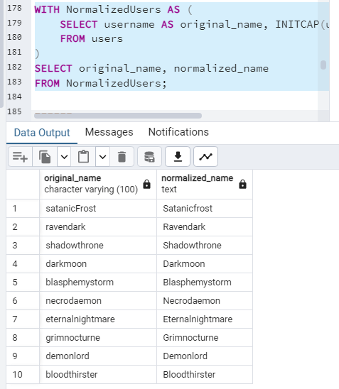

Exercise 4: Recursive CTE for Hierarchical Data

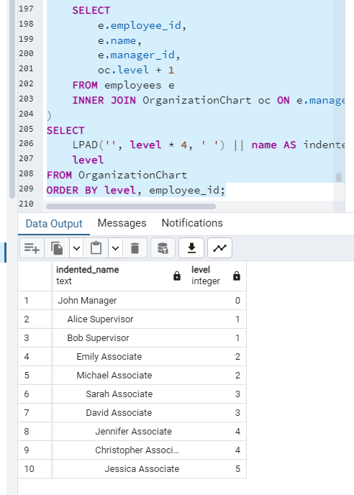

Exercise 5: Advanced Recursive CTE

