Config change:

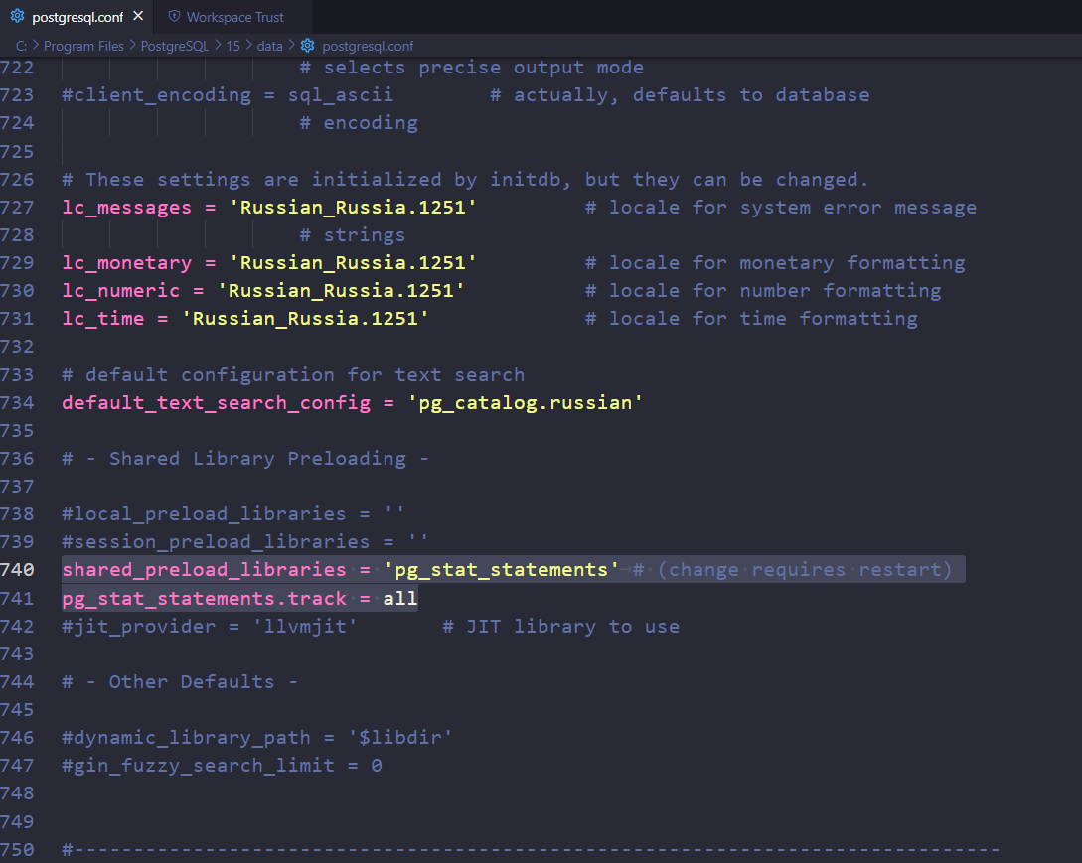

Select, update, delete:

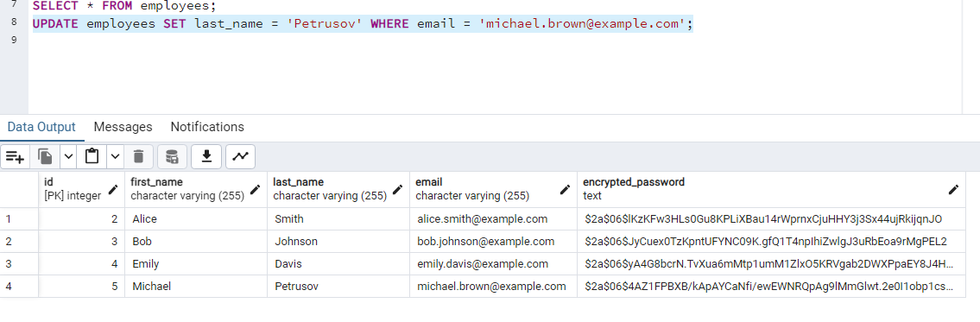

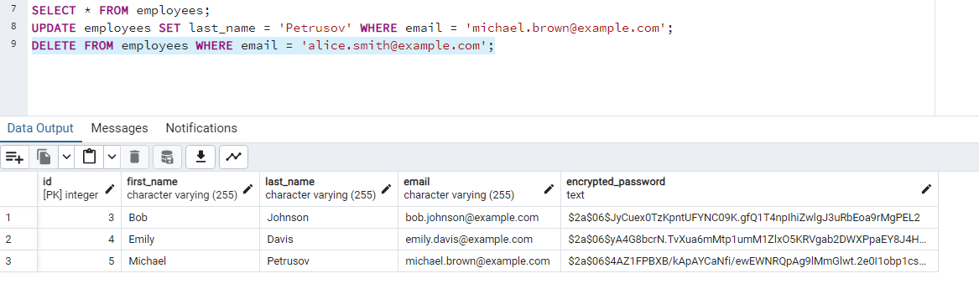

Pgcrypto:

