Task Title: Portfolio
[1]Objective:

Designed and developed a responsive personal portfolio website to showcase projects, technical skills, education, and contact information. Built using HTML, CSS, and JavaScript with a modern user interface, smooth navigation, project showcase section, downloadable resume, and direct links to live demos and GitHub repositories. The website is optimized for desktop and mobile devices, providing an engaging user experience and professional online presence.
[2]Project Description:
The portfolio features a modern user interface with responsive design, smooth navigation, interactive sections, and visually appealing layouts. It includes dedicated sections for About, Skills, Projects, Education, and Contact Information, allowing visitors to easily explore the candidate's qualifications and achievements.The website also provides direct access to professional profiles such as GitHub and LinkedIn, along with resume download functionality. The project demonstrates front-end web development skills, UI/UX design principles, and the ability to create a professional online presence suitable for internship applications, job opportunities, and networking purposes.
Key Features:
Professional Hero & Personal Branding Section – Showcases personal introduction, career objectives, profile image, social links, and resume access to create a strong first impression.
Responsive Navigation System – Includes smooth scrolling, section-based navigation, and a mobile-friendly hamburger menu for seamless browsing across all devices.
Project Showcase Portfolio – Displays featured projects with organized layouts, enabling visitors to explore technical skills, development experience, and achievements.
Skills & Technology Highlights – Presents programming languages, web technologies, development tools, and core competencies in an attractive and structured format.
Education & Achievement Timeline – Provides a clear overview of academic qualifications, CGPA, educational milestones, and career progress.
Resume & Professional Networking Integration – Offers direct resume viewing/downloading along with GitHub, LinkedIn, email, and phone connectivity for professional engagement.
Modern Responsive User Interface – Fully optimized for desktop, tablet, and mobile devices with clean layouts, intuitive interactions, and accessibility-focused design.
Premium Visual Experience – Features modern typography, gradients, animations, hover effects, interactive components, and performance-optimized architecture for a professional look and feel.

[3]Project Screenshots:
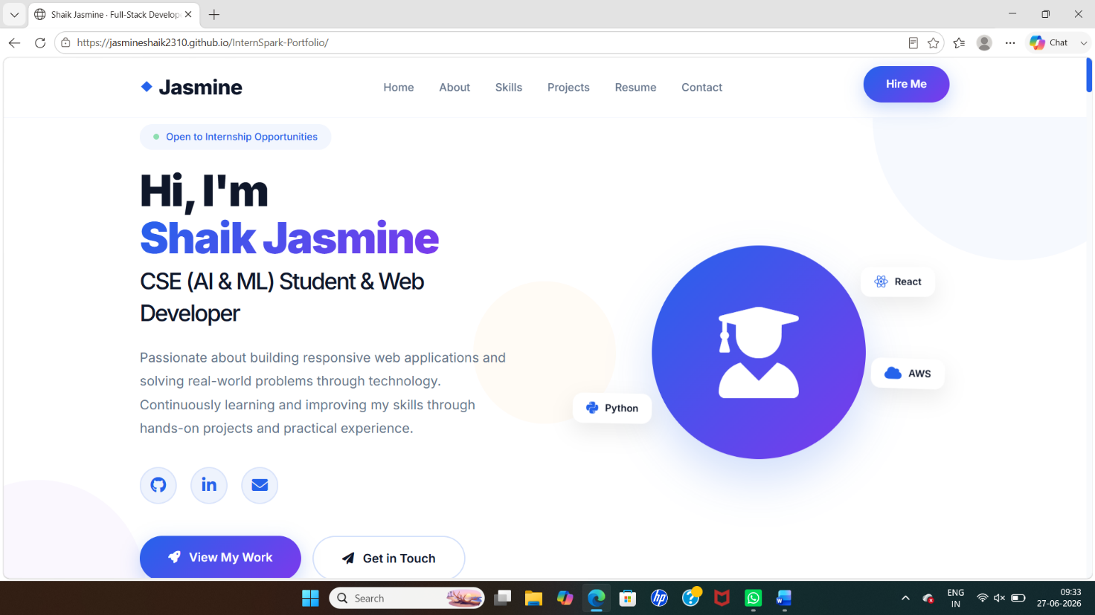
Fig 3.1: Home

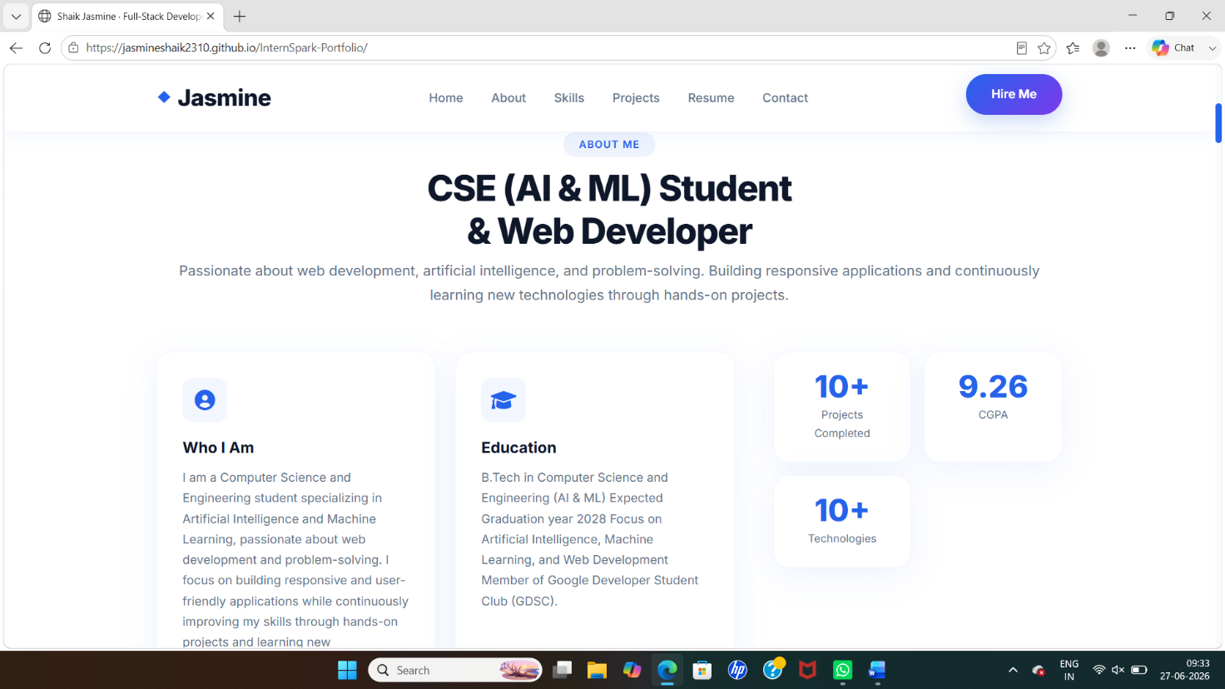
Fig 3.2: About

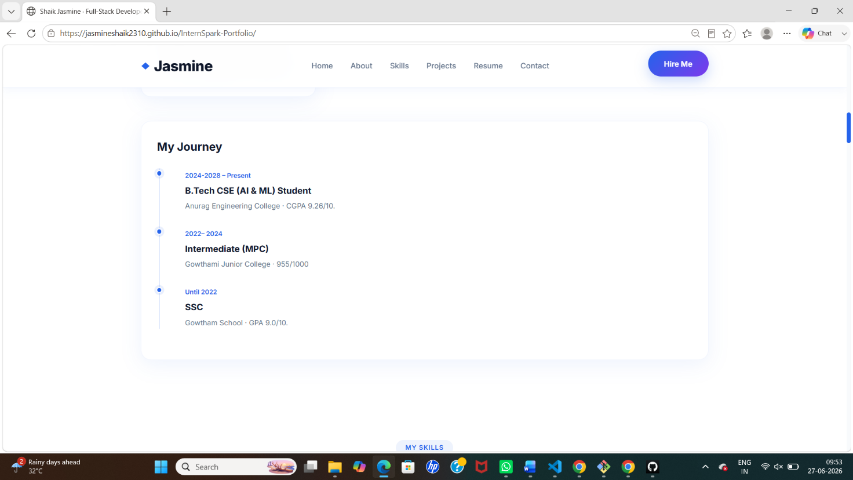
Fig 3.2: My Journey

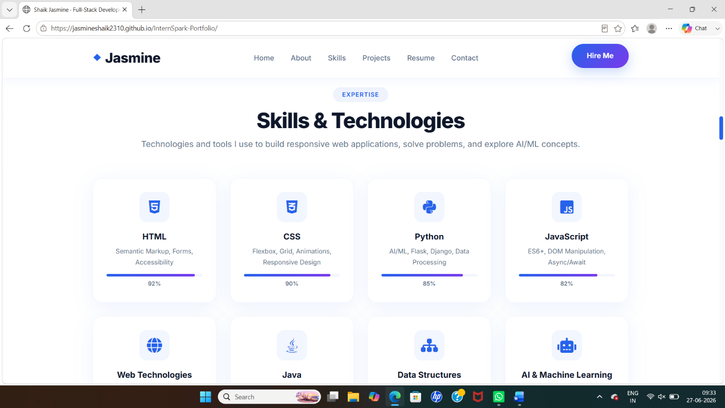
Fig 3.3: My Skills

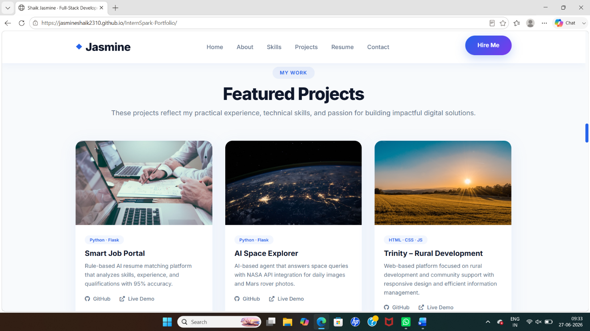
Fig 3.4(a): Hands-on Projects

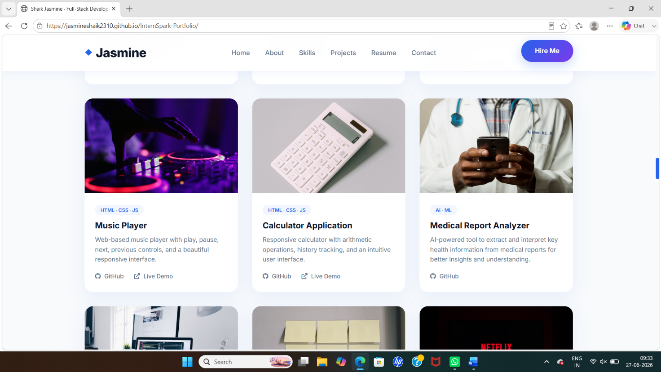
Fig 3.4(b): Hands-on Projects

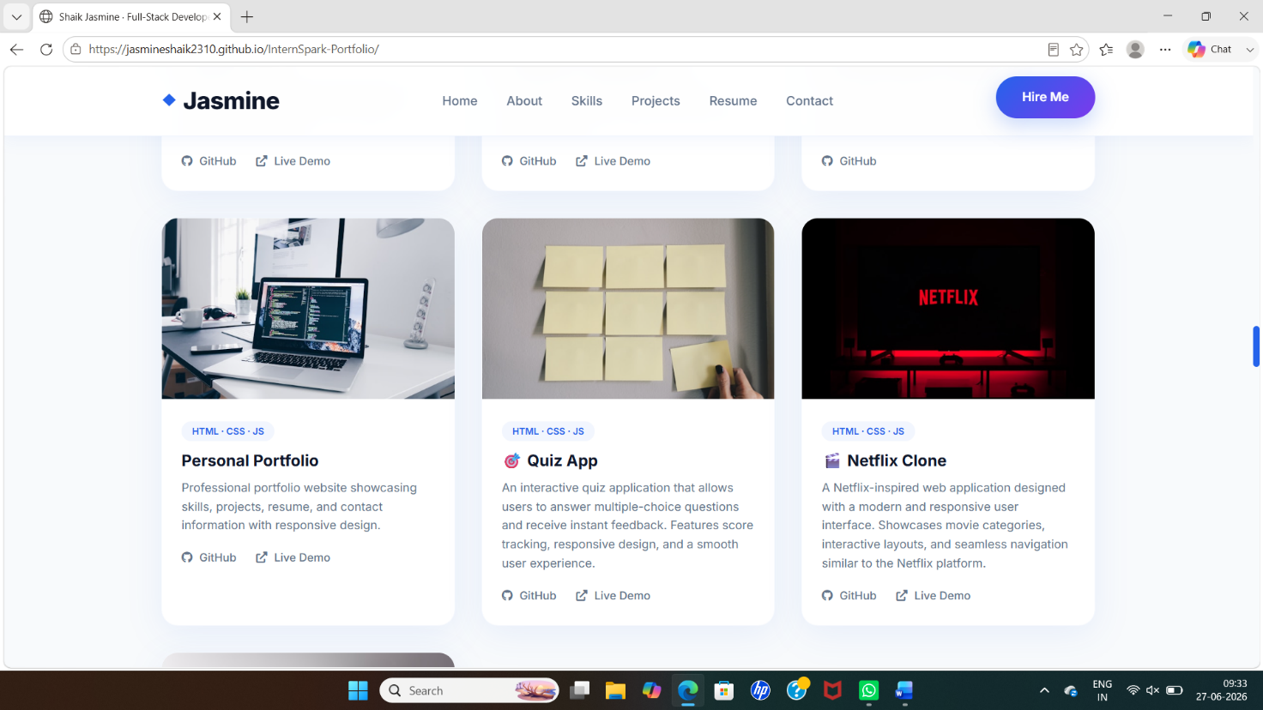
Fig 3.4(c): Hands-on Projects

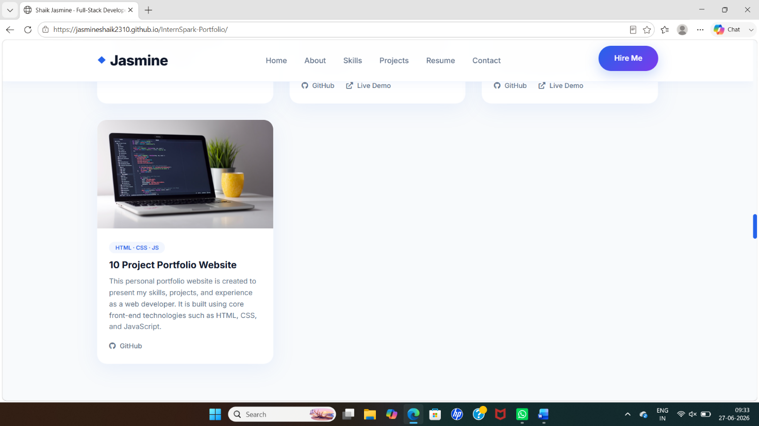
Fig 3.4(d): Hands-on Projects

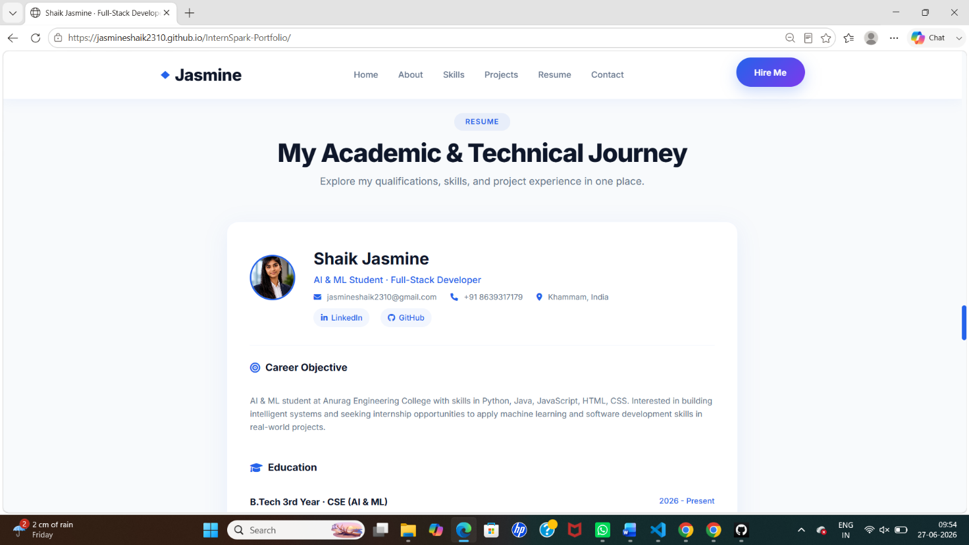
Fig 3.5: Resume

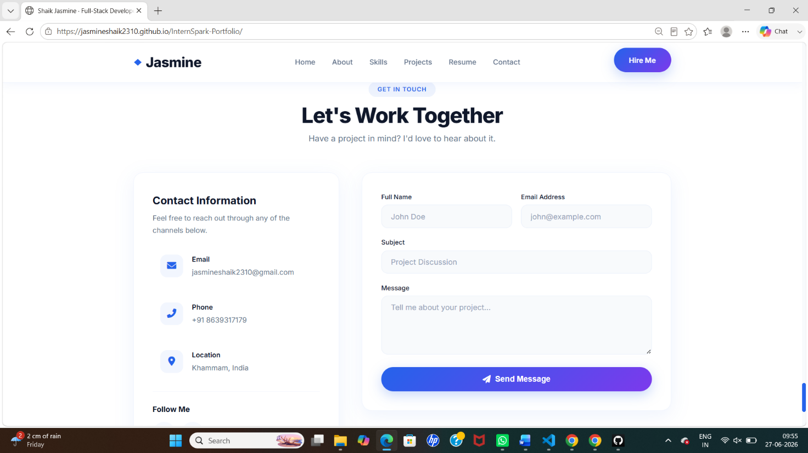
Fig 3.6: Contact

[4]Code Snippets:
HTML:
<!DOCTYPE html>
<html lang="en">
<head>
<meta charset="UTF-8">
<meta name="viewport" content="width=device-width, initial-scale=1.0">
<title>Shaik Jasmine | Portfolio</title>

<link rel="stylesheet" href="css/style.css">
<link rel="stylesheet" href="https://cdnjs.cloudflare.com/ajax/libs/font-awesome/6.5.1/css/all.min.css">
<style>
*{
margin:0;
padding:0;
box-sizing:border-box;
font-family:Arial,sans-serif;
}

body{
background:#f5f7fb;
color:#333;
line-height:1.6;
}

nav{
background:#0f172a;
color:#fff;
display:flex;
justify-content:space-between;
align-items:center;
padding:15px 8%;
}

nav ul{
display:flex;
list-style:none;
gap:20px;
}

nav a{
color:#fff;
text-decoration:none;
}

.hero{
text-align:center;
padding:80px 20px;
background:#2563eb;
color:#fff;
}

.hero h1{
font-size:50px;
}

.hero p{
margin:20px 0;
}

.btn{
display:inline-block;
padding:12px 25px;
background:#fff;
color:#2563eb;
border-radius:6px;
text-decoration:none;
font-weight:bold;
}

section{
padding:60px 8%;
}

h2{
margin-bottom:20px;
color:#2563eb;
}

.skills{
display:grid;
grid-template-columns:repeat(auto-fit,minmax(180px,1fr));
gap:20px;
}

.card{
background:#fff;
padding:20px;
border-radius:10px;
box-shadow:0 5px 10px rgba(0,0,0,.1);
text-align:center;
}

footer{
background:#0f172a;
color:#fff;
text-align:center;
padding:20px;
}
</style>
</head>

<body>

<nav>
<h2>Jasmine</h2>

<ul>
<li><a href="#">Home</a></li>
<li><a href="#">About</a></li>
<li><a href="#">Skills</a></li>
<li><a href="#">Projects</a></li>
<li><a href="#">Contact</a></li>
</ul>
</nav>

<section class="hero">

<h1>Shaik Jasmine</h1>

<p>
AI & ML Student | Full Stack Developer
</p>

<a href="#" class="btn">
View Portfolio
</a>

</section>

<section>

<h2>About Me</h2>

<p>
Passionate Computer Science student specializing in AI & ML.
I enjoy building responsive websites and solving real-world
problems using modern web technologies.
</p>

</section>

<section>

<h2>Skills</h2>

<div class="skills">

<div class="card">
<i class="fab fa-html5"></i>
<h3>HTML</h3>
</div>

<div class="card">
<i class="fab fa-css3-alt"></i>
<h3>CSS</h3>
</div>

<div class="card">
<i class="fab fa-js"></i>
<h3>JavaScript</h3>
</div>

<div class="card">
<i class="fab fa-python"></i>
<h3>Python</h3>
</div>

</div>
</section>
Css:
/* Tablets & small laptops */
@media (max-width: 1024px) {
.hero-container {
grid-template-columns: 1fr;
text-align: center;
}

.hero-content {
align-items: center;
order: 2;
}

.hero-visual {
order: 1;
}

.hero-description {
max-width: 100%;
}

.hero-stats {
justify-content: center;
}

.hero-buttons {
justify-content: center;
}

.hero-title {
font-size: 3rem;
}

.hero-image-wrapper {
max-width: 350px;
margin: 0 auto;
}

.profile-circle {
width: 250px;
height: 250px;
font-size: 6rem;
}

.floating-card {
font-size: 0.75rem;
padding: 0.4rem 0.9rem;
}

.card-1 { top: 0; right: 0; }
.card-2 { bottom: 5%; left: 0; }
.card-3 { bottom: 20%; right: 0; }

.about-grid {
grid-template-columns: 1fr;
}

.about-main {
grid-template-columns: 1fr 1fr;
}

.contact-wrapper {
grid-template-columns: 1fr;
}

.resume-header {
flex-direction: column;
text-align: center;
}

.resume-contact {
justify-content: center;
}
}

/* Mobile devices */
@media (max-width: 768px) {
.nav-container {
flex-direction: column;
gap: 0.8rem;
}

.nav-links {
justify-content: center;
gap: 1rem;
flex-wrap: wrap;
}

.nav-cta {
display: none;
}

.section-title {
font-size: 2rem;
}

.hero-title {
font-size: 2.2rem;
}

.hero-stats {
gap: 1.5rem;
}

.stat-number {
font-size: 1.4rem;
}

.hero-buttons {
flex-direction: column;
width: 100%;
}

.hero-buttons .btn {
width: 100%;
text-align: center;
}

.about-main {
grid-template-columns: 1fr;
}

.about-sidebar {
grid-template-columns: 1fr 1fr;
}

.skills-grid {
grid-template-columns: 1fr 1fr;
}

.projects-grid {
grid-template-columns: 1fr;
}

.form-row {
grid-template-columns: 1fr;
}

.footer-content {
flex-direction: column;
text-align: center;
}

.footer-links {
justify-content: center;
}
}

/* Small phones */
@media (max-width: 480px) {
.container {
padding: 0 1rem;
}

.section-title {
font-size: 1.6rem;
}

.hero-title {
font-size: 1.8rem;
}

.hero-description {
font-size: 1rem;
}

.profile-circle {
width: 180px;
height: 180px;
font-size: 4rem;
}

.floating-card {
display: none;
}

.hero-stats {
flex-direction: column;
gap: 0.8rem;
}

.stat-item {
flex-direction: row;
gap: 0.5rem;
align-items: center;
}

.about-sidebar {
grid-template-columns: 1fr;
}

.skills-grid {
grid-template-columns: 1fr;
}

.resume-card {
padding: 1.5rem;
}

.resume-contact {
flex-direction: column;
align-items: center;
}

.resume-actions {
flex-direction: column;
}

.resume-actions .btn {
width: 100%;
text-align: center;
}

.contact-form-wrapper,
.contact-info-card {
padding: 1.2rem;
}
}
JavaScript:
// ===== SCRIPT.JS =====

document.addEventListener('DOMContentLoaded', function() {
// ===== 1. ACTIVE NAV LINK =====
const navLinks = document.querySelectorAll('.nav-links a');
const currentPath = window.location.pathname.split('/').pop() || 'index.html';

navLinks.forEach(link => {
const href = link.getAttribute('href');
if (href === currentPath) {
link.classList.add('active');
} else {
link.classList.remove('active');
}
});

// ===== 2. SMOOTH SCROLL =====
document.querySelectorAll('a[href^="#"]').forEach(anchor => {
anchor.addEventListener('click', function(e) {
const targetId = this.getAttribute('href');
if (targetId !== '#' && targetId.startsWith('#')) {
e.preventDefault();
const target = document.querySelector(targetId);
if (target) {
target.scrollIntoView({ behavior: 'smooth', block: 'start' });
}
}
});
});

// ===== 3. CONTACT FORM =====
const contactForm = document.querySelector('.contact-form');
if (contactForm) {
contactForm.addEventListener('submit', function(e) {
e.preventDefault();
const btn = this.querySelector('.btn-submit');
const originalText = btn.innerHTML;

btn.innerHTML = '<i class="fas fa-spinner fa-spin"></i> Sending...';
btn.disabled = true;

setTimeout(() => {
btn.innerHTML = '<i class="fas fa-check"></i> Message Sent!';
btn.style.background = '#22c55e';
btn.style.border = 'none';

setTimeout(() => {
btn.innerHTML = originalText;
btn.style.background = '';
btn.disabled = false;
this.reset();
}, 3000);
}, 2000);
});
}

// ===== 4. SKILLS ANIMATION =====
const skillBars = document.querySelectorAll('.skill-progress-bar');
if (skillBars.length > 0) {
const observer = new IntersectionObserver((entries) => {
entries.forEach(entry => {
if (entry.isIntersecting) {
const bar = entry.target;
const width = bar.style.width;
bar.style.width = '0%';
setTimeout(() => { bar.style.width = width; }, 200);
}
});
}, { threshold: 0.3 });

skillBars.forEach(bar => observer.observe(bar));
}

// ===== 5. NAVBAR SCROLL EFFECT =====
const navbar = document.querySelector('.navbar');
if (navbar) {
window.addEventListener('scroll', function() {
if (window.scrollY > 30) {
navbar.style.boxShadow = '0 4px 20px rgba(37, 99, 235, 0.06)';
} else {
navbar.style.boxShadow = 'none';
}
});
}

// ===== 6. PROJECT CARD HOVER =====
document.querySelectorAll('.project-card').forEach(card => {
card.addEventListener('mouseenter', function() {
const img = this.querySelector('.project-image');
if (img) {
img.style.transform = 'scale(1.02)';
}
});
card.addEventListener('mouseleave', function() {
const img = this.querySelector('.project-image');
if (img) {
img.style.transform = 'scale(1)';
}
});
});

// ===== 7. ANIMATED COUNTERS =====
const statNumbers = document.querySelectorAll('.stat-number');
if (statNumbers.length > 0) {
const observer = new IntersectionObserver((entries) => {
entries.forEach(entry => {
if (entry.isIntersecting) {
const el = entry.target;
const text = el.textContent;
const number = parseInt(text.replace(/[^0-9]/g, ''));
if (!isNaN(number)) {
let current = 0;
const increment = Math.ceil(number / 40);
const timer = setInterval(() => {
current += increment;
if (current >= number) {
el.textContent = text.replace(/[0-9]+/, number);
clearInterval(timer);
} else {
el.textContent = text.replace(/[0-9]+/, current);
}
}, 30);
}
}
});
}, { threshold: 0.3 });

statNumbers.forEach(num => observer.observe(num));
}

// ===== 8. RESUME DOWNLOAD (USING PRINT METHOD) =====
const downloadBtn = document.getElementById('downloadResumeBtn');
if (downloadBtn) {
downloadBtn.addEventListener('click', function(e) {
e.preventDefault();

const btn = this;
const originalText = btn.innerHTML;

// Add print styles
const style = document.createElement('style');
style.id = 'print-style';
style.textContent = `
@media print {
.resume-actions { display: none !important; }
.navbar { display: none !important; }
footer { display: none !important; }
.section-header { display: none !important; }
.resume-card {
box-shadow: none !important;
border: 1px solid #ddd !important;
padding: 30px !important;
}
body { background: white !important; }
.container { max-width: 100% !important; padding: 20px !important; }
.resume-wrapper { max-width: 100% !important; }
.resume-header { padding-bottom: 15px !important; }
.resume-body { padding: 10px 0 !important; }
.resume-section:last-child { margin-bottom: 0 !important; }
.resume-contact span { display: inline-block !important; }
.skills-tags .skill-tag { display: inline-block !important; }
.strengths-grid .strength-tag { display: inline-block !important; }
.languages-grid .language-tag { display: inline-block !important; }
.resume-social a { display: inline-block !important; }
}
`;
document.head.appendChild(style);

btn.innerHTML = '<i class="fas fa-spinner fa-spin"></i> Preparing...';
btn.disabled = true;

setTimeout(() => {
window.print();
btn.innerHTML = originalText;
btn.disabled = false;
}, 500);

// Remove style after print
setTimeout(() => {
const printStyle = document.getElementById('print-style');
if (printStyle) printStyle.remove();
}, 2000);
});
}

// ===== 9. PRINT VERSION BUTTON =====
const printBtn = document.querySelector('.resume-actions .btn-outline');
if (printBtn) {
printBtn.addEventListener('click', function(e) {
e.preventDefault();

const style = document.createElement('style');
style.id = 'print-style-2';
style.textContent = `
@media print {
.resume-actions { display: none !important; }
.navbar { display: none !important; }
footer { display: none !important; }
.section-header { display: none !important; }
.resume-card {
box-shadow: none !important;
border: 1px solid #ddd !important;
padding: 30px !important;
}
body { background: white !important; }
.container { max-width: 100% !important; padding: 20px !important; }
.resume-wrapper { max-width: 100% !important; }
.resume-header { padding-bottom: 15px !important; }
.resume-body { padding: 10px 0 !important; }
}
`;
document.head.appendChild(style);

window.print();

setTimeout(() => {
const printStyle = document.getElementById('print-style-2');
if (printStyle) printStyle.remove();
}, 2000);
});
}

console.log('🚀 Portfolio loaded successfully!');
});
// ===== 10. SMOOTH SCROLL FOR ALL ANCHOR LINKS =====
document.querySelectorAll('a[href^="#"]').forEach(anchor => {
anchor.addEventListener('click', function(e) {
const targetId = this.getAttribute('href');
if (targetId !== '#' && targetId.startsWith('#')) {
e.preventDefault();
const target = document.querySelector(targetId);
if (target) {
target.scrollIntoView({
behavior: 'smooth',
block: 'start'
});
}
}
});
});

[5]GitHub Repository Link:
https://github.com/jasmineshaik2310/InternSpark-Portfolio
[6]Hosted Project Link:
https://jasmineshaik2310.github.io/InternSpark-Portfolio/
[7]Conclusion:
Successfully developed and deployed the project using HTML, CSS, and JavaScript. The project helped in improving practical skills in web development.
Name: Shaik Jasmine
Candidate ID: IS-2026-12707
Domain: Frontend Developer Intern

