Advanced Events – Documentation

**Exporting event data from Evanced**

* Log in to the Room Reservation module and choose “View/Print Room Schedules”
* Choose your date range and select your rooms.
* In order to be able to export to CSV, first select “full list” next to “Display by” (see below).
* After making these settings changes, you will be able to select the CSV radio button.

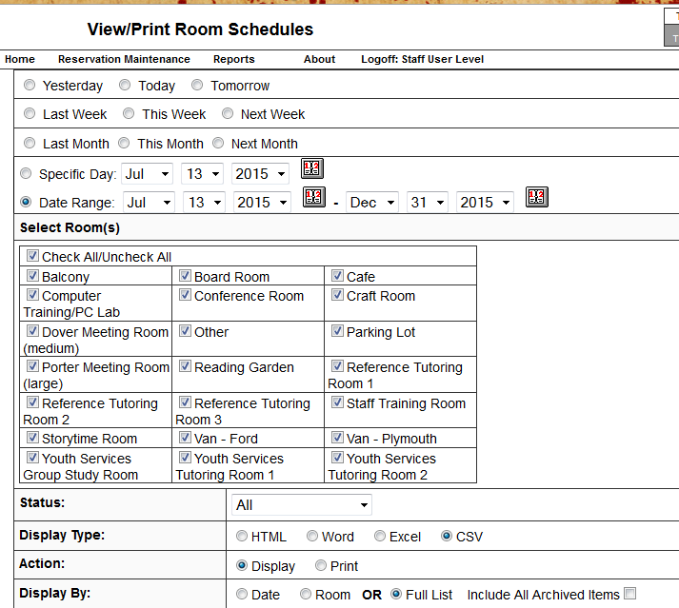

Next, select the columns that you use in your management of the evanced site and that are going to be used in the Drupal site. Click “submit” (see below). If you click “save as” this report will be saved and can be used again.

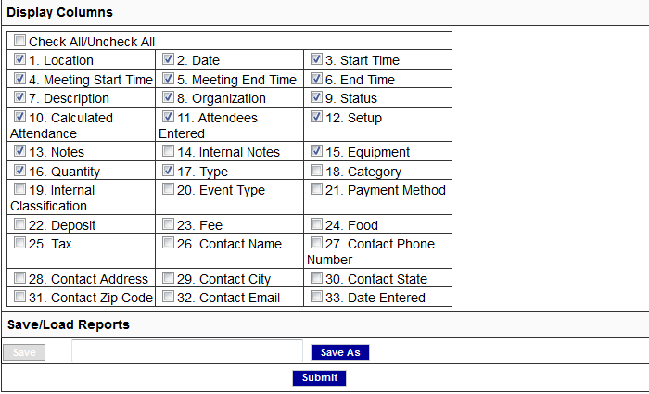

**Exporting registration info from evanced**

* Log in to the Event System Maintenance module.
* Choose “Event Attendance”
* Choose an event from the calendar
  + You will see names of attendants and contact info depending on your local setup
* Choose “Export to CSV” (see below).
* IMPORTANT: keep track of these files as based on the current state of the code in the repo, they must be matched to their corresponding drupal node.

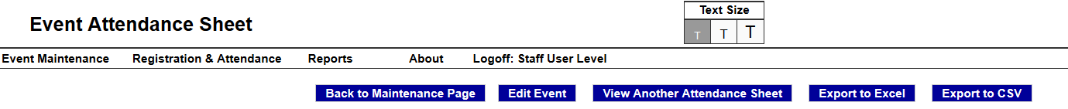

**Uploading registration information to the new drupal site**

* open up evanced_reginfo_migrate.php a text editor and edit the database connection information (starting at line 81) to match the drupal site database that you created when you installed the drupal-based website.
* Open a browser on the machine with access to the new site’s database and a working webserver (I recommend [xampp](https://www.apachefriends.org/index.html) for test applications)
* Open evanced_reginfo_migrate.php in the browser via the webserver (http://localhost/ evanced_reginfo_migrate.php , not opening as a file)
* Select the nid of the event in the drupal-based site that you are migrating to (see below)
* Select the csv file with the registration info from the evanced site that you are migrating from
* Click “submit”

