Ingmar manage knowledge transfer

# List of abbreviations

MNC: multinational corporation

HQ: headquarter

# Introduction 4

H1: the degree of family business in the management of the subsidiary level, the more transfer of knowledge will be

H2: the more percentage share of family ownership in the business, the more transfer of knowledge will be

H3: the degree of subsidiary managers’ involvement in the network configuration is positively related with success of subsidiary’s development

H4: the degree of family member’s involvement in local network with external is positively related with success of subsidiary’s development

# Theoretical backgrounds 10

Family business

-internationalization

-degree of family business’ involvement

-percentage of family ownership

-degree of subsidiary managers’ involvement

**Headquarters-subsidiary’s relationship**

Transfer of knowledge

Network configuration

# Relationship Between HQ and Subsidiary

The paper starts by trying to understand the relationship between the HQ and subsidiary with four different theories. Network theory points out the relationship is network-base framework that configures the lines of service or production. Knowledge transfer depicts the HQ as a knowledge transmitter to economically profitable products and services. Information processing theory considers HQ as a center of information collector by coordinating resources and dispersing information about the market to reach the economy of scale. Agent theory takes HQ as principal, and subsidiary as agent to maximize the profits under restrictions and limitations.

## 2.1 Network theory – HQ in network-based framework

J. Kenneth Benson considers that the interorganizational network can be described as political economy with the distribution of two scarce resources, money and authority (Benson 1975). In the context of this network theory, the subsidiary as participant in the organizations pursues the supply of resources, while it depends also on a larger environment with the authority of the HQ to have a flow of resources.

Sumatra Ghoshal also concludes that the relationship between the HQ and subsidiary is network-based framework (Ghoshal & Bartlett 1990). The network can be shared between geographic footprints, or can be between functions. He visualizes the network consisting of all internal and external partners including customers, suppliers, regulators and competitors within which MNC interacts. He also explains that the resource configuration in MNC are based on the characteristics of the external network. For example, Ericsson has closed a few of its factories around the world, and has converted many of them into manufacturing centers that produce a narrow range of products. Alcatel gives specific mandates or specific task of technology pursuit to sub-units, rather than letting them produce independently a range of products within a country.

## 2.2 Knowledge transfer theory – HQ as knowledge transmitter

According to Bruce Kogut, the transferring of knowledge and the mode of transferring the knowledge are the foundation to an evolution theory of the multinational corporations (Kogut & Zander 2003). The HQ plays a role in transferring knowledge to subsidiaries. He argues that the choice of transfer mode is explained by the degree of tacitness of technology; and that firms are social communities that work as efficiently mechanisms to create and transmit knowledge into economically rewarded products and services.

Ingmar Björkman concludes that by assessing the knowledge residing the networks of headquarters and subsidiaries, MNCs can exploit the existing knowledge and combine these sources of knowledge to explore new issues (Björkman et al, 2004).

## 2.3 Information processing theory – HQ as information collector and disperser

According to William G. Egelhoff, a parent HQ interacts with subsidiaries by acting as a collector of information center in a hierarchy in the MNCs. HQ can achieve by designing hierarchical structure to provide coordination in the group. The advantage of hierarchy of HQ lies where it can coordinate the resources, and disperse the information to achieve economies of scale in a market, and even economies of scale across different products horizontally in the same market (Egelhoff 2010).

Hau L. Lee more specially discusses about the information sharing in the supply chain in the intraorganizational community (Lee & Whant 2000). Due to the globalization of business, the HQ needs to face up the challenges in coordinating the resources, dealing with long delivery lead times, high buffer stock, complex logistics and high cost of coordination.

## 2.4 Agent theory – HQ as principal to agent

Sharon Watson O’Donnell explores the relationship between the HQ and subsidiaries by agent theory to predict the use of monitoring mechanisms and incentive compensation (Donnell 2000).

The agent theory refers to maximizing the “principal’s” welfare by giving proper mechanism of supervision and incentives to “agent”. In the context of MNC, the HQ as the principal, delegates responsibilities and decision-making authority to the managers of subsidiaries, in order to achieve the goal congruence. According to the agent theory, the HQ as principal needs to use monitoring and incentive mechanisms to limit the capacities of managers of subsidiaries.

Nitin Nohria also shares the same point-of-view that the characteristics of headquarters-subsidiary relations make it similar to principal-agent relationships (Nohria & Ghoshal 1990). The principal of headquarter makes decision by relying on the information uniquely processed by subsidiaries. At the same time, the headquarter needs to align the interests of local subsidiaries with that of global strategy, while giving them a degree of autonomy.

# How headquarter add values to subsidiaries

After the reflections of relationship in different frameworks of theories, the paper tries to analyze how headquarters can add values to subsidiaries in different frameworks through the analysis of the relations, and analyze their research methods.

According to Alfred D. Chandler, the executives at the headquarter carry out activities at the two levels of functions (Chandler 1991). One is at the functional level of entrepreneurial or value-adding activity: executives take decisions to allocate resources, in order to achieve a long-term strategic goal. One is at the functional level of more administrative or loss-preventive activity: executives monitor the performance of organizations, and redefine the line of services or production to maximize the efficiency of organizational capacities.

Michael Goold further explains his concept of “parenting advantage” that he proposed back in the 1990s. The parenting advantage refers to “the creation of more value out of a group’s portfolio of business than any other owner could, is still an essential objective” (Goold & Campbell 2002). Goold rephrases the “parenting” in more new aspects such as corporate value-added, hierarchical relationships and the roles of different management levels and units.

He explains that parenting roles can be explained in two levels. One is the minimum corporate parenting role, which involves governance and administration procedures that facilitate the bureaucratic efficiency at the subsidiary level. The other is the value-added parenting role, where the parents exert influence and restraints to subsidiaries. For example, DOW adds value by emphasizing on manufacturing excellence; Tinto adds value by providing technic expertise to improve operations; BP adds value by implementing a performance culture; Virgin adds value by leveraging branding values into different aspects, from airlines through financial services.

Graph 1: Company structure

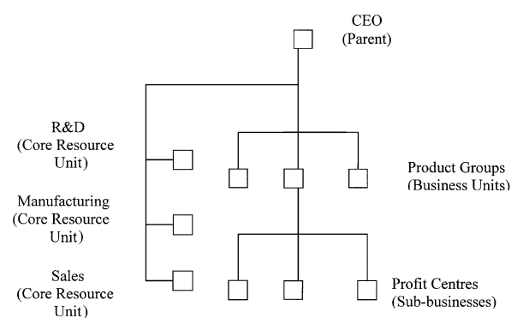

He explains parenting roles in complex structure, and how parents bring value to subsidiaries. For example the parent needs to retain more responsibilities in creating the policies and constraints; the parent has to be more involved in guiding the coordination between units; the parent needs to pay less control to output-based measures of performance, rather than to the design and working of the organization.

Graph 2: The extended parent

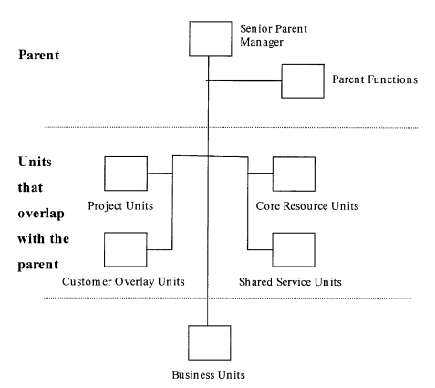

Here the parenting values can be extended more in the following analysis under the four frameworks of network theory, knowledge transfer theory, information processing theory and agent theory.

## 3.1 Network theory

By making research on the cases of MNCs such as GE, Phillips, P&G, and etc. Ghoshal makes three suggestions of configuring a quality network, to make sure that the HQ can add values to subsidiaries (Ghoshal & Bartlett, 1990).

1. HQ needs to design a network for various companies with different degree of density. A high degree of density means a high degree of interactiveness across the MNC, including between the HQ and subsidiary. The differences can be expected along both geographical and functional dimensions. For example, in terms of functions, the R&D is more densely interconnected across borders within MNC. In terms of countries, Japan has more density in connections than the US. In different organizational settings such as service or manufacturing, the density of networks differs too in the context of organizations.
2. HQ needs to focus on different parameters of the external network in addition to density. The parameters can proposed by Krackhardt (Krackhardt 1989) can be connectedness, hierarchy, least-upperboundedness, and graph efficiency, as the elements to describe the networks and to construct the networks.

Ulf Andersson proposes the value of embeddness of subsidiary in the external networks. He comes to the conclusion that external network helps to reinforce the technical embeddedness and indirectly impact the on subsidiary performance and competence development within the MNC (Andersson et al. 2002). In this sense, it largely depends on the HQ to actively involve subsidiary in external network, and to stimulate the diffusion of subsidiary competence, and to transfer it to subunits.

He makes the research on 97 Swedish MNC subsidiaries, and conducts interviews and questionnaires for managers at subsidiary and headquarter levels to assess the relationship, and to evaluate the performance with the counterparty. In the end the data results are validated by the nomological validity model (LISREL model).

Graph 3: The subsidiary’s external network embeddedness and importance for MNC development

(Andersson et al. 2002)

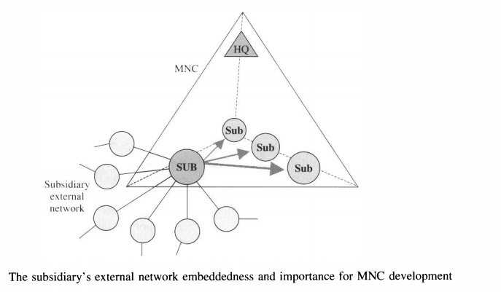

## 3.2 Knowledge transfer theory

According to Kogut, the transferring of knowledge and the mode of transferring the knowledge are the foundation to an evolution theory of the multinational corporations (Kogut & Zander 2003).

Kogut concludes that firms grow by transferring new technologies to subsidiaries. HQ strengthens its competitive advantage by playing a role in transmitting advanced technologies to subsidiaries. In transferring the knowledge to subsidiaries, HQ adds values by specifying the degree of knowledge and by designing appropriate mechanisms to transfer knowledge according to their different modes.

He makes the research by first contacting the technical directors at the group level, and by asking them to recommend five people who have considerable knowledge in the manufacturing process and innovation processes. Then he contacts these people by preparing questionnaires about their knowledge in the history of innovation. The questionnaire data concerns 35 innovations, and the sample size of the tests consists of the 82 instances of the transfer of the capability to manufacture.

Ingmar Björkman (Björkman et al. 2004) indicates that MNCs can influence the inter-unit knowledge transfer by specifying the objectives of subsidiaries. By conducting questionnaires and interviews on a sample of 134 Finnish and Chinese MNC subsidiaries, and by conducting statistical analysis and correlations, he explains that the MNC headquarters can use certain organizational mechanism such as the focus in top management compensations based on knowledge transfer can influence knowledge flows, and control the inter-unit transfer of subsidiary competences.

# Family business

Despite the large presence of family business and the expansion of the size, limited literature research has been documented on the HQ-subsidiary relationship in the context of family business. This may be due to the fact that family businesses are traditionally considered small-medium businesses rather than multinational companies. Therefore the research on the family business starts first with the definition of family business and the scale of business..

The definition of family business is fundamental to the researchers and yet remains a challenge to researchers. Until now there is “no widely accepted definition of a family business” (Littunen & Hyrsky 2000). An analysis of research of definition is focused on three domains: ownership, management involvement, and generation transfer.

Definition还可以再挖掘

Littunen, H., & Hyrsky, K. (2000). “The early entrepreneurial stage in Finish family and nonfamily firms” *Family Busienss Review,* 13(1), 41-54

The definition of family businesses can fall into three general categories (Sharma, 2004): articulation of multiple operation definitions of family firms (Astrachan & Shanker, 2003; Heck& Stafford, 2001; Westhead & Cowling, 1998), involvement of family members (Astrachan, Klein, & Smyrnios, 2002), and development of family firm typologies (Sharma, 2002).

Astrachan proposes an alternative method for measuring the extent of family influence, as a measurement of the impact of family on enterprises. He proposes a standardized system of the assessment on a continuous scale instead of an absolute category. He devises the F-PEC subscales including power, experience and culture (Astrachan, Klein, & Smyrnios, 2002).

Sharma develops a family firm typology by using family values regarding property rights, role of business in family and modes of family involvement in ownership and management (Sharma, 2002).

Pramodita Sharma (2004). An overview of the field of family business studies: current status and directions for the future. Family Business Review, vol. XVII, no. 1.

Astrachan, J.H., Klein, S.B., & Smyrnios, K.X. (2002). The F-PEC scale of family business definition problem. Family Business Review, 15 (1), 45-58.

Sharma, P. (2002). Shareholder mapping technique: Toward the development of a family firm typology. Paper presented at the Academy of Management meetings. Denver, CO.

The definition of family business proposed by Graves is practical to the research and it depends on the degree of family business. Graves proposes to define the family business as the one that is family majority owned (>50%), and has at least one family member in the management team, as consistent with the previous literature (Graves 2004). Therefore the research will be conducted according to this concept.

Chris Graves and Jill Thomas (2004), “Internationalisation of the Family Business: A Longitudinal Perspective”, *Int. J. Globalisation and Small Business*, Vol. 1, No. 1, 2004.

Researchers have developed different theories for the special characteristics of family business. Here the paper tries to elaborate the research on the internationalization of family businesses, and explain how the different factors in the family business may determine the success of internationalization, and further make an impact on family HQ-subsidiary relationship.

Sharma 25 years of family

Family business

-internationalization

-degree of family business’ involvement

-percentage of family ownership

-degree of subsidiary managers’ involvement

# Hypothesis 10

Family business

-internationalization

-degree of family business’ involvement

-percentage of family ownership

-degree of subsidiary managers’ involvement

# Data and methods 11

# Results 8

# Discussion 3

# Theoretical and practical implications 3

# Limitation 1

# Conclusions 2