Cherryservers.com WHMCS server provisioning addon 1.0

REQUIREMENTS

WHMCS 7.0 or greater
WHMCS six template

INSTALL

- Upload “modules/servers/cherryservers/” to “modules/servers”

SETUP

Create a WHMCS product at setup→products

Select the module “Cherryservers” in the “module name” field

Write your Cherryservers.com API key in the “API Key” field and click the “Save changes” button.

If the API key is invalid, a warning will be displayed:

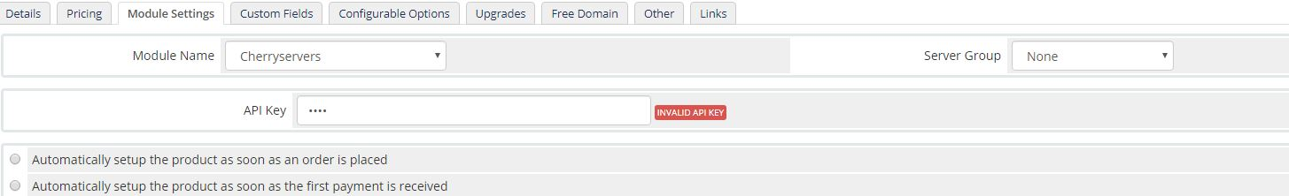
If the API key is valid, a new field will be displayed named “Team”, select a team and click the “Save changes” button.

After the team is selected, two new fields will be displayed, “Plan” and “Region”. Select the plan and region that will be used when the service is provisioned.

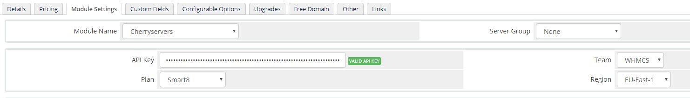

PRODUCT CUSTOM FIELDS

hostname: OPTIONAL. Used to set the default server hostname.
serverid: REQUIRED. Used to store the server id once provisioned.
os: OPTIONAL. Used to allow your customer to select an operating system in the order form. If created, the field type must be dropdown and the “select options” value :

Ubuntu 18.04 64bit,Ubuntu 16.04 64bit,CentOS 7 64bit,CentOS 6 64bit,Debian 9 64bit,Debian 8 64bit

Note: You can customize the custom fields names using friendly names, more info at https://docs.whmcs.com/Custom_Fields#Friendly_Display_Names .
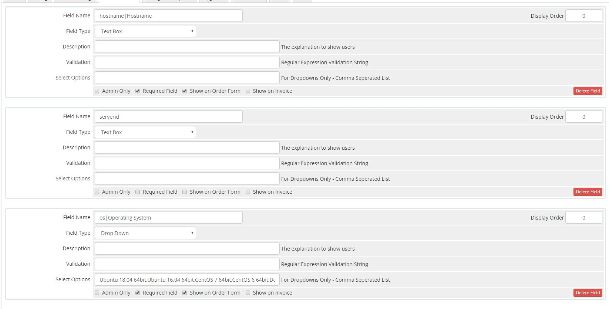

ADMIN SERVICE DETAILS

If the service is active, the server details will be displayed after the “Module Commands” button area.

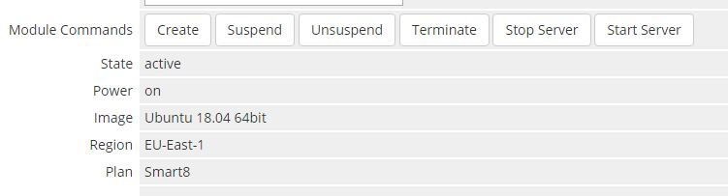
ADMIN COMMANDS

Create: Will provision the service with the product (plan,team,region) and service custom fields(hostname,operating system) settings.

Suspend: Will power off the server and set the service as “suspended”. The client area is not availabel if suspended/terminated. For automatic service suspend on invoice overdue check https://docs.whmcs.com/Automation_Settings#Enable_Suspension .

Unsuspend: Will power on the server and set the service as “active”. For automatic service unsuspend on invoice payment check https://docs.whmcs.com/Automation_Settings#Enable_Suspension .

Terminate: Will REMOVE the server. For automatic service terminations on invoice overdue check https://docs.whmcs.com/Automation_Settings#Termination_Days

Stop: Will power off the server. The WHMCS service status will not change.
Start: Will power on the server. The WHMCS service status will not change.

CLIENT AREA

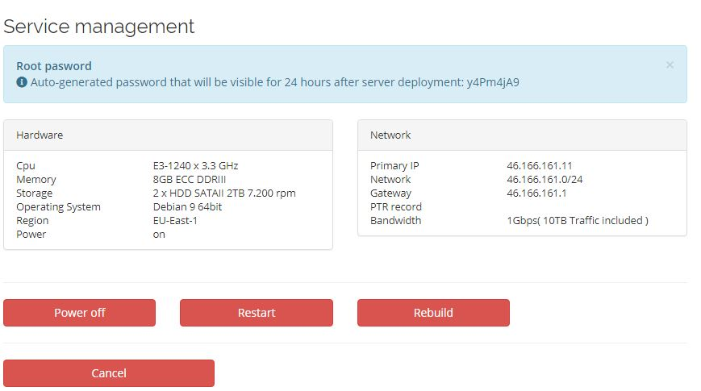
When the service is provisioned for the first time, the server password will be displayed for 24 hours ( same behaviour the cherryservers panel has). Also the server details will be displayed in two different panels.

Client area commands:

Power off: Will power off the server if the power status is on.
Power on: Will power ofn the server if the power status is off.
Restart: Will reboot the server

Rebuild: Open popup with options to rebuild the server with the service product settings and a dropdown to select operating system, new hostname and password.

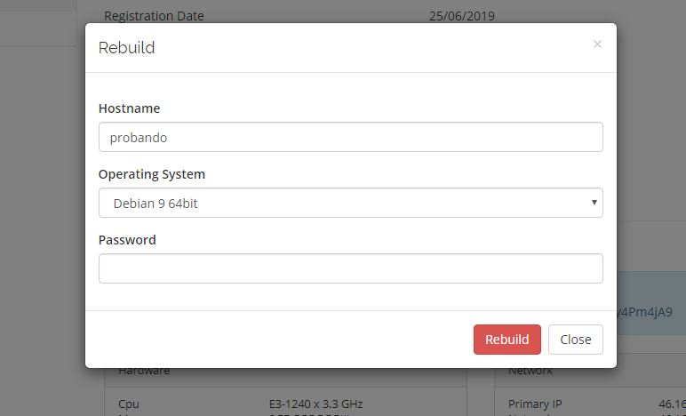

Cancel: Will open the service cancel request form.

If the service is been provisioned, the command buttons will not be displayed but a warning alert:

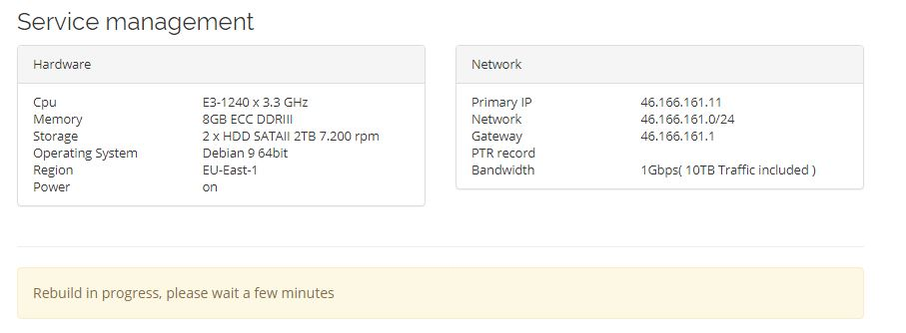
LANGUAGE

The language files are located in “modules/servers/cherryservers/lang”. English, spanish, french and german languages were added, if the language is not supported english will be used by default.

Note: Additional languages can be added by renaming the files with the language name.

GENERAL NOTES

The cherryservers.com API does not provide access to bandwidth data. That requirement was removed as requested but if the API adds that feature within the first year of support it will be added free of charge.

