2.1 SORTING A LIST WITH NEGATIVE NUMBERS

AIM
To write a program that sorts a list containing negative numbers in ascending order.
ALGORITHM
1. Start the program.
2. Define a function sort_list(arr) that uses Python’s built-in sorted().
3. Pass the list [-5, -1, -3, -2, -4] to the function.
4. The function returns the sorted list.
5. Print the result.
6. End the program.
PROGRAM
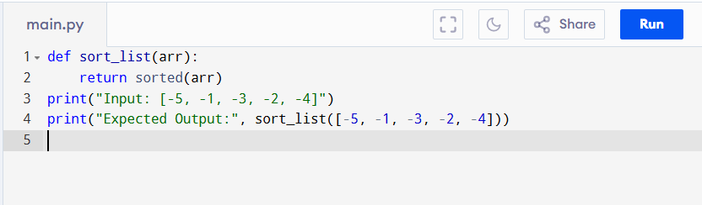
Input:
[-5, -1, -3, -2, -4]
Output:
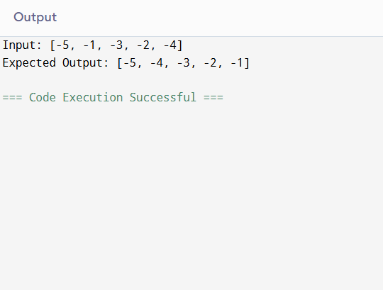
RESULT:
Thus the program is successfully executed and the output is verified.

PERFORMANCE ANALYSIS:
Time Complexity:
- Best Case: O(n) (if already sorted).
- Average & Worst Case: O(n log n).
Space Complexity:
- O(n), due to Timsort’s auxiliary storage.

