2.11 CONVEX HULL

AIM
To write a program that finds the convex hull of a set of 2D points using the brute force approach
ALGORITHM
1.For every pair of points (p, q) in the set:
- Compute the orientation of all other points relative to the line (p, q).
- If all points lie on the same side or are collinear → the segment (p, q) belongs to the convex hull.
2. Collect all unique points that belong to hull edges.
3. Sort the hull points in counter-clockwise (CCW) order using the polar angle (atan2).
4.List of hull points in CCW order.

PROGRAM
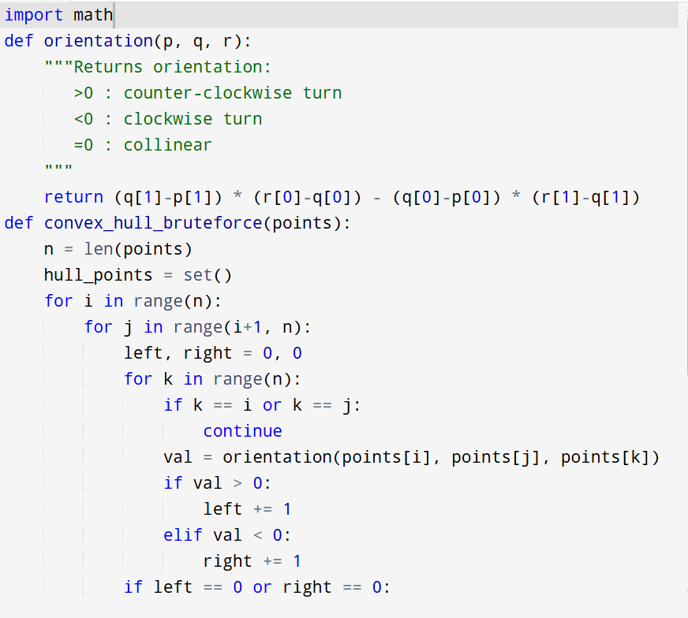

Input: points = [(1, 1), (4, 6), (8, 1), (0, 0), (3, 3)]

Output:
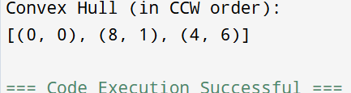

RESULT:
Thus the program is successfully executed and the output is verified.

PERFORMANCE ANALYSIS:
Time Complexity:
- For every pair of points (p, q) → O(n2)O(n^2)O(n2)
- For each pair, check all other points → O(n)O(n)O(n)
- Total = O(n3)O(n^3)O(n3)
Space Complexity: O(n)O(n)O(n) (to store hull points).

