2.13 ASSIGNMENT PROBLEM USING EXHAUSIVE SEARCH

AIM
The aim of this program is to solve the Assignment Problem using exhaustive search.
ALGORITHM
1. Start
2.Input the cost matrix, where cost[i][j] represents the cost of assigning worker i to task j.
3. Generate all permutations of task assignments (i.e., all possible ways to assign tasks to workers).
4.For each permutation:
- Compute the total cost by summing the costs of each worker-task pairing.
- Keep track of the minimum cost and its corresponding assignment.
5. Output the optimal assignment and the minimum cost.
6. Stop

PROGRAM
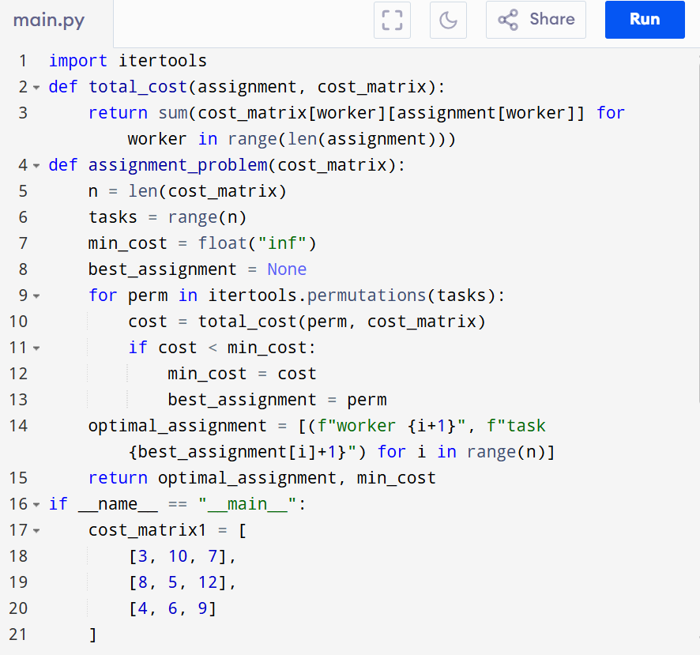

Input: points = cost_matrix1 = [
[3, 10, 7],
[8, 5, 12],
[4, 6, 9]
]
cost_matrix2 = [
[15, 9, 4],
[8, 7, 18],
[6, 12, 11]
]

Output:
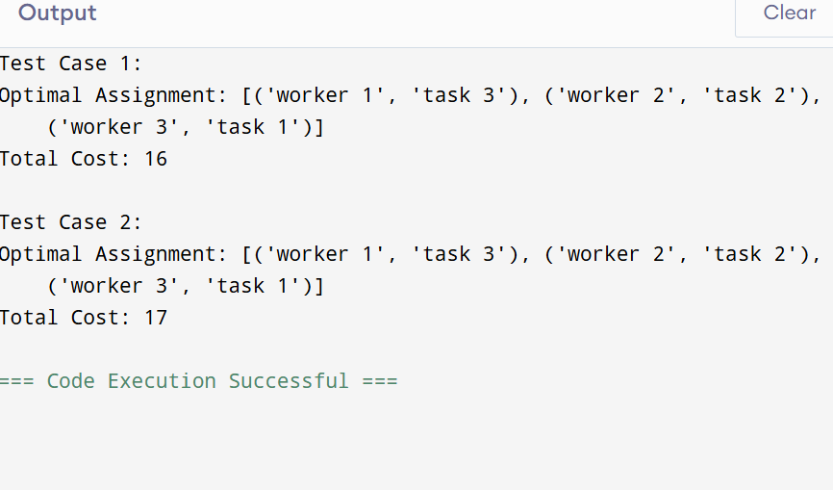

RESULT:
Thus the program is successfully executed and the output is verified.

PERFORMANCE ANALYSIS:
Time Complexity:
- Generating all permutations: O(n!)
- Computing cost per assignment: O(n)
- Total = O(n! * n)
Space Complexity: O(n) for storing assignment.

