2.14 Knapsack Problem

Aim: The aim of this program is to solve the 0–1 Knapsack Problem using the exhaustive search approach.
Algorithm:
1. Start
2.Input the list of weights, values, and the knapsack capacity.
3.Generate all possible subsets of items using intercools combinations.
4.For each subset:
- Check feasibility (total weight ≤ capacity).
- Compute total value.
- Keep track of the subset with the maximum total value.
5.Return the optimal selection of items and the maximum value.
6.Stop
Program:
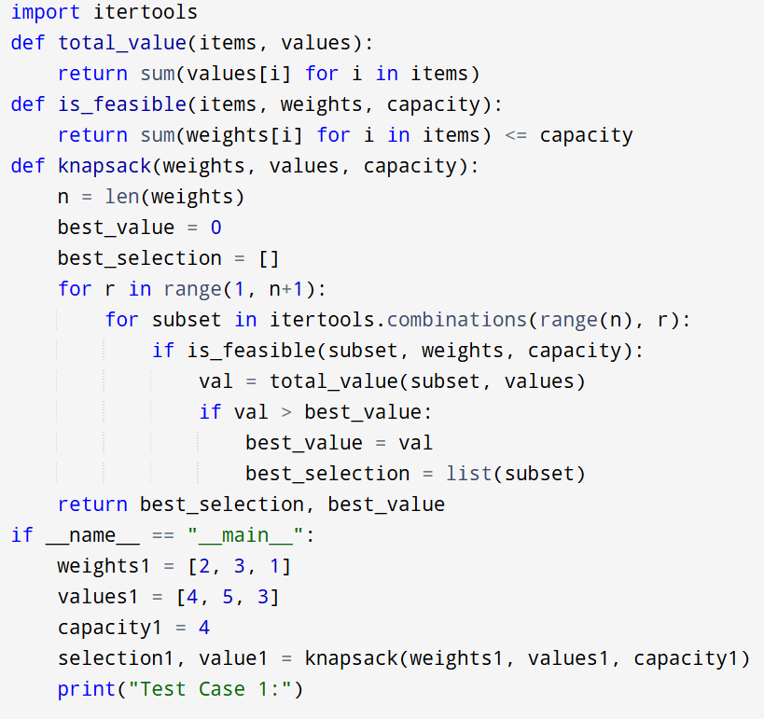
Input:
Weights: [2, 3, 1]
Values: [4, 5, 3]
Capacity: 4

Output:
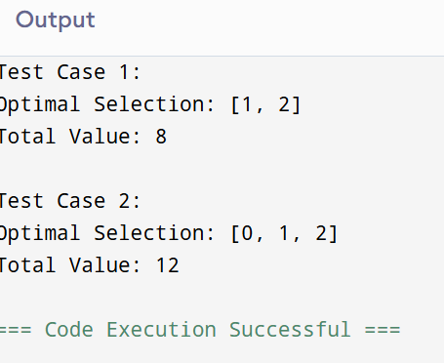
Result: Thus the program is successfully executed and the output is verified.
Performance analysis:
Time Complexity:
- Generating all subsets: O(2^n)
- Computing weight and value per subset: O(n)
- Total = O(n * 2^n)
Space Complexity:
- Storing one subset at a time: O(n)
- No extra storage of all subsets (only iterated).
- Overall = O(n)

