2.2 SELECTION SORTING

AIM
To describe the Selection Sort algorithm's process of sorting an array.
ALGORITHM
1.For each index i from 0 to n-2:
2. Assume the element at i is the smallest.
3.Compare it with the rest of the unsorted region.
4.Find the index of the smallest element.
5.Swap the smallest element with arr[i].

PROGRAM
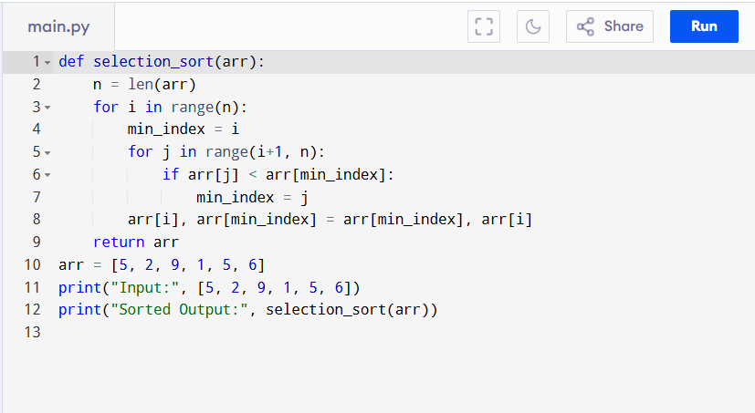
Input:
[5, 2, 9, 1, 5, 6]

Output:
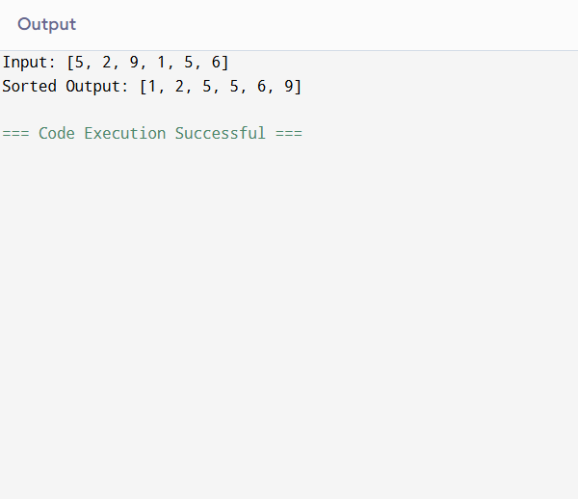
RESULT:
Thus the program is successfully executed and the output is verified.

PERFORMANCE ANALYSIS:
- Time Complexity:
  - Best Case (Already Sorted): Still scans entire array → O(n²) comparisons, O(n) swaps.
  - Worst Case (Reverse Sorted): O(n²) comparisons, O(n) swaps.
  - Average Case: O(n²) comparisons.
- Space Complexity:
  - O(1) (in-place sorting).

