2.4 OPTIMIZED FUNCTION

AIM
To implement and test an optimized sorting algorithm (Selection Sort) on a given list and analyze its performance.
ALGORITHM
1. Start with the entire unsorted list.
2. For each index i from 0 to n-1:
- Assume the element at i is the minimum.
- Traverse the rest of the list (i+1 to n-1) to find the true minimum element.
- If a smaller element is found, update the minimum index.
- Swap the found minimum with the element at index i.
3. Repeat until the whole list is sorted.
PROGRAM
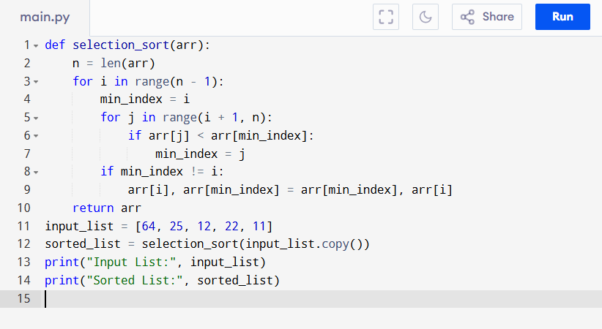
Input:
[64, 25, 12, 22, 11]
Output:
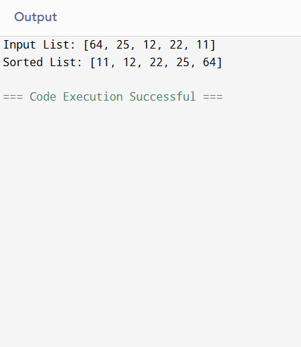
RESULT:
Thus the program is successfully executed and the output is verified.

PERFORMANCE ANALYSIS:
- Time Complexity:
  - Best Case: comparisons, swaps (if already sorted).
  - Worst Case: comparisons and swaps.
- Space Complexity: (in-place sorting).

