2.8 SEQUENCE OF CHARACTERS

AIM
To return all strings in words that is a substring of another word. You can return the answer in any order
ALGORITHM
1. Iterate over each word in words.
2. For each word, check every other word in the list.
3. If the current word is found as a substring of any other word, add it to the result.
4. Return the list of such words.

PROGRAM
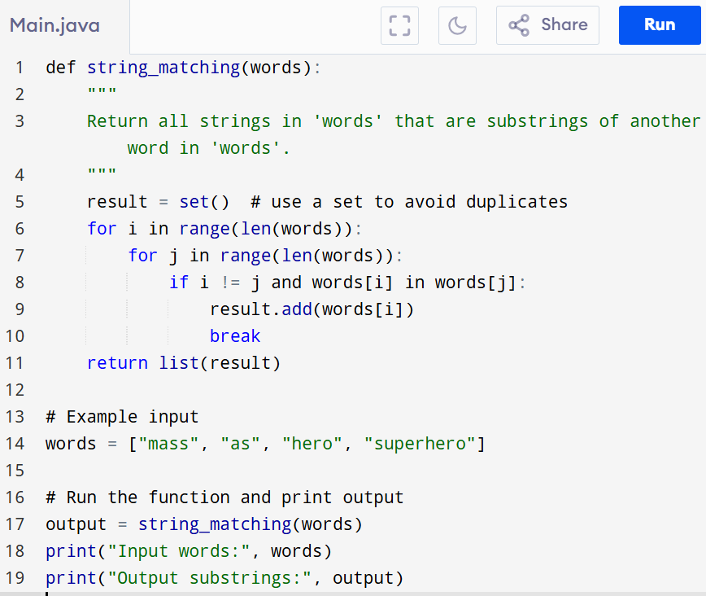
Input:
words = ["mass", "as", "hero", "superhero"]

Output:
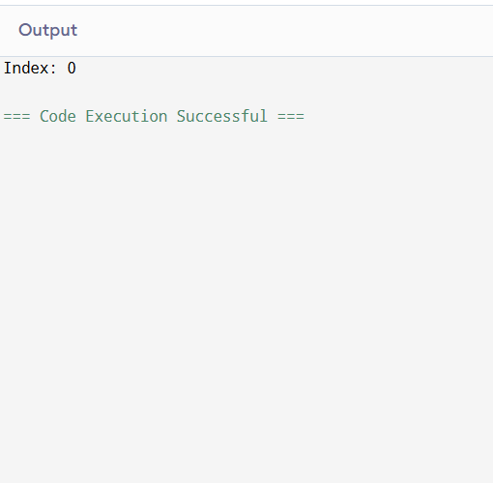

RESULT:
Thus the program is successfully executed and the output is verified.

PERFORMANCE ANALYSIS:
Time Complexity:
- Sorting: O(n log n)
- Nested loops: For each word, check all longer words → O(n²)
- Substring check (word in other_word): O(k * k) in worst case
- Overall: O(n² * k²)
Space Complexity:
- Output list: O(n) in the worst case (all words could be substrings)
- Additional space: O(1)

