2.9 BRUTE FORCE TECHINQUE

AIM
To write a program that finds the closest pair of points in a set of 2D points using the brute force approach.
ALGORITHM
1. A list of points (x, y).
2. Define a function to calculate the Euclidean distance between two points.
d=(x2−x1)2+(y2−y1)2d = \sqrt{(x_2 - x_1)^2 + (y_2 - y_1)^2}d=(x2​−x1​)2+(y2​−y1​)2​
3.Compare each pair of points (i, j) where i<ji < ji<j.
4. Track the minimum distance and the corresponding pair.
5.Return the pair with the smallest distance and the distance value.
PROGRAM
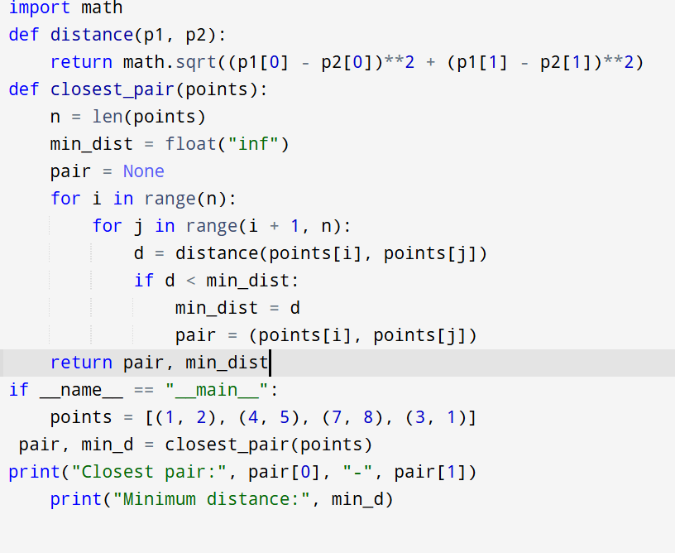
Input:
points = [(1, 2), (4, 5), (7, 8), (3, 1)

Output:
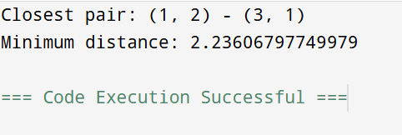

RESULT:
Thus the program is successfully executed and the output is verified.

PERFORMANCE ANALYSIS:
- Time Complexity: O(n2)O(n^2)O(n2) (because we check all pairs)
- Space Complexity: O(1)O(1)O(1) (only storing min distance & pair)

