2.10 BRUTE FORCE TECHINQUE

AIM
To write a program that finds the closest pair of points in a set of 2D points using the brute force approach.
ALGORITHM
1. For every pair of points (p, q) in the set:
- Form a line equation.
- Check if all other points lie on the same side or on the line.
- If true → (p, q) is part of the convex hull.
2.Collect all such points to form the hull.
3.Handle collinear points: include them if they are extreme (farthest on the same line).
PROGRAM
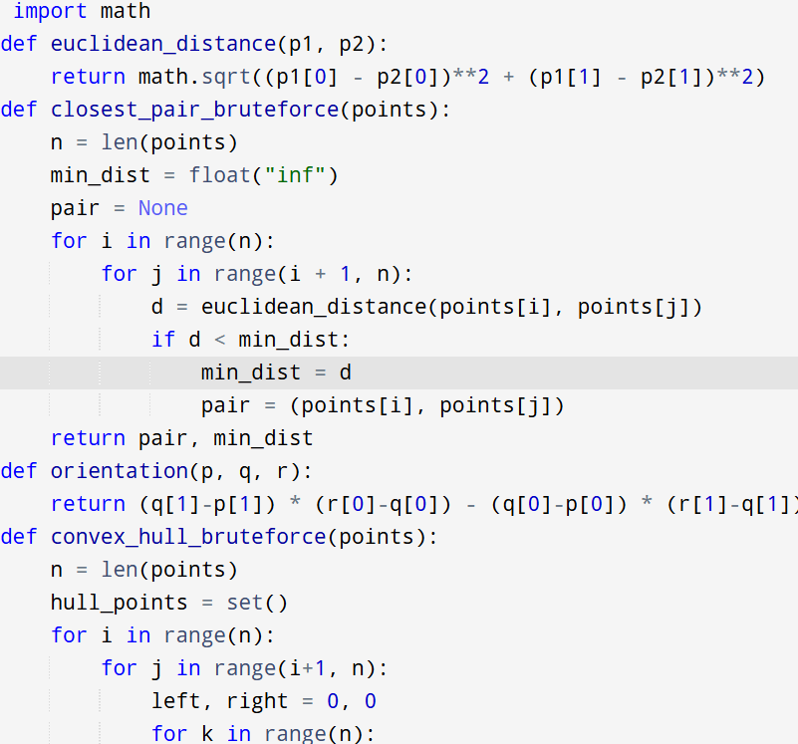
Input:
points = [(1, 2), (4, 5), (7, 8), (3, 1)

Output:
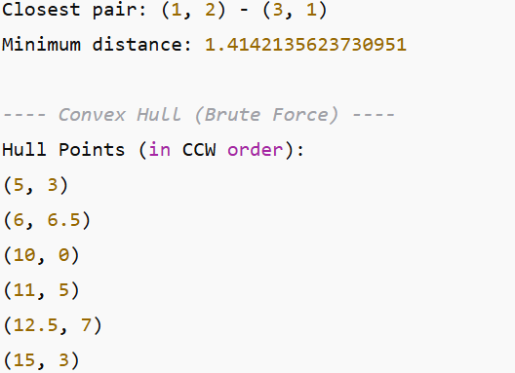

RESULT:
Thus the program is successfully executed and the output is verified.

PERFORMANCE ANALYSIS:
Closest Pair:
- Time: O(n2)O(n^2)O(n2)
- Space: O(1)O(1)O(1)
Convex Hull (Brute Force):
- Time: O(n3)O(n^3)O(n3) (pair selection × point checks)
- Space: O(n)O(n)O(n) (storing hull points)

