Exp-6.1
Title:
Visualization of the N-Queens Problem Solutions

Aim:
To understand the placement of queens on an N×N chessboard through graphical representations for different values of N (4, 5, and 8) and to demonstrate how visualization aids in debugging and gaining insights into the problem's complexity.

Algorithm
- Initialize an empty N×N board with '.' representing empty cells.
- Start placing queens row by row, beginning from the first row.
- For the current row, iterate over each column to find a safe position.
- Check if placing a queen at the current cell does not conflict with previously placed queens in:
  - The same column
  - The upper left diagonal
  - The upper right diagonal
- If safe, place the queen ('Q') at the current cell and move to the next row recursively.
- If a conflict occurs or no valid placements are possible in a row, backtrack by removing the queen from the previous row and try different positions.
- Repeat steps 3-6 until all queens are placed or all possible placements are exhausted.

Input:
N = 4
N = 5

Output:
.Q..
...Q
Q...
..Q.

Q....
..Q..
....Q
.Q...
...Q.

Performance Analysis:
Time Complexity: O(N!)
Space Complexity: O(N²⁾

Program output :
def solveNQueens(N):
board = [['.' for _ in range(N)] for _ in range(N)]

def isSafe(row, col):
# Check column conflicts
for i in range(row):
if board[i][col] == 'Q':
return False
# Check upper left diagonal
i, j = row - 1, col - 1
while i >= 0 and j >= 0:
if board[i][j] == 'Q':
return False
i -= 1
j -= 1
# Check upper right diagonal
i, j = row - 1, col + 1
while i >= 0 and j < N:
if board[i][j] == 'Q':
return False
i -= 1
j += 1
return True

def backtrack(row):
if row == N:
printBoard(board)
return True
for col in range(N):
if isSafe(row, col):
board[row][col] = 'Q'
if backtrack(row + 1):
return True
board[row][col] = '.'
return False

backtrack(0)
Program Output:
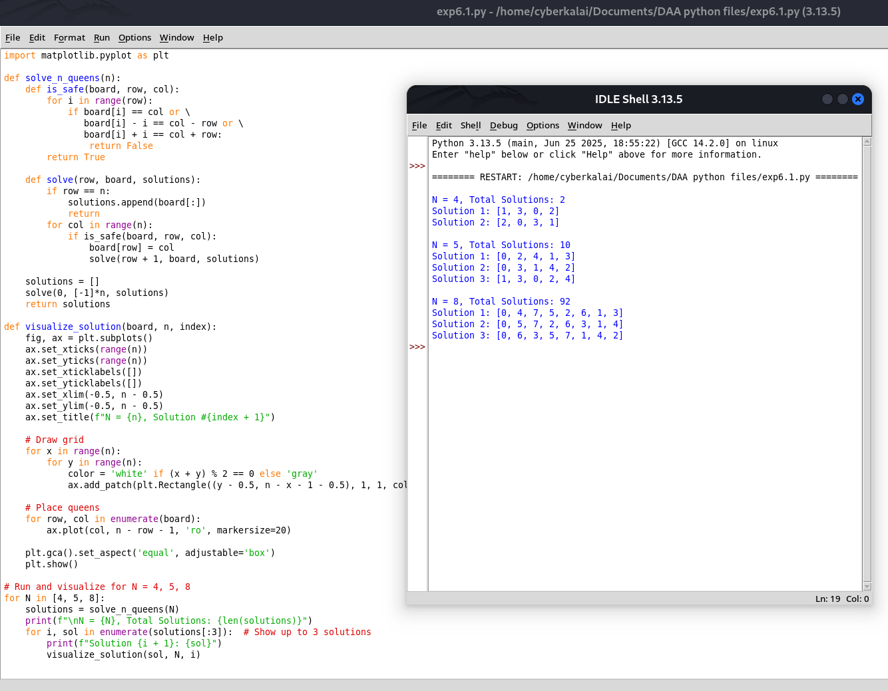
Result:
Thus, the Nqueens program is implemented and got output executed successfully.

