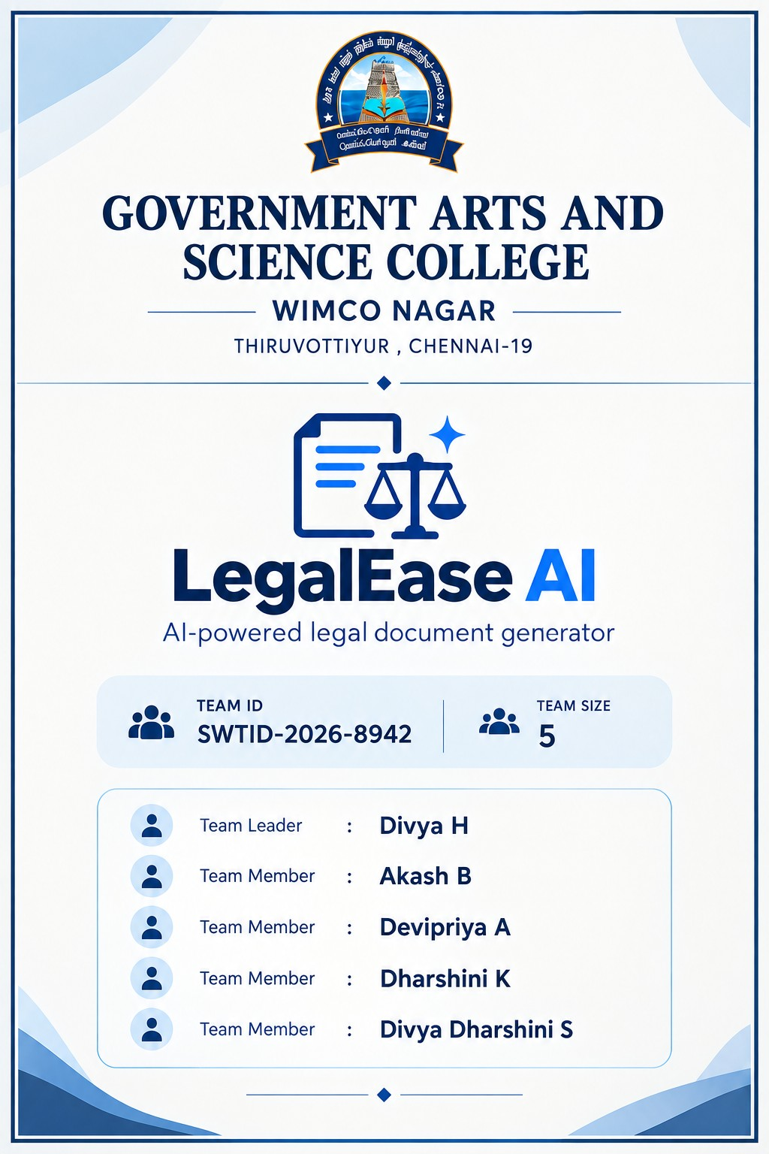

LEGALEASEAI
AI-Assisted Legal Document Drafting System
PROJECT DOCUMENTATION
Prepared & Developed by
DHARSHINI
Professional Student Project • Python • FastAPI • Gemini AI
“From project idea → code → debugging → working AI API → ﬁnal document”
01 | PROJECT OVERVIEW
Understanding what Dharshini built and why it exists
Project Vision
LegalEaseAI is a Python-based application designed to generate structured legal-document drafts from
user-provided information. The system connects a frontend form to a FastAPI backend and then uses
Google Gemini through the oﬃcial Python SDK to generate the draft.
Core objective
Accept document details from the user in a simple interface.
Send the structured information to the FastAPI backend.
Build a controlled prompt from the submitted ﬁelds.
Generate a draft through Gemini AI.
Return the generated document text to the frontend.
Keep the workﬂow understandable, testable and maintainable.
Dharshini’s role in the implementation
The project workﬂow documented here treats Dharshini as the developer responsible for assembling
the application, conﬁguring the environment, connecting the API layers, testing requests and ﬁxing

runtime errors.
02 | PROJECT STRUCTURE
Know exactly where each part belongs
LegalEaseAI/
backend/
main.py
routes.py
__init__.py
ai_core/
__init__.py
gemini_generator.py
frontend/
app.py
.env
requirements.txt
# Developer: Dharshini
What each ﬁle does
backend/main.py — starts and exposes the FastAPI application.
backend/routes.py — contains the API route logic.
backend/ai_core/gemini_generator.py — connects the backend to Gemini and creates the AI prompt.
frontend/app.py — provides the user-facing interface.
.env — stores local conﬁguration and the Gemini API key.
requirements.txt — records Python dependencies.
Simple mental model
Frontend → FastAPI route → Gemini generator → Gemini API → generated draft → FastAPI response
→Frontend.
03 | ENVIRONMENT & API KEY
Dharshini’s local conﬁguration layer
.env ﬁle

The real API key should never be placed in documentation, screenshots, GitHub repositories or chat
messages. Because the key was previously visible during troubleshooting, it should be revoked/rotated
and replaced with a new key before ﬁnal submission.
.gitignore
.env
.venv/
__pycache__/
*.pyc
# Developer: Dharshini
Important
Use a placeholder in the report. Never paste the real secret into the report.
04 | GEMINI GENERATOR
The AI integration written by Dharshini
from google import genai
import os
from dotenv import load_dotenv
load_dotenv()
class GeminiDocumentGenerator:
def __init__(self):
api_key = os.getenv("GEMINI_API_KEY")
if not api_key:
raise ValueError(
"GEMINI_API_KEY not found in .env ﬁle"
)
self.client = genai.Client(api_key=api_key)
# Developer: Dharshini
What happens here?
load_dotenv() loads local environment variables.
GEMINI_API_KEY is read without hard-coding the secret.
genai.Client creates the Gemini client.
The class keeps AI generation logic separate from the API route.
05 | PROMPT CONSTRUCTION
Turning form data into an AI instruction

document_type = data.get("document_type", "Document")
jurisdiction = data.get("jurisdiction", "")
parties = data.get("parties", [])
terms = data.get("terms", "")
effective_date = data.get("effective_date", "")
language = data.get("language", "English")
prompt = f"""
Create a professional draft {document_type}.
Jurisdiction:
{jurisdiction}
Parties:
{parties}
Terms:
{terms}
Effective Date:
{effective_date}
Language:
{language}
Use only the information provided.
Do not invent missing names, addresses,
dates, or amounts.
Create a clear and properly structured document.
Mention that this is a draft requiring
legal review.
Developer: Dharshini
"""
Why these instructions matter
The prompt explicitly tells the model to use the supplied information and avoid inventing missing facts.
It also makes the legal-review status clear, so the output is positioned as a draft rather than a
substitute for professional legal advice.
06 | MODEL REQUEST & RESPONSE
The actual AI generation step
model = os.getenv(
"GEMINI_MODEL",
"gemini-3.8-ﬂash"
)
response = self.client.models.generate_content(
model=model,
contents=prompt
)
return response.text
# Developer: Dharshini

Execution ﬂow
Read the conﬁgured model name from .env.
Fall back to the conﬁgured current model name if the environment variable is absent.
Send the constructed prompt to Gemini.
Read response.text.
Return the generated draft to the API layer.
Successful runtime evidence
During debugging, the backend eventually returned HTTP 200 OK for POST /generate, conﬁrming that
the local API request completed successfully.
07 | TEMPORARY 503 FAILURE
Dharshini’s debugging journey
for attempt in range(3):
try:
response = self.client.models.generate_content(
model=model,
contents=prompt
)
return response.text
except Exception as e:
error_message = str(e)
if (
"503" in error_message
or "UNAVAILABLE" in error_message
or "high demand" in error_message.lower()
):
if attempt < 2:
wait_time = 2 ** attempt
time.sleep(wait_time)
continue
raise e
# Developer: Dharshini
Observed error
The API returned HTTP 500 because the upstream Gemini service returned HTTP 503 UNAVAILABLE
with a high-demand message. This was different from the earlier local connection problem.
Debugging lesson
A 500 from the local backend does not automatically mean the Python code itself is broken. The
underlying exception must be read to identify whether the failure is local, conﬁguration-related, or
caused by a temporary upstream service condition.

08 | INSTALLATION & VIRTUAL ENVIRONMENT
Preparing Dharshini’s Python environment
PS C:\LegalEaseAI> .\.venv\Scripts\python.exe -m pip install google-genai
The dependency check showed google-genai was installed in the project virtual environment. Using the
virtual-environment Python executable avoids accidentally installing packages into a different Python
installation.
PS C:\LegalEaseAI> .\.venv\Scripts\python.exe -m uvicorn backend.main:app --reload --port 8000
Expected result
INFO: Uvicorn running on
http://127.0.0.1:8000
INFO: Application startup complete.
Developer: Dharshini
09 | STARTING THE BACKEND
The command Dharshini should run
Recommended working directory
Open the terminal at the LegalEaseAI project root — the folder containing backend, frontend, .env and
requirements.txt.
PS C:\LegalEaseAI> .\.venv\Scripts\python.exe -m uvicorn backend.main:app --reload --port 8000
Why this command is reliable
It explicitly uses the project virtual environment.
It starts backend.main:app from the project root.
--reload automatically restarts the server after code changes.
--port 8000 keeps the local API endpoint predictable.
Browser checks
http://127.0.0.1:8000/docs
http://127.0.0.1:8000/openapi.json
# Developer test: Dharshini

10 | FRONTEND → API REQUEST
How the complete request travels
User ﬁlls the LegalEaseAI form

frontend/app.py

POST http://127.0.0.1:8000/generate

backend/routes.py

GeminiDocumentGenerator

Gemini API

Generated draft

JSON response

Frontend
Developer ﬂow: Dharshini
What Dharshini should verify
Backend terminal shows the POST request.
The response status is 200 for a successful generation.
The frontend displays the returned document.
A 500 response should be followed by checking the backend traceback.
11 | FASTAPI / DOCS
Testing the API without guessing
Swagger / OpenAPI

FastAPI automatically exposes interactive API documentation at /docs. This is useful for Dharshini
because the endpoint can be inspected and tested independently from the frontend.
GET /docs
GET /openapi.json
POST /generate
# Developer: Dharshini
Known successful checks
GET /docs → 200 OK
GET /openapi.json → 200 OK
POST /generate → 200 OK after the temporary Gemini service issue cleared.
Why this is useful
If /docs works but the frontend cannot generate a document, the debugging focus can move to the
frontend request or payload rather than assuming the entire backend is down.
12 | DEBUGGING HISTORY
From ﬁrst error to working request
Stage Observed problem Resolution / lesson
1 WinError 10061 / connection
refused
Backend was not listening
on port 8000.
2 PowerShell execution policy Used the project Python
executable / adjusted
environment workﬂow.
3 No module named backend Started Uvicorn from the
correct project root.
4 Gemini model 404 Updated the conﬁgured
model from the unavailable
older model.
5 Gemini 503 high demand Retried after the upstream
service temporarily reported
high demand.
6 Final POST /generate 200 OK Backend + Gemini
integration completed
successfully.
Key debugging principle
Read the deepest useful error message ﬁrst. The same HTTP 500 can represent very different root

causes.
13 | GITHUB & PROJECT HYGIENE
How Dharshini should prepare the repository
Files to commit
backend/
frontend/
requirements.txt
README.md
.gitignore
# Safe repository contents — Dharshini
Files that should stay local
.env
.venv/
__pycache__/
*.pyc
# Never commit secrets — Dharshini
Suggested commit sequence
git init
git add .
git commit -m "Initial LegalEaseAI project"
git status
# Developer: Dharshini
Before pushing, verify that .env is ignored and that no API key appears in source ﬁles, screenshots,
documentation or Git history.
14 | END-TO-END TEST PLAN
Dharshini’s ﬁnal veriﬁcation checklist
Check Expected result
Virtual environment Project Python executable runs correctly
Dependencies google-genai and required packages are
installed
Environment .env contains a valid rotated key and model
name

Backend Uvicorn starts on 127.0.0.1:8000
API docs /docs and /openapi.json return successfully
Generate POST /generate returns 200 for a valid
request
Frontend Generated text is displayed
Security No API key appears in GitHub or report
Dharshini’s ﬁnal run
PS C:\LegalEaseAI> .\.venv\Scripts\python.exe -m uvicorn backend.main:app --reload --port 8000
Then open the frontend, submit a test document, and conﬁrm that the backend terminal records POST /
generate with a successful response.
15 | FINAL PROJECT SUMMARY
Professional handover for Dharshini
What the project demonstrates
Python project organization with separated frontend, backend and AI logic.
FastAPI-based API development.
Environment-variable based secret management.
Gemini API integration through google-genai.
Prompt construction from structured user input.
Real-world debugging across local and upstream service failures.
Basic retry handling for temporary service unavailability.
API testing through FastAPI Swagger/OpenAPI.
Repository hygiene and secret-protection practices.
Future development areas
Add stronger input validation and structured request models.
Add automated tests for routes and document generation.
Add persistent document history if required.
Improve error messages shown to end users.
Add authentication and role-based access if deployed publicly.

Add document export formats such as PDF/DOCX.
Review generated legal drafts with qualiﬁed legal professionals before real-world use.
Developer statement
This documentation records the implementation and debugging workﬂow of LegalEaseAI in a way that
lets Dharshini explain not only what the project does, but also where each piece of code belongs, how it
is executed, and how the major runtime errors were diagnosed.
THANK YOU
LegalEaseAI
Prepared & Developed by DHARSHINI
Project Drive Link: Open Google Drive Project Link

