**Tools Used**

1.Visual Studio Community

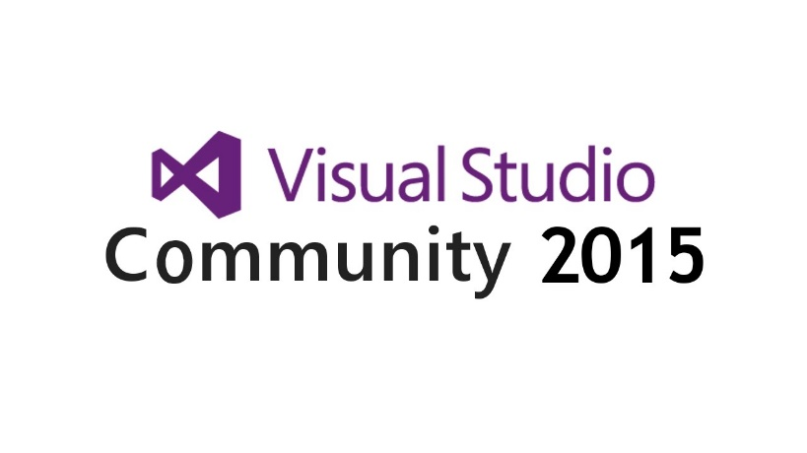

Visual Studio Community 2015 is a free, full-featured IDE with powerful coding productivity features, cross-platform mobile development tools for Windows, iOS and Android, tools for web and cloud development, and access to thousands of extensions. This edition of Visual Studio is available for free for individual developers, open source development, academic research, education and small professional teams. After installation, check out the Visual Studio Gallery. It provides quick access to tools, controls, and templates to help you get the most out of Visual Studio. To find out what's new in Visual Studio 2015, see the Visual Studio 2015 Release Notes. For a list of fixed bugs and known issues, see the Visual Studio 2015 KB Article.

Alternative Tool

* **WebMatrix**

The selection of this tool

Visual Studio 2015 Products can code with confidence in your language, find and fix code issues quickly, and refactor with ease. It debugs cross-language locally or remotely. Diagnose performance issues without leaving the debugger workflow.

2. WebStorm



WebStorm is a commercial IDE built by JetBrains for editing JavaScript, HTML, and CSS. It is built on the IntelliJ IDEA platform.

Alternative Tool

* PhpStorm
* *NetBeans*
* Atom
* Dreamweaver

The selection of this tool

WebStorm features advanced support for JavaScript, HTML, CSS, and their modern successors, as well as for frameworks such as AngularJS or React, debugging, and integration with the VCS and various web development tools:

* Intelligent Editor with coding assistance for JavaScript, Node.js, ECMAScript 6, TypeScript, CoffeeScript, and Dart as well as HTML, CSS, Less, Sass and Stylus. Cosing assistance includes syntax highlighting, documentation lookup, and refactorings.
* On-the-fly code analysis, error highlighting, and quick fixes.
* Powerful navigation across the project and advanced rafactorings.
* Support for modern frameworks: AngularJS, React, Meteor, Express and more.
* Built-in debugger for the client-side code and Node.js.
* Integration with the build tools (Grunt, Gulp), code quality tools (JSHint, JSLint, ESLint, JSCS), test runners (Karma, Mocha) and VCS (Git, GitHub, Mercurial, SVN).
* VCS Integrations: out-of-the-box support for Subversion, Perforce, Git, and CVS with changelists and merge.

3. Visual Paradigm

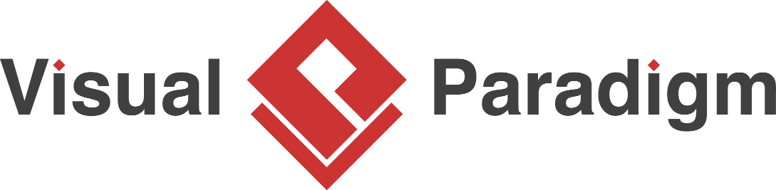

Visual Paradigm is a software tool designed for software development teams to model business information system and manage development processes. Visual Paradigm supports key industry modeling languages and standards such as [Unified Modeling Language (UML)](http://www.uml.org/), [SysML](http://www.sysml.org/" \t "_blank), [SoaML](http://www.omg.org/spec/SoaML/" \t "_blank), [BPMN](http://www.bpmn.org/), XMI, etc. It offers complete tool-set software companies need for [requirements capturing](https://www.visual-paradigm.com/features/uexceler-supports/#flowofevents),[process analysis](https://www.visual-paradigm.com/features/business-process-modeling/), [system design](https://www.visual-paradigm.com/features/uml-and-sysml-modeling/), [database design](https://www.visual-paradigm.com/features/database-design/), and etc.

Alternative Tool

* Draw.io
* Microsoft Visio
* UML Designer
* Creately.com

The selection of this tool

Visual Paradigm can create UML Diagram perfectly. And correct principles diagram. It can also handle design of others diagram such as business modeling Wireframe and so on