Objective: To test basic programming knowledge (conditional constructs , loop etc) and collections. Implement all possible conditions.

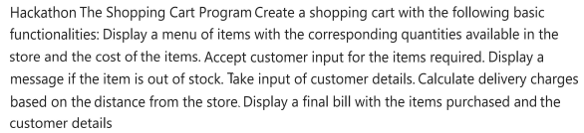

For delivery charges

If upto 15 km then 50 Rs

If 15 to 30 km then 100 rs

Create a console application for shopping cart program

Sample screen shot for reference. You are allowed to do slight modifications and additions to given requirements

