DAY 1:23-02-2024
MODULE-1:PYTHON FOR DATA ANALYSIS
Task-1:
Review of core python concepts:data types,operators,control flow, functions,modules,pacakages.
1.IDE-Integrated development environment(google colab)
2.Github repositrory creation(foldername-DataAnalaysis)
NUMPY:
It is used for numerical or scientific computation in arrays,vectors,matrices
Functions:
1.creation of array:It is used to create array
import numpy as np
arr=np.array([1,2,3,4,5],dtype=int)
print(arr)
Output:[1. 2. 3. 4. 5.]
2. Zeros & ones:
It is used to create a matrix m*n with values 0&1
zeros=np.zeros((3,3),dtype=float)
print(zeros)
ones=np.ones((2,2),dtype=int)
print(ones)
output:[[0. 0. 0.]
[0. 0. 0.]
[0. 0. 0.]]
[[1 1]
[1 1]]
3.arrange:
It is used to get the values of a given specified range.
->arrange=np.arange(100)
print(arrange)
Output:
[ 0 12 3 4 5 6 7 8 9 10 11 12 13 14 15 16 17 18 19 20 21 22 23 24 25 26 27 28 29 30 31 32 33 34 35 36 37 38 39 40 41 42 43 44 45 46 47 48 49 50 51 52 53 54 55 56 57 58 59 60 61 62 63 64 65 66 67 68 69 70 71 72 73 74 75 76 77 78 79 80 81 82 83 84 85 86 87 88 89 90 91 92 93 94 95 96 97 98 99]
->arrange=np.arange(0,100,5)
print(arrange)
Output:
[ 0 5 10 15 20 25 30 35 40 45 50 55 60 65 70 75 80 85 90 95]

4.array manipulation:
->reshaping of an array:
arr=np.array([1,2,3,4,5],dtype=int)
reshaped=arr.reshape(5,1)
print(reshaped)
Output:
[[1]
[2]
[3]
[4]
[5]]
->slicing a array: It will slice a array of given range.
arr=np.array([1,2,3,4,5],dtype=int)
sliced=arr[2:4]
print(sliced)
Output:
[3 4]
->Transpose of a array:
a=np.array([1,2,3,4,5,6,7,8])
b=a.T
print(b)
Output:
[1 2 3 4 5 6 7 8]
->spliting of a array:
a=np.array([1,2,3,4,5,6,7,8])
b=np.split(a,2)
print(b)
Output:
[array([1, 2, 3, 4]), array([5, 6, 7, 8])]
5.matrix multiplication:
a=np.array([[1,2],[3,4]])
b=np.array([[5,6],[7,8]])
c=np.dot(a,b)
print(c)
Output:
[[19 22]
[43 50]]

6.Eigen values:
c=np.dot(a,b)
d=np.linalg.eig(c)
print(d)
Output:
EigResult(eigenvalues=array([5.80198014e-02, 6.89419802e+01]), eigenvectors=array([[-0.75781077, -0.40313049],[ 0.65247439, -0.91514251]]))

7.load&save txt: DAP=np.loadtxt("/content/drive/MyDrive/Dataset/DAP1.txt",dtype=int)
d=np.savetxt("/content/DAP1.txt",DAP)
print(d)
print(DAP)
Output:
[[ 1 2 3 4 5]
[ 6 7 8 9 10]
[11 12 13 14 15]]
->import numpy as np
data=np.arange(0,100,5)
d=np.savetxt("/content/lab.txt",data)
print(d)
print(data)
Output:
[ 0 5 10 15 20 25 30 35 40 45 50 55 60 65 70 75 80 85 90 95 ]
8.random:
import numpy as np
a=np.random.rand()
print(a)
Output:0.9569699039864433
import numpy as np
b=np.random.randint(0,1)
print(b)
Output: 0.4308181891705497

9.Array functions:
->Array dimension:
c=np.array([[1,2],[3,4]])
print(c.ndim)
Output:
2
->Array size:
c=np.array([[1,2],[3,4]])
print(c.shape) OUTPUT:(2,2)
->Array type:
c=np.array([[1,2],[3,4]])
print(type(c))
Output:
<class 'numpy.ndarray'>
10.Linespace:
import numpy as np
a=np.linspace(0.8,2,5)
print(a)
Output:
[0.8 1.1 1.4 1.7 2. ]
11.Reshape:
b=np.arange(0,5)
print(b)
c=np.arange(24).reshape(3,2,4)
print(c)
Output:
[0 1 2 3 4]
[[[ 0 1 2 3]
[ 4 5 6 7]]

[[ 8 9 10 11]
[12 13 14 15]]

[[16 17 18 19]
[20 21 22 23]]]

12.Array Mul && Element Mul:
-> a=np.array([[1,2],[3,4]])
b=np.array([[5,6],[3,4]])
print(a*b)
Output:
[[ 5 12]
[ 9 16]]
-> a=np.array([[1,2],[3,4]])
b=np.array([[5,6],[3,4]])
print(a@b)
c=np.dot(a,b)
print(c)
Output:
[[11 14]
[27 34]]
[[11 14]
[27 34]]
13.sum:
from numpy import random
a=np.ones([2,3],dtype=int)
print(a)
print(a.sum())
print(a.sum(axis=0))
print(a.max())
Output:
[[1 1 1]
[1 1 1]]
6
[2 2 2]
14.floor:returns integer value less than or equal to that integer
a=np.floor(np.random.random((2,12)))
print(a)
Output:[[0. 0. 0. 0. 0. 0. 0. 0. 0. 0. 0. 0.]
[0. 0. 0. 0. 0. 0. 0. 0. 0. 0. 0. 0.]]
15.ceil:returns integer value greater than or equal to that integer
a=np.ceil(np.random.random((2,12)))
print(a)
Output:[[1. 1. 1. 1. 1. 1. 1. 1. 1. 1. 1. 1.]
[1. 1. 1. 1. 1. 1. 1. 1. 1. 1. 1. 1.]]
16.cumsum:
print(a.cumsum(axis=1))
a=np.array([2,3,5,6])
print(a.cumsum())
a=np.array([1,2,3,4,5,6])
Output:
[[0. 0. 0. 0. 0. 0. 0. 0. 0. 0. 0. 0.]
[0. 0. 0. 0. 0. 0. 0. 0. 0. 0. 0. 0.]]
[ 2 5 10 16]

17.Vertical stack:
a=np.array([1,2,3,5,6,7])
b=np.array([9,3,8,5,1,4])
print(np.vstack((a,b)))
Output:
[[1 2 3]
[5 6 7]
[9 3 8]
[5 1 4]]
18.Horizontal stack:
a=np.array([1,2,3,5,6,7])
b=np.array([9,3,8,5,1,4])
print(np.hstack((a,b)))
Output:
[[1 2 3 9 3 8]
[5 6 7 5 1 4]]
19:dstack():number of rows become number of group.. column become rows,group become column
c=np.arange(30).reshape(2,3,5)
print(d)
d=np.dstack(c))
Output:
[[[ 0 15]
[ 1 16]
[ 2 17]
[ 3 18]
[ 4 19]]

[[ 5 20]
[ 6 21]
[ 7 22]
[ 8 23]
[ 9 24]]

[[10 25]
[11 26]
[12 27]
[13 28]
[14 29]]]

20.eye:
a1=np.eye(4)
print(a1)
output:
[[1. 0. 0. 0.]
[0. 1. 0. 0.]
[0. 0. 1. 0.]
[0. 0. 0. 1.]]

21.full:
a1=np.full((2,2),3)
print(a1)
print(a1.itemsize)
output:

[[3 3]
[3 3]]
8

22.symmetric:
x=[1,2,3]
a=np.asarray(x)
print(a)
print(type(a))

Output:
[1 2 3]
<class 'numpy.ndarray'>

23.inner:
x=np.array([1,4,0],float)
y=np.array([2,2,1],float)
print(np.inner(x,y))

Output:
10.0

24.outer:
x=np.array([1,4,0],float)
y=np.array([2,2,1],float)
print(np.outer(x,y))

Output:

[[2. 2. 1.]
[8. 8. 4.]
[0. 0. 0.]]

25.cross:
x=np.array([1,4,0],float)
y=np.array([2,2,1],float)
print(np.cross(x,y))

Output:
[ 4. -1. -6.]

26.rint:

a=np.array([1.2,2.8,3.5,4.0,5.6,6.1,7.8])
np.rint(a)

Output:
array([1., 3., 4., 4., 6., 6., 8.])

27.true_divide:

a=np.array([10,6,8,4,48])
b=np.array([5,3,2,1,6])
np.true_divide(a,b)

Output:
array([2., 2., 4., 4., 8.])

28.unique:
a=np.array([1,1,2,2,3,3])
np.unique(a)

Output:
array([1, 2, 3])

29.intersection:
a=np.array([[1,1],[2,3]])
b=np.array([[1,4],[6,3]])
np.intersect1d(a,b)

Output:
array([1, 3])

30.setdiff:
a=np.array([[1,1,2,3]])
b=np.array([[1,4,6,3]])
np.setdiff1d(a,b)

Output:
array([2])

31.hypot:
a=8
b=6
c=np.hypot(a,b)
print(c)

Output:
10.0

32.dividemod:
a=np.array([10,21,30,40,50,60])
b=np.array([20,21,2,20,25,25])
d=np.divmod(a,b)
print(d)
Output:
(array([ 0, 1, 15, 2, 2, 2]), array([10, 0, 0, 0, 0, 10]))
33.mod:
a=np.array([10,21,30,40,50,60])
b=np.array([20,21,2,20,25,25])
c=np.mod(a,b)
print(c)
Output:
[10 0 0 0 0 10]
34.divide:
a=np.array([10,21,30,40,50,60])
b=np.array([20,21,2,20,25,25])
c=np.divide(a,b)
print(c)

Output:
[ 0.5 1. 15. 2. 2. 2.4]

35.multiply:
a=np.array([10,21,30,40,50,60])
b=np.array([20,21,2,20,25,25])
c=np.multiply(a,b)
print(c)

Output:
[ 200 441 60 800 1250 1500]

36.normal distribution:
from numpy import random
x=random.normal(size=(2,3))
print(x)

Output:
[[-2.28521328 0.70503614 -0.29790369]
[ 1.02765475 -0.5978811 1.16515452]]
37.#loc-meam,scale-sd
from numpy import random
x=random.normal(loc=1,scale=2,size=(2,3))
print(x)
Output:
[[-1.12698084 -4.33883962 -0.46599944]
[-0.03518578 -0.83401198 1.37426357]]
38.Binomial distribution:
from numpy import random
x=random.binomial(n=12,p=0.5,size=10)
print(x)
Output:
[6 6 6 8 8 8 5 8 6 4]
39.poission distribution:
from numpy import random
x=random.poisson(lam=2,size=10)
print(x)
Output:
[0 2 0 2 3 2 0 1 1 3]

40.choice:
->from numpy import random
x=random.choice([2,4])
print(x)
->from numpy import random
y=random.choice([3,5],p=[0.5,0.5],size=(3,5))
print(y)

Output:
2
[[3 3 5 3 3]
[3 3 5 5 3]
[5 3 3 3 5]]

DAY 2:24-02-2024
PANDAS:
Data manipulation package for tabular data.
Functions:
1.Series:
import pandas as pd
a=["jwalitha",'ramya','durga','jahnavi','lahari','sunny','deepthi']
r=pd.Series(a,index=[67,43,44,89,34,45,23])
print(r)
Output:
67 jwalitha
43 ramya
44 durga
89 jahnavi
34 lahari
45 sunny
23 deepthi
dtype: object
2.Read:
df=pd.read_csv("/content/diabetcsv.csv")
print(df)
Output:
preg plas pres skin insu mass pedi age class
0 6 148 72 35 0 33.6 0.627 50 tested_positive
1 1 85 66 29 0 26.6 0.351 31 tested_negative
2 8 183 64 0 0 23.3 0.672 32 tested_positive
3 1 89 66 23 94 28.1 0.167 21 tested_negative
4 0 137 40 35 168 43.1 2.288 33 tested_positive
.. ... ... ... ... ... ... ... ... ...
763 10 101 76 48 180 32.9 0.171 63 tested_negative
764 2 122 70 27 0 36.8 0.340 27 tested_negative
765 5 121 72 23 112 26.2 0.245 30 tested_negative
766 1 126 60 0 0 30.1 0.349 47 tested_positive
767 1 93 70 31 0 30.4 0.315 23 tested_negative

[768 rows x 9 columns]

3.Excel:
import pandas as pd
df=pd.read_excel("/content/diabetcsv (1).xlsx")
print(df)
Output:
preg plas pres skin insu mass pedi age class
0 6 148 72 35 0 33.6 0.627 50 tested_positive
1 1 85 66 29 0 26.6 0.351 31 tested_negative
2 8 183 64 0 0 23.3 0.672 32 tested_positive
3 1 89 66 23 94 28.1 0.167 21 tested_negative
4 0 137 40 35 168 43.1 2.288 33 tested_positive
.. ... ... ... ... ... ... ... ... ...
763 10 101 76 48 180 32.9 0.171 63 tested_negative
764 2 122 70 27 0 36.8 0.340 27 tested_negative
765 5 121 72 23 112 26.2 0.245 30 tested_negative
766 1 126 60 0 0 30.1 0.349 47 tested_positive
767 1 93 70 31 0 30.4 0.315 23 tested_negative

[768 rows x 9 columns]
4.Head:
import pandas as pd
df=pd.read_csv("/content/diabetcsv.csv")
print(df.head())
Output:
preg plas pres skin insu mass pedi age class
0 6 148 72 35 0 33.6 0.627 50 tested_positive
1 1 85 66 29 0 26.6 0.351 31 tested_negative
2 8 183 64 0 0 23.3 0.672 32 tested_positive
3 1 89 66 23 94 28.1 0.167 21 tested_negative
4 0 137 40 35 168 43.1 2.288 33 tested_positive

4.Tail:
import pandas as pd
df=pd.read_csv("/content/diabetcsv.csv")
print(df.tail(n=9))

Output:
preg plas pres skin insu mass pedi age class
758 1 106 76 0 0 37.5 0.197 26 tested_negative
759 6 190 92 0 0 35.5 0.278 66 tested_positive
760 2 88 58 26 16 28.4 0.766 22 tested_negative
761 9 170 74 31 0 44.0 0.403 43 tested_positive
762 9 89 62 0 0 22.5 0.142 33 tested_negative
763 10 101 76 48 180 32.9 0.171 63 tested_negative
764 2 122 70 27 0 36.8 0.340 27 tested_negative
765 5 121 72 23 112 26.2 0.245 30 tested_negative
766 1 126 60 0 0 30.1 0.349 47 tested_positive
5.Describe:#gives count of values,mean,std
import pandas as pd
df=pd.read_csv("/content/diabetcsv.csv")
print(df.describe)
Output:
<bound method NDFrame.describe of preg plas pres skin insu mass pedi age class
0 6 148 72 35 0 33.6 0.627 50 tested_positive
1 1 85 66 29 0 26.6 0.351 31 tested_negative
2 8 183 64 0 0 23.3 0.672 32 tested_positive
3 1 89 66 23 94 28.1 0.167 21 tested_negative
4 0 137 40 35 168 43.1 2.288 33 tested_positive
.. ... ... ... ... ... ... ... ... ...
763 10 101 76 48 180 32.9 0.171 63 tested_negative
764 2 122 70 27 0 36.8 0.340 27 tested_negative
765 5 121 72 23 112 26.2 0.245 30 tested_negative
766 1 126 60 0 0 30.1 0.349 47 tested_positive
767 1 93 70 31 0 30.4 0.315 23 tested_negative

[768 rows x 9 columns]>
6.Describe().T:
import pandas as pd
df=pd.read_csv("/content/diabetcsv.csv")

print(df.describe().T)
Output:
count mean std min 25% 50% 75%
preg 768.0 3.845052 3.369578 0.000 1.00000 3.0000 6.00000
plas 768.0 120.894531 31.972618 0.000 99.00000 117.0000 140.25000
pres 768.0 69.105469 19.355807 0.000 62.00000 72.0000 80.00000
skin 768.0 20.536458 15.952218 0.000 0.00000 23.0000 32.00000
insu 768.0 79.799479 115.244002 0.000 0.00000 30.5000 127.25000
mass 768.0 31.992578 7.884160 0.000 27.30000 32.0000 36.60000
pedi 768.0 0.471876 0.331329 0.078 0.24375 0.3725 0.62625
age 768.0 33.240885 11.760232 21.000 24.00000 29.0000 41.00000

max
preg 17.00
plas 199.00
pres 122.00
skin 99.00
insu 846.00
mass 67.10
pedi 2.42
age 81.00

7.isnull:
import pandas as pd
df=pd.read_csv("/content/diabetcsv.csv")
df.isnull().head(7)
df.isnull().tail(7)
isnull().sum() #gives the count of null values in each column
print(df.isnull().sum())
output:
Names 0
Initials 0
SEM1 7
SEM2 0
SEM3 1
Grade 0
Placed 0
dtype: int64
print(df.isnull().sum().sum()) #output:8
print(df[['SEM1','Names']]) #extracting column
output:
SEM1 Names
0 9.8 Joe
1 8.9 Rajesh
2 NaN Kissan
3 NaN Mary
4 NaN Jeen
5 NaN Raj
6 9.9 Hassan
7 7.7 Mari
8 NaN Jess
9 NaN Rajini
10 NaN Kiran
11 7.7 Maya
12 9.8 Jolin
13 8.9 Rajesh
14 9.3 Riya
15 9.9 Sana
16 7.7 Mark

8.Sum:
import pandas as pd
df=pd.read_csv("/content/grades_withnulls.csv")
print(df.isnull().sum())
Output:
Names 0
Initials 0
SEM1 3
SEM2 0
SEM3 1
Grade 0
Placed 0
dtype: int64
9.Extracting column:
import pandas as pd
df=pd.read_csv("/content/grades_withnulls.csv")
print(df['SEM1'])
Output:
0 9.8
1 8.9
2 9.9
3 7.7
4 9.8
5 8.9
6 9.9
7 7.7
8 NaN
9 NaN
10 NaN
11 7.7
12 9.8
13 8.9
14 9.3
15 9.9
16 7.7
Name: SEM1, dtype: float64

10.Extracting row:
import pandas as pd
df=pd.read_csv("/content/grades_withnulls.csv")
print(df[df.index==1])
Output:
Names Initials SEM1 SEM2 SEM3 Grade Placed
1 Rajesh M 8.9 9.1 9.3 A 1
11.Extracting rows of given range:
import pandas as pd
df=pd.read_csv("/content/grades_withnulls.csv")
print(df[df.index.isin(range(2,5))])
Output:
Names Initials SEM1 SEM2 SEM3 Grade Placed
2 Kissan V 9.9 9.8 10.0 A 0
3 Mary N 7.7 8.0 NaN B 0
4 Jeen K 9.8 9.1 9.9 A+ 1
12. rows as series:
import pandas as pd
df=pd.read_csv("/content/grades_withnulls.csv")
print(df.loc[3])
Output:
Names Mary
Initials N
SEM1 7.7
SEM2 8.0
SEM3 NaN
Grade B
Placed 0
Name: 3, dtype: object
13. Column in given range:
import pandas as pd
df=pd.read_csv("/content/grades_withnulls.csv")
(df.loc[6:11,'SEM1']==None)
print(df)
Output:
6 9.9
7 7.7
8 NaN
9 NaN
10 NaN
11 7.7
Name: SEM1, dtype: float64

14.rows specified:
import pandas as pd
df=pd.read_csv("/content/grades_withnulls.csv")
df.loc[[1,3]]
Output:

 | Names | Initials | SEM1 | SEM2 | SEM3 | Grade | Placed
1 | Rajesh | M | 8.9 | 9.1 | 9.3 | A | 1
3 | Mary | N | NaN | 8.0 | NaN | B | 0
df.loc[10:15,['Names','Grade']] #prints the columns with in given range of rows
Output:
 | Names | Grade
10 | Kiran | A
11 | Maya | B
12 | Jolin | A+
13 | Rajesh | A
14 | Riya | A
15 | Sana | A

df.iloc[10:14,:3] #row,column
Output:
 | Names | Initials | SEM1
10 | Kiran | V | NaN
11 | Maya | N | NaN
12 | Jolin | K | 9.8
13 | Rajesh | M | 8.9

df2.loc[:5,["Names"]]
Output:
 | Names
0 | Joe
1 | Rajesh
2 | Kissan
3 | Mary
4 | Jeen
5 | Raj
df2.loc[df['Names']=='Rajesh'] #particular details
Output:
 | Names | Initials | SEM1 | SEM2 | SEM3 | Grade | Placed
1 | Rajesh | M | 8.9 | 9.1 | 9.3 | A | 1
13 | Rajesh | M | 8.9 | 9.1 | 9.3 | A | 1
df[df.Grade=='A']
df[df.SEM2==10]
Output:
Names | Initials | SEM1 | SEM2 | SEM3 | Grade | Placed
joe | k | 9.8 | 10.0 | 9.9 | A+ | 1
#PRINTS particular column which satisfies the condition
df.loc[df['SEM1'] > 9.8,['Names']]
Output:
 | Names
2 | Kissan
6 | Hassan
15 | Sana
df3=df.copy()
df3
#drops columns which consists nan
df3.dropna(inplace=True,axis=1) # inplace says not to rechange in df
df3
Output:
 | Names | Initials | SEM2 | Grade | placed
0 | Joe | K | 10.0 | A+ | 1
1 | Rajesh | M | 9.1 | A | 1
2 | Kissan | V | 9.8 | A | 0
3 | Mary | N | 8.0 | B | 0
4 | Jeen | K | 9.1 | A+ | 1
5 | Raj | M | 9.1 | A | 1
6 | Hassan | V | 9.0 | A | 1
7 | Mari | N | 8.0 | B | 1
8 | Jess | K | 9.1 | A+ | 1
9 | Rajini | M | 9.1 | A | 0
10 | Kiran | V | 9.3 | A | 0
11 | Maya | N | 8.0 | B | 0
12 | Jolin | K | 9.1 | A+ | 1
13 | Rajesh | M | 9.1 | A | 1
14 | Riya | M | 9.9 | A | 1
15 | Sana | V | 9.3 | A | 0
16 | Mark | N | 8.0 | B | 1
#drops both rows and columns which consists nan
df3.dropna(inplace=True,how='all') #inplace says not to rechange in df
df3
# Inplace of nan mean value is replaced
mv=df['SEM1'].mean()
df=df.fillna(mv)
print(df)

Output:
Names Initials SEM1 SEM2 SEM3 Grade Placed
0 Joe K 9.800000 10.0 9.900000 A+ 1
1 Rajesh M 8.900000 9.1 9.300000 A 1
2 Kissan V 9.900000 9.8 10.000000 A 0
3 Mary N 7.700000 8.0 8.992857 B 0
4 Jeen K 9.800000 9.1 9.900000 A+ 1
5 Raj M 8.900000 9.1 9.300000 A 1
6 Hassan V 9.900000 9.0 9.200000 A 1
7 Mari N 7.700000 8.0 7.100000 B 1
8 Jess K 8.992857 9.1 9.900000 A+ 1
9 Rajini M 8.992857 9.1 9.300000 A 0
10 Kiran V 8.992857 9.3 9.200000 A 0
11 Maya N 7.700000 8.0 7.100000 B 0
12 Jolin K 9.800000 9.1 9.900000 A+ 1
13 Rajesh M 8.900000 9.1 9.300000 A 1
14 Riya M 9.300000 9.9 10.000000 A 1
15 Sana V 9.900000 9.3 9.200000 A 0
16 Mark N 7.700000 8.0 7.000000 B 0

DAY 3:26-02-2024
MATPLOTLIB PLOTTINGS:
#CRICKET
import numpy as np
import matplotlib.pyplot as plt
runs=np.array([100,50,91,78,89,25,34,19,9,10])
w=np.array([1,0,2,0,3,7,8,9,7,5])
plt.scatter(w,runs,color='red')
plt.title('IndvsAus_score')
plt.show()
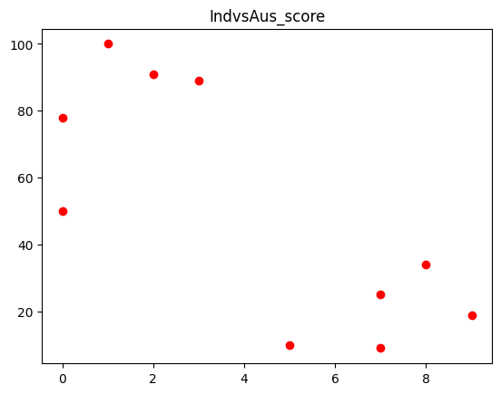

#LINSPACE:
import numpy as np
import matplotlib.pyplot as plt
tigar=np.linspace(-2*np.pi,2*np.pi,100)
print(tigar)
OUTPUT:
[-6.28318531 -6.15625227 -6.02931923 -5.9023862 -5.77545316 -5.64852012
-5.52158709 -5.39465405 -5.26772102 -5.14078798 -5.01385494 -4.88692191
-4.75998887 -4.63305583 -4.5061228 -4.37918976 -4.25225672 -4.12532369
-3.99839065 -3.87145761 -3.74452458 -3.61759154 -3.4906585 -3.36372547
-3.23679243 -3.10985939 -2.98292636 -2.85599332 -2.72906028 -2.60212725
-2.47519421 -2.34826118 -2.22132814 -2.0943951 -1.96746207 -1.84052903
-1.71359599 -1.58666296 -1.45972992 -1.33279688 -1.20586385 -1.07893081
-0.95199777 -0.82506474 -0.6981317 -0.57119866 -0.44426563 -0.31733259
-0.19039955 -0.06346652 0.06346652 0.19039955 0.31733259 0.44426563
0.57119866 0.6981317 0.82506474 0.95199777 1.07893081 1.20586385
1.33279688 1.45972992 1.58666296 1.71359599 1.84052903 1.96746207
2.0943951 2.22132814 2.34826118 2.47519421 2.60212725 2.72906028
2.85599332 2.98292636 3.10985939 3.23679243 3.36372547 3.4906585
3.61759154 3.74452458 3.87145761 3.99839065 4.12532369 4.25225672
4.37918976 4.5061228 4.63305583 4.75998887 4.88692191 5.01385494
5.14078798 5.26772102 5.39465405 5.52158709 5.64852012 5.77545316
5.9023862 6.02931923 6.15625227 6.28318531]

#PLOT:
plt.plot(tigar,np.sin(tigar),color='black')
plt.title("sin(x)")
plt.show()
OUTPUT:
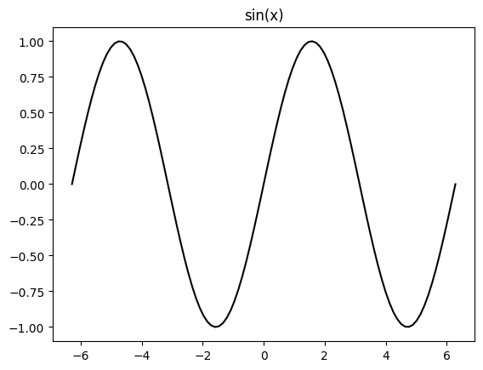

->import numpy as np
import matplotlib.pyplot as plt
#creating x
overs = np.arange(5,50,5)
overs_a = np.arange(5,30,5)
#creating y
runs_i = np.array([25,51,84,131,160,189,220,250,267])
runs_a = np.array([15,41,94,110,151])
wickets = np.array([12,32,96])
#plotting
plt.plot(overs,runs_i,color='blue',label='India')
plt.plot(overs_a,runs_a,color='yellow',label = 'Aus')
#combining two graphs
plt.legend(loc='best')
plt.show()

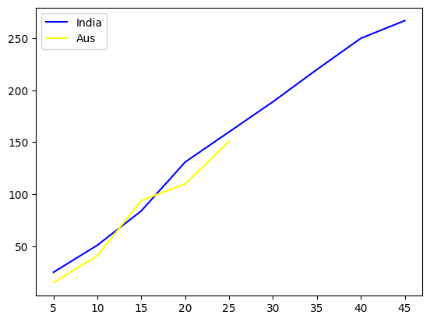
->import matplotlib.pyplot as plt
a = [230,560,780,127,128]
b = [200,160,270,127,400]
years = [1,2,3,4]
profit_a = [(a[i]-a[i-1]) for i in range(1,len(a))]
profit_b = [(b[i]-b[i-1]) for i in range(1,len(b))]
plt.subplot(2,1,2)
plt.plot(years,profit_a,color='hotpink',linewidth = '3',label =
'CompanyA',marker='*',ms='15',mec='k')
plt.subplot(2,1,1)
plt.plot(years,profit_b,color='black',linestyle='dotted',label =
'CompanyB',marker = 'H')
plt.show()
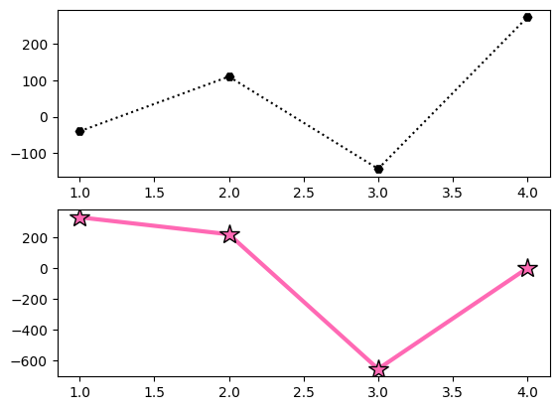

OUTPUT:
->import numpy as np
import matplotlib.pyplot as plt
a = np.array([25, 60, 5, 10])
labels = ["AIML", "Python", "Pandas", "Numpy"]
explode = [0.2, 0, 0, 0]#cutting of particular piechart value
x=['black','green','yellow','red']
plt.pie(a, labels=labels, explode=explode, startangle=180,colors=x)
plt.show()

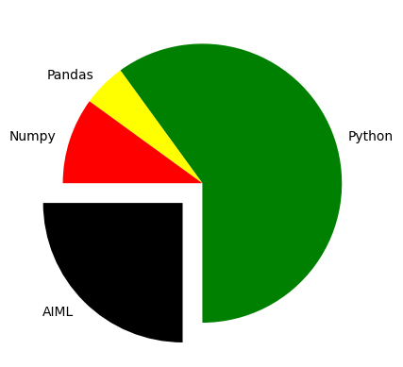

SEABORN:
scatterplot
import seaborn as sns
import matplotlib.pyplot as plt
tips=sns.load_dataset("tips")
print(tips)
sns.scatterplot(x="total_bill",y="tip",data=tips)
plt.title("scatter plot of total bill vs tip")
plt.xlabel("total bill($)")
plt.ylabel("tip($)")
plt.show()
OUTPUT:
total_bill tip sex smoker day time size
0 16.99 1.01 Female No Sun Dinner 2
1 10.34 1.66 Male No Sun Dinner 3
2 21.01 3.50 Male No Sun Dinner 3
3 23.68 3.31 Male No Sun Dinner 2
4 24.59 3.61 Female No Sun Dinner 4
.. ... ... ... ... ... ... ...
239 29.03 5.92 Male No Sat Dinner 3
240 27.18 2.00 Female Yes Sat Dinner 2
241 22.67 2.00 Male Yes Sat Dinner 2
242 17.82 1.75 Male No Sat Dinner 2
243 18.78 3.00 Female No Thur Dinner 2

[244 rows x 7 columns]

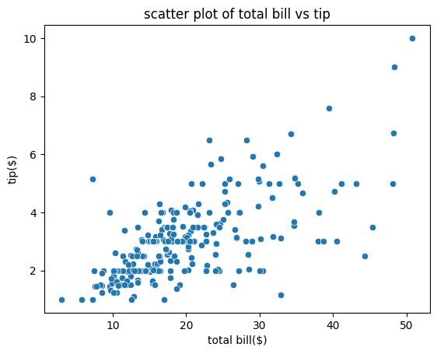

scatterplot
import seaborn as sns
import matplotlib.pyplot as plt
iris=sns.load_dataset("iris")
sns.scatterplot(x="sepal_length",y="sepal_width",data=iris)
plt.title("sepal_length vs sepal_width")
plt.xlabel("sepal_length")
plt.ylabel("sepal_width")
plt.show()
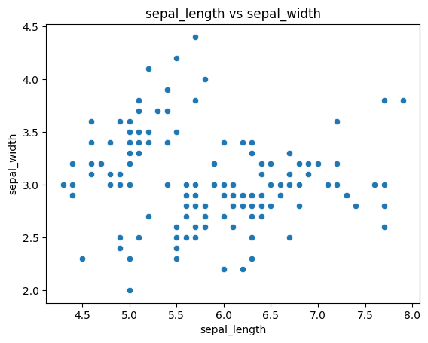

Barplot
import seaborn as sns
import matplotlib.pyplot as plt
iris=sns.load_dataset("iris")
sns.barplot(x="sepal_length",y="sepal_width",data=iris)
plt.title("sepal_length vs sepal_width")
plt.xlabel("sepal_length")
plt.ylabel("sepal_width")
plt.show()
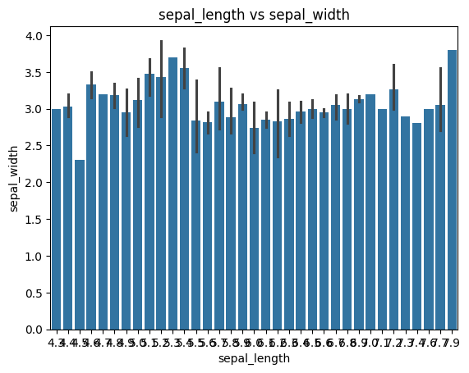

Boxplot
import seaborn as sns
import matplotlib.pyplot as plt
iris=sns.load_dataset("iris")
sns.boxplot(x="sepal_length",y="sepal_width",data=iris)
plt.title("sepal_length vs sepal_width")
plt.xlabel("sepal_length")
plt.ylabel("sepal_width")
plt.show()
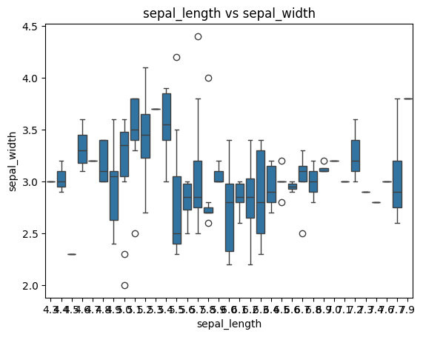

Violinplot
import seaborn as sns
import matplotlib.pyplot as plt
tips=sns.load_dataset("tips")
print(tips)
sns.violinplot(x="total_bill",y="tip",data=tips)
plt.title("scatter plot of total bill vs tip")
plt.xlabel("total bill($)")
plt.ylabel("tip($)")
plt.show()
total_bill tip sex smoker day time size
0 16.99 1.01 Female No Sun Dinner 2
1 10.34 1.66 Male No Sun Dinner 3
2 21.01 3.50 Male No Sun Dinner 3
3 23.68 3.31 Male No Sun Dinner 2
4 24.59 3.61 Female No Sun Dinner 4
.. ... ... ... ... ... ... ...
239 29.03 5.92 Male No Sat Dinner 3
240 27.18 2.00 Female Yes Sat Dinner 2
241 22.67 2.00 Male Yes Sat Dinner 2
242 17.82 1.75 Male No Sat Dinner 2
243 18.78 3.00 Female No Thur Dinner 2

[244 rows x 7 columns]

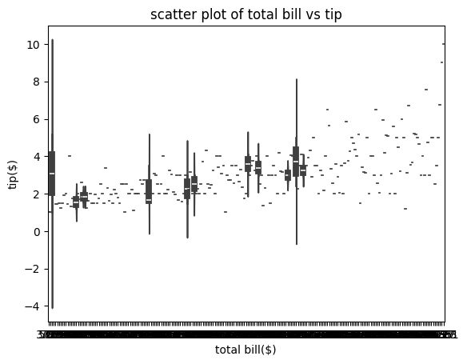

lineplotimport pandas as pd
import seaborn as sns
import matplotlib.pyplot as plt
a=pd.read_csv("/content/grades_withnulls.csv")
b=sns.lineplot(x='SEM1',y='SEM2',data=a)
plt.show()

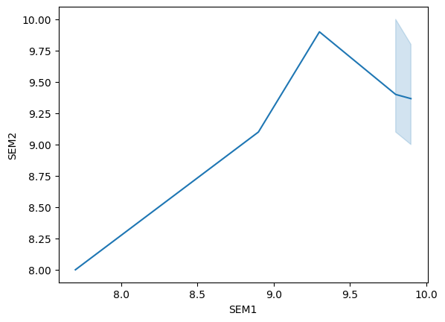

import seaborn as sns
import matplotlib.pyplot as plt
iris=sns.load_dataset("iris")
correlation_matrix=iris.corr()
sns.heatmap(correlation_matrix,annot=True,cmap="coolwarm")
plt.title("correlation heatmap of iris dataset")
plt.show()
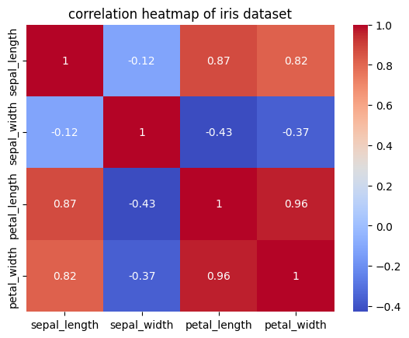
Jointplot
import seaborn as sns
import matplotlib.pyplot as plt
tips=sns.load_dataset("tips")
print(tips)
sns.jointplot(x="total_bill",y="tip",data=tips)
plt.title("scatter plot of total bill vs tip")
plt.xlabel("total bill($)")
plt.ylabel("tip($)"
plt.show()

total_bill tip sex smoker day time size
0 16.99 1.01 Female No Sun Dinner 2
1 10.34 1.66 Male No Sun Dinner 3
2 21.01 3.50 Male No Sun Dinner 3
3 23.68 3.31 Male No Sun Dinner 2
4 24.59 3.61 Female No Sun Dinner 4
.. ... ... ... ... ... ... ...
239 29.03 5.92 Male No Sat Dinner 3
240 27.18 2.00 Female Yes Sat Dinner 2
241 22.67 2.00 Male Yes Sat Dinner 2
242 17.82 1.75 Male No Sat Dinner 2
243 18.78 3.00 Female No Thur Dinner 2

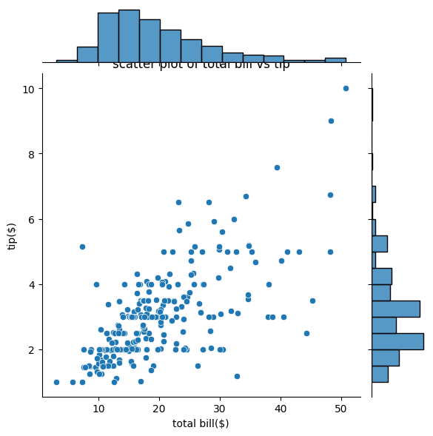

Countplot
import seaborn as sns
import matplotlib.pyplot as plt
titanic=sns.load_dataset("titanic")
sns.countplot(x="class",data=titanic)
plt.title("passenger class distribution")
plt.xlabel("class")
plt.ylabel("count")
plt.show()
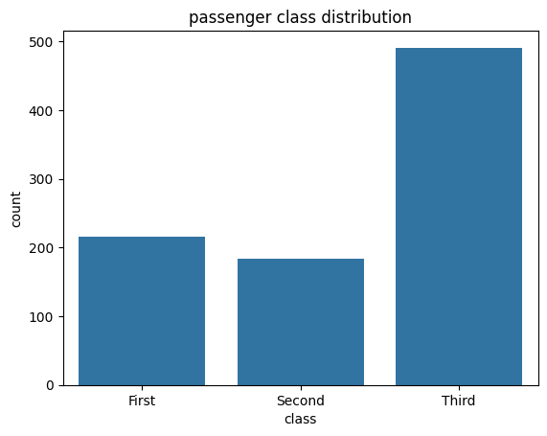

Lmplot
import seaborn as sns
import matplotlib.pyplot as plt
tips=sns.load_dataset("tips")
sns.lmplot(x="total_bill",y="tip",data=tips)
plt.title("scatter plot of total bill vs tip")
plt.xlabel("total bill($)")
plt.ylabel("tip($)")
plt.show()
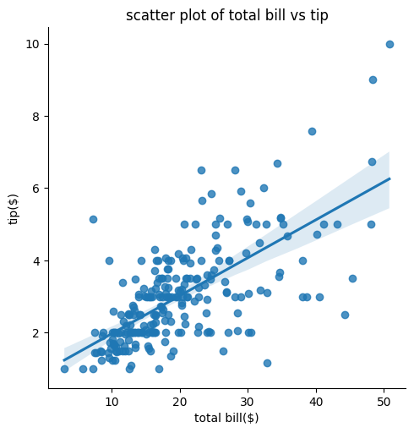

subplot
import seaborn as sns
import matplotlib.pyplot as plt
titanic=sns.load_dataset("titanic")
g=sns.FacetGrid(titanic,col="class")
g.map(sns.histplot,"age")
plt.subplots_adjust(top=0.8)
g.fig.suptitle("age distribution by passenger class")

plt.show()
