1) Создание игрового поля

class MyGame(arcade.Window):  
 # Главный класс игры  
  
 def __init__(self):  
 super().__init__(SCREEN_WIDTH, SCREEN_HEIGHT, "School project")  
  
 file_path = os.path.dirname(os.path.abspath(__file__))  
 os.chdir(file_path)  
  
 self.frame_count = 0  
  
 self.game_over = False  
  
 # Список всех спрайтов  
 self.all_sprites_list = None  
 self.ufo_list = None  
 self.bullet_list = None  
 self.enemy_bullet_list = None  
 self.tank_life_list = None  
 self.car_list = None  
  
 # Очки игрока  
 self.score = 0  
 self.player_sprite = None  
 self.lives = 3  
  
 self.shape_list = None  
  
 arcade.set_background_color(arcade.color.DARK_GREEN)

2) Создание не игровых объектов

# растановка домиков в случайном порядке  
for i in range(HOUSE_COUNT):  
 house_sprite = arcade.Sprite("images/house.png")  
 house_sprite.center_x = random.randrange((SCREEN_WIDTH // HOUSE_COUNT) * i + , (SCREEN_WIDTH // HOUSE_COUNT) * (i + 1) - 60)  
 house_sprite.center_y = random.randrange(160, SCREEN_HEIGHT - 280)  
 self.all_sprites_list.append(house_sprite)

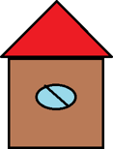

# растановка ёлочек в случайном порядке  
for i in range(PAIN_COUNT):  
 pain_sprite = arcade.Sprite("images/pine.png")  
 pain_sprite.center_x = random.randrange((SCREEN_WIDTH // PAIN_COUNT) * i + , (SCREEN_WIDTH // HOUSE_COUNT) * (i + 1) - 30)  
 pain_sprite.center_y = random.randrange(120, SCREEN_HEIGHT - 300)  
 self.all_sprites_list.append(pain_sprite)



3) Создание игровых объектов

# растановка машинок в случайном порядке  
for i in range(CAR_COUNT):  
 car_sprite = CarSprite("images/auto_00.png", SCALE)  
 car_sprite.center_x = random.randrange((SCREEN_WIDTH // CAR_COUNT) * i + , (SCREEN_WIDTH // CAR_COUNT) * (i + 1) - 120)  
 car_sprite.center_y = random.randrange(65, SCREEN_HEIGHT - 265)  
 self.all_sprites_list.append(car_sprite)  
 self.car_list.append(car_sprite)

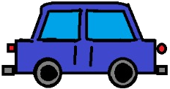

# ставим танк игрока  
self.score = 0  
self.player_sprite = TankSprite("images/tank.png", SCALE)  
self.all_sprites_list.append(self.player_sprite)  
self.lives = 3

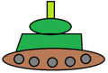

# создание вражеских тарелок  
for i in range(STARTING_UFO_COUNT):  
 enemy_sprite = UfoSprite("images/ufo.png", SCALE)  
 enemy_sprite.guid = "Ufo"  
  
 enemy_sprite.center_y = TOP_LIMIT  
 enemy_sprite.center_x = random.randrange(LEFT_LIMIT, RIGHT_LIMIT)  
  
 enemy_sprite.change_x = random.random() * 2 - 1  
 enemy_sprite.change_y = - random.randrange(1, 4)  
  
 self.all_sprites_list.append(enemy_sprite)  
 self.ufo_list.append(enemy_sprite)

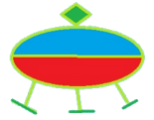

4. создание информационных объектов

# иконки жизней игрока  
cur_pos = 10  
for i in range(self.lives):  
 life = arcade.Sprite("images/tank_mini.png", SCALE)  
 life.center_x = cur_pos + life.width  
 life.center_y = life.height  
 cur_pos += life.width  
 self.all_sprites_list.append(life)  
 self.tank_life_list.append(life)

# написаьт очки игрока на экране  
output = f"Score: {self.score}"  
arcade.draw_text(output, 10, 70, arcade.color.WHITE, 13)  
  
output = f"Ufo Count: {len(self.ufo_list)}"  
arcade.draw_text(output, 10, 50, arcade.color.WHITE, 13)

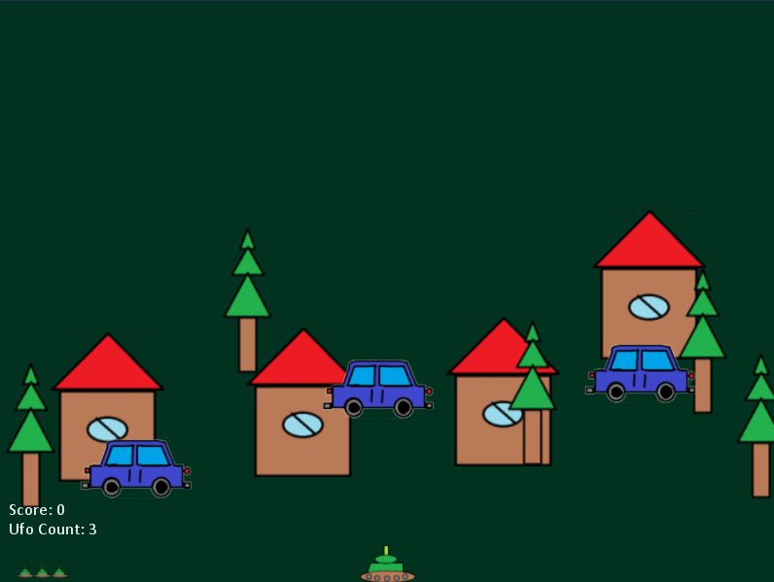

5. Игровой цикл

а. Расчёт новых позиций игровых объектов

для танка:

def update(self):  
 # Обновление позиции танка  
 self.center_x += self.change_x  
 self.center_y += self.change_y  
  
 super().update()

для нло:

def update(self):  
 super().update()  
 # Если тарелка выходит за пределы экрана, то появится с другой стороны  
 if self.center_x < LEFT_LIMIT:  
 self.center_x = RIGHT_LIMIT  
 if self.center_x > RIGHT_LIMIT:  
 self.center_x = LEFT_LIMIT  
 if self.center_y > TOP_LIMIT:  
 self.center_y = BOTTOM_LIMIT  
 if self.center_y < BOTTOM_LIMIT:  
 self.center_y = TOP_LIMIT

для бластера танка:

bullet_sprite = BulletSprite("images/laserBlue01.png", SCALE)  
bullet_sprite.guid = "Bullet"  
  
bullet_speed = 13  
bullet_sprite.change_y = math.cos(math.radians(self.player_sprite.angle)) * bullet_speed  
bullet_sprite.change_x = -math.sin(math.radians(self.player_sprite.angle)) * bullet_speed  
  
bullet_sprite.center_x = self.player_sprite.center_x  
bullet_sprite.center_y = self.player_sprite.center_y  
bullet_sprite.update()  
  
self.all_sprites_list.append(bullet_sprite)  
self.bullet_list.append(bullet_sprite)

для бластера нло:

if self.frame_count % 20 == 0:  
 for ufo in self.ufo_list:  
 bullet_sprite = BulletSprite("images/laserBlue01.png", SCALE)  
 bullet_sprite.guid = "Bullet UFO"  
  
 bullet_speed = 8  
 bullet_sprite.change_y = -math.sin(math.radians(random.randrange(45, 135))) * bullet_speed  
 bullet_sprite.change_x = math.cos(math.radians(random.randrange(45, 135))) * bullet_speed  
  
 bullet_sprite.center_x = ufo.center_x  
 bullet_sprite.center_y = ufo.center_y  
 bullet_sprite.update()  
  
 self.all_sprites_list.append(bullet_sprite)  
 self.enemy_bullet_list.append(bullet_sprite)

б. расчёт столкновений объектов

проверка столкновения бластера танка с тарелками

for bullet in self.bullet_list:  
 self.ufo_list.use_spatial_hash = False  
 ufos_plain = arcade.check_for_collision_with_list(bullet, self.ufo_list)  
 self.ufo_list.use_spatial_hash = True  
 ufos_spatial = arcade.check_for_collision_with_list(bullet, self.ufo_list)  
 if len(ufos_plain) != len(ufos_spatial):  
 print("ERROR")  
  
 ufos = ufos_spatial  
  
 for ufo in ufos:  
 ufo.kill()  
 bullet.kill()

проверка столкновения бластеров тарелок с танком

for bullet in self.enemy_bullet_list:  
 player_shoot = arcade.check_for_collision(bullet, self.player_sprite)  
 if player_shoot:  
 bullet.kill()  
 if self.lives > 0:  
 self.lives -= 1  
 self.player_sprite.respawn()  
 self.tank_life_list.pop().kill()  
 print("Crash")  
 else:  
 self.game_over = True  
 print("Game over")

проверка столкновения бластера тарелки с машинами горожан

for bullet in self.enemy_bullet_list:  
 cars_spatial = arcade.check_for_collision_with_list(bullet, self.car_list)  
  
 for car in cars_spatial:  
 bullet.kill()  
 if car.max_life > 0:  
 buf = "images/auto_0%d.png" % (4 - car.max_life)  
 new_car = CarSprite(buf, SCALE)  
 new_car.center_x = car.center_x  
 new_car.center_y = car.center_y  
 new_car.max_life = car.max_life - 1  
 self.all_sprites_list.append(new_car)  
 self.car_list.append(new_car)  
 car.kill()  
 else:  
 car.kill()

проверка столкновения танка игрока с тарелками

if not self.player_sprite.respawning:  
 ufos = arcade.check_for_collision_with_list(self.player_sprite, self.ufo_list)  
 if len(ufos) > 0:  
 if self.lives > 0:  
 self.lives -= 1  
 self.player_sprite.respawn()  
 ufos[0].kill()  
 self.tank_life_list.pop().kill()  
 print("Crash")  
 else:  
 self.game_over = True  
 print("Game over")

в. Реагирование на нажатия клавишь

def on_key_press(self, symbol, modifiers):  
 # обработчики нажатий клавиш  
  
 # Игрок нажал на пробел - выстрел из танка  
 if not self.player_sprite.respawning and symbol == arcade.key.SPACE:  
 bullet_sprite = BulletSprite("images/laserBlue01.png", SCALE)  
 bullet_sprite.guid = "Bullet"  
  
 bullet_speed = 13  
 bullet_sprite.change_y = math.cos(math.radians(self.player_sprite.angle)) * bullet_speed  
 bullet_sprite.change_x = -math.sin(math.radians(self.player_sprite.angle)) * bullet_speed  
  
 bullet_sprite.center_x = self.player_sprite.center_x  
 bullet_sprite.center_y = self.player_sprite.center_y  
 bullet_sprite.update()  
  
 self.all_sprites_list.append(bullet_sprite)  
 self.bullet_list.append(bullet_sprite)  
  
 # Игрок нажал влево  
 if symbol == arcade.key.LEFT:  
 self.player_sprite.change_x -= 2  
 # игрок нажал вправо  
 elif symbol == arcade.key.RIGHT:  
 self.player_sprite.change_x = 2  
  
def on_key_release(self, symbol, modifiers):  
 # игрок отжал клавишу влево или вправо - танк остановился  
 if symbol == arcade.key.LEFT:  
 self.player_sprite.change_x = 0  
 elif symbol == arcade.key.RIGHT:  
 self.player_sprite.change_x = 0

г. Отрисовка игровых объектов и информационных надписей

def on_draw(self):  
 # отрисовка экрана  
  
 arcade.start_render()  
  
 # отрисовка всех спрайтов  
 self.all_sprites_list.draw()  
  
 # написаьт очки игрока на экране  
 output = f"Score: {self.score}"  
 arcade.draw_text(output, 10, 70, arcade.color.WHITE, 13)  
  
 output = f"Ufo Count: {len(self.ufo_list)}"  
 arcade.draw_text(output, 10, 50, arcade.color.WHITE, 13)