**Project 6： Statistics and Bootstrapping**

**EE 511 – Section** Tuesday 5:00pm—5:50pm

**Name: Yiqi Feng**

**Student ID #:** 9057129035

***1. Problem Statement***



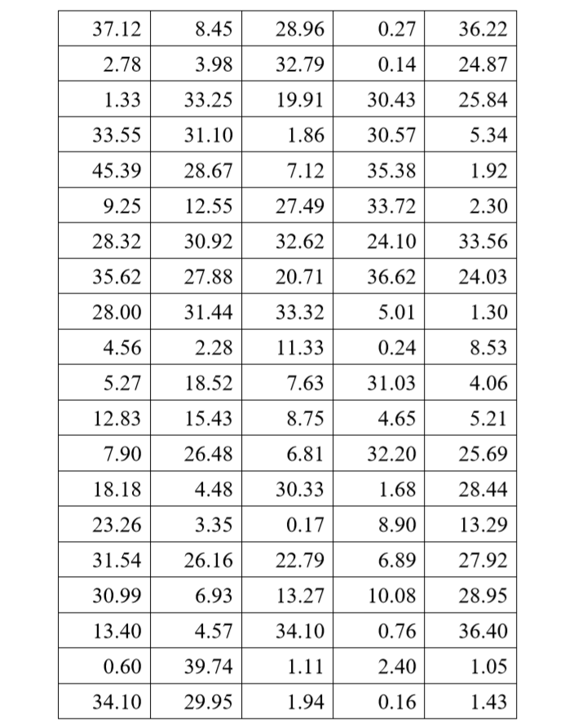

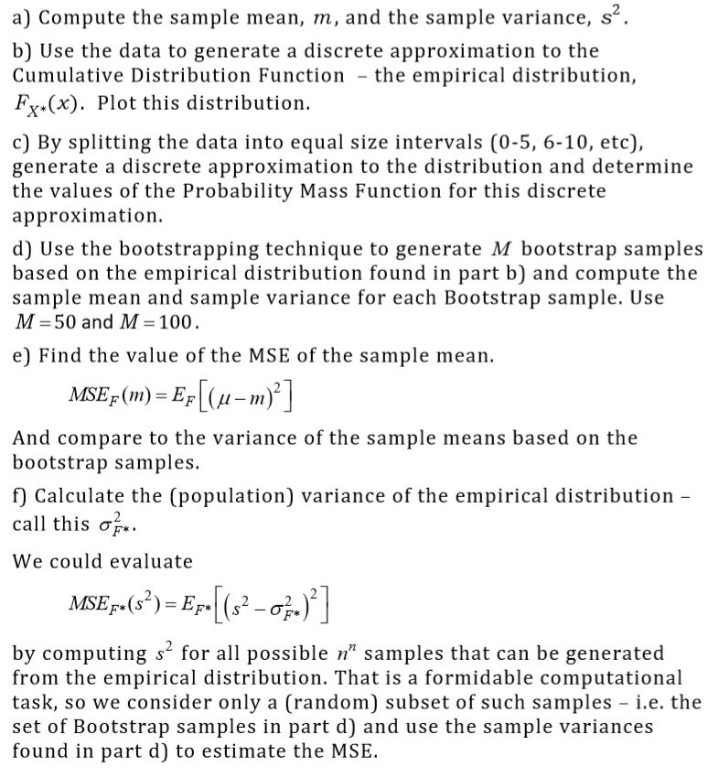

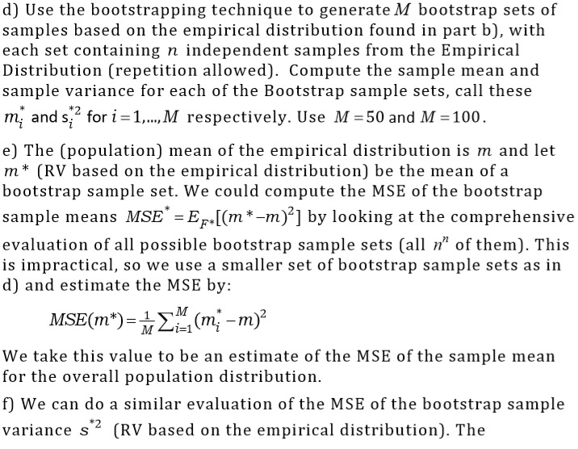

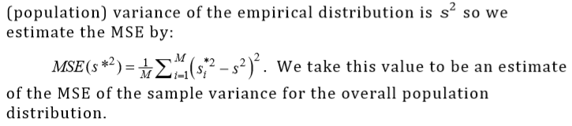

***2. Theoretical Analysis***

Problem a：

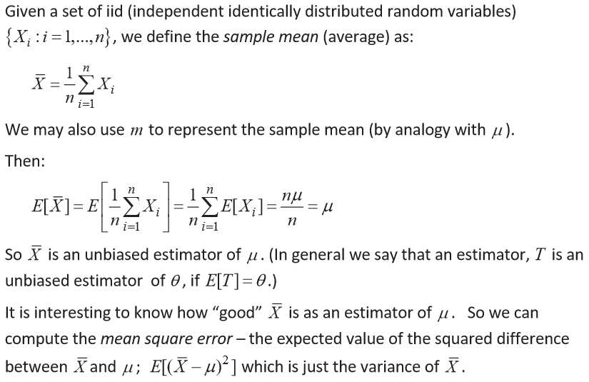

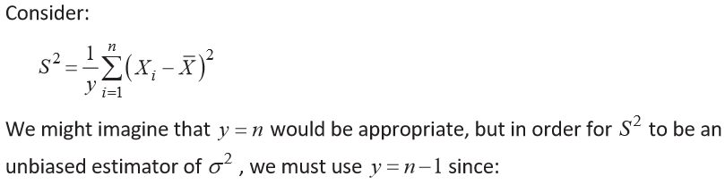

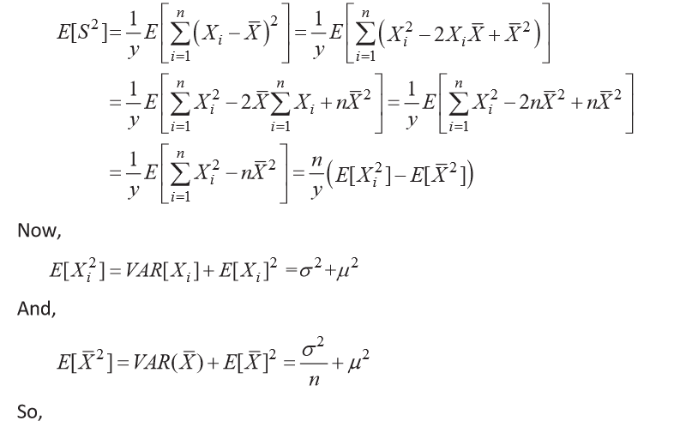

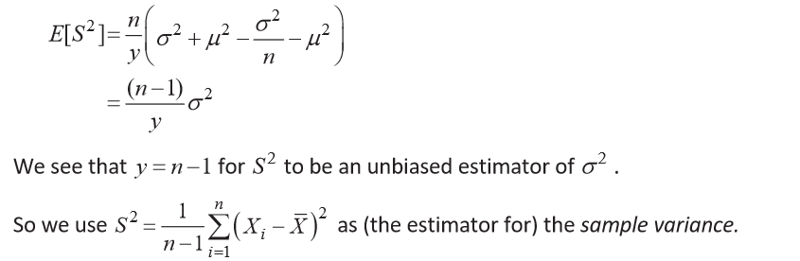

Problem b:

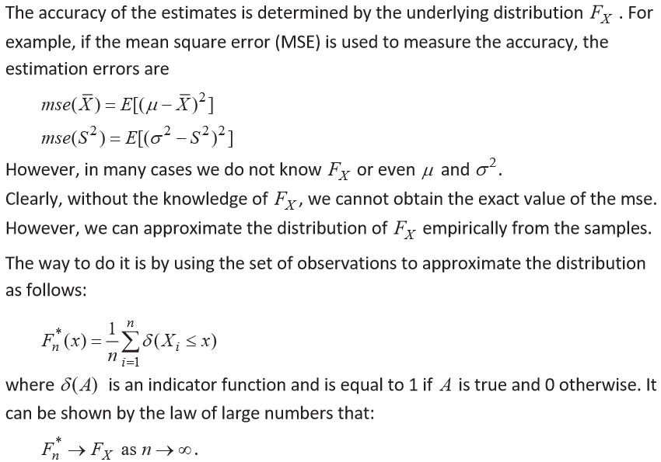

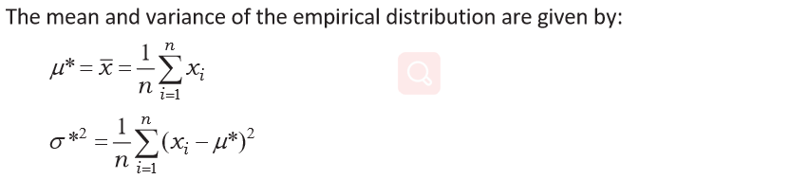

Problem c:

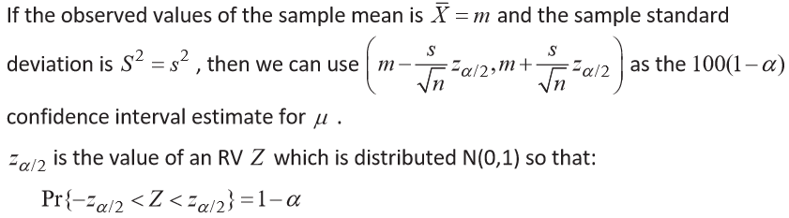

Problem d:

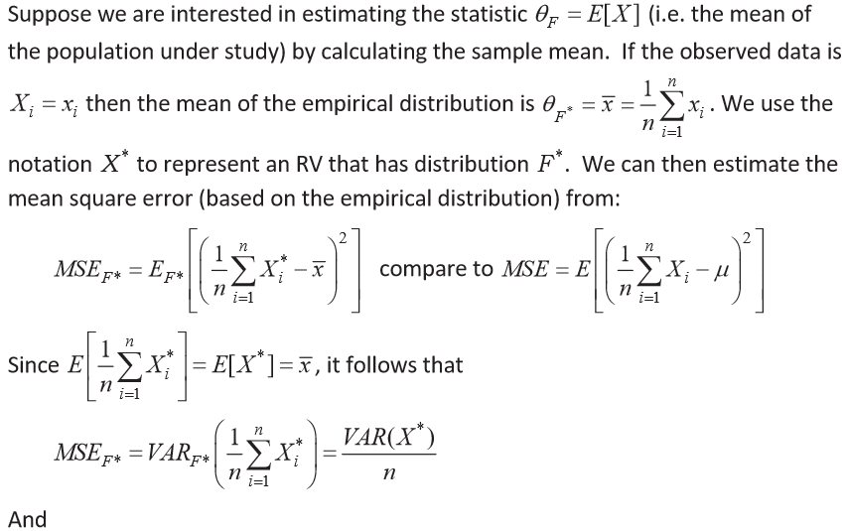

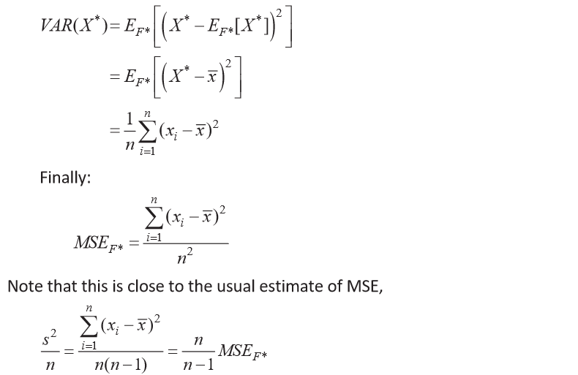

Problem e:

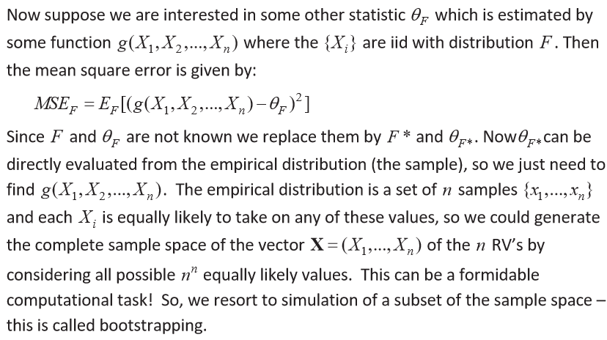

Problem f:

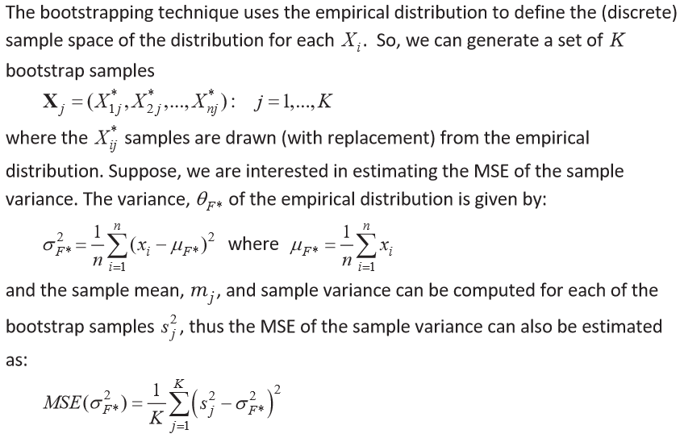

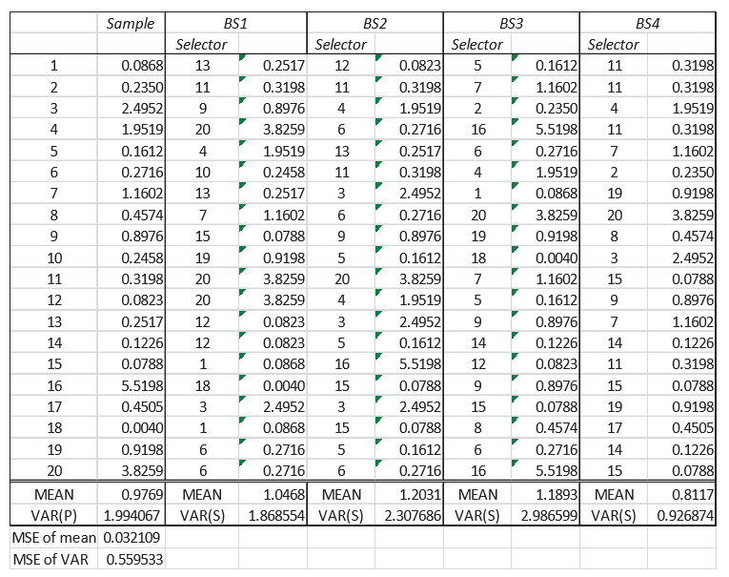

***3. Simulation Methodology***

According to theoretical analysis，I use Matlab to run simulations.

***4. Experiments and Results***

Problem a:

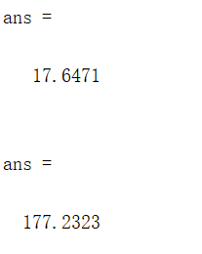

The sample mean, m, is 17.6471. And the sample variance, s2, is 177.2323.

Problem b:

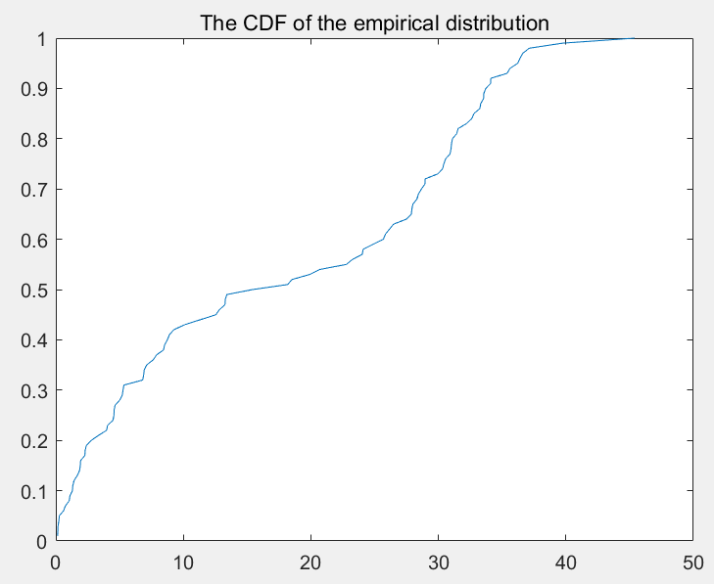

Problem c:

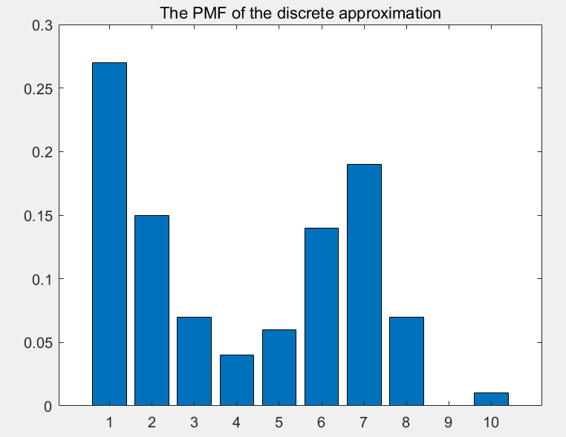

Problem d:

M=50

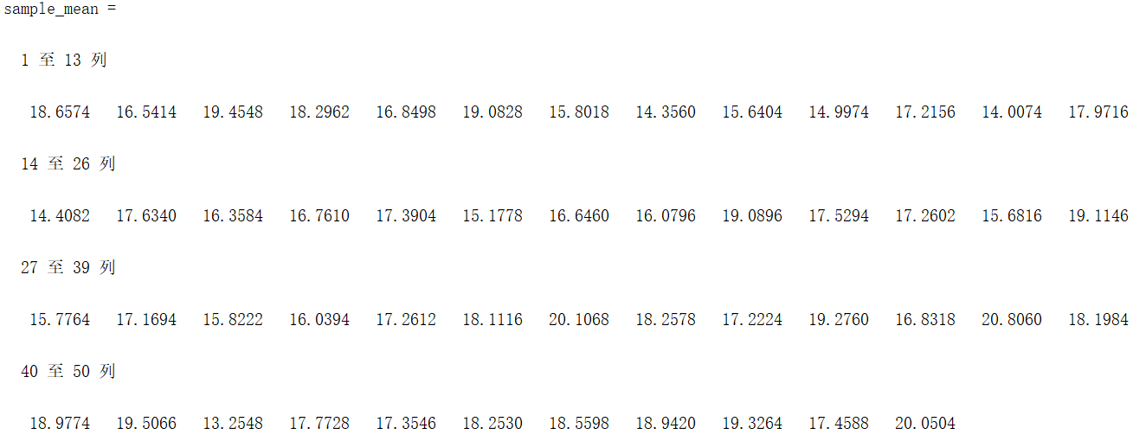

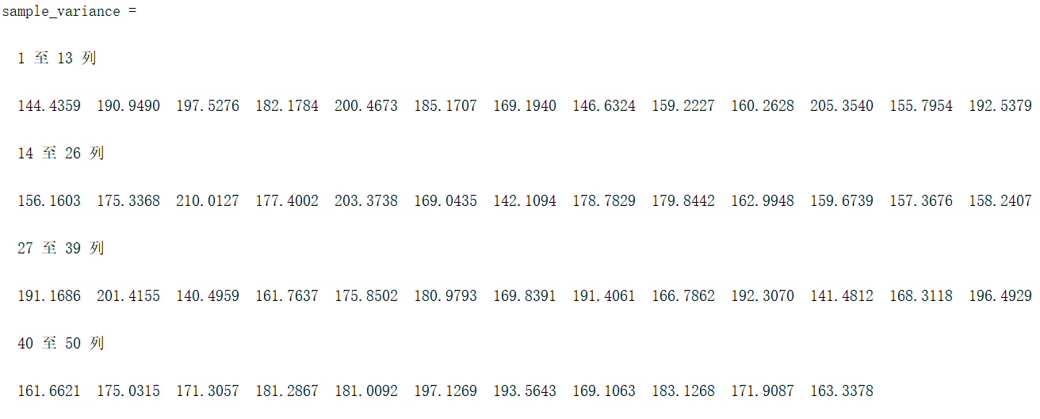

M=100

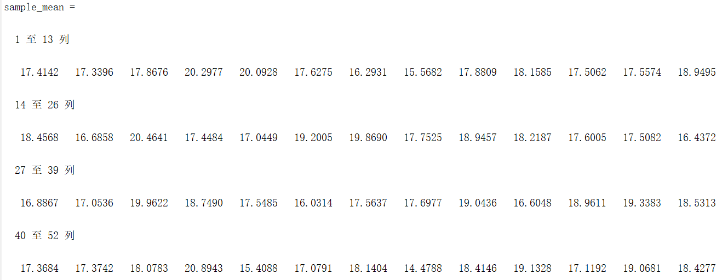

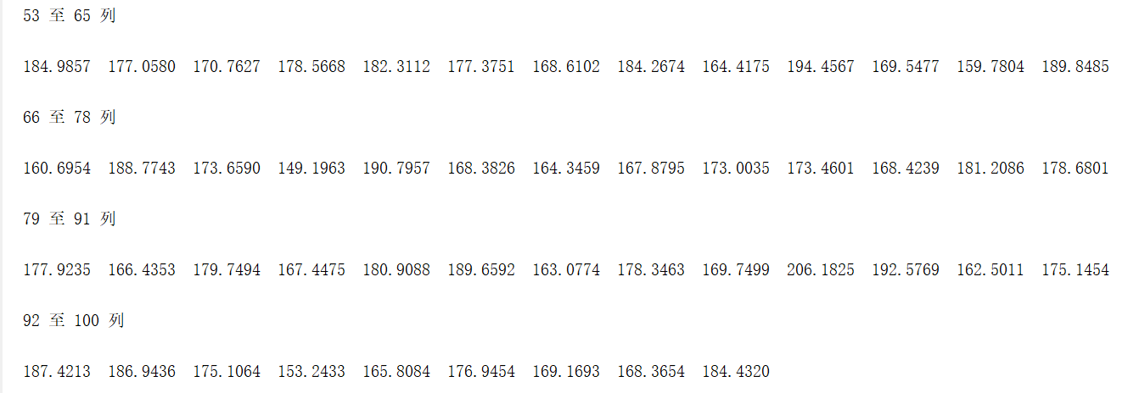

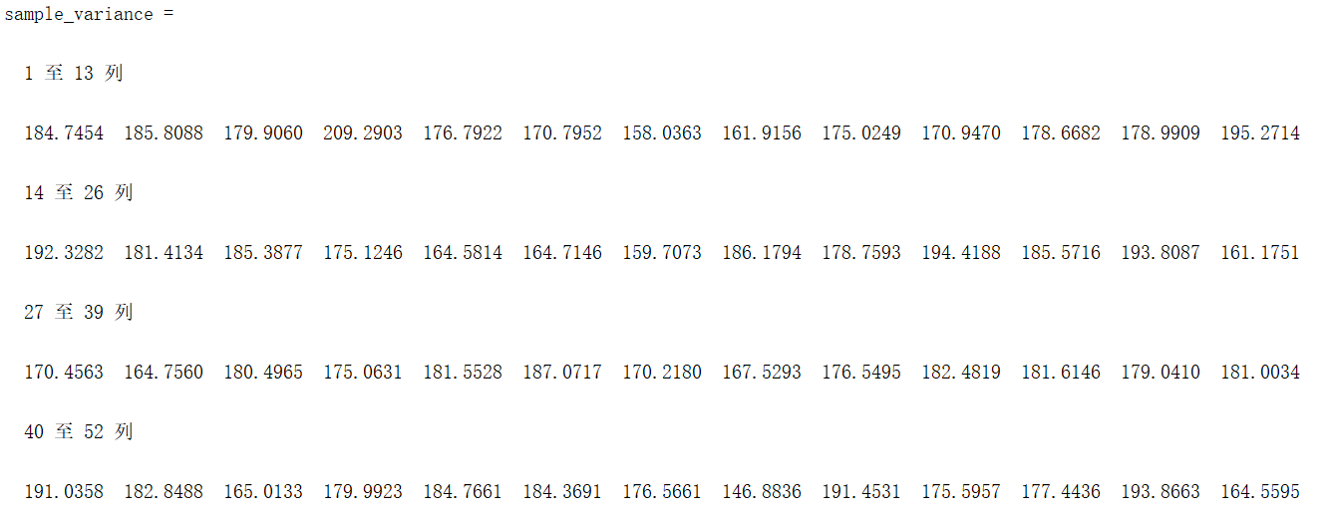

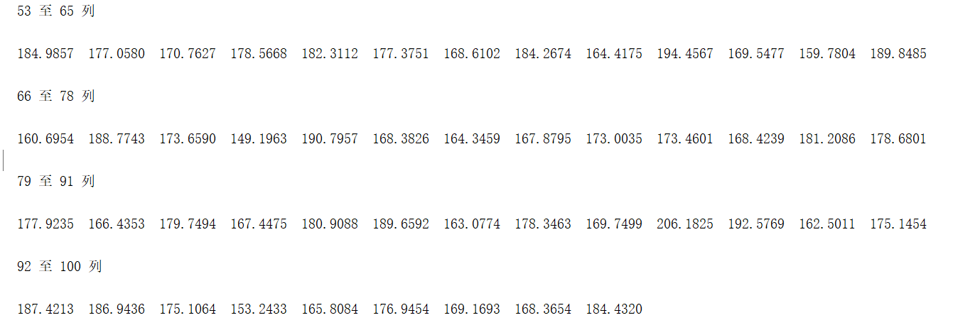

Problem e,f:

M=50，

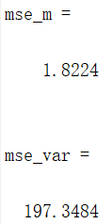

M=100，

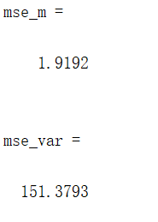

***5. Source Code***

**The code for Problem a:**

num = xlsread('data');

mean(data)

var(data)

**The code for Problem b:**

n = 100;

num = xlsread('data');

y = sort(num);

x = (1:1:n)./n;

figure(1);

plot(y,x);

title('The CDF of the empirical distribution');

**The code for Problem c:**

n = 100;

num = xlsread('data');

y = sort(num);

max = y(n);

interval = ceil(max / 5);

pmf = zeros(1, interval);

for i = 1 : n

index = ceil(data(i) / 5);

pmf(index) = pmf(index) + 1;

end

pmf = pmf/n;

figure(1);

bar(pmf);

title('The PMF of the discrete approximation');

**The code for Problem d.e.f:**

clear;

n = 100;

num = xlsread('data');

M = 50; % M can be 100

sample = zeros(M, M);

sample_mean = zeros(1, M);

sample_variance = zeros(1, M);

for i = 1 : M

for j = 1 : M

index = randi(100);

sample(i, j) = num(index);

end

sample_mean(i) = mean(sample(i, :));

sample_variance(i) = var(sample(i, :));

end

m = mean(num);

var = var(num);

mse_m = sum(sum(( sample_mean-m).^2))/M;

mse_var = sum(sum(( sample_variance-var).^2))/M;

sample_mean

sample_variance

mse_m

mse_var