Cheryl Liao

Assignment #2

CSC528: Computer Vision

**Problem 1:** Image Data Acquisition:

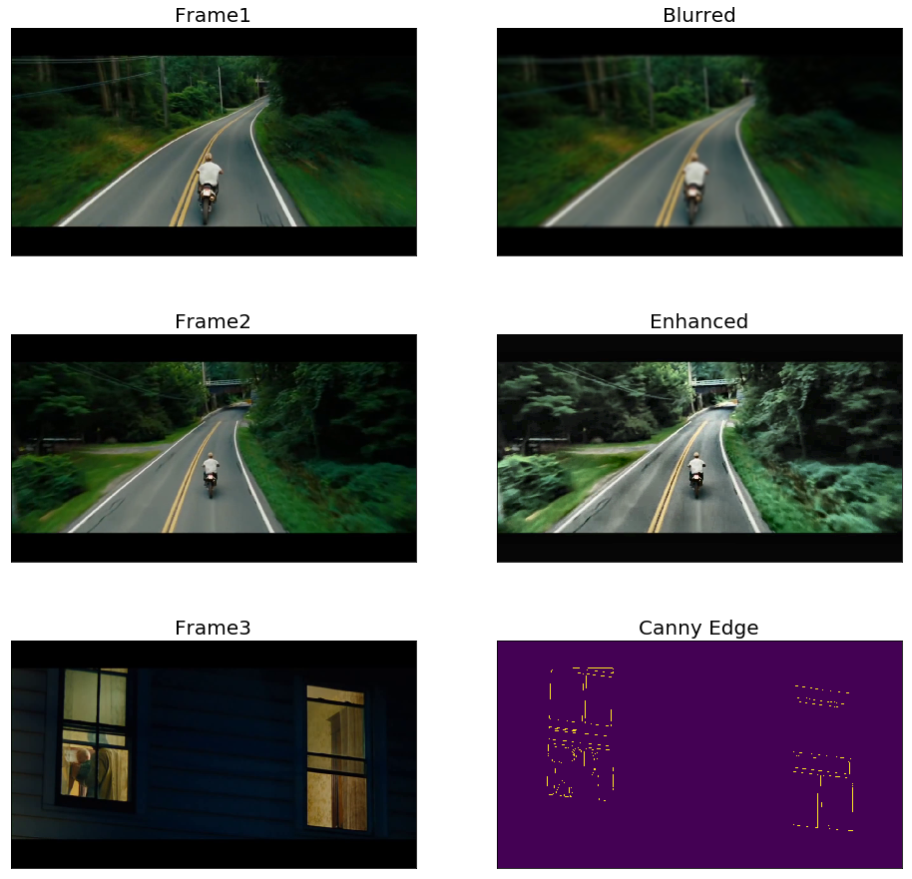

Here three frames were extracted from an mp4 file; the first frame is blurred with a Gaussian filter of size 15x15. The second frame is enhanced using contrast-limited adaptive histogram equalization. The edges in the third frame is extracted using canny edge detector.

**Problem 2:** Harris Corner Detector:

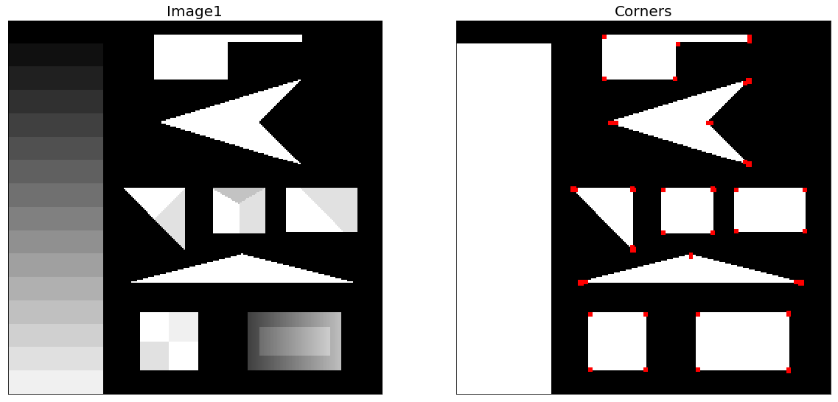

I used dst1 = cv2.cornerHarris(one,2,3,0.1), openCV’s built in harris function, which has the below parameters:

* **img** - Input image, it should be grayscale and float32 type.
* **blockSize** - It is the size of neighbourhood considered for corner detection
* **ksize** - Aperture parameter of Sobel derivative used.
* **k** - Harris detector free parameter in the equation.

**The output, dst1, was then applied to the original image and assigned red colored dots.** oneDots[dst1>0.001*dst1.max()]=[0,0,255]

**I picked dist1>0.001, which is relatively sensitive, to detect all major outlines.**

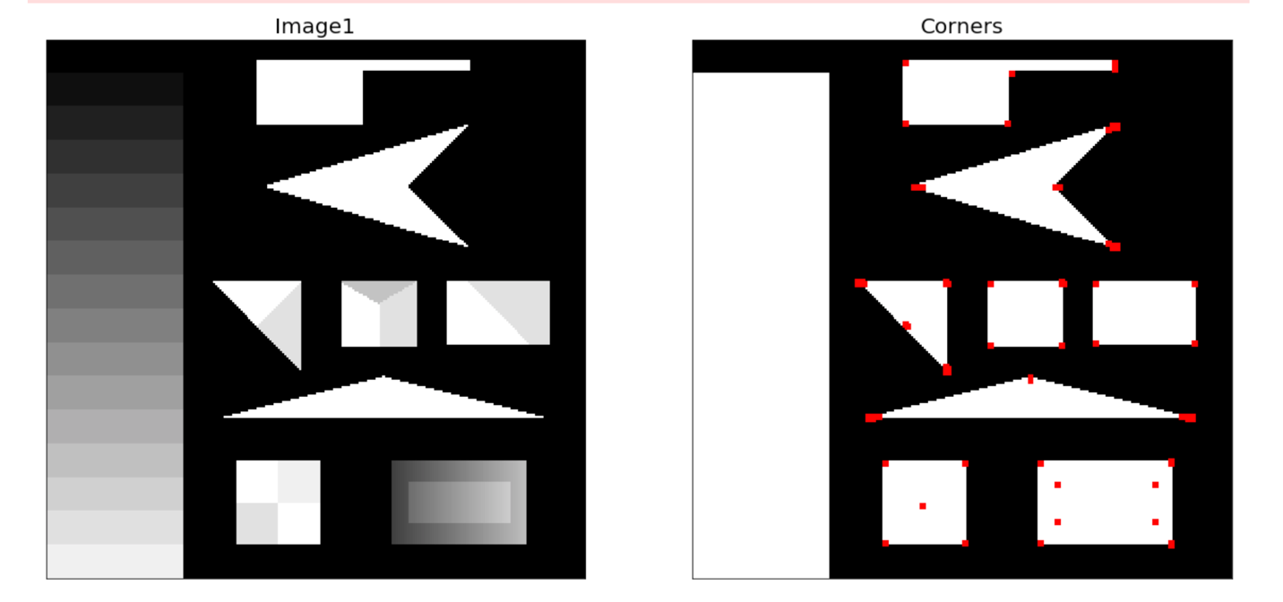

**Here using dst1>0.0001 the difference can be seen in the amount of more subtle corners being detected.**

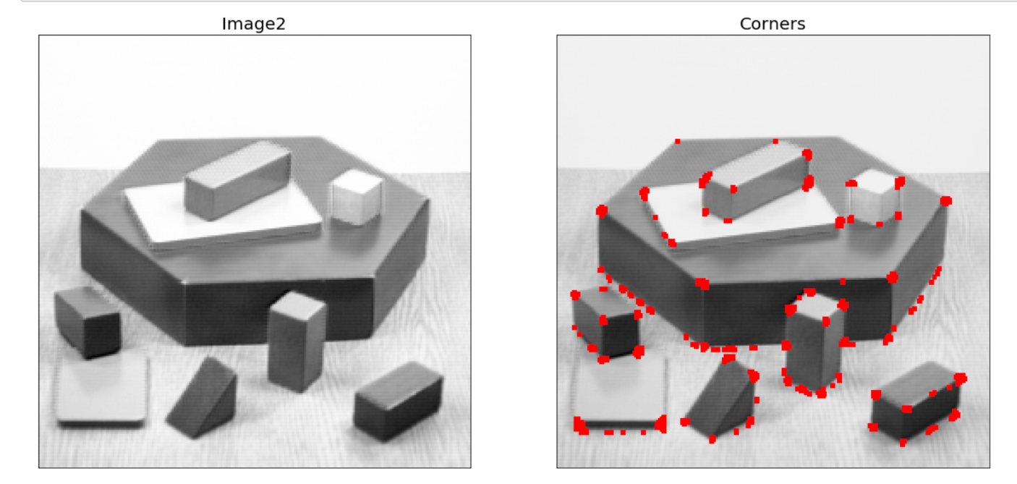

Setting dist > 0.01. With the same inputs for the Harris detector function.

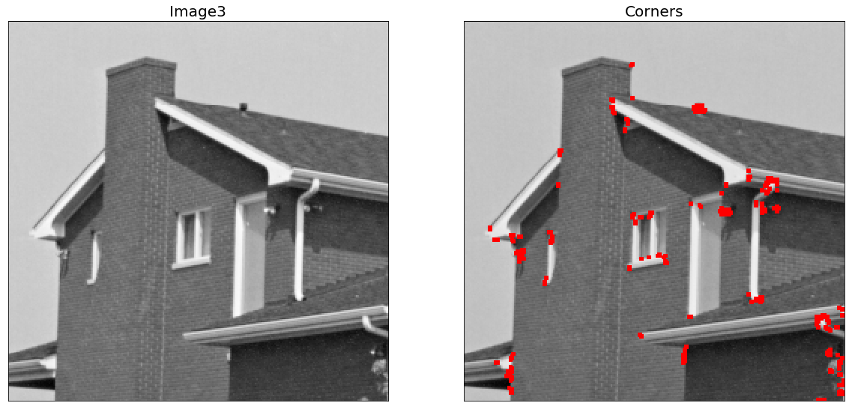

Here I used the same parameters for the cornerHarris functioin. To display the corners, I used dst3>0.01*dst3.max() to display the dots. All relevant corners seem to be detected.

While input for all three images stayed constant, the output for image 1 had to be fine-tuned to be more sensitive to the subtle corners.

**Problem 3:** Laplacian blob detector:

Here we use red blobs to identify scale invariant features of the below images. These points usually lie on high-contrast regions, such as edges.

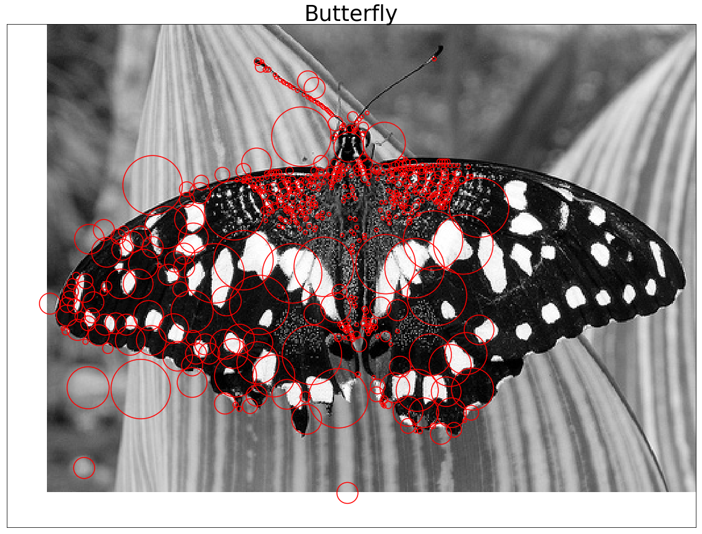

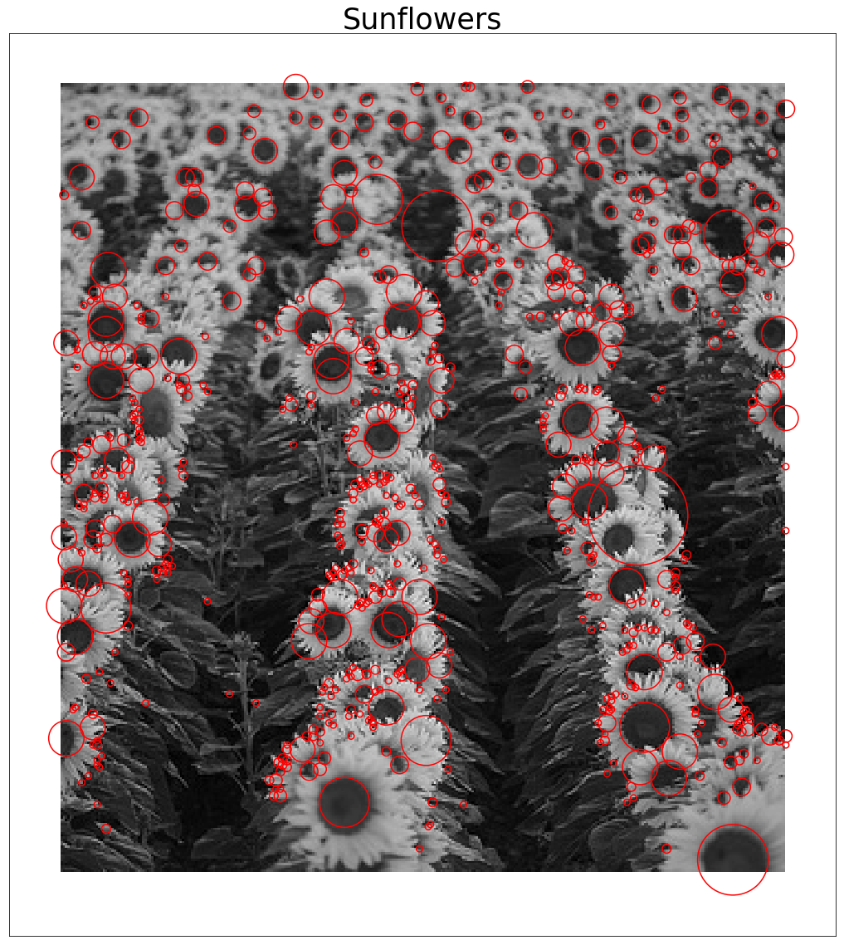

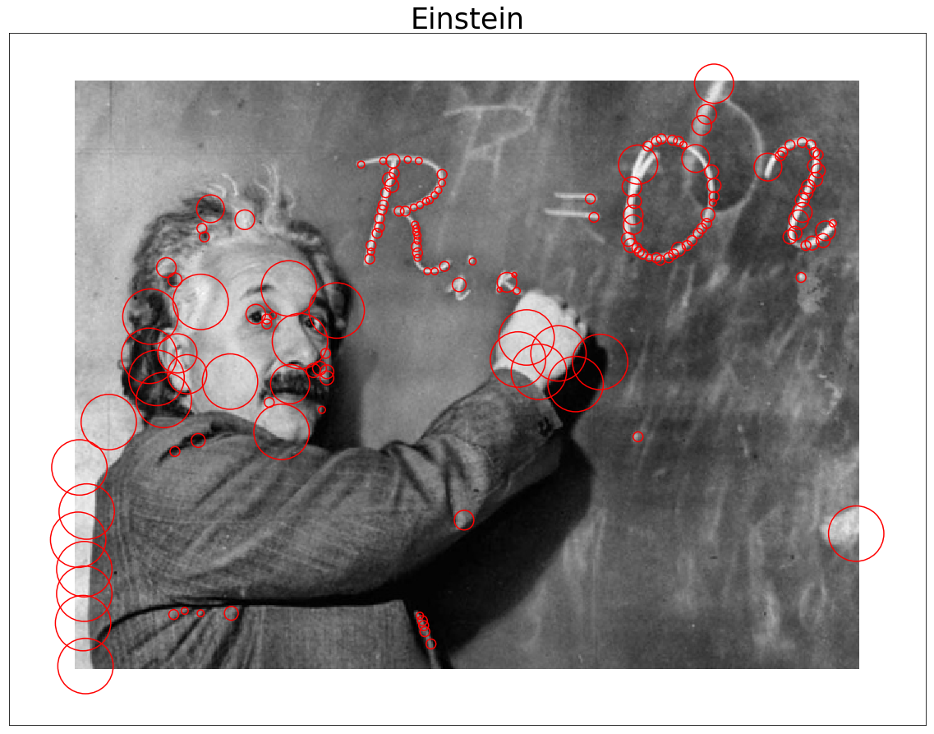

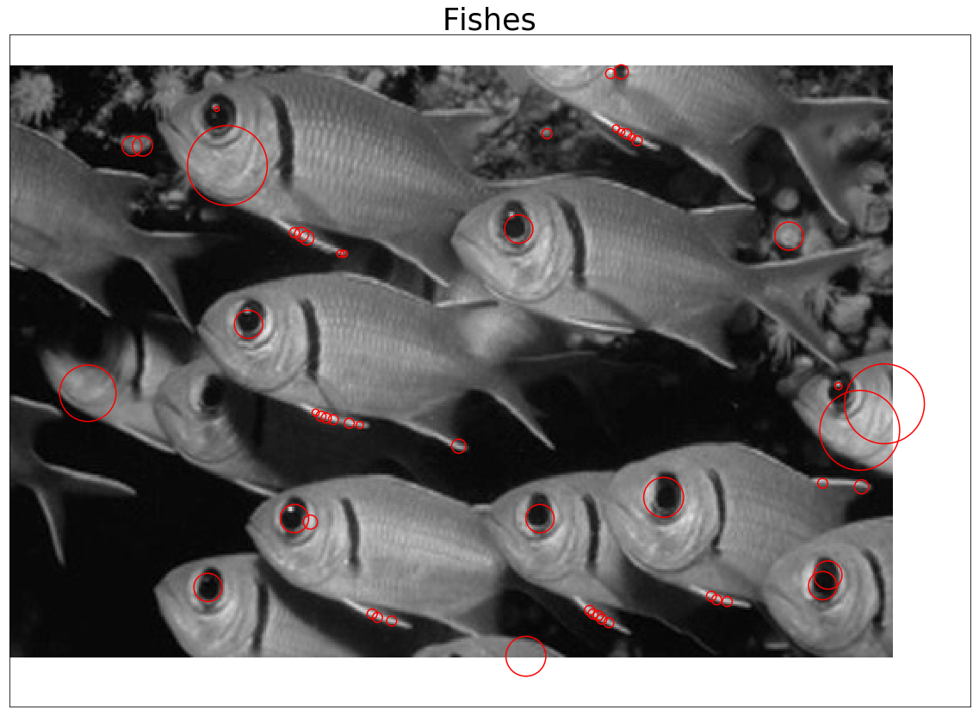

Due to having utilized a python function that gets rid of overlapping blobs, the produced results are a lot cleaner than the suggested outputs; which is better in my personal opinion. However, we can see that all significant scale invariant features are identified.