Cheryl Liao

Assignment #1

CSC528: Computer Vision

**Problem 1: CCD to Camera Transformation:**

1. Field of View = 2 × arctan(L/2f), where L is the width of the image
2. Assume 12 is the width of the array, horizontal FOC = 2 × arctan(12/48)= 28 degrees
3. Assume 16 is the height of the array, vertical FOC = 2 × arctan(16/48)= 36 degrees
4. A wider field of view lowers the resolution, while a more narrow field of view enhances resolution, so there is inverse relationship between field of view and resolution.

**Problem 2: Expanding an image:**

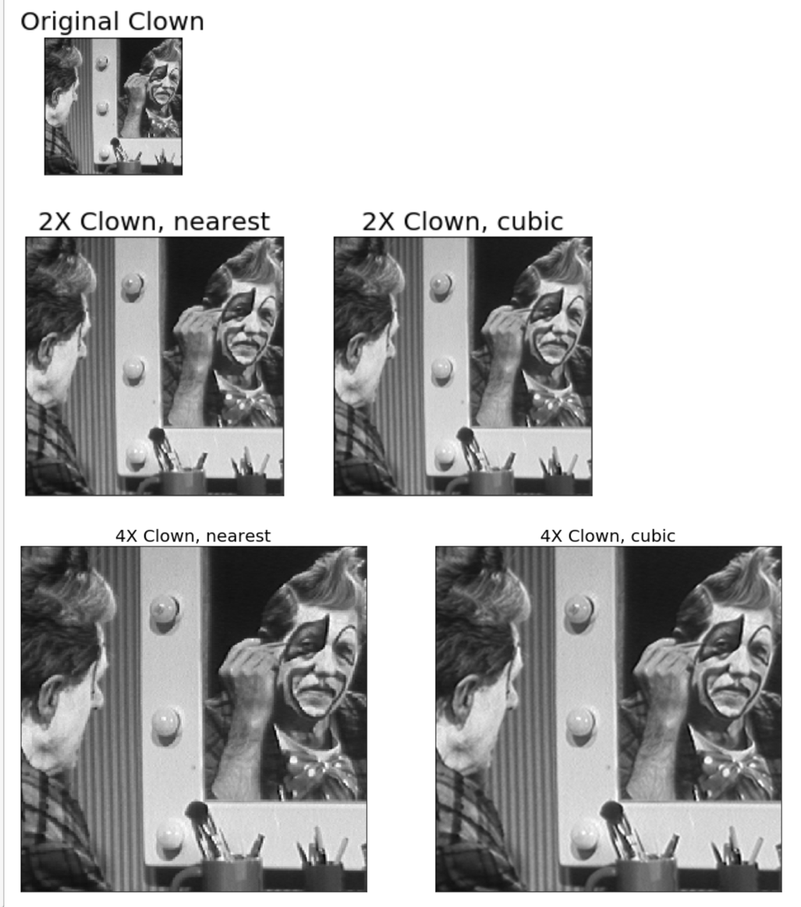**­**

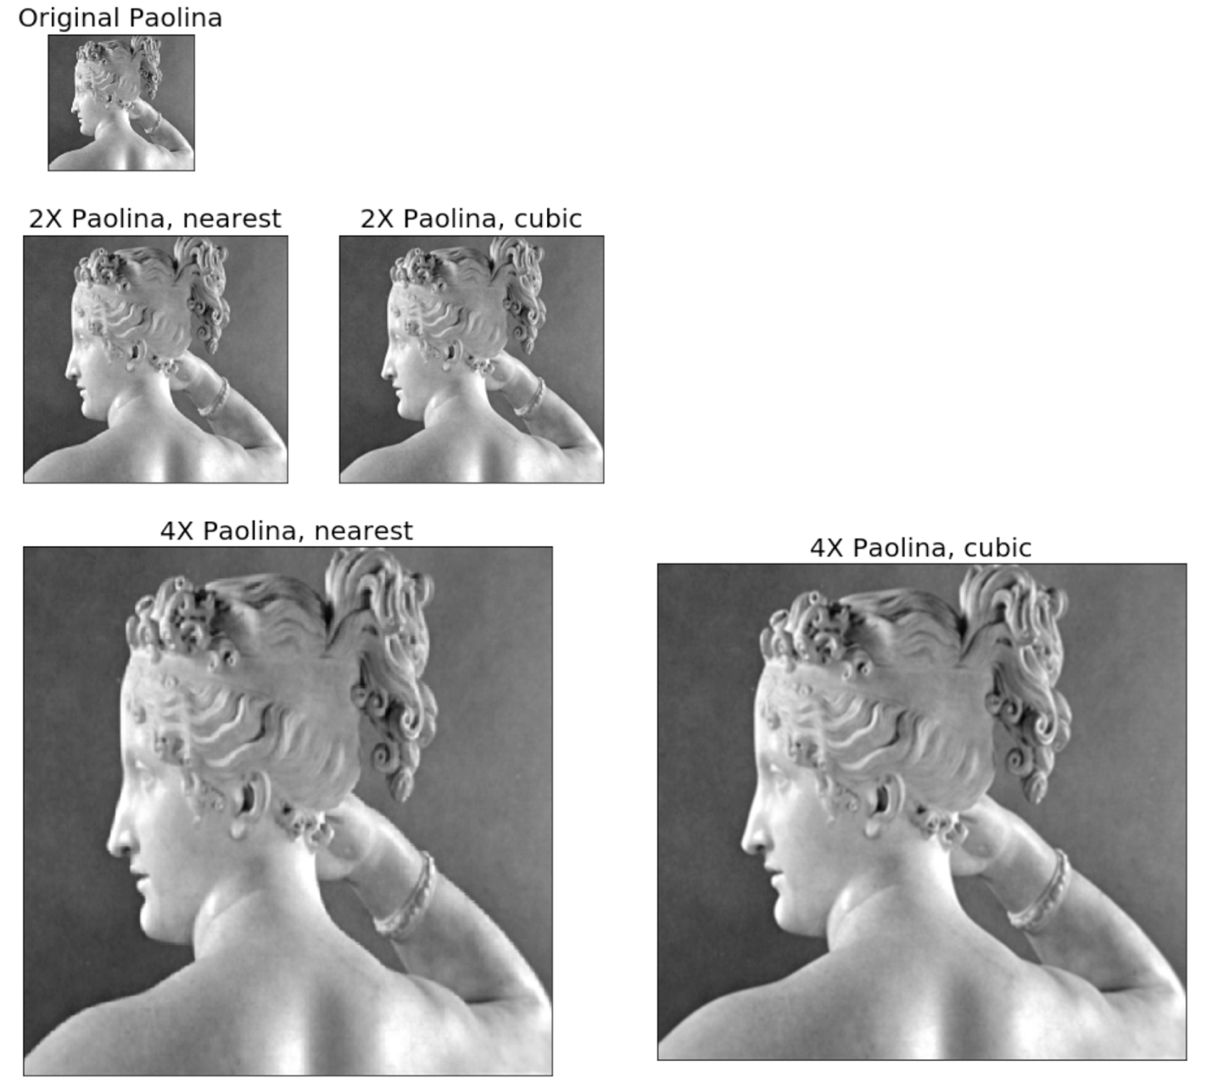

The images were expanded using inter_nearest and inter_cubic, respectively. Inter_nearest simply uses the nearest pixel values to fill in missing pixel values are when expanding the image. Inter_cubic is a bicubic interpolation over 4x4 pixel neighborhood; it a fits third degree polynomial equation between the two known pixels to interpolate information about the missing pixels in-between.

Both methods are similar in that they both use existing pixels to interpolate missing pixel values in between them. Whereas nearest neighbor simply duplicates the values, bicubic fits a smoother curve in between the known pixels, therefore arriving at a more natural zoom out image, albeight more computationally intensive.

**Problem 3: Zero-crossings detector:**

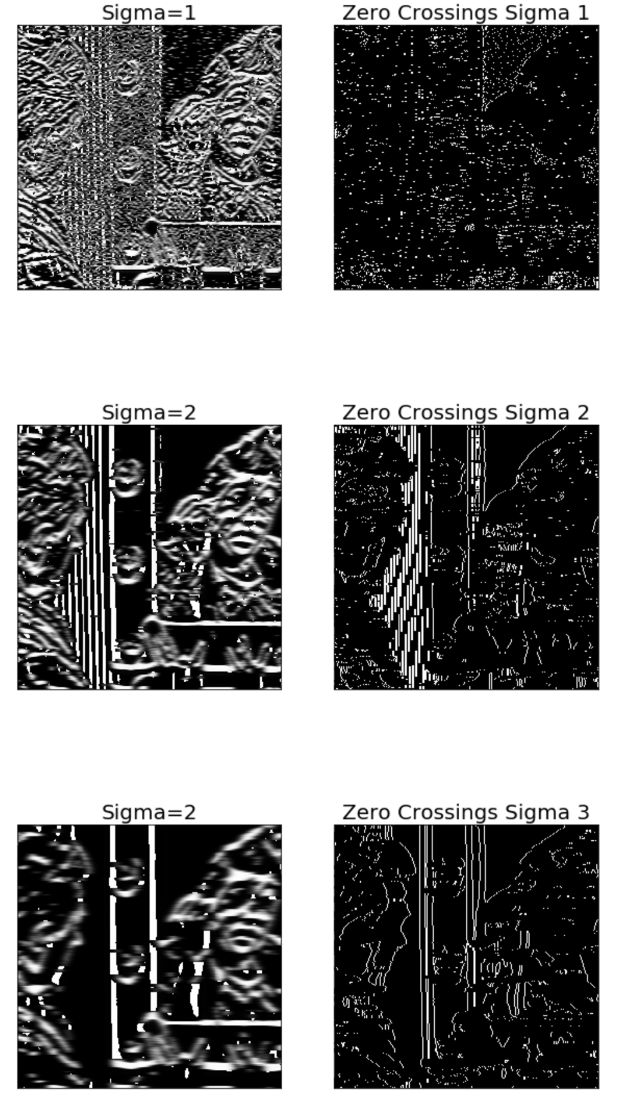

ii. & iii. As the level of smoothing is increased, noise decreases and the zero crossings start only to show more important contours at each successive levels of smoothing as opposed to also displaying noise.

**Problem 4: Computer Vision Concepts:**

1. Perspective projection:

The position (x′,y′) in the image plane of a point at position(x, y ,z) in the scene is found by computing the coordinates(x′,y′) of the intersection of the line of sight passing through the scene point (x, y, z) with the image plane. Ultimately, position of a point(x, y, z) in the image plane is derived by the ratios of the triangles shown in the graph:

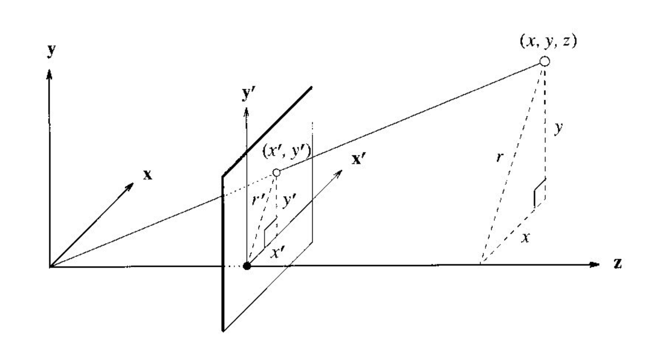

Such that x′= (f/z)*x, y′= (f/z)*y.

1. Vanishing point:

A property of projection, parallel lines converge at a vanishing point in the projection plane; all directions in the same plane have vanishing points on the same line.

1. Stereopsis:

A process where two or more cameras can be utilized to determine range or depth of field.

1. Optical flow:

Optical flow or optic flow is the pattern of apparent motion of objects, surfaces, and

edges in a visual scene caused by the relative motion between an observer (an eye or a

camera) and the scene

1. Parallax:

the effect whereby the position or direction of an object appears to differ when viewed from different positions, e.g. through the viewfinder and the lens of a camera.