Cheryl Liao

CSC 578-701

Intro to Neural networks

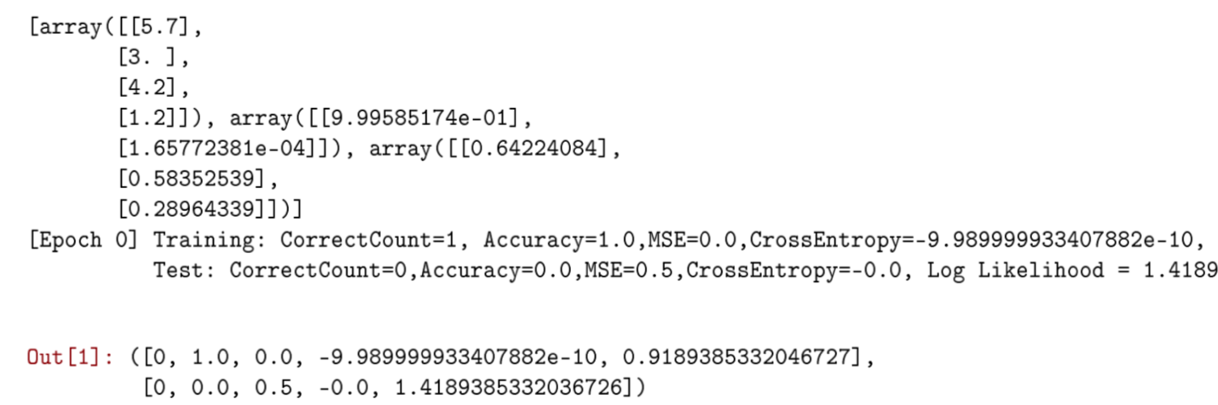

Above is the output after running the first task and modifying the code to print the values in activations and making sure everything prints. 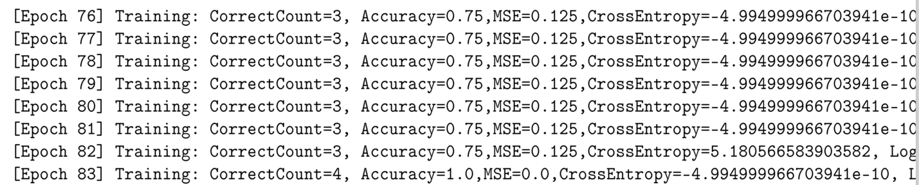

Using the smaller xor data set to check early stopping; the model finally stops after 83 epochs using the parameters given, even though many more epochs are needed it did terminate after reading Accuracy=1.0

For the iris.csv data, I could not get the prediction to achieve 100% accuracy; however, adjusting the weights shows significant difference in accuracy quality. For the original architecture of [4,2,3] in the saved network in iris-423.dat, the resulting accuracy is 0.946 at the end of 100 epochs: 

Going into the file and changing the architecture to [40,20,30] results in accuracy of 0.95

Keeping all things equal and lowering the learning rate from 3 to 1 results in improvement:



Signifying that the data is prone to overshooting if learning rate is too high.

However none of the adjustments are able to terminate with 100% accuracy, perhaps if we have even larger dataset