Cheryl Liao

Assignment #4

CSC482: Applied Image Analysis

**Problem 1:** **Fourier Transform Properties:**

a): 4. Rotating the image should result in a Fourier that has been rotated by the same amount.

b): 6, enlarging the image shrinks the Fourier space.

c): 2, translation should result in no change since the Fourier is centered at the zero point.

**Problem 2:** **Co-occurrence matrix and Haralick texture descriptors:**

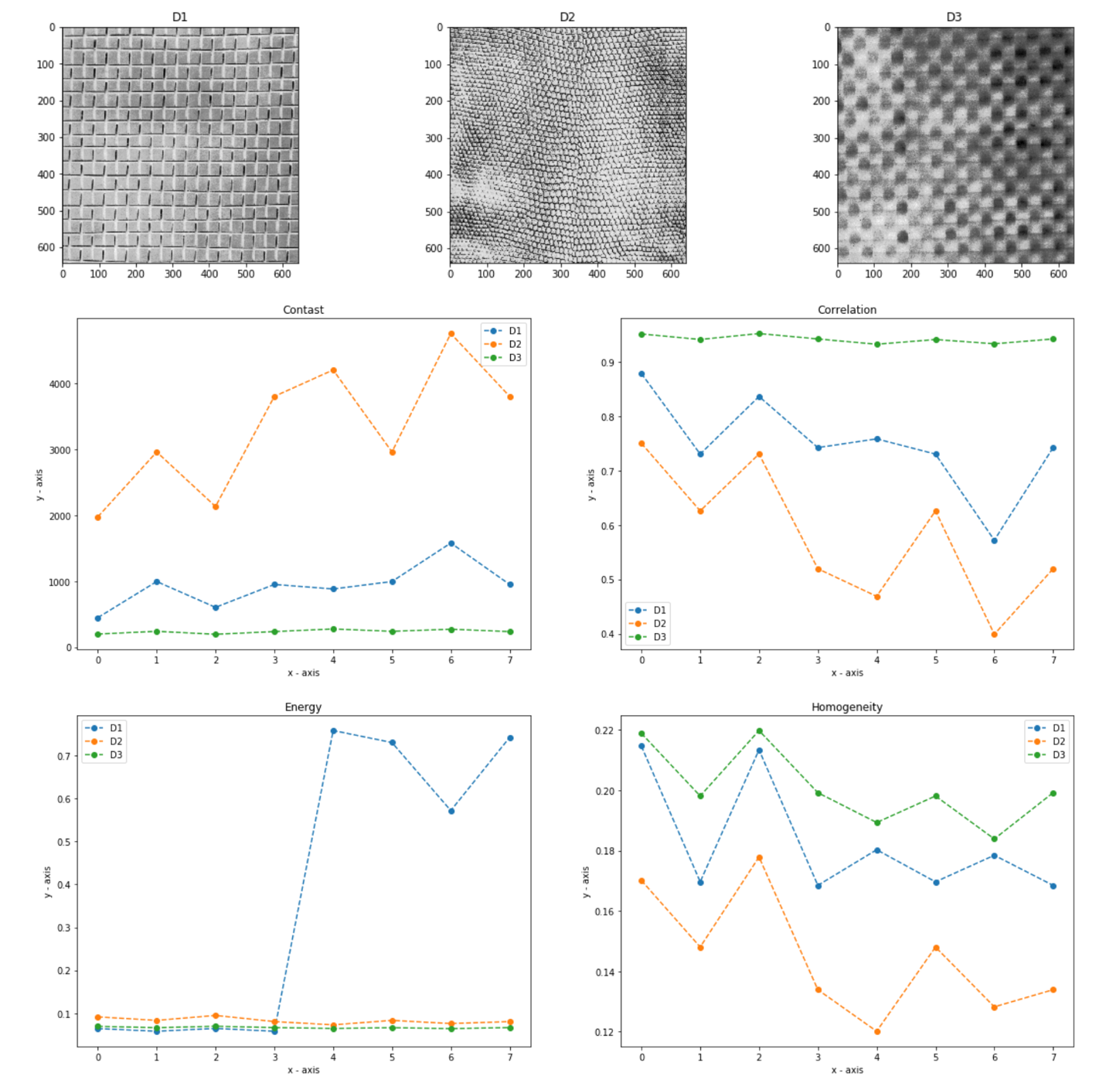

The figures are plotted in the order of 0,45,90,135 degrees of distance 1, and 0,45,90,135 degrees of distance 2. So in general, the contrast increases from distance 1 to 2, the correlation decreases from distance 1 to 2, the energy increase from distance 1 to two and homogeneity decreases as distance increases. Contrast seems to be highest for D2, D3 has highest correlation and homogeneity values, since it does appear to have the smoothest texture. While the energy value for D1 increases dramatically as distance jumped from 1 to 2.

**Problem 3:** **Binary image feature descriptors:**

Output for compactness, circularity and eccentricity for the various shapes in the python program:

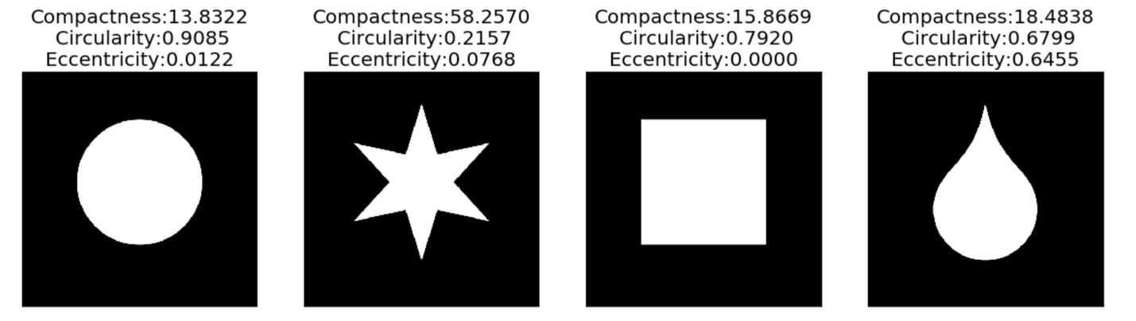

Textbook Outcome:

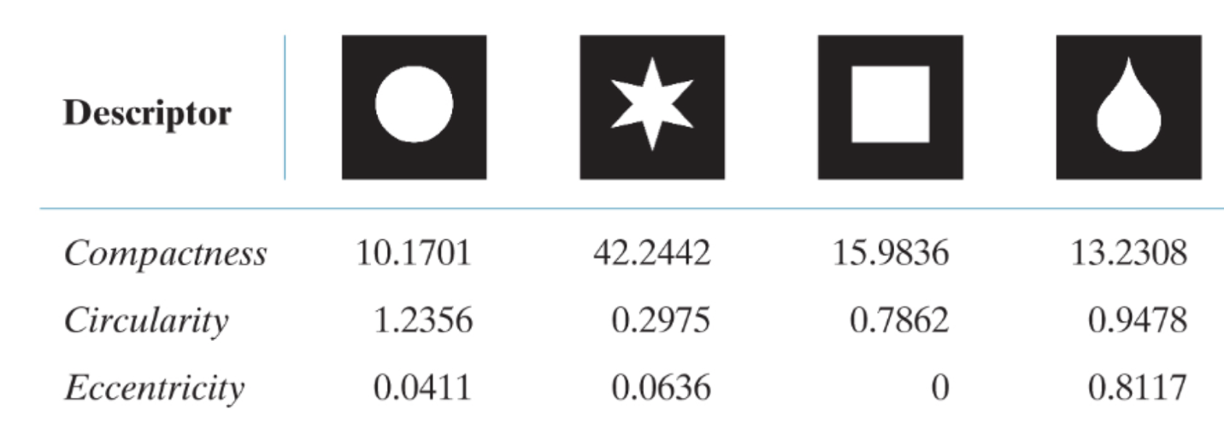

In general, the outputs agree but is the best for the square.

The letters and their respective values:

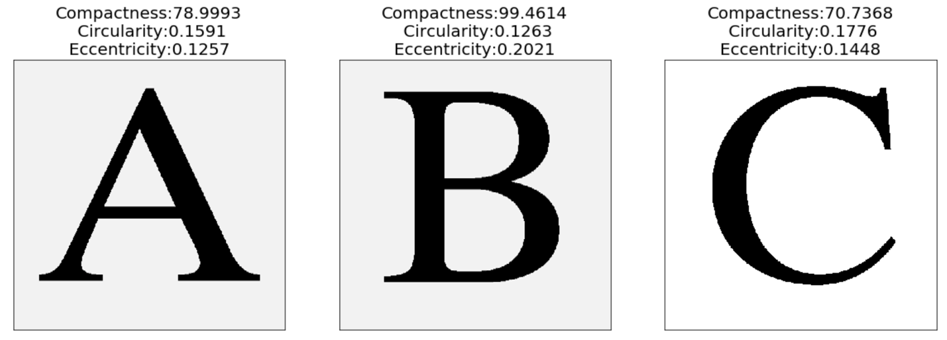

In this case compactness alone should be enough to separate the three letters, since the

compactness for A is almost 80 and that of C is about 70, which is still 10 values apart.

Letter A and its distorted version:

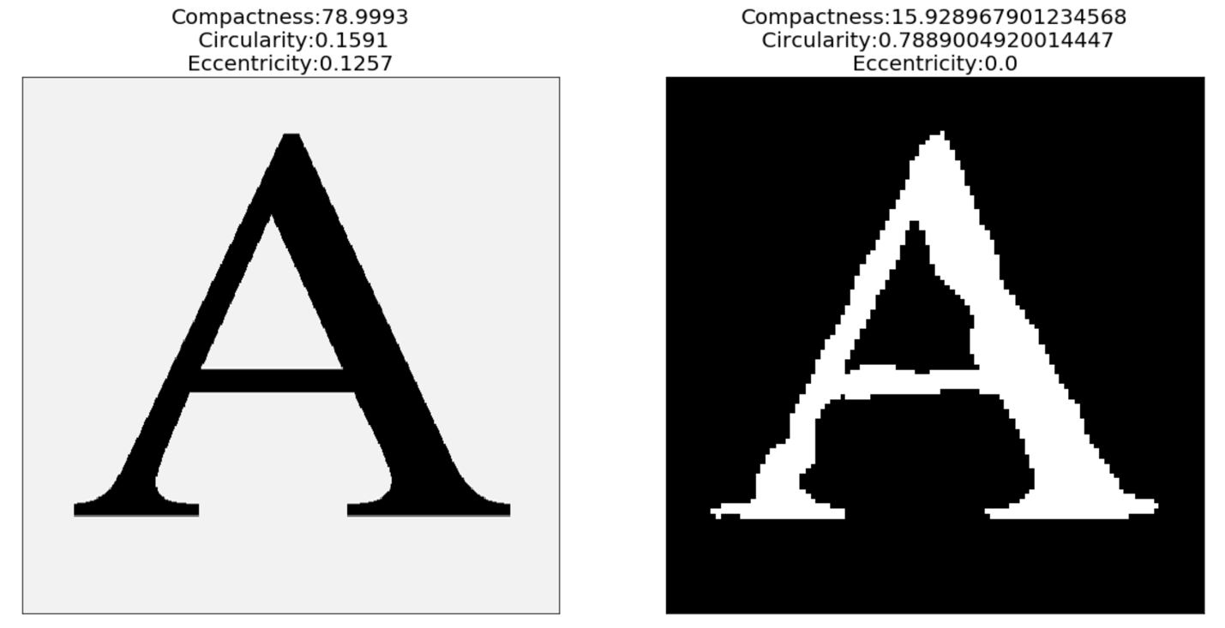

It appears that all the values vary to a significant degree, so any of them should be enough to discriminate between the two.