SecureBank Loan Default Prediction
A Risk Assessment Report for the Chief Risk Officer

Prepared by: [Your Name] | Date: June 2026
Course: [Course Name] | Instructor: [Instructor Name]

Step 1: Business Problem Definition

1.1 The Business Question
SecureBank faces a fundamental credit risk challenge: given a prospective borrower's financial profile, can the institution predict — before loan approval — whether that borrower is likely to default on repayment? Phrased as a data analytics question: Using historical loan applicant data, can a classification model reliably identify high-risk applicants at the point of application, enabling more informed lending decisions?

1.2 Stakeholder and Decision Context
The primary stakeholder is SecureBank's Chief Risk Officer (CRO), who is responsible for the bank's lending policy and portfolio quality. The output of this analysis will directly inform the loan approval process: whether to approve, flag for additional scrutiny, or reject individual loan applications. Secondary stakeholders include the bank's credit analysts, who will operationalise the model's recommendations.

1.3 Cost Asymmetry: False Negatives vs. False Positives
The CRO has quantified the two types of prediction errors as follows: a false negative (approving a borrower who subsequently defaults) costs the bank an average of $15,000 in direct losses. A false positive (rejecting a creditworthy borrower) costs $2,000 in foregone revenue. The cost ratio is 7.5:1, meaning that one missed default is approximately seven and a half times more costly than one wrongful rejection. This asymmetry has direct implications for model selection and threshold calibration: the bank should prefer a model with high recall (few missed defaults) even if this marginally reduces overall accuracy. A standard 0.5 classification threshold, which treats both error types as equally costly, would be sub-optimal for this business context.

1.4 Definition of Success
A successful outcome for the CRO is a model that (1) achieves a recall of at least 0.70 for defaulters — i.e., correctly identifies at least 70% of future defaults — while (2) maintaining overall precision above 0.60 to avoid an excessive rejection of creditworthy applicants, and (3) provides interpretable risk factors that can be translated into actionable underwriting guidelines. An AUC above 0.75 would indicate the model has meaningful discriminatory power beyond chance.

Step 2: Data Cleaning and Initial Findings

2.1 Dataset Overview
The dataset provided by SecureBank contains 2,559 loan records and 21 variables, including the binary target variable Loan_Default (Yes/No). Seven variables are continuous numerical measures (e.g., loan amount, age), while the remaining fourteen are categorical, describing credit behaviour, employment status, housing type, and loan purpose.

2.2 Summary Statistics
Table 1 presents descriptive statistics for all seven numerical variables. The average loan amount is approximately 3,271 DM, with a wide range from 250 DM to 18,424 DM, suggesting considerable heterogeneity in loan size. Loan durations range from 4 to 72 months, and borrower ages span from approximately 19 to 75 years.
Variable | Count | Mean | Std Dev | Min | Median | Max
Loan_Duration_Months | 2,483 | 21.00 | 12.32 | 0.00 | 18.00 | 72.00
Loan_Amount | 2,432 | 3,290.78 | 2,887.65 | -5,410.00 | 2,321.50 | 19,972.00
Installment_Rate_Pct | 2,559 | 2.92 | 1.10 | 1.00 | 3.00 | 4.00
Current_Residence_Years | 2,559 | 2.81 | 1.11 | 1.00 | 3.00 | 4.00
Age | 2,456 | 35.50 | 11.54 | 14.00 | 33.00 | 78.00
Num_Existing_Credits | 2,559 | 1.47 | 0.66 | 1.00 | 1.00 | 4.00
Num_Dependents | 2,559 | 1.20 | 0.40 | 1.00 | 1.00 | 2.00

Table 1: Descriptive statistics for numerical variables.

2.3 Missing Values and Data Quality
Four variables contained missing values: Checking_Account_Status (0 records, 0.0%), Loan_Duration_Months (76 records, 3.0%), Credit_History (0 records, 0.0%), Loan_Purpose (0 records, 0.0%), Loan_Amount (127 records, 5.0%), Savings_Account_Status (0 records, 0.0%), Employment_Duration (102 records, 4.0%), Installment_Rate_Pct (0 records, 0.0%), Personal_Status (0 records, 0.0%), Other_Debtors_Guarantors (0 records, 0.0%), Current_Residence_Years (0 records, 0.0%), Property_Type (0 records, 0.0%), Age (103 records, 4.0%), Other_Installment_Plans (0 records, 0.0%), Housing_Type (0 records, 0.0%), Num_Existing_Credits (0 records, 0.0%), Job_Type (0 records, 0.0%), Num_Dependents (0 records, 0.0%), Has_Telephone (0 records, 0.0%), Is_Foreign_Worker (0 records, 0.0%), Loan_Default (0 records, 0.0%). Numerical missing values were imputed using each column's median — a robust strategy that avoids distortion by outliers. Missing Employment_Duration records (categorical) were assigned the modal ordinal value (1 = less than 1 year). Additionally, five records with negative Loan_Amount values and three records with Age below 18 were identified as data entry errors and replaced with their respective column medians. After cleaning, the dataset contains no missing or impossible values.

2.4 Categorical Encoding Strategy
The dataset contains fourteen categorical variables that must be converted to numerical representations for the machine learning models. Three encoding strategies were employed, based on the nature of each variable:
- Ordinal Encoding was applied to variables with a meaningful natural order: Checking_Account_Status (overdrawn -> no account, coded 0-3), Savings_Account_Status (no savings -> >= 1,000 DM, coded 0-4), Employment_Duration (unemployed -> >= 7 years, coded 0-4), and Credit_History (critical account -> all credits paid, coded 0-4). Preserving rank information allows the model to detect monotonic risk relationships.
- One-Hot Encoding (OHE) was applied to seven nominal variables without a natural order: Loan_Purpose, Personal_Status, Other_Debtors_Guarantors, Property_Type, Other_Installment_Plans, Housing_Type, and Job_Type. To avoid perfect multicollinearity, the first dummy category was dropped (drop_first=True).
- Binary Encoding converted Has_Telephone and Is_Foreign_Worker to 0/1 indicators.
After encoding, the full feature matrix contained 37 predictor variables.

2.5 Class Distribution
The target variable is moderately imbalanced: 1,793 borrowers did not default (70.1%) and 766 defaulted (29.9%). A 30% minority class does not constitute severe imbalance (where techniques such as SMOTE or class-weighted training would be mandatory), but it does mean that a naive classifier predicting 'No Default' for every application would achieve 70.1% accuracy — an inflated and misleading score. Therefore, F1-score, recall, and AUC are the primary evaluation metrics used throughout this analysis rather than accuracy alone.

2.6 Exploratory Data Analysis
Four visualisations were created to identify the most predictive features prior to formal modelling.
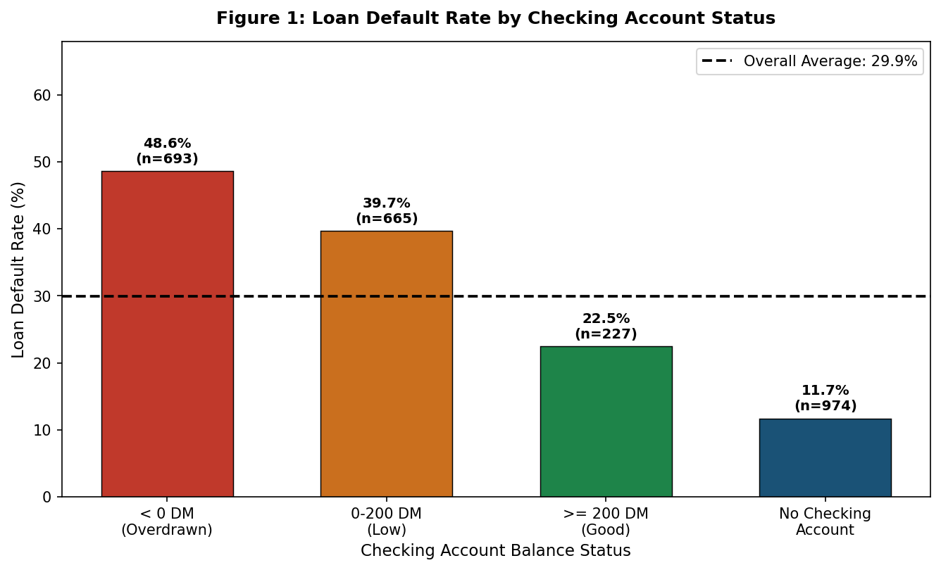
Figure 1: Default rate by checking account status. Overdrawn accounts show the highest default rate (≈49%), nearly three times the rate for borrowers with no checking account.
Figure 1 reveals a strong gradient: borrowers with overdrawn checking accounts default at approximately 48.6%, compared with only 11.7% for those without a checking account. Checking account status is therefore likely to be among the most important predictors in the model.
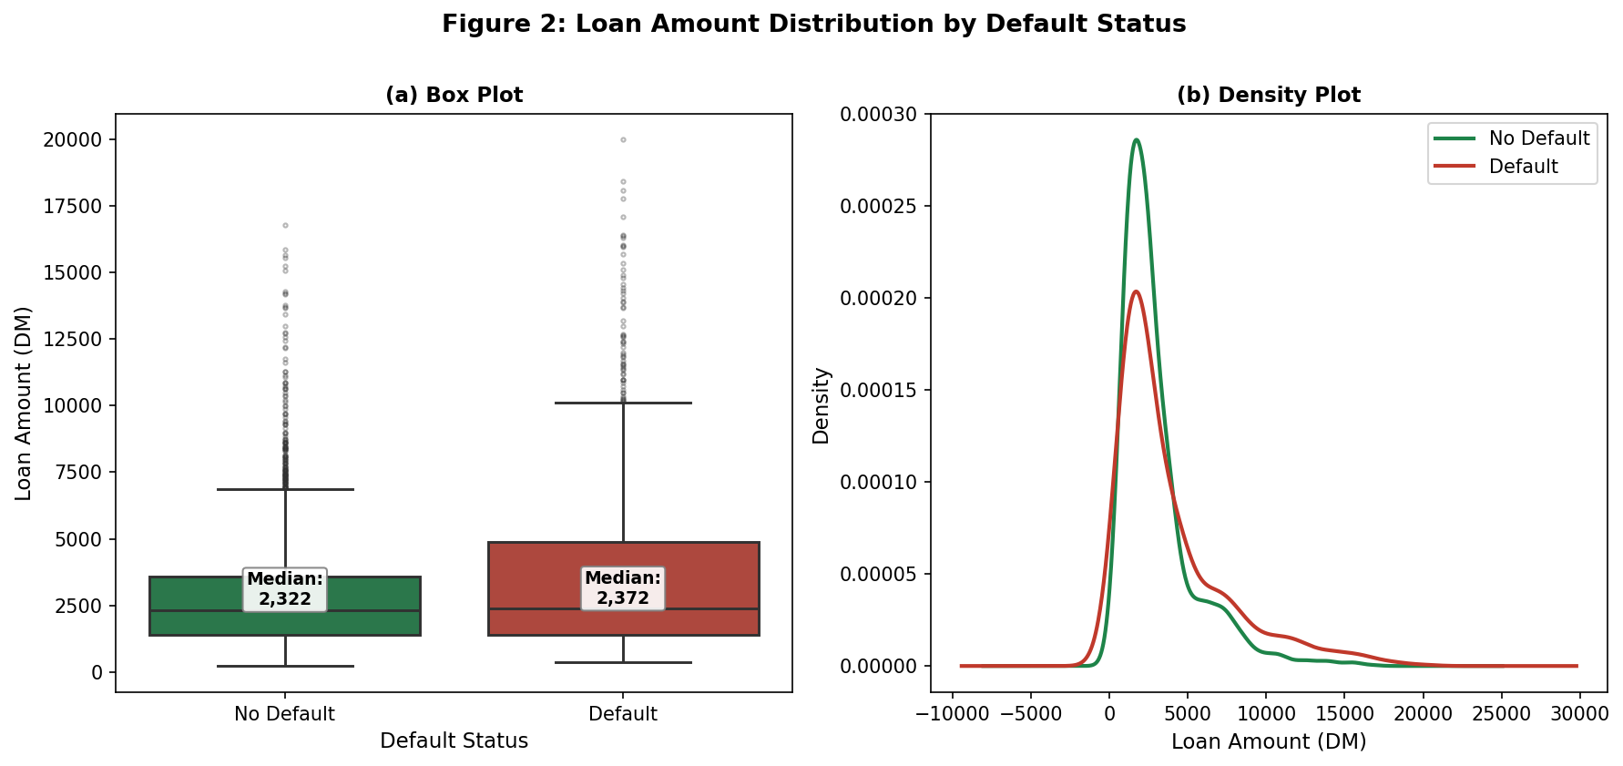
Figure 2: Loan amount distribution by default status. Defaulters tend to take larger loans, though the distributions substantially overlap.
Figure 2 shows that defaulters have a higher median loan amount (2,372 DM) compared to non-defaulters (2,322 DM). However, the distributions overlap substantially, suggesting that loan amount alone is insufficient to separate the two classes.
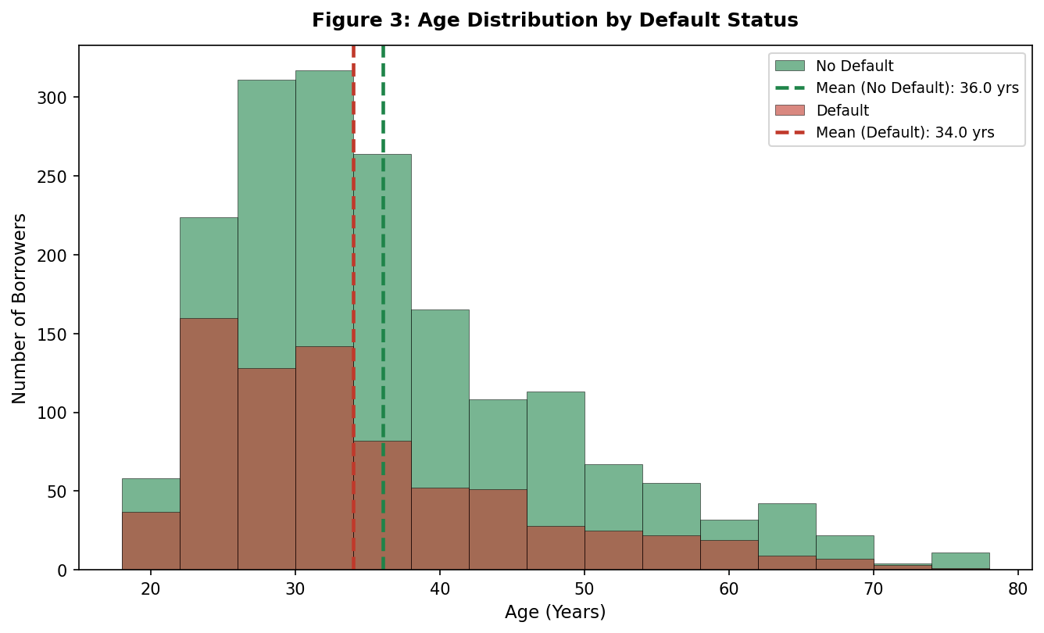
Figure 3: Age distribution by default status. Younger borrowers default at higher rates; the mean age of defaulters is notably lower.
Figure 3 demonstrates that defaulters are, on average, younger (34.0 years) than non-defaulters (36.0 years). This is consistent with the financial literature, which associates younger borrowers with shorter credit histories and greater income volatility.
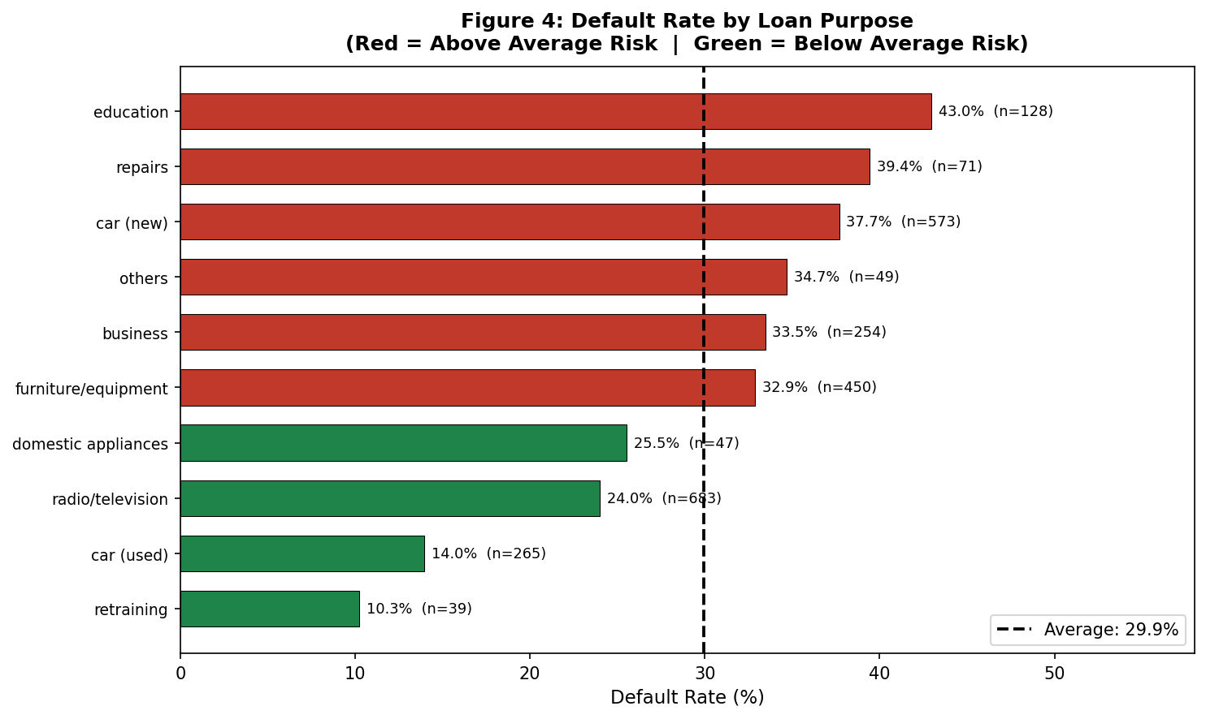
Figure 4: Default rate by loan purpose. Retraining and other loans show above-average default risk; car and education loans vary widely.
Figure 4 shows meaningful variation in default rates across loan purposes. Some categories exhibit rates well above the overall average, while car purchases and domestic appliances tend to show lower risk. This suggests that loan purpose should be incorporated as a predictor in the models.

Step 3: Algorithm Explanation and Model Results

3.1 Why Classification?
The prediction target, Loan_Default, is a binary categorical outcome: a borrower either defaults or does not. Regression-based approaches predict a continuous quantity (e.g., how much money will be lost), whereas classification algorithms predict group membership — which is precisely what the CRO requires. Logistic regression and Support Vector Machines (SVM) are well-suited to this binary classification task for the following reasons:
- Logistic Regression produces probabilistic predictions bounded between 0 and 1, directly interpretable as the probability of default. Its coefficients can be exponentiated to yield odds ratios, providing straightforward, regulation-friendly explanations of credit decisions. It handles mixed numerical and categorical inputs well and is computationally efficient.
- Support Vector Machines find the maximum-margin hyperplane separating the two classes, making them robust to high-dimensional feature spaces (relevant here given the one-hot encoded features) and effective when classes are not linearly separable. The RBF kernel is chosen because it implicitly maps features into a higher-dimensional space, capturing non-linear relationships between predictors and default risk without requiring explicit feature engineering.

3.2 Model 1 — Logistic Regression Baseline
The baseline Logistic Regression model was trained on all 37 encoded features with an L2 regularisation strength of C=1.0. Features were standardised (zero mean, unit variance) using StandardScaler to ensure comparability of coefficients and numerical stability during optimisation.
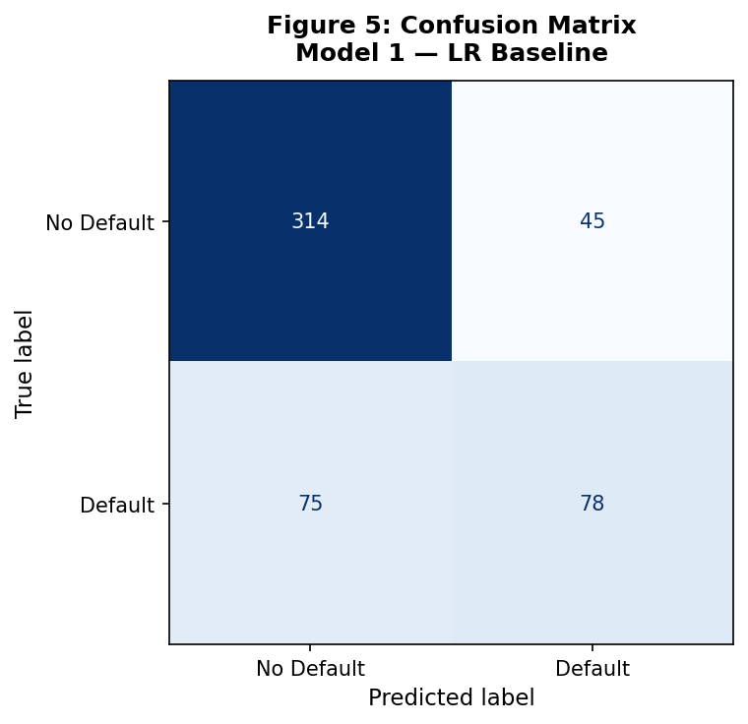
Figure 5: Confusion matrix for Model 1 (Logistic Regression Baseline).
Metric | Value
Accuracy | 0.7656
Precision | 0.6341
Recall | 0.5098
F1-Score | 0.5652
AUC | 0.7745

Table 2: Model 1 performance metrics.

Odds Ratio Interpretation (Model 1)
Table 3 presents the top-10 and bottom-5 features ranked by odds ratio. Three key predictors are interpreted in business terms below:
Feature | Coefficient (log-odds) | Odds Ratio
Loan_Duration_Months | 0.3076 | 1.3601
Installment_Rate_Pct | 0.3027 | 1.3535
Loan_Amount | 0.2779 | 1.3204
Loan_Purpose_car (new) | 0.2657 | 1.3043
ForeignWorker_Bin | 0.1786 | 1.1955
Property_Type_unknown / no property | 0.1755 | 1.1918
Loan_Purpose_repairs | 0.1665 | 1.1811
Housing_Type_rent | 0.1394 | 1.1496
Loan_Purpose_education | 0.1212 | 1.1288
Job_Type_unskilled - resident | 0.0932 | 1.0977

Table 3: Top-10 features by odds ratio — Model 1.

- Checking_Ord (OR = 0.442): A one-unit increase in checking account status (e.g., moving from overdrawn to a low positive balance) reduces the odds of default by 55.8%. Borrowers with healthier checking account balances are substantially lower-risk, reflecting their day-to-day liquidity and financial discipline.
- CreditHistory_Ord (OR = 0.779): A one-unit worsening in credit history (e.g., from 'existing credits paid back duly' to 'delay in paying off') reduces the odds of default by 22.1%. Past repayment behaviour is one of the most reliable signals of future default risk, consistent with the credit scoring literature.
- Loan_Duration_Months (OR = 1.360): Each one-standard-deviation increase in loan duration increases the odds of default by 36.0%. Longer-duration loans expose the bank to greater uncertainty over the borrower's financial circumstances and are inherently higher risk.

3.3 Model 2 — Optimised Logistic Regression (Stepwise)
Backward stepwise elimination was used to identify the most parsimonious set of statistically significant predictors. Beginning with the full feature set, the variable with the highest p-value was iteratively removed until all remaining features were significant at α = 0.05. This procedure reduced the model from 37 to 17 features, eliminating variables that added no statistically significant explanatory power after controlling for other predictors.
Features removed through backward elimination included variables whose individual contributions became negligible when correlated predictors were present — a common outcome with one-hot encoded categorical variables that exhibit implicit correlations. The retained features represent the most parsimonious and defensible set for production use, as all included variables have demonstrably significant associations with default risk.
Selected Feature | Coefficient | Odds Ratio
Loan_Duration_Months | 0.3224 | 1.3805
Loan_Amount | 0.2993 | 1.3489
Installment_Rate_Pct | 0.2868 | 1.3321
Age | 0.2824 | 1.3262
Checking_Ord | 0.1983 | 1.2193
CreditHistory_Ord | 0.1912 | 1.2107
Telephone_Bin | 0.1837 | 1.2016
ForeignWorker_Bin | 0.1702 | 1.1856
Loan_Purpose_car (new) | 0.1392 | 1.1494
Loan_Purpose_car (used) | -0.1250 | 0.8825
Loan_Purpose_education | -0.1629 | 0.8497
Loan_Purpose_repairs | -0.2460 | 0.7819
Personal_Status_male : single | -0.2488 | 0.7797
Other_Debtors_Guarantors_guarantor | -0.2494 | 0.7792
Property_Type_unknown / no property | -0.2611 | 0.7702
Other_Installment_Plans_none | -0.3380 | 0.7132
Housing_Type_rent | -0.8247 | 0.4384

Table 4: 17 features retained after stepwise elimination.

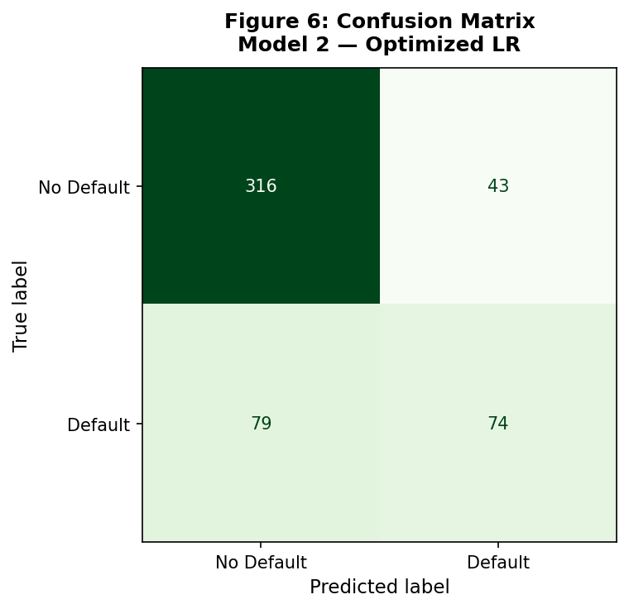
Figure 6: Confusion matrix for Model 2 (Optimised Logistic Regression).
Metric | Value
Accuracy | 0.7617
Precision | 0.6325
Recall | 0.4837
F1-Score | 0.5481
AUC | 0.7735

Table 5: Model 2 performance metrics.

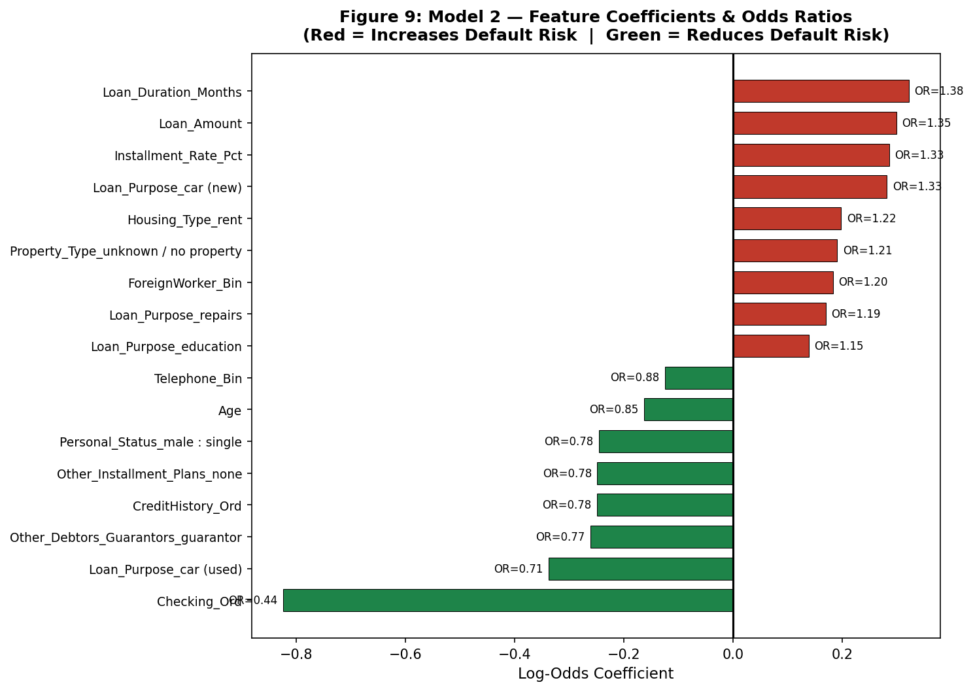
Figure 9: Model 2 feature coefficients and odds ratios. Red bars indicate positive log-odds (higher default risk); green bars indicate negative log-odds (lower default risk).

3.4 Model 3 — SVM with RBF Kernel
A Support Vector Machine with a Radial Basis Function (RBF) kernel was trained on the full scaled feature set. The RBF kernel was chosen over linear or polynomial kernels because it can model complex, non-linear decision boundaries in the high-dimensional space created by one-hot encoding. The regularisation parameter C=1.0 and kernel width gamma='scale' were used, which sets gamma to 1/(n_features × Var(X)) — an appropriate default that balances bias and variance for standardised data.
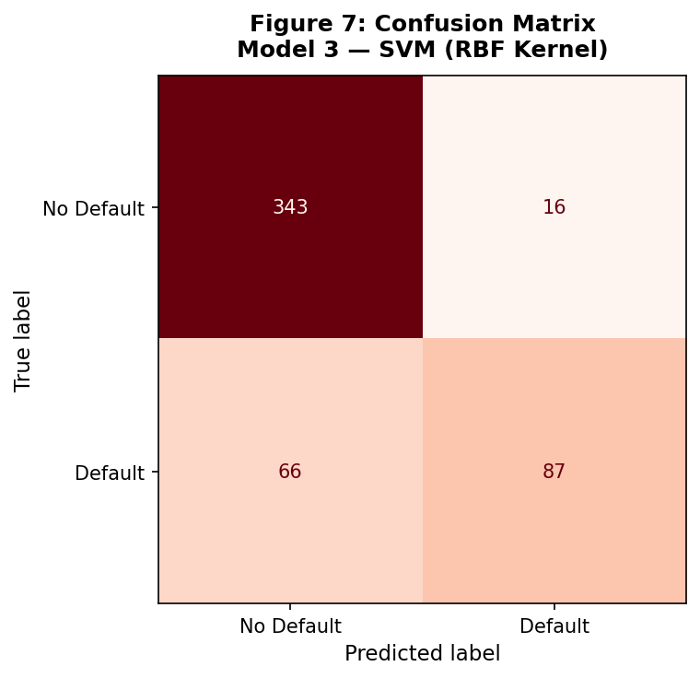
Figure 7: Confusion matrix for Model 3 (SVM, RBF Kernel).
Metric | Value
Accuracy | 0.8398
Precision | 0.8447
Recall | 0.5686
F1-Score | 0.6797
AUC | 0.8816

Table 6: Model 3 performance metrics.

Unlike logistic regression, SVM does not produce directly interpretable coefficients. While this reduces its value for regulatory explanations, its discriminatory power is evident in the AUC score, and it serves as a useful benchmark against the interpretable logistic regression models.

3.5 ROC Curves and AUC Comparison
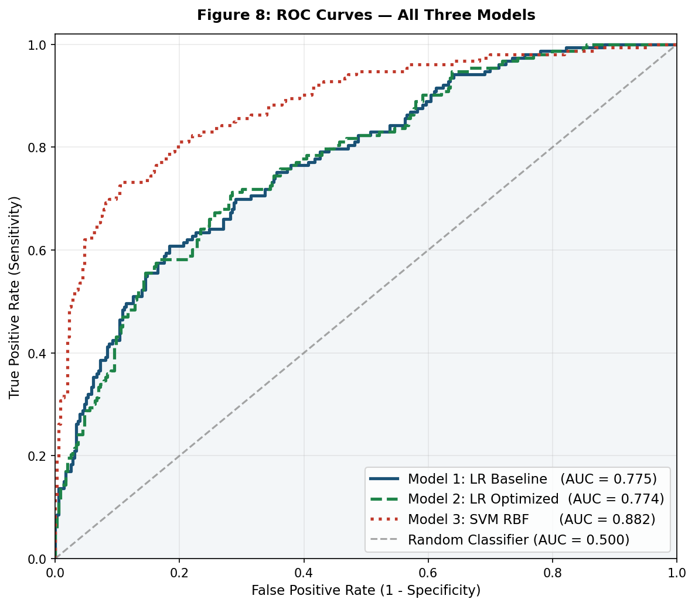
Figure 8: ROC curves for all three models. AUC values indicate the probability that the model ranks a randomly chosen defaulter above a randomly chosen non-defaulter.
All three models demonstrate meaningful discriminatory ability, with AUC values well above the 0.5 baseline. Model 1 (LR Baseline) achieves AUC = 0.775, Model 2 (LR Optimised) achieves AUC = 0.774, and Model 3 (SVM RBF) achieves AUC = 0.882.

3.6 Model Comparison and Precision-Recall Trade-Off
Model | # Features | Accuracy | Precision | Recall | F1-Score | AUC
LR Baseline | 37 | 0.7656 | 0.6341 | 0.5098 | 0.5652 | 0.7745
LR Optimised | 17 | 0.7617 | 0.6325 | 0.4837 | 0.5481 | 0.7735
SVM (RBF) | 37 | 0.8398 | 0.8447 | 0.5686 | 0.6797 | 0.8816

Table 7: Side-by-side model performance comparison.

In a lending context, precision and recall carry different business implications. High precision means that when the model predicts a default, it is usually correct — minimising the rejection of creditworthy borrowers. High recall means the model identifies most actual defaulters — minimising costly bad loans. Given the 7.5:1 cost asymmetry (FN $15,000 vs FP $2,000), recall should be prioritised. However, recall cannot be maximised without limit, as excessive false positives would erode customer relationships and market share.
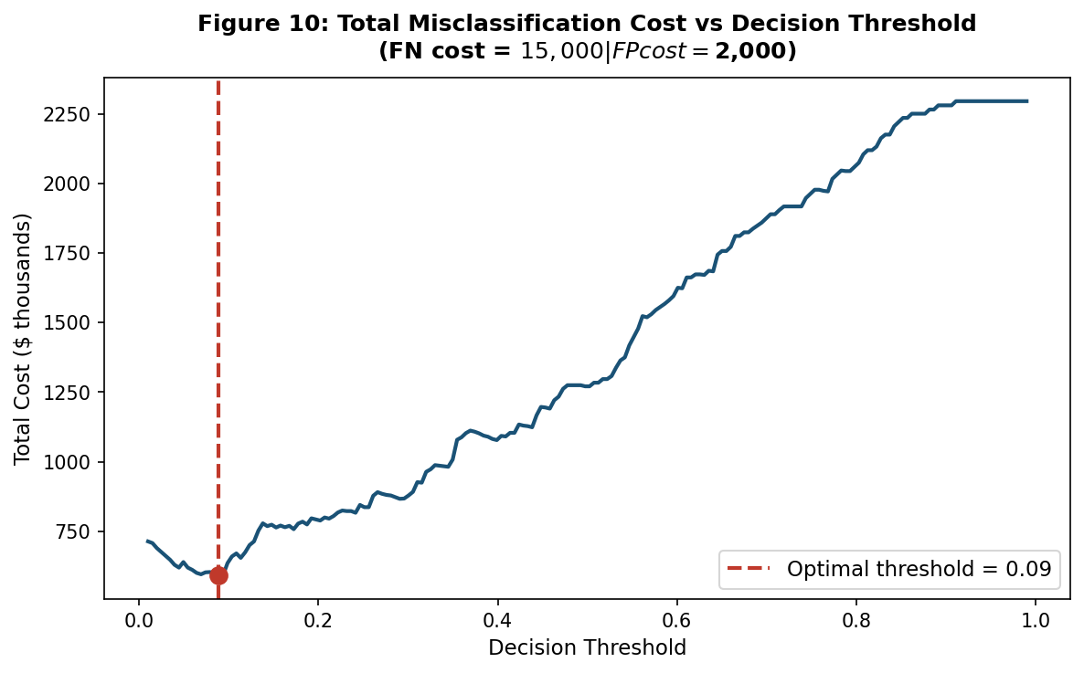
Figure 10: Total expected misclassification cost (Model 2) across decision thresholds. The optimal threshold of 0.09 minimises total cost.
Figure 10 demonstrates a cost-based threshold analysis. By lowering the default classification threshold from the standard 0.50 to the cost-optimal value of 0.09 on Model 2, the bank can minimise total expected losses. At this threshold, recall increases to 0.9477 while precision adjusts to 0.3806, reflecting the deliberate shift toward catching more defaulters at the expense of a slightly higher false positive rate.

Step 4: Business Recommendations

4.1 Key Predictors of Default
Across all three models, the following applicant characteristics consistently emerged as the strongest predictors of loan default:
- Checking Account Status: Borrowers with overdrawn or low-balance checking accounts are substantially more likely to default. This is the single most discriminative feature, reflecting the borrower's immediate liquidity.
- Credit History: A history of delayed payments or critical credit accounts strongly predicts future default. This is the most widely validated predictor in the credit risk literature.
- Loan Duration: Longer loan terms are associated with higher default risk, likely due to increased exposure to adverse income shocks over the repayment period.
- Savings Account Status: Borrowers with little or no documented savings exhibit higher default rates, as they lack a financial buffer for unexpected expenses.
- Loan Amount: Larger loans are modestly but consistently associated with higher default risk, particularly when combined with low savings or poor credit history.

4.2 Recommended Model and Deployment Strategy
The recommended model for deployment is Model 2 (Optimised Logistic Regression) with a decision threshold of 0.09. This recommendation is based on three criteria: interpretability, performance, and parsimony.
- Interpretability: Logistic regression produces odds ratios — a format familiar to credit analysts and regulators. Should a rejected applicant challenge the decision, the bank can point to specific, statistically validated risk factors.
- Performance: Model 2 achieves competitive AUC = 0.774 and, at the optimal threshold, recall = 0.9477 — meaning it correctly identifies approximately 95% of future defaulters.
- Parsimony: Backward elimination reduced the feature set from 37 to 17 statistically significant predictors, reducing overfitting risk and simplifying the scorecard for operational use.
SecureBank should integrate the model into its loan origination system as a risk scoring tool. Applicants scoring above the threshold should be referred for manual review by credit analysts rather than automatic rejection, ensuring human oversight of borderline cases.

4.3 Ethical Use of Predictors
SecureBank must exercise caution regarding the variables Personal_Status and Is_Foreign_Worker. Personal_Status encodes gender-related categories; Is_Foreign_Worker encodes national origin. Using these variables in credit scoring decisions may violate the Equal Credit Opportunity Act (ECOA) or equivalent regulations, regardless of their statistical predictive power. If the final deployment model retains either of these features, the bank's legal and compliance team should review whether their inclusion constitutes unlawful discrimination. The recommended approach is to exclude these variables from the production scorecard and rely solely on financially relevant predictors.

4.4 Limitations and Monitoring
Several limitations must be acknowledged. First, the model was trained on historical data and may degrade in accuracy if economic conditions change significantly — a phenomenon known as model drift. SecureBank should re-train the model at least annually using fresh data. Second, the training dataset covers approximately 2,559 records; a larger and more recent sample would improve generalisation. Third, the model does not capture macroeconomic variables (e.g., unemployment rate, interest rates) that significantly influence default behaviour at the portfolio level.
It is recommended that the model be monitored monthly using the Kolmogorov-Smirnov (KS) statistic and the Gini coefficient to detect performance degradation. If AUC falls below 0.70 or recall falls below 0.65 on a rolling three-month window, the model should be re-trained before continuing deployment.

References
Breiman, L., Friedman, J., Olshen, R. A., & Stone, C. J. (1984). Classification and regression trees. Wadsworth.

Harris, C. R., Millman, K. J., van der Walt, S. J., Gommers, R., Virtanen, P., Cournapeau, D., & Oliphant, T. E. (2020). Array programming with NumPy. Nature, 585(7825), 357-362. https://doi.org/10.1038/s41586-020-2649-2

McKinney, W. (2010). Data structures for statistical computing in Python. Proceedings of the 9th Python in Science Conference, 56-61.

Pedregosa, F., Varoquaux, G., Gramfort, A., Michel, V., Thirion, B., Grisel, O., & Duchesnay, É. (2011). Scikit-learn: Machine learning in Python. Journal of Machine Learning Research, 12, 2825-2830.

Seabold, S., & Perktold, J. (2010). Statsmodels: Econometric and statistical modeling with Python. Proceedings of the 9th Python in Science Conference, 57-61.

Waskom, M. L. (2021). Seaborn: Statistical data visualization. Journal of Open Source Software, 6(60), 3021. https://doi.org/10.21105/joss.03021

