- PING: the ping command send an ICMP echo requests to a packet destination. You can use it to either ping a domain name or any IP address.
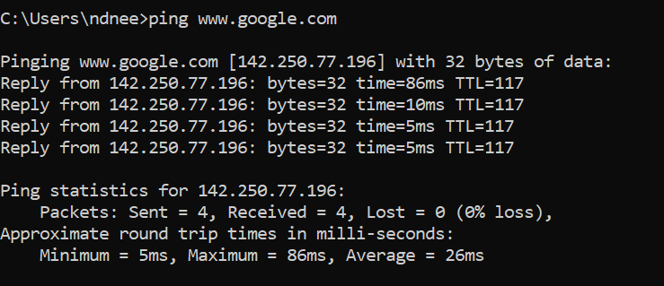

IPCONFIG/IFCONFIG: The ipconfig command is used on Windows, while the ifconfig command is used on Linux, Mac OS X, and other Unix-like operating systems. These commands allow you to configure your network interfaces and view information about them.
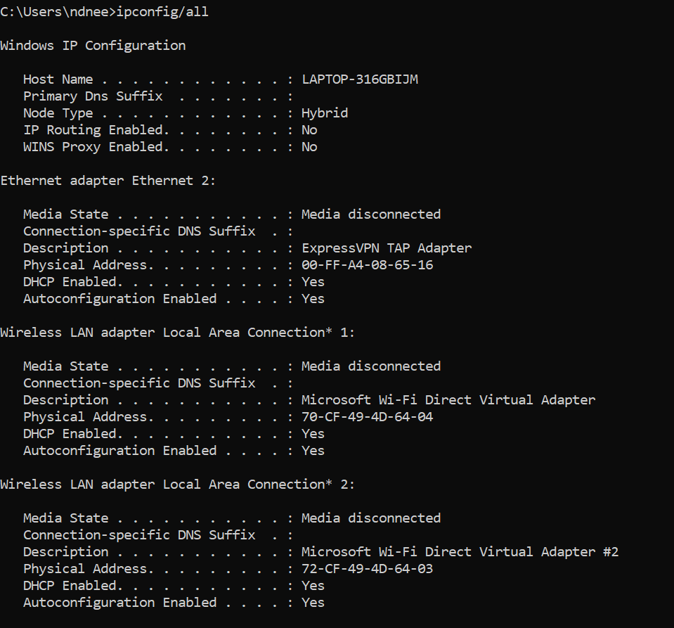
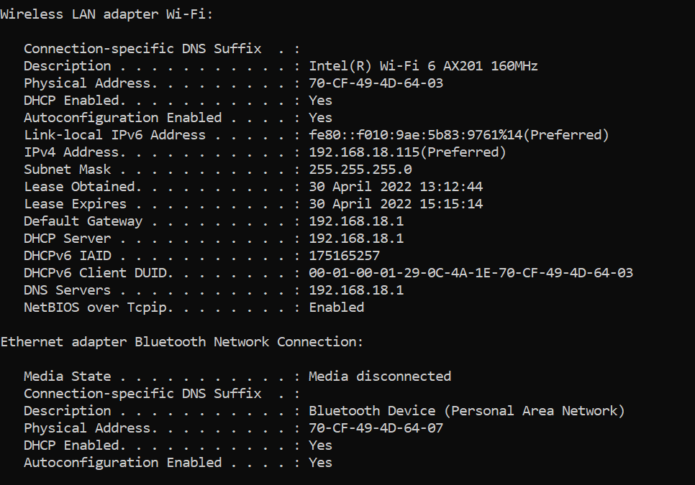
Here, the ipconfig/all command is used to display all the configured network interfaces, IP addresses, DNS servers, and other information.

TRACERT: the tracert command is similar to ping, but provides information related to the path that has been taken by a packet.
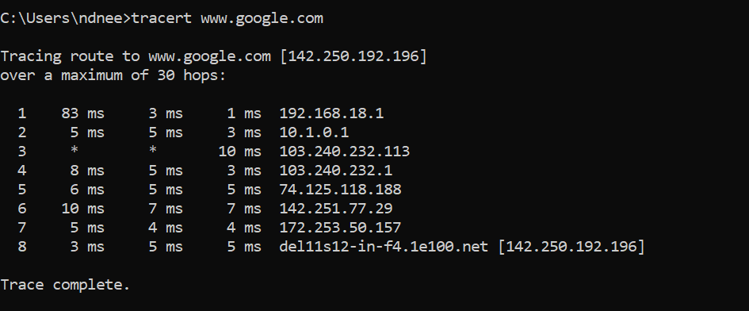

ARP: The arp command displays and modifies the Internet-to-adapter address translation tables used by the Address in Networks and communication management. The arp command displays the current ARP entry for the host specified by the HostName variable.

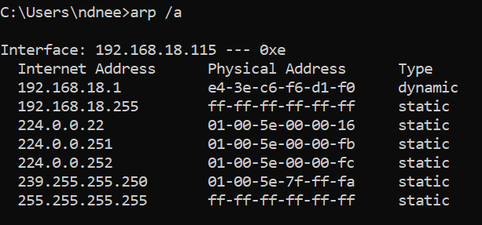

NETSTAT: netstat stands for network statistics. This command displays incoming and outgoing network connections as well as other network information.

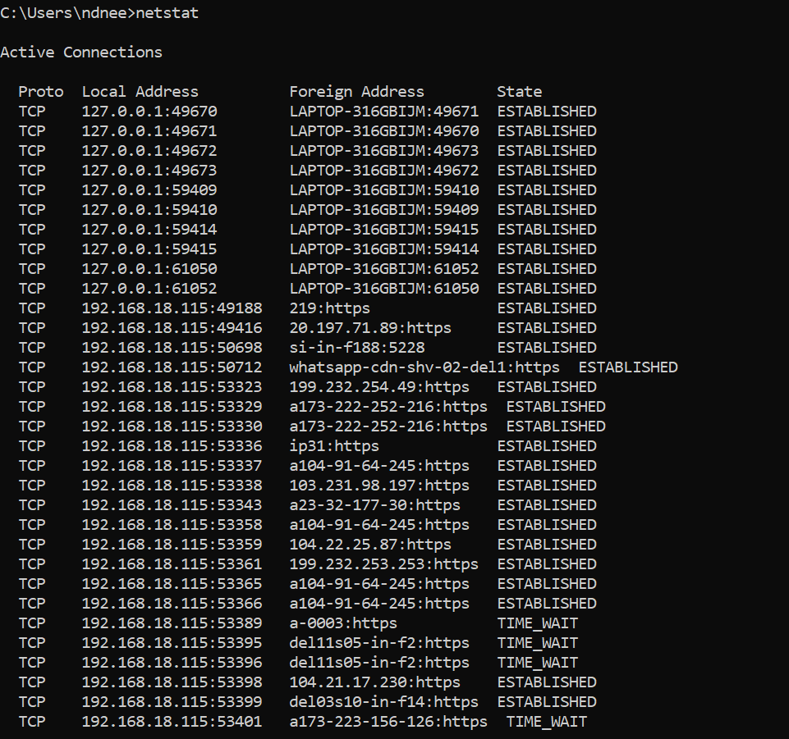

WHOIS: The whois command looks up the registration record associated with a domain name. This can show you more information about who registered and owns a domain name, including their contact information.

