**E - Commerce Website Project**

Francheska Monique Palma Gil

Jerson Ray Desierto

1. **Introduction**

In today’s technology, buying and selling of products and services have become more prevalent. With the limitations of mobility because of the pandemic, E-commerce is continuously growing exponentially in various industries. Most consumers have become more reliant on online shopping and online marketing. Therefore, an E-commerce website is a perfect space for all types of businesses. This website will specifically be handling Computer components, parts, accessories and upgrades for all the consumer’s needs.

1. **Objectives**

The goal of this project is to provide a website that is user-friendly, easy to navigate, responsive and good visual appeal that allows the user to experience a straightforward and hassle-free online shopping experience. In developing this website, the objectives of the developers are the following:

* To identify the needs and the preferences of the target audience.
* To know what products to put for availability in the E-commerce website
* To create and design an E-commerce website with a simple but well-designed layout
* To create a database for the customer information and transaction
* To create an admin panel for administrative and monitoring of transactions and website runtime
* To design a layout that will provide a user-friendly browsing and shopping experience that includes a login and signup feature, add and remove product carts, sorting and searching from categories.
* To provide a unique user experience by appealing to their preferences and allow customer queries for engagement
* By the deadline period, the developers will manage and maintain the overall website wherein by then, the product will be sent and deployed for submission.

1. **Target Users**

The E-Commerce website will specifically target all consumers that are interested in replacing, upgrading or simply modifying their computer units. This website can also cater larger industries that are looking for a direct supply for computer parts, accessories and anything computer related.

And because this website will serve a large environment, it is optimal for an organized display of products and a user- friendly interface that enables a fast and smooth user experience, thus the possible features would be:

* shopping cart
* search-bar
* customer and admin login
* category
* Sorting
* Admin panel
* Graphs and data visualization
* Update user information

1. **Methodology**

Software development life cycle is the process of planning, creating, developing and deploying a software or system. It provides a systematic framework as the foundation of the development of the software that becomes the structure of the overall project. There are numerous methodologies that provide structure to the deliverables of the project. A few of them are Waterfall methodology, V-model, Lean methodology. Agile methodology, DevOps, Spiral, Iterative etc. Regardless of the methodology used, the phases of the Software development life cycle should include Planning and Requirement gathering, Scope and project analysis, Designing, Building and development, and deployment and maintenance.

In this project, the software development life cycle used will be Agile methodology, this consists of (1) gathering of requirements (2) planning (3) design (4) develop (5) release (6) track and monitor for maintenance)

In web development, testing and developing is done simultaneously, while traditional software development undergoes each phase one at a time, therefore an incremental development strategy is applicable. This is a development strategy that allows each successful version of the prototype to be used to develop additional user-friendly features in each successive iteration. This can be implemented in the Agile sense given that Agile methodology is iterative and incremental that allows repetition and refactoring the internal structure of the product. Through this methodology, combining incremental development and iterative development where repetition of the work and improving the overall product, will allow a more efficient and successful deployment of the project.

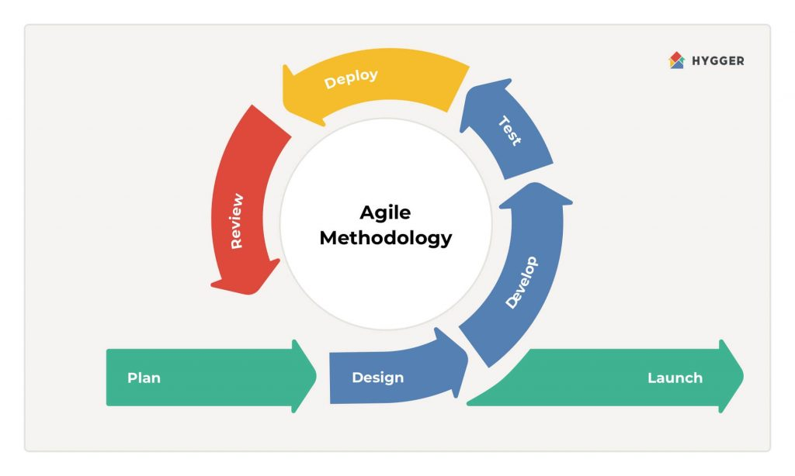

Figure 1.A

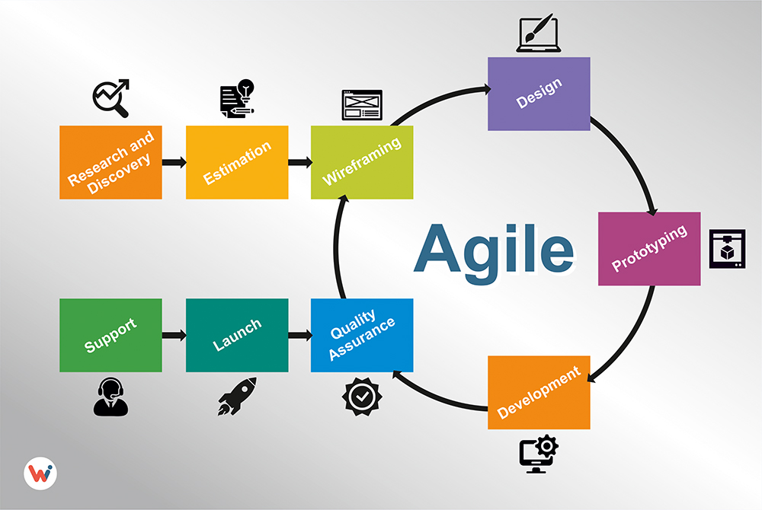

Figure 1.B

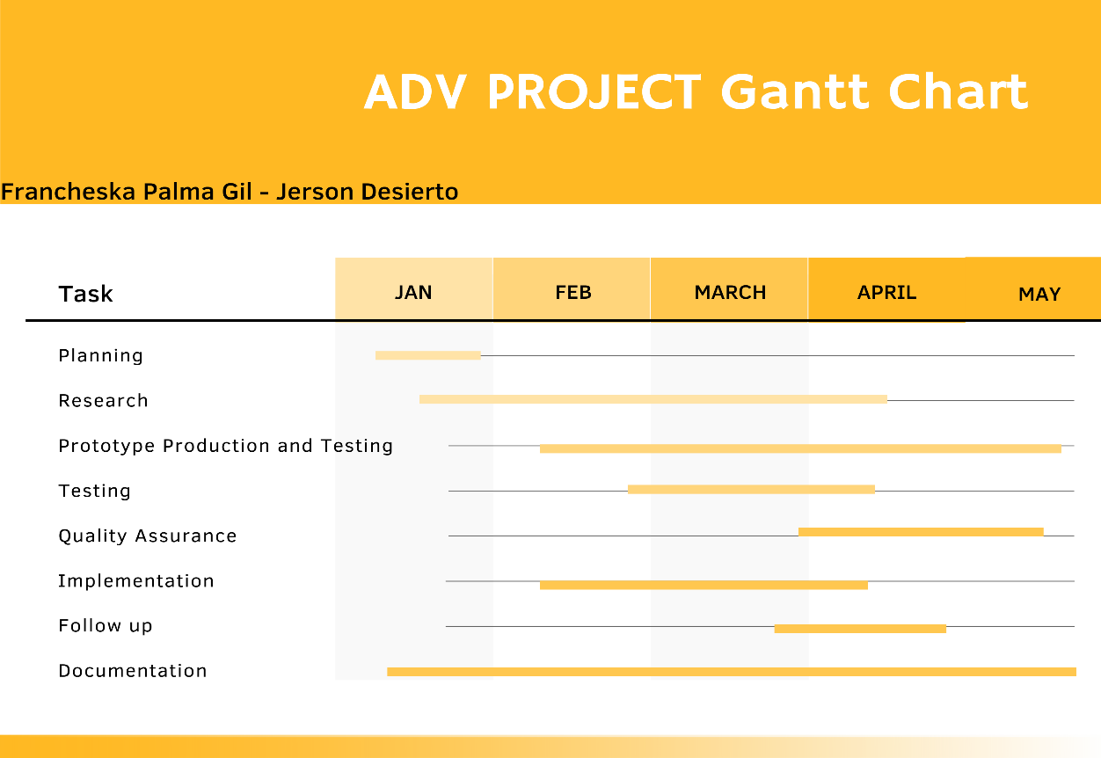

1. **Results and Discussion**

The results of the project has addressed the problems that most online users face when browsing and using online shopping , the website has met the goal of this project, which is to provide a website that is user-friendly, easy to navigate, responsive and good visual appeal that allows the user to experience a straightforward and hassle free online shopping experience.

In developing this website, We have implemented features such as sorting, searching, categorizing and customer login. This website includes an admin panel that can provide an overview on the product stocks, product list, number of users, and graphical visualization of different product and user data. All the product, sales , cart and user data is stored in a database that can be viewed in the admin panel. This website is fully functional and can Create, Read, Update and Delete information stored from the database.

This website still has room for improvement, it is recommended to improve the security of the stored data in the database to the website, and enhance the graphic user interface of the website for ease of use. The product view can still be improved to have more information and stocks. The navigation bar can be better in terms of design and layout when hovering the drop down menu.

1. **Appendices**

**Curriculum Vitae**

**Code Snippets**

**Screenshots**

I - Introduction

- The project context should describe the background in terms of what factors drive the project. It can be either due to technological advancements, organizational process, improvement, or directive.

- What is the problem that is needed to address why you create your project

- What is your solution to address the problem you mentioned?

- Purpose of the Project (This should explain the intended purpose of the project as well as outline the potential advantages/benefits for having such this project).

- 3 - 5 paragraphs

Ia - Objectives (At least 3) SMART

Ib - Target user(s)

II - Methodology

- What methodology you use to create the project? (SDLC)

- Work Plan (Example: Gantt Chart)

III - Result and Discussion

- Result (was the app useful to address the said problem?)

- Recommendation (What are your recommendation to improve the app?)

IV - Appendices

- Curriculum Vitae

- Code Snippets

- Screenshots