Name: ___________________________________

**Challenge: Switches**

**Switches Challenge:**

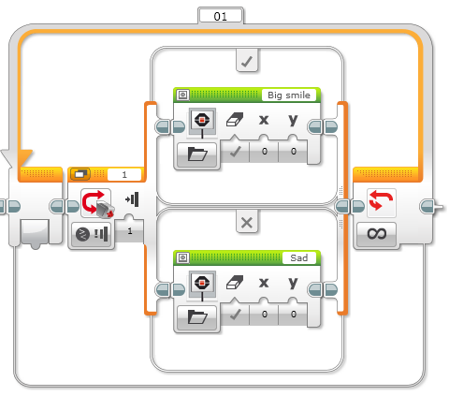Write a program that changes based on if the touch sensor is pressed or not pressed.

If pressed, your EV3 is happy! Display a smiley face. If not pressed, the EV3 is sad! Display a sad face.

What else can you use the display block for?