Eric Roberts and Jerry Cain Handout #48

CS 106J May 31, 2017

Section Handout #8: Real World Javascript

Portions of this handout by Jason Chen

You’ve made it! Congratulations! This is our last section, and once again I would like to thank everyone for all the hard work you’ve put in all quarter. The teaching staff have had an amazing time learning with all of you, and we wish you the very best!

For this section, we’re going to have some fun and show you something fun you can do with the skills you’ve acquired, as well as some introduction to basic HTML and CSS.

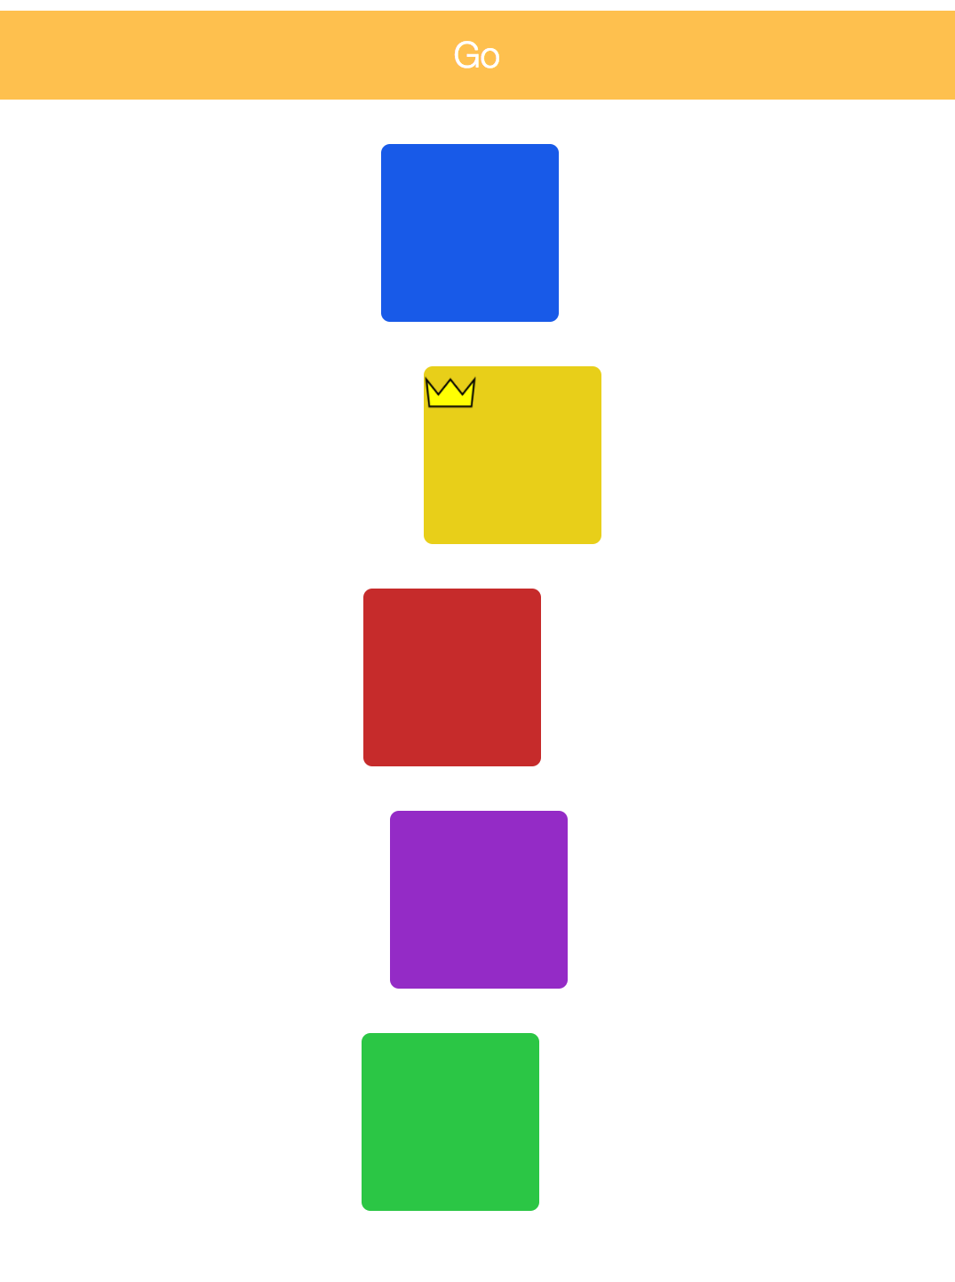

1. Block Races

We’re going to write a small website that has five blocks lined up on the left side of the page when we first visit the page. There will also be a button at the top that the user can press.

When the user presses the button, the five blocks will start racing. They’ll move forward with random speeds, so we won’t know which block will make it to the end first!

The first block that makes it to the end will receive a crown. The image to the right shows the blocks racing after one round has already occurred and the yellow block has won.

You’ll want to think about putting together concepts like randomness, setting functions to run at intervals, moving objects to different locations, et cetera. We’ll also teach you some HTML and CSS to get you started! There are also all types of extensions you can do with this small demo like adding in ways the mouse would interact would the blocks.

2. Review

Also, come to section with any questions you have from the material we covered the last few weeks! Just a reminder, our final exam will be June 14th, 8:30 am – 11:30 am. Ryan and I will be holding a review session the evening of Sunday June 11th, exact details TBD.

Lastly, if you are interested in where you can go from here on out, please come talk to any of us. We would love to point you in the right direction based on your interests. There’s so much out there and CS106J was just the beginning!