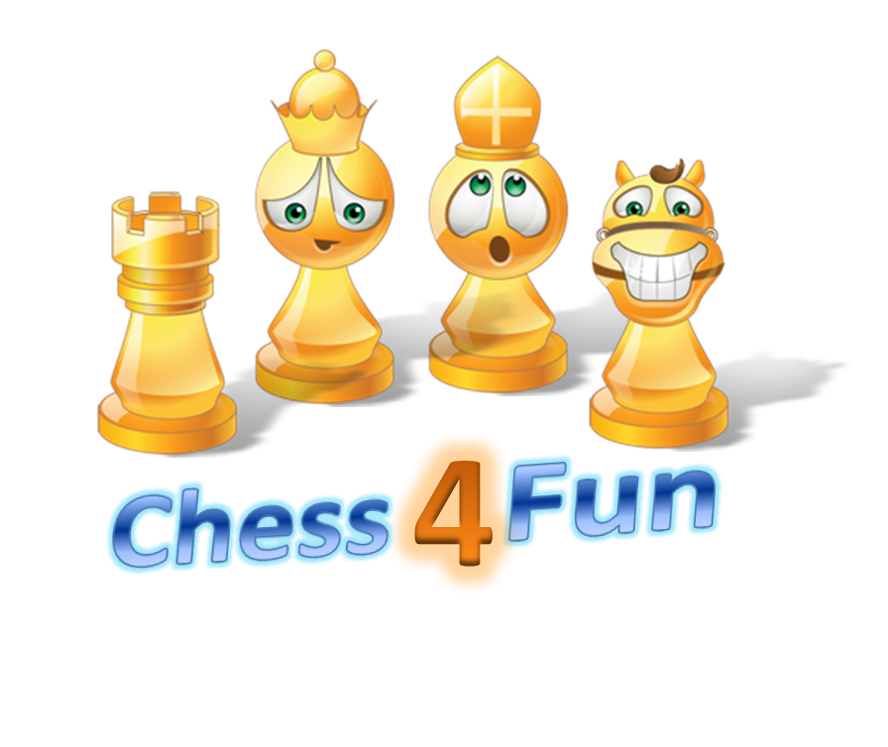

Game Design: Report on the Technology Fair Project, design and, development

Technology Fair

2016

**Installer:** [**https://github.com/chess4fun/chess4fun/tree/master/app**](https://github.com/chess4fun/chess4fun/tree/master/app)

**Documentation:** [**https://github.com/chess4fun/chess4fun/wiki**](https://github.com/chess4fun/chess4fun/wiki)

**Code:** [**https://github.com/chess4fun/chess4fun**](https://github.com/chess4fun/chess4fun)

## Ananya S. Tadepalli

## Dhvanish Vaghela

Contents

Introduction 2

About Creators 2

Ananya Sai Tadepalli 2

Dhvanish Vaghela 2

Game Design 2

Why do we need a new Chess game? 2

Game flow 3

Development Tools/ Resources 4

Design Details 4

Definition of Terms 4

Draw the chess board and pieces 5

Display puzzle options 5

Initialize game 5

Receive player input and take action 5

Citations/ Credits 7

Experience 8

Player Guide 9

Installation 9

Play 9

Upcoming features 10

# Introduction

This project is started with an aim of learning game design, coding, team-work and participating in [Georgia Educational Technology Fair](http://gatechfair.org/)

Why Game design? After reviewing all the topics for the technology fair we found game design most interesting and challenging.

# About Creators

## Ananya Sai Tadepalli

Ananya is a 3rd grader from Crabapple Crossing Elementary school. She loves to dance and play chess. She has been member of USCF and school chess club since 2012.

## Dhvanish Vaghela

Dhvanish is a 3rd grader from Crabapple Crossing Elementary school. He is a budding Basketball player and loves to play chess. He has been member of USCF and school chess club since 2013.

# Game Design

Brainstormed on various games we could build such as educational games, basketball, but decided to build something on Chess because it was common interest for both of us. We also wanted to make sure player has some fun in addition to learning chess.

## Why do we need a new Chess game?

1. Other chess based games aren't fun and make children lose interest in the game.
2. Other chess based games focus on chess only and have no fun games.
3. Other chess based games don't give you options so that after you check all the options only one is correct.

# Game flow

1. Player is shown a splash screen with game logo.
2. Player must press enter to begin
3. Player is shown a help page with information about the game. Player can continue to the game by pressing space bar.
4. Player starts at level 1
5. Each level can have any number of puzzles. In the initial version we have three puzzles per each level.
6. Each level is named after a chess piece.
   1. level 1: Pawn, in this level animation of a pawn jumping with a corresponding sound is shown
   2. level 2: Knight, in this level animation of a Knight jumping with a corresponding sound is shown
   3. level 3: Bishop, in this level animation of a Bishop jumping with a corresponding sound is shown
   4. level 4: Rook, in this level animation of a Rook jumping with a corresponding sound is shown
   5. level 5: Queen, in this level animation of a Queen jumping with a corresponding sound is shown
7. The animations jump to a higher step as player answers a question correctly.
8. After correctly answering all questions in a level player advances to next level
9. There will be a fun game between two levels. Player can earn bonus points by completing this game
10. A wrong answer will receive negative points (-10) and a correct answer will get you (+10)
11. There is no restriction on number of trials till getting the correct answer
12. To exit the game they can press 'ESC' at anytime
13. Player can see last ten high scores using menu option ”High Scores”
14. Player can get a certificate using menu option “Certificate”

# Development Tools/ Resources

This is a Windows based game.

1. We have used YOYO Game Maker studio free version, which allows windows based games only
2. EXCEL for generating puzzle data
3. [Mr Data Converter](https://shancarter.github.io/mr-data-converter/) for converting excel data to json
4. Citation: <http://www.easybib.com/cite/view>
5. Code sharing : [github](https://github.com/chess4fun/chess4fun)
6. Documentation: [Github-wiki](https://github.com/chess4fun/chess4fun/wiki)

# Design Details

### Definition of Terms

1. Room: A room is the screen space in which game is played. There can be multiple rooms. In our game we have rooms for each level and separate rooms for introduction congrats etc.
2. Object: An object is placed inside the game room. Some objects are visible like a pawn and there are other objects which are not visible. Like the input object which waits for an input and acts on it. All visible objects have a sprite attached which defines how the object looks. Objects can have events and actions configured to them. For example in our game when player clicks Escape, the exit objects triggers and event and action to close the game.
3. Sprite: A sprite can have one or more images. When it has more images those help in animating the sprite.
4. Background: A background can be created using an image. Once it is defined it can be added to the room. There can be multiple backgrounds one on top of other.
5. Sound: Sound can be added from a mp3 file. Once it is defined, it can be triggered using events and actions on objects.

There are four key components to the game, each of these are explained in the next four sections.

## Draw the chess board and pieces

1. Use sprites to design the black and white squares in the chess board. Finally take a snapshot and make it into a background in order to save memory.
2. Create a sprite for each of 12 chess pieces
3. Define a json format for reading the game position
4. Read game position and add the correct sprite in the position specified 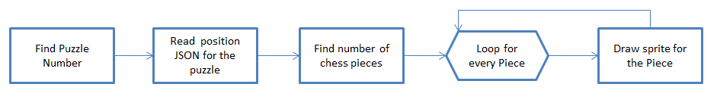

## Display puzzle options

1. Read puzzle options and correct answer from a json file
2. Display the options in the screen
3. set global variable for correct answer 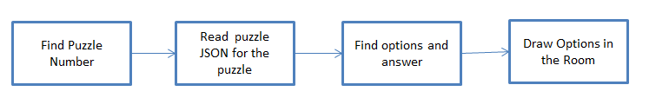

### Initialize game

1. Set the starting game level, puzzle, score etc
2. Go to the first room

### Receive player input and take action

1. Read the player input.
2. Check if it is 1, 2, 3, 4 or ESC.
3. If not display message showing allowed inputs.
4. If ESC is pressed close game.
5. If 1, 2, 3 or 4 is pressed, check if it matches with the correct answer
6. If number entered does not match correct answer display message to player to try again
7. If it matches correct answer, check if player has solved all puzzles in the level
8. If player solved all puzzles in the level, check if it is the last level
9. If it is the last level congratulate player on completing the game
10. If it is not the last level congratulate player on completing the level. Increment the level. Assign points. Navigate player to a fun game.
11. Restart the room at the current or new level

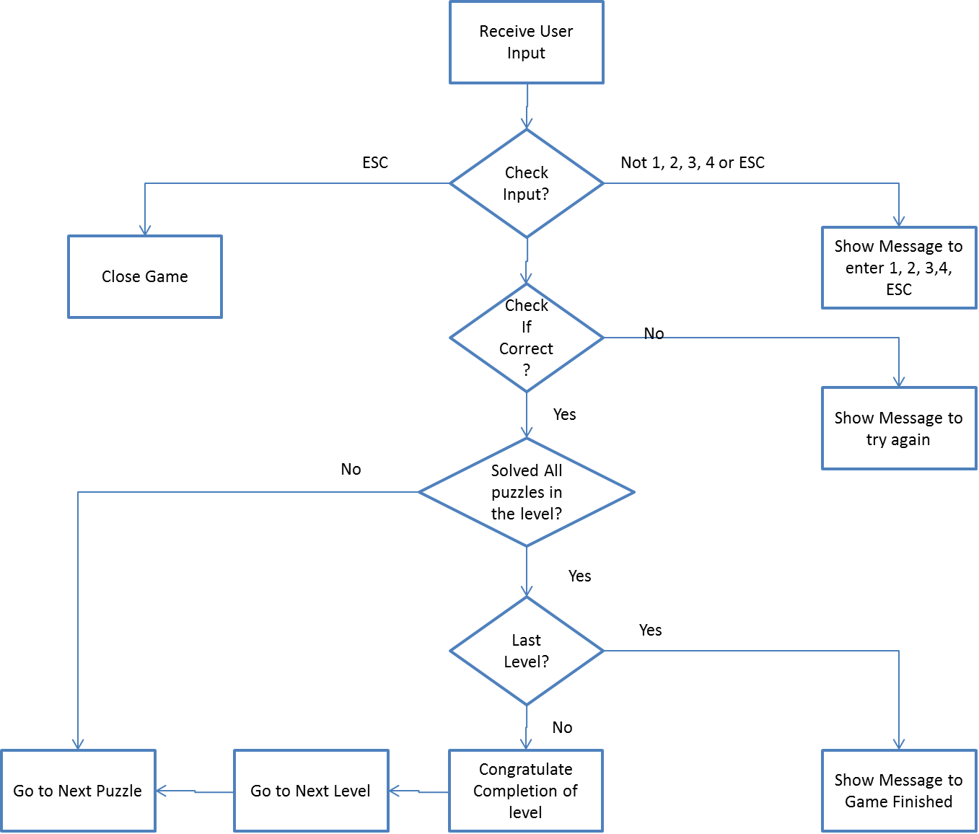

# Citations/ Credits

1. "Game Maker Basic Chess Tutorial - Part 1/4: Setting Up the Board." YouTube. YouTube, n.d. Web. 06 Jan. 2016. <<https://www.youtube.com/watch?v=vEwNYf3rk7U>>. Used this video to understand how to create a chess board and lay out chess pieces
2. "Chess Icons - Download 60 Free Chess Icons Here." Chess Icons - Download 60 Free Chess Icons Here. N.p., n.d. Web. 06 Jan. 2016. <<http://www.iconarchive.com/tag/chess>>. Used this source to download various icon for King, Queen etc
3. "GameMaker Tutorials: Using JSON Data." JASON LEE ELLIOTT. N.p., 21 May 2015. Web. 06 Jan. 2016. <<http://jasonleeelliott.com/using-json-data/>>. Used this site to understand how to read puzzle data and create each puzzle.
4. "Mr. Data Converter." Mr. Data Converter. N.p., n.d. Web. 06 Jan. 2016. <<https://shancarter.github.io/mr-data-converter/>>. Used this tool to transform puzzle data in excel to json format.
5. "SoundBible.com." Free Sound Clips. N.p., n.d. Web. 06 Jan. 2016. <<http://soundbible.com/>>. Background sounds for the game were downloaded from this source
   1. Intro sound: <http://soundbible.com/2041-News-Intro.html>
   2. Puzzle background: <http://sandbox.yoyogames.com/make/resources>
   3. Applause sound: <http://soundbible.com/2087-Audience-Applause.html>
   4. Footsteps: <http://soundbible.com/911-Footsteps.html>
   5. Sound wrong: <http://soundbible.com/2062-Metal-Gong-1.html>
6. "Free Images - Pixabay." Free Images - Pixabay. N.p., n.d. Web. 06 Jan. 2016. <<https://pixabay.com/>>. Used this site for free images for backgrounds
   1. Space: <https://pixabay.com/en/centaurus-a-ngc-5128-galaxy-11190/>
   2. Confetti: <http://free-style.mkstyle.net/web/wp-content/uploads/confetti-background-34.jpg>
   3. Abstract: <https://pixabay.com/en/pastels-geometric-abstract-design-788676/>
   4. Certificate: <http://britannia.vsb.bc.ca/business_education/images_business_ed/OfficialAchievementCertificate.jpg>
7. "Iconset: Vista Chess Icons by Icons-Land (6 Icons)." Vista Chess Iconset (6 Icons). N.p., n.d. Web. 28 Jan. 2016. <http://www.iconarchive.com/show/vista-chess-icons-by-icons-land.html>. Non commercial use license
   1. Logo image queen: <http://www.iconarchive.com/show/vista-chess-icons-by-icons-land/Queen-Yellow-icon.html>
   2. Logo image knight: <http://www.iconarchive.com/show/vista-chess-icons-by-icons-land/Knight-Yellow-icon.html>
   3. Logo image Bishop: <http://www.iconarchive.com/show/vista-chess-icons-by-icons-land/Bishop-Yellow-icon.html>
   4. Logo image Rook: <http://www.iconarchive.com/show/vista-chess-icons-by-icons-land/Rook-Yellow-icon.html>
   5. Image Pawn: <http://www.iconarchive.com/show/vista-chess-icons-by-icons-land/Pawn-Yellow-icon.html>
8. "Fire Icon Clip Art." Fire Icon Clip Art at Clker.com. N.p., n.d. Web. 28 Jan. 2016. <http://www.clker.com/clipart-11123.html>.
9. "Create a Text GIF." <i>Bloggif : Create Text GIF for Free</i>. N.p., n.d. Web. 06 Jan. 2016. <span>Used this site to create animated text</span>
10. "Checkmate Problems Worksheets | Chess Puzzles!" Checkmate Problems Worksheets | Chess Puzzles! N.p., n.d. Web. 30 Jan. 2016. <http://www.chesspuzzles.com/checkmate-worksheets>. Puzzle

# Experience

1. We had to go through several tutorials to learn the tools. We build a few sample games to understand each component.
2. We got help from our parents whenever we were stuck with a problem. They also helped us understand how to choose images and sounds that are royalty free.
3. We initially tried to use Scratch to build our animations, but we could not find an easy way to pull those animations into our game. So we decided to build simple animations using sprites.
4. We learnt a lot about working as a team and saving all work to github saved us several times. We did brainstorming, voting for name of the game etc.

# Player Guide

## Installation

Download the installer from link

1. You will need a Windows 7 or higher PC
2. Run the installer in order to install the game

## Play

1. Start the game using the game icon on your desktop
2. After you see the splash screen click any key to strt the game
3. For each puzzle 4 options are shown
4. Click the number corresponding to the correct answer in order to score points and move to next puzzle. Alternatively, you can click on the option using computer mouse
5. At any point you can exit the game by clicking the ESC key
6. Score is displayed under the puzzle
7. A jumping animation and sound show which level you are on
8. Once you graduate from a level you can play a fun game.
9. The objective of the ‘Fun Game’ game is to take the stranded rocket to the spaceship before time runs out. You can move the rocket using arrow keys. If you can reach the spaceship before time runs out you will receive a bonus of 10 points.
10. If you complete all 5 levels your total score is compared with the top ten highest scores and if it is within the top scores, it is added to the list.
11. You can view list of top ten scores and date when it was achieved, using the menu option “High Scores”. It will show the date, time and score.
12. You will be able to generate a certificate by clicking on the “Certificate” menu option. The certificate will display the percentage based on the highest score achieved so far.

## Upcoming features

1. Adding player history and save game features
2. Ability to change settings such as background, music, puzzles etc
3. Ability to scan a puzzle