PAWmilya — Pet Photo Descriptions
59 photos from Pets.zip • Copy-paste-ready visual descriptions • No age field. Names and categories are previous demo labels, not verified statuses. Photos that may show the same pet are marked for review.

01. Mochi — Cat
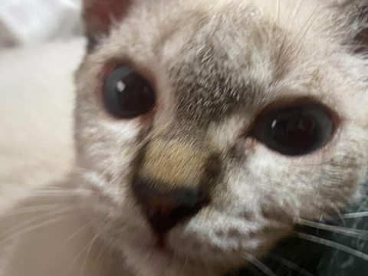
Suggested section (demo): Adoptable Pets
Description: A close-up photo of a light-colored cat with darker shading around its face, large dark eyes, and a small dark nose.
Picture filename: 854529904_1118146980602054_7445856317810637607_n.jpg

02. Miso — Cat
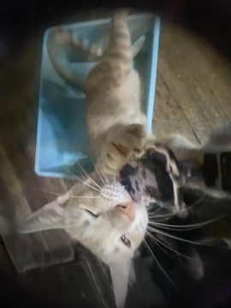
Suggested section (demo): Missing Pets
Description: A light orange-and-white cat photographed near a window, with its head turned toward the camera.
Picture filename: 856238997_1137105122212492_5545379849433471921_n.jpg

03. Mittens — Cat

Suggested section (demo): Found Pets
Description: A slender light orange tabby cat with large upright ears, sitting on a dark chair.
Picture filename: 856334071_2431563350910577_7299721577400290028_n.jpg

04. Luna — Cat
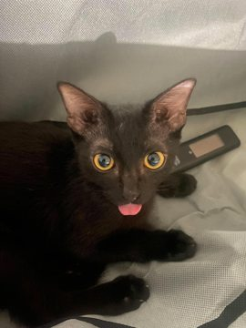
Suggested section (demo): Adoptable Pets
Description: A black cat with bright yellow-green eyes, resting on a light-colored surface.
Picture filename: 856670211_28805548825721886_103087284524291964_n.jpg

05. Oreo — Cat

Suggested section (demo): Missing Pets
Description: A black cat wearing a pink knitted outfit, sitting indoors with its ears upright.
Picture filename: 857225048_1607245857815973_7889620523070290250_n.jpg
Photo grouping note: Possible same cat as photo 6.

06. Nala — Cat

Suggested section (demo): Found Pets
Description: A black cat wearing a pink knitted outfit, photographed from the front near a white door.
Picture filename: 857743066_1576938267803743_7179051749705413404_n.jpg
Photo grouping note: Possible same cat as photo 5.

07. Pebbles — Cat
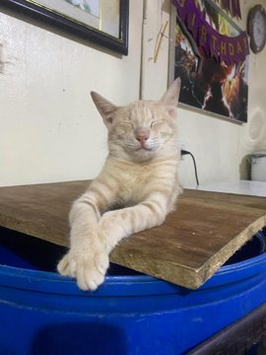
Suggested section (demo): Adoptable Pets
Description: A light cream-colored tabby cat resting its front paws on a raised surface, with its eyes partly closed.
Picture filename: 857885088_1431252509113753_8071236408745040679_n.jpg

08. Coco — Cat
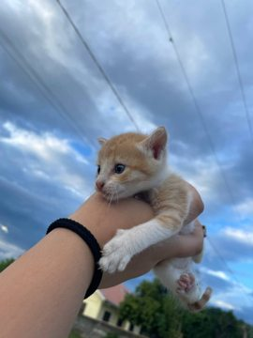
Suggested section (demo): Missing Pets
Description: A small orange-and-white kitten being gently held up outdoors against a blue sky.
Picture filename: 857976125_1436972288527678_5937296440420173870_n.jpg
Photo grouping note: Possible same kitten as photos 10 and 15.

09. Mimi — Cat
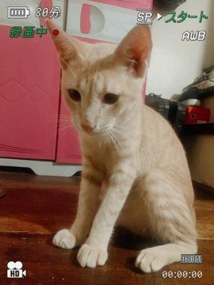
Suggested section (demo): Found Pets
Description: An orange-and-white cat sitting upright indoors, with pale fur on its chest and paws.
Picture filename: 857994784_1111598865071896_2366712700107666247_n.jpg

10. Toby — Cat
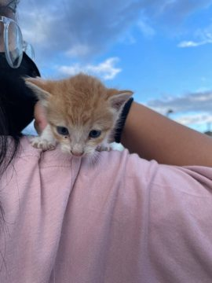
Suggested section (demo): Adoptable Pets
Description: A small orange-and-white kitten being held close to a person outdoors, with a blue sky in the background.
Picture filename: 859144052_2038480096854267_2617063094501566726_n.jpg
Photo grouping note: Possible same kitten as photos 8 and 15.

11. Ash — Cat
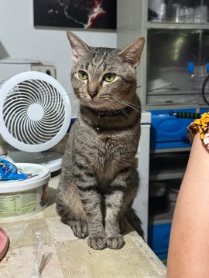
Suggested section (demo): Missing Pets
Description: A gray-brown tabby cat sitting indoors, with dark stripes and alert eyes.
Picture filename: 860779911_2294500007967725_8117351326256477477_n.jpg

12. Biscuit — Cat

Suggested section (demo): Found Pets
Description: A light-colored cat wearing a pink knitted outfit, photographed indoors against a patterned background.
Picture filename: 861094274_4738607949794060_7458924150534689404_n.jpg

13. Pip — Cat
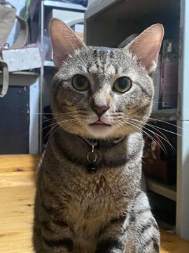
Suggested section (demo): Adoptable Pets
Description: A gray-brown tabby cat with large round eyes and a collar, sitting upright near a doorway.
Picture filename: 861132704_1118245760970335_8477747162769772019_n.jpg

14. Olive — Cat
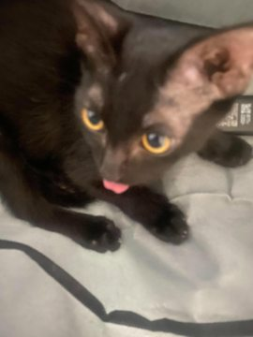
Suggested section (demo): Missing Pets
Description: A close-up photo of a black cat with yellow-green eyes and its pink tongue slightly visible.
Picture filename: 861420693_1149608624262619_3854490794010717703_n.jpg

15. Smokey — Cat
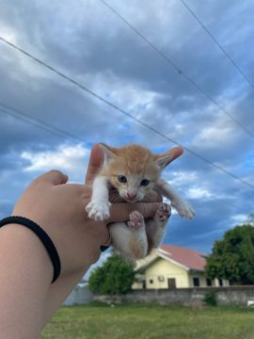
Suggested section (demo): Found Pets
Description: A small orange-and-white kitten being held outdoors, with its legs stretched forward.
Picture filename: 861896490_2089033398396099_1332824336184266189_n.jpg
Photo grouping note: Possible same kitten as photos 8 and 10.

16. Pumpkin — Cat

Suggested section (demo): Adoptable Pets
Description: A black cat resting under furniture on a wooden floor.
Picture filename: 863738630_1084275984430414_6533006258277745728_n.jpg

17. Buggy — Cat
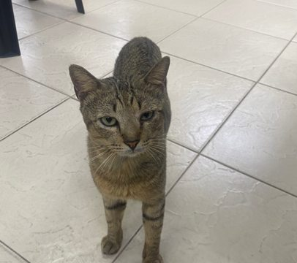
Suggested section (demo): Missing Pets
Description: A gray tabby cat standing on tiled flooring, looking directly toward the camera.
Picture filename: Buggy.jpg

18. Charles — Cat

Suggested section (demo): Found Pets
Description: A white-and-brown cat with a darker patch around one eye, photographed in close-up.
Picture filename: Charles.jpg

19. Cookie — Cat
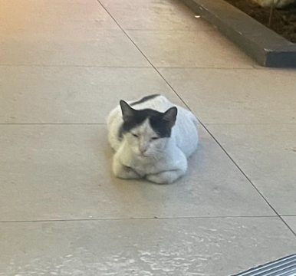
Suggested section (demo): Adoptable Pets
Description: A white-and-gray cat curled up on a tiled floor near an entrance.
Picture filename: Cookie.jpg

20. Garfield — Cat
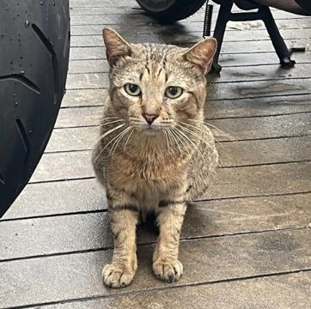
Suggested section (demo): Missing Pets
Description: A brown tabby cat sitting on wooden decking, facing the camera with upright ears.
Picture filename: Garfield.jpg

21. Lili — Cat

Suggested section (demo): Found Pets
Description: A gray-brown tabby cat shown close-up outdoors, with green leaves in the background.
Picture filename: Lili.jpg

22. Pao — Cat

Suggested section (demo): Adoptable Pets
Description: A light cream-colored dog sitting on a road, with floppy ears and a dark nose.
Picture filename: Pao.jpg

23. Potato — Cat
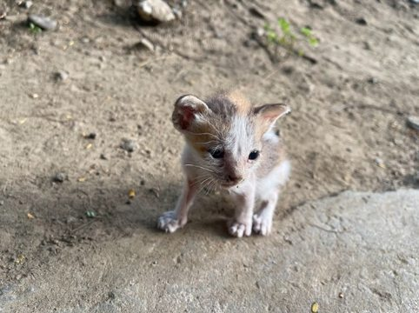
Suggested section (demo): Missing Pets
Description: A small white-and-orange kitten standing on bare ground outdoors.
Picture filename: Potato.jpg

24. Shiro — Cat
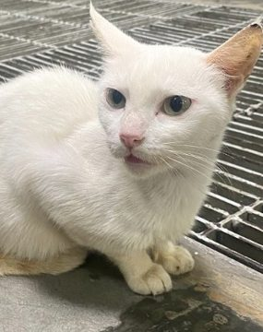
Suggested section (demo): Found Pets
Description: A white cat with pale eyes sitting beside a metal grate, facing slightly to the side.
Picture filename: Shiro.jpg

25. Snow — Cat
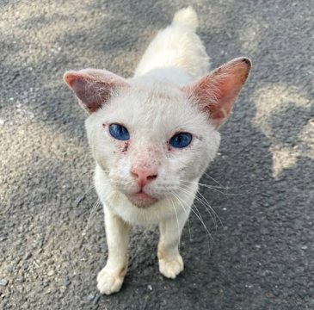
Suggested section (demo): Adoptable Pets
Description: A white cat standing outdoors on rough pavement, with pale eyes and pink ears.
Picture filename: Snow.jpg

26. Toothless — Cat
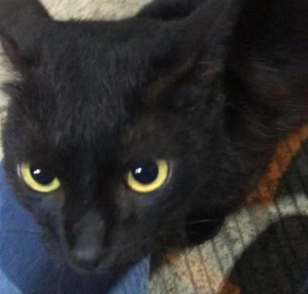
Suggested section (demo): Missing Pets
Description: A black cat shown in close-up, with large yellow eyes and pointed ears.
Picture filename: Toothless.jpg

27. Buddy — Dog
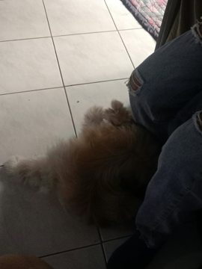
Suggested section (demo): Adoptable Pets
Description: A dark fluffy dog resting on tiled flooring beside someone’s legs.
Picture filename: 851709015_1716158530122869_200914899674902995_n.jpg

28. Max — Dog
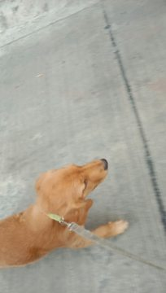
Suggested section (demo): Missing Pets
Description: A small tan dog photographed from above while sitting on a gray floor.
Picture filename: 851709020_1102255505757731_5574960157448660528_n (1).jpg
Photo grouping note: Appears identical to photo 29; verify.

29. Bella — Dog
Suggested section (demo): Found Pets
Description: A small tan dog photographed from above while sitting on a gray floor.
Picture filename: 851709020_1102255505757731_5574960157448660528_n.jpg
Photo grouping note: Appears identical to photo 28; verify.

30. Charlie — Dog
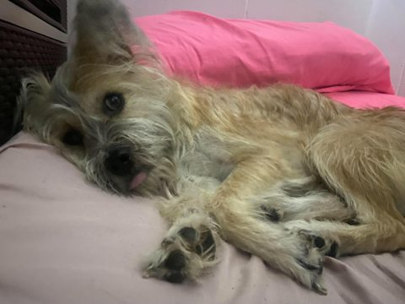
Suggested section (demo): Adoptable Pets
Description: A small shaggy tan dog resting on a bed, with long fur around its face.
Picture filename: 855439472_1138620671948123_8525749463116455835_n.jpg

31. Daisy — Dog
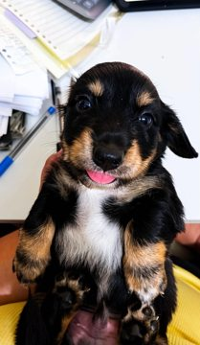
Suggested section (demo): Missing Pets
Description: A small black-and-tan dog with a white chest, sitting indoors and looking toward the camera.
Picture filename: 856883872_1146164388379888_1913542566013113201_n.jpg

32. Rocky — Dog
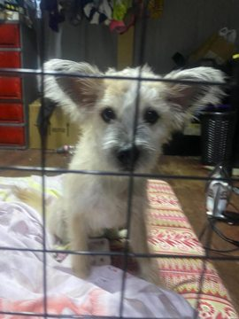
Suggested section (demo): Found Pets
Description: A small light-colored dog with upright ears, photographed behind a metal gate.
Picture filename: 856883872_1626036565820626_6087303861394416392_n.jpg

33. Lola — Dog

Suggested section (demo): Adoptable Pets
Description: A small black, white, and tan dog resting on a bright green surface.
Picture filename: 857187109_29283351627944451_2902355746283100230_n.jpg

34. Cooper — Dog
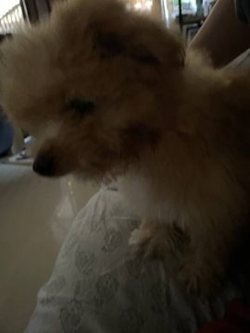
Suggested section (demo): Missing Pets
Description: A fluffy light brown dog photographed indoors, with a thick coat and small pointed ears.
Picture filename: 857599111_3296885857170672_349169259184842268_n.jpg

35. Bailey — Dog
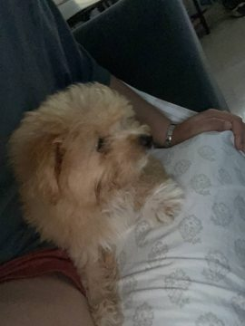
Suggested section (demo): Found Pets
Description: A small fluffy cream-colored dog resting beside a person on a bed.
Picture filename: 857976125_1977830739559049_278865652746310899_n.jpg

36. Milo — Dog
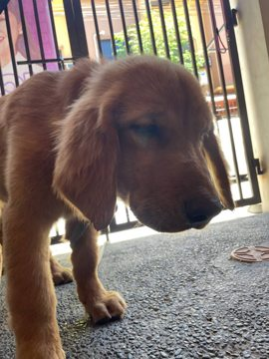
Suggested section (demo): Adoptable Pets
Description: A reddish-brown dog standing near a gate, photographed from the side.
Picture filename: 858178683_1838373247317978_6931758537050317640_n.jpg

37. Lucky — Dog
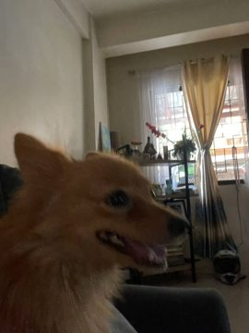
Suggested section (demo): Missing Pets
Description: A fluffy orange-brown dog shown indoors in profile, with pointed ears.
Picture filename: 858251325_1771109491332305_1339004286215541595_n.jpg

38. Rosie — Dog

Suggested section (demo): Found Pets
Description: A small black-and-tan dog wearing a pink patterned outfit, sitting on a bed.
Picture filename: 858473066_1873430470689379_2023109326888118024_n.jpg
Photo grouping note: Appears identical to photo 43; verify.

39. Bingo — Dog
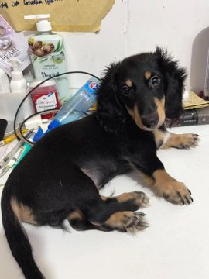
Suggested section (demo): Adoptable Pets
Description: A black-and-tan dog with floppy ears lying on a light-colored floor.
Picture filename: 858544056_2334672650632915_5942805673512427229_n.jpg

40. Teddy — Dog

Suggested section (demo): Missing Pets
Description: A small black-and-tan dog lying on a dark seat, facing the camera.
Picture filename: 858762120_2658167221280725_2760422769068670870_n.jpg

41. Poppy — Dog
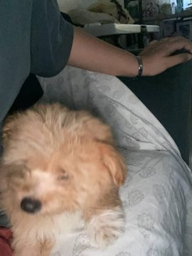
Suggested section (demo): Found Pets
Description: A fluffy cream-colored dog resting on bedding, photographed from above.
Picture filename: 858979235_2015738845785145_1012812517297429463_n.jpg

42. Bruno — Dog
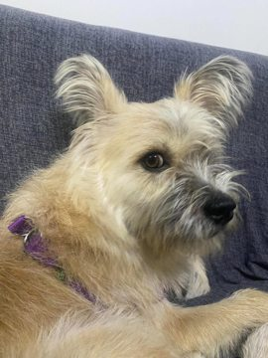
Suggested section (demo): Adoptable Pets
Description: A scruffy light tan dog with long facial fur and upright ears, looking to the side.
Picture filename: 860030935_1438961234236362_6902780743402176754_n.jpg

43. Sunny — Dog

Suggested section (demo): Missing Pets
Description: A small black-and-tan dog wearing a pink patterned outfit, shown in profile.
Picture filename: 860995560_2626000154515460_6777019832105233627_n.jpg
Photo grouping note: Appears identical to photo 38; verify.

44. Patches — Dog

Suggested section (demo): Found Pets
Description: A fluffy tan dog with its tongue out, photographed indoors in close-up.
Picture filename: 861229347_1431299068429025_7044382442062408510_n.jpg

45. Choco — Dog

Suggested section (demo): Adoptable Pets
Description: A small reddish-brown dog with upright ears and round dark eyes, photographed indoors.
Picture filename: 862183605_1695754355557109_780582319910457756_n.jpg

46. Rex — Dog

Suggested section (demo): Missing Pets
Description: A golden-brown dog looking up toward the camera outdoors, with its mouth open.
Picture filename: 862226497_1096070760061350_2440384624234739087_n.jpg

47. Bambi — Dog
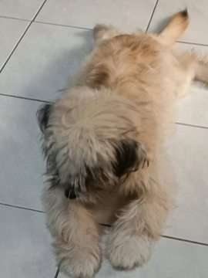
Suggested section (demo): Found Pets
Description: A shaggy tan dog photographed from behind while walking on tiled flooring.
Picture filename: 862226497_1782774009657117_8639393313372566317_n.jpg

48. Cloud — Dog

Suggested section (demo): Adoptable Pets
Description: A fluffy golden retriever puppy sitting on green grass with its mouth open.
Picture filename: Adorable Golden Retriever Puppy with a Big Smile – Cute Dog Photo Inspiration.jpg
Photo grouping note: Appears identical to photo 50; verify.

49. Goldie — Dog
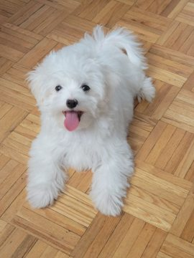
Suggested section (demo): Missing Pets
Description: A small fluffy white dog sitting outdoors, wearing a light blue neck accessory.
Picture filename: Maltese puppy.jpg

50. Fluffy — Dog

Suggested section (demo): Found Pets
Description: A fluffy golden retriever puppy sitting on green grass with its mouth open.
Picture filename: Shih Tzu Lovers Club.jpg
Photo grouping note: Appears identical to photo 48; verify.

51. Cookie — Dog

Suggested section (demo): Adoptable Pets
Description: A fluffy brown-and-white husky-like puppy sitting on grass with its mouth open.
Picture filename: That look when he thinks I’m hiding snacks behind the camera😭💗.jpg

52. Peanut — Dog

Suggested section (demo): Missing Pets
Description: A small white fluffy dog resting on a cushion indoors.
Picture filename: cute white fluffy dog.jpg

53. Brownie — Dog

Suggested section (demo): Found Pets
Description: A small white fluffy dog sitting on a rug in front of a door.
Picture filename: download (1).jpg

54. Pochi — Dog
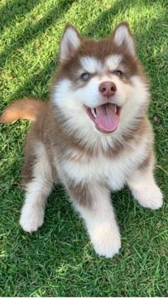
Suggested section (demo): Adoptable Pets
Description: A fluffy white spitz-type dog sitting on patterned floor tiles with its tongue out.
Picture filename: download (2).jpg

55. Snowy — Dog

Suggested section (demo): Missing Pets
Description: A short-haired golden-brown dog sitting on green grass outdoors.
Picture filename: download (3).jpg

56. Kiko — Dog

Suggested section (demo): Found Pets
Description: A small fluffy white dog sitting on wooden flooring with its tongue out.
Picture filename: download (4).jpg

57. Puppy — Dog
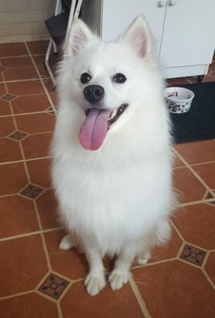
Suggested section (demo): Adoptable Pets
Description: A small black-and-white fluffy dog with long facial fur, looking up toward the camera.
Picture filename: download (5).jpg

58. Archie — Dog

Suggested section (demo): Missing Pets
Description: A fluffy golden puppy sitting on a light tiled floor, looking toward the camera.
Picture filename: download.jpg

59. Finn — Dog

Suggested section (demo): Found Pets
Description: A small cream-and-tan fluffy dog outdoors, with its tongue out and greenery in the background.
Picture filename: 💛💛.jpg

