**Documentation**

**Download github files(documentation, edge impulse generated library, waste detection code and camerawebserver code) Note: separate device for now**

**Extact:**

[**https://github.com/chesterific/waste-detect/tree/master**](https://github.com/chesterific/waste-detect/tree/master)

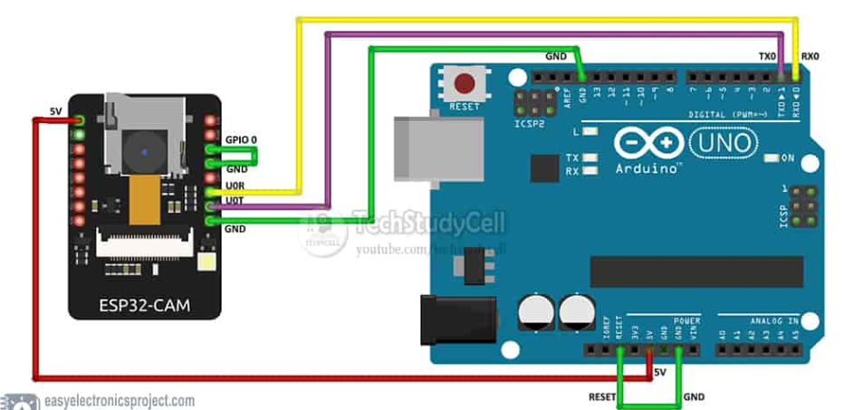**Circuit Diagram**

**Boards manager install:** *tools/board/boardsmanager*

**Preferences:**

**Copy&paste**

https://dl.espressif.com/dl/package_esp32_index.json,http://arduino.esp8266.com/stable/package_esp8266com_index.json

**Tools**

**Add zip file from edge impulse**

**Open extracted folder from github.**

**this is for wate detection**