Scenario 1: 5 red urns, 6 red balls

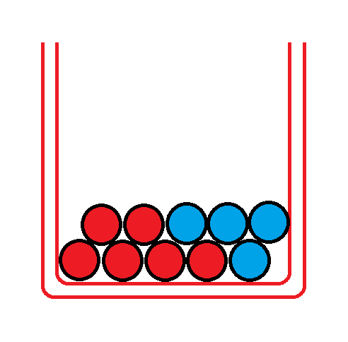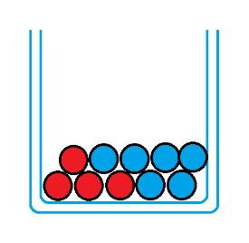

Scenario 2: 9 red urns, 7 red balls

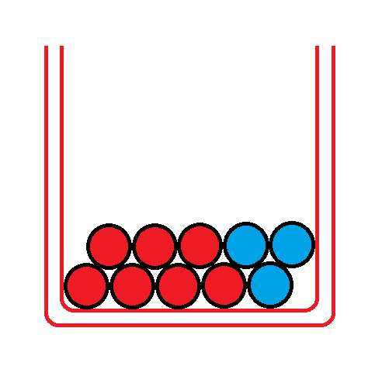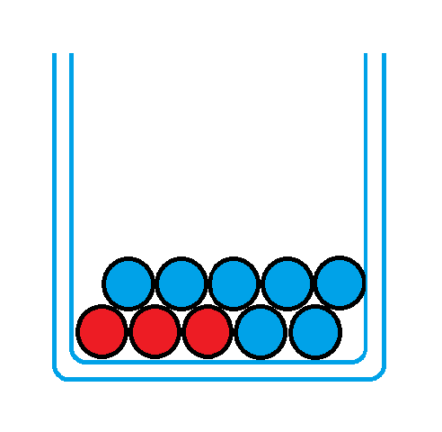

Scenario 3: 7 red urns, 9 red balls

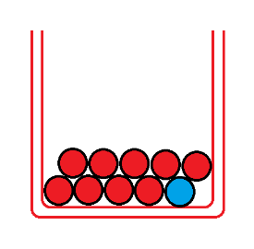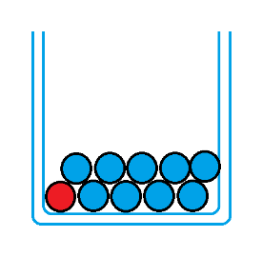

Scenario 4: 6 red urns, 8 red balls

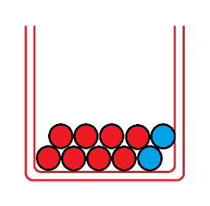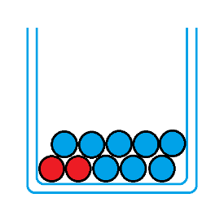

Scenario 5: 8 red urns, 7 red balls



Scenario 6: 4 red urns, 6 red balls



Scenario 7: 2 red urns, 6 red balls



Scenario 8: 3 red urns, 7 red balls



Scenario 9: 1 red urn, 8 red balls



