Financial Aid and the Transition to College:

The Experiences of California High School Seniors in 2025

XXX, 2026

Authors:

Jacob Jackson, Stephanie Luna-Lopez, and Christina Sun - California Education Lab

Jessica Moldoff and Ryan Fuller - California Student Aid Commission

Introduction

Financial aid helps reduce the cost of college for students and is associated with higher rates of college outcomes such as persistence and graduation (Nguyen et al., 2019). In California, students apply for financial aid through the Free Application for Federal Student Aid (FAFSA). Eligible students may be offered state and federal grants, money for college that doesn’t need to be paid back, as well as access to federal student loans and work study. California students who are not U.S. citizens cannot complete a FAFSA;instead, they may submit The California Dream Act Application (CADAA). In this case, students are only considered for state financial aid programs, including the Cal Grant program.

The complexity of the financial aid process is well-documented (CITE), including the initial FAFSA application process. Recently, both the state and federal governments have implemented reforms to improve the financial aid application process. In 2021, California’s AB 469 set into motion a new FAFSA policy, requiring LEAs serving high school students to ensure seniors apply for aid through the FAFSA/CADAA or formally opt out of applying for aid. In 2023, the federal government introduced a redesigned FAFSA with a goal of reducing the form’s complexity and streamline the application process. But, the introduction for the 2024-25 cycle was riddled with problems. It launched three months later (December 31, 2023) than it typically does each year (October 1, 2023). In addition, many students experienced technical issues with the new application. A survey of high school seniors from the Class of 2024 revealed that half of respondents who successfully completed a financial aid application found the process somewhat or very difficult. As a result, many colleges and students faced significant delays in financial aid awards and college enrollment decisions.

The second year of the redesigned FAFSA for 2025-26 cycle was improved in some ways. Overall, there was an 11% increase in FAFSA/CADAA submissions compared to 2024-25. But Class of 2025 still faced a later release date than normal (November 21), and other ongoing challenges. It was released about a month earlier than the 2024-25 FAFSA and ... In this report, we share results from a survey of all California financial aid applicants from the high school Class of 2025, including students’ high school experiences, their plans for life after high school, their perceptions of college affordability, and their experience with applying for and receiving financial aid award letters. Importantly, many of the same questions were included in both the 2024 and 2025 surveys, allowing us to track shifts in student experiences as the redesigned FAFSA rolled out.

Financial Aid Application for the Senior Class of 2025

Students start the process of deciding about higher education well before they graduate from high school. Learning about college and the availability of aid could help students make informed decisions and take the steps necessary to ensure college eligibility. With this in mind, we asked students to recall when they first heard about the FAFSA/CADAA (Figure 1). About two-thirds (67%) of respondents reported hearing about financial aid applications before their senior year, and just over one-third (36%) reported hearing about the FAFSA/CADAA in their freshman or sophomore year. These rates are up from 2024, suggesting that the new FAFSA/CADAA policy (AB 469) could be leading to a culture change around financial aid. Yet, given that one-third of students reported learning of financial aid in their senior year, there remains an opportunity to increase and broaden access to college-related knowledge earlier in high school.

Figure 1. Timing of first knowledge of the FAFSA/CADAA by (2024 vs 2025)
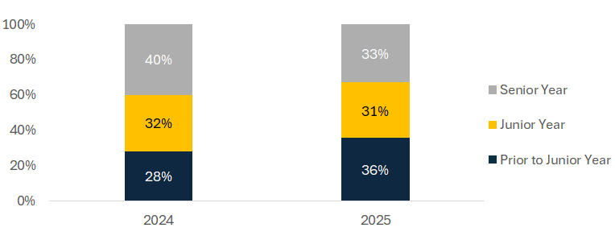
Note. When did you first hear of the FAFSA or CADAA? N=6,798

There are significant differences in FAFSA/CADAA knowledge by student parental education level (Figure 2). About 72% of continuing-generation respondents reported hearing about FAFSA before their senior year, compared to 62% of first-generation respondents. Both first-generation and continuing-generation students in the 2025 graduating cohort were about 6 percentage points more likely to have learned about the FAFSA/CADAA prior to their junior year.than respondents in the 2024 graduating cohort. Despite improvements in awareness earlier in high school, a persistent information gap remains between first-generation and continuing-generation students.

Figure 2. Timing of first knowledge of FAFSA/CADAA by parent education (2024 vs 2025)

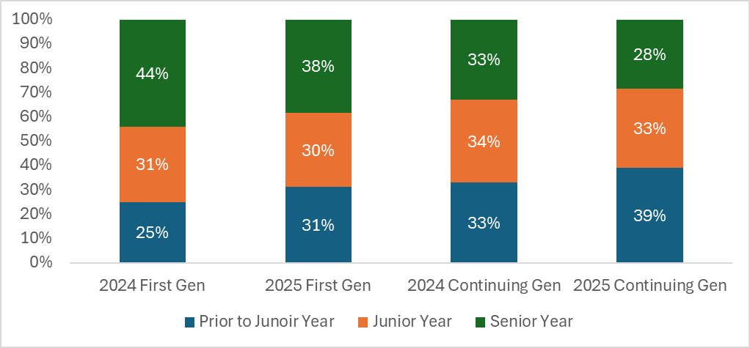
Note. When did you first hear of the FAFSA or CADAA? Not all respondents reported a parent's education level, and some indicated they didn’t know, reducing the sample size. 2024 N=11,238; 2025 N=5,125

When students learned about the FAFSA/CADAA varies across 10 California regions. In most regions, more than 60 percent of students had heard of the aid applications before their senior year (Figure 3). However, in several regions, approximately 40% of the respondents did not hear about the aid applications until their senior year–including the North San Joaquin Valley (44%), South San Joaquin Valley (41%), North Coast (41%), and Superior (44%). These differences suggest that some region-based efforts may help increase FAFSA/CADAA knowledge and applications across the state.

Figure 3. Percent of students hearing about FAFSA/CADAA prior to their senior year (by region)
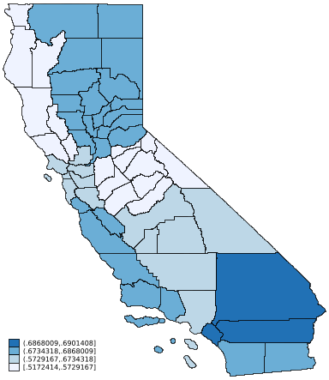

Note. When did you first hear of the FAFSA or CADAA? Regional percentages represent the combined percent of students who heard about the FAFSA/CADAA prior to, or in, their junior year. N=4,826

Students generally complete the FAFSA/CADAA with the explicit intention of applying for aid for college. California has a new FAFSA policy that mandates that schools have all California high school seniors fill out a financial aid application (or officially opt-out), However, given California’s new FAFSA policy, some students may be completing the FAFSA simply to comply with the policy. In fact, about 61% of respondents indicated they completed the aid applications to determine their eligibility for financial aid (Figure 4), while 39% indicated that it was a graduation requirement, 26% said it was an expectation at their high school, and 9% said it was a class requirement. When taken together, 60% of students indicated that completing the FAFSA was a graduation requirement, an expectation at their school, and/or a class assignment. In this case, students were just as likely to apply for aid at least in part because they were required or expected to (60%) as they were to apply to find out about financial aid eligibility (61%).
In open-ended questions, students also shared details about their financial aid as reasons for completing the FAFSA. One student wrote:

“I completed the FAFSA because I need financial aid to continue my education. Without it, I wouldn't be able to afford college and I might have to give up on my dream of going to college and just work instead.”

Figure 4. Reasons students completed the FAFSA or CADAA

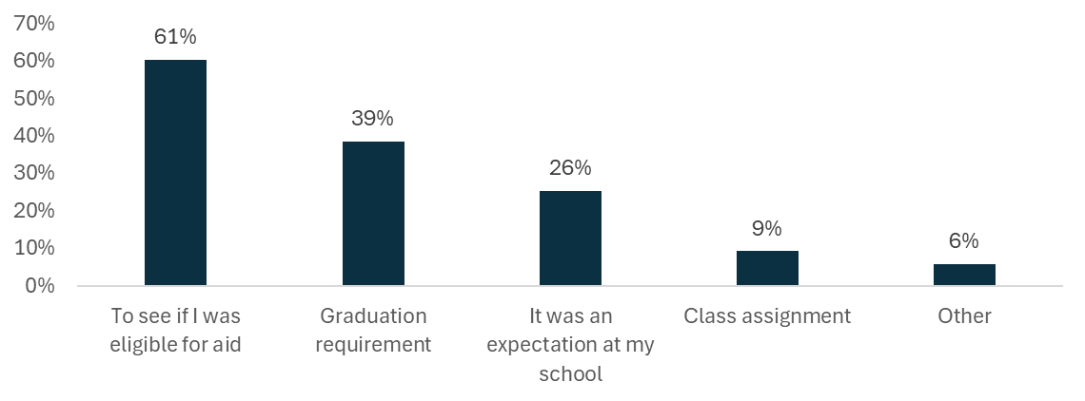
Note. Why did you complete the FAFSA/CADAA? N=6,796. Categories do not add to 100% because students can select more than one category.

Students from racial and ethnic groups that have been historically underrepresented at colleges, as well as first-generation students were more likely to complete the FAFSA/CADAA due to school requirements or expectations (Figure 5). Specifically, a larger proportion of Black (63%) and Hispanic/Latino students (62%) cited high school requirements as their reasons for completing the aid applications compared to their Asian (57%) and White (47%) peers. Respondents who would be first-generation college students and those who would be continuing-generation students were about as likely to fill out an application because their school expects or requires it.

Figure 5. Percent of students indicating that school expectations or requirements were a reason they applied for aid.

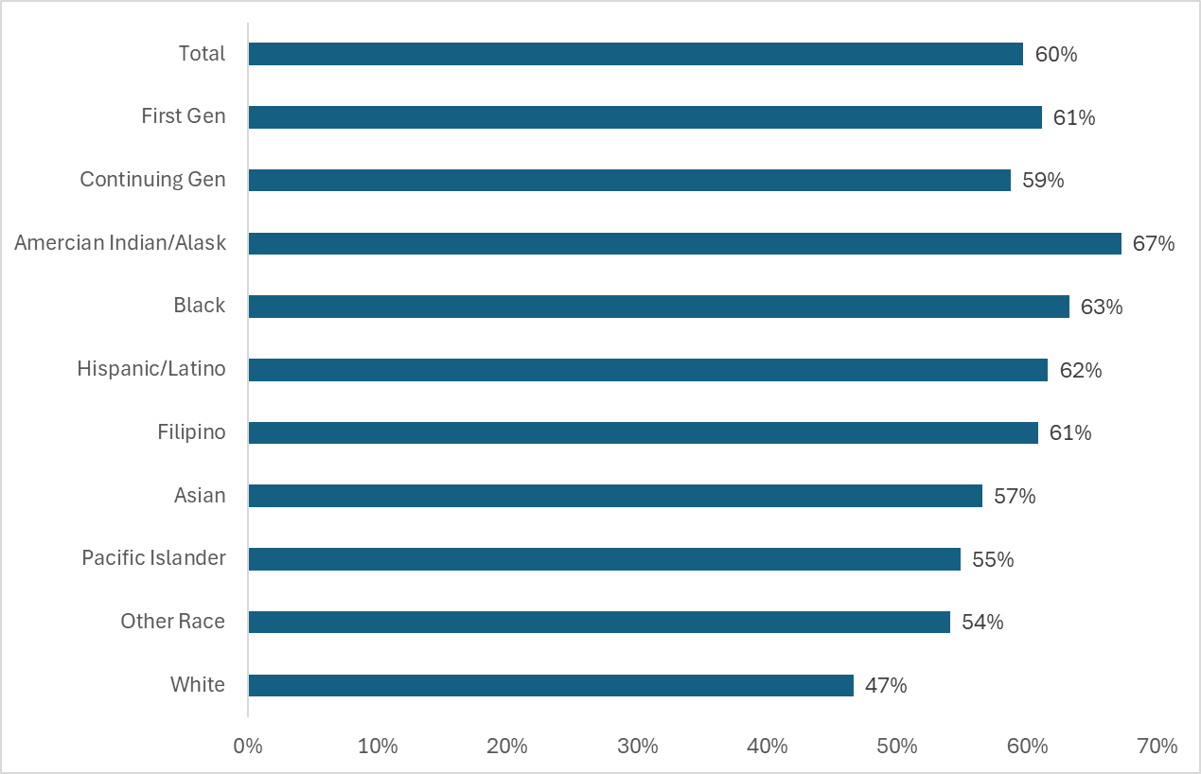
Note. Why did you complete the FAFSA/CADAA? Subsample includes those who selected “It was a graduation requirement at my school”, “It was an expectation at my school”, and/or “it was a class assignment.” N=6,796

Financial Aid Application Challenges

As our 2024 survey results showed us, some students and families face difficulties when filling out financial aid applications. Students in 2024 who used the FAFSA were often hampered by technical difficulties, had to fill out or submit an application multiple times, had difficulty adding parents or financial contributors to their applications, and mixed-status families (those with members with differing immigration and citizenship statuses) had particular difficulty submitting the form. These difficulties appear to be waning. In 2025, approximately 71% of respondents said applying for financial aid was very easy or somewhat easy compared to only 51% of students in 2024 (Figure 6). Furthermore, the share of students who found the application very difficult decreased from 12% in 2024 to 3% in 2025 and the share that found it very easy increased from 10% to 17%.

Figure 6. Students had less difficulty applying for financial aid in 2025

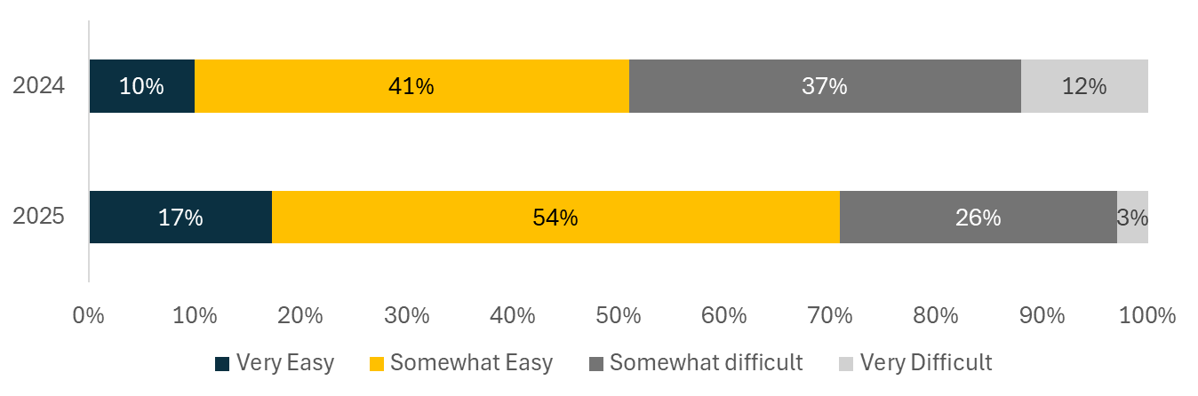
Note. How difficult was it to apply for financial aid? 2024 survey N= 10,744; 2025 survey N=6,452

These improvements in the financial aid application experience appear widespread across student groups and locations. However, difficulties in the application process were more pronounced for some student subgroups. Figure 7 shows that 31% of first-generation students reported that applying for financial aid was somewhat or very difficult compared to 26% of their continuing-generation peers. Pacific Islander and Hispanic/Latinx students were also more likely to find applying for aid somewhat or very difficult compared to the average student in the state.

Figure 7. Difficulty of applying for aid by student demographics

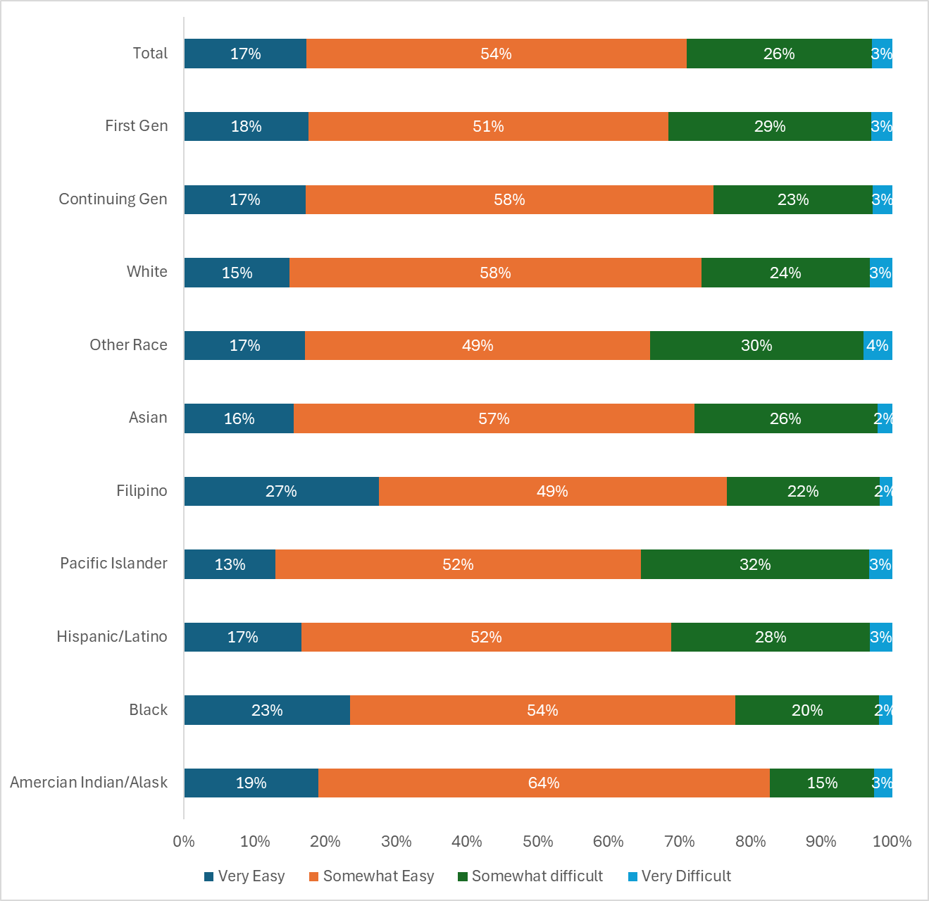
Note. How difficult was it to apply for financial aid? Total N=6,452; students who chose a parent education level N=5,002; f students who chose a race category N=5,499.

Students identified several types of challenges they faced when applying for financial aid. Nearly one-quarter of respondents (23%) found the application confusing, 15% had issues with financial contributors (most often their parents) and 11% said it took them multiple attempts.

One student who faced technical challenges noted:

“The site just didn't save the information several times and the site overall was just so glitchy. I filled it out as soon as it opened too, it wasn't due to heavy use.”

Compared with the graduating class of 2024, respondents from the 2025 graduation class reported a significant improvement in many of the previously identified difficulty areas. In 2025, 42% of seniors reported no difficulties compared to 25% in 2024 (Figure 8). The percentage of survey respondents reporting technical difficulties with the FAFSA declined from 34% in 2024 to 15% in 2025. Likewise, the percentage of respondents reporting for multiple submission attempts decreased from 24% to 11% between the 2024 and 2025 graduating cohorts.

Conversely, respondents in 2025 were more likely to be concerned about sharing their family’s information with the federal or state government than they were in 2024, with the percentage of respondents citing this concerning rising from 12% to 17%. Importantly, FAFSA applications leverage IRS data and send additional financial data to the federal government, while the CADAA sends information to California. The current political climate may have heightened concerns about disclosing sensitive family information, particularly for undocumented students or students from mixed-status households (CITE).

Figure 8. Challenges students faced when applying for financial aid (2024 vs. 2025)

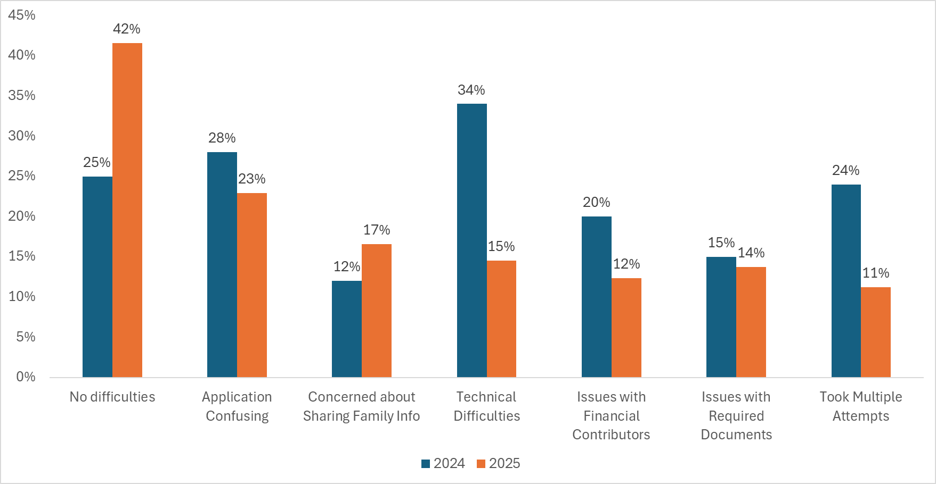

Note. What challenges did you face when applying for financial aid? 2024 N=10,701; 2025 N=6,750. Categories do not add to 100% because students can select more than one category. categories omitted from the figure that reported same rates in 2024 to 2025: Didn’t know which application to complete, Couldn’t find someone to help, and Other. Less than 8 percent of students selected those answers each year.

Financial Aid Application Supports

Whether they find the aid application(s) somewhat easy or face challenges, students often seek support when applying for aid. In this case, students relied most heavily on high school counselors (45%), their parents (44%). Respondents also indicated that workshops at their high schools (25%) and teachers (24%) supported their application process. Some students reported on family members (16%), online resources (10%), friends (9%), and community workshops (6%).

The sources of support differed substantially by student subgroup . Two-thirds of continuing-generation respondents relied primarily on parents (67%), while first-generation respondents drew support from a broader network of school-based resources including high school counselors (52%), high school workshops (28%), and teachers (28%) . These findings indicate the importance of school-level support for first-generation students.

Figure 9: Financial Aid supporters by parent education
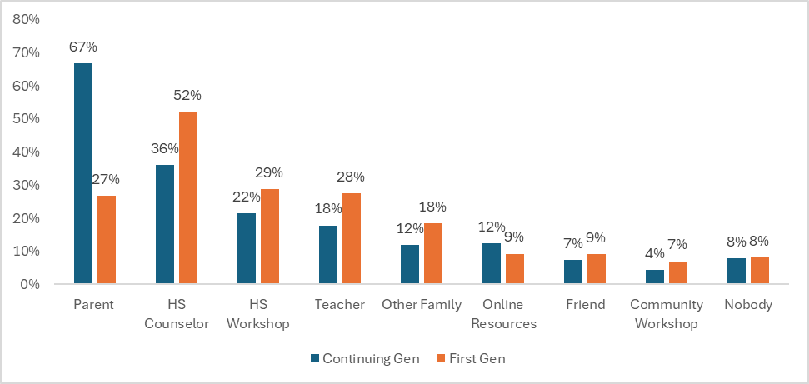
Note. Please tell us about the support you received in completing your FAFSA/CADAA. N= 5,120. Categories do not add to 100% because students can select more than one category.

Regional differences also emerged in students’ reported sources of support. Students from the North and South San Joaquin Valley reported the highest rates of support from high school counselors. Whereas, students from the Superior, San Francisco Bay Area, San Diego, and Orange County regions relied more heavily on parents for assistance with their financial aid applications (Figure 10). a larger proportion of students in the San Joaquin Valley are first-time college students compared to San Francisco Bay Area, San Diego, and Orange Counties where respondents were more likely to continuing generation students. However, even among only first-generation students, students in North and South San Joaquin Valley were the most likely to rely on counselors for FAFSA/CADAA support.

Figure 10. Regional responses to parental and high school counselor support
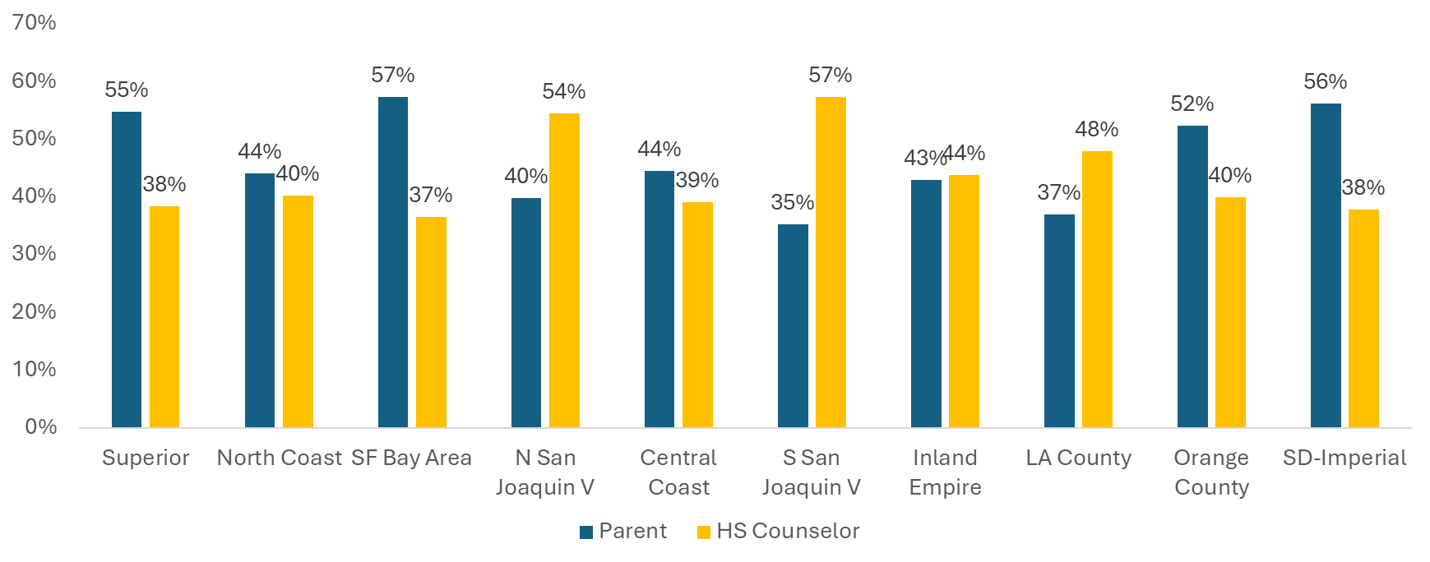
Note. Please tell us about the support you received in completing your FAFSA/CADAA. Subsample of students who indicated parent or high school counselor. N=4,820. Categories do not add to 100% because students can select more than one category.

Planning to Pay for College

In order to make the best-informed decision on whether and where to enroll in college, and how to afford their education, high school seniors need clear information about the potential costs. Although all students in our survey applied for aid, not all students heard back from colleges about their financial aid options by the time they graduated. On average, 30% of respondents were contacted via email, letter, or phone about financial aid by all of the colleges to which they applied by the time they took this survey (May 2025-July 2025). Approximately 41% were contacted by at least one college, and 29% were not contacted by any college to which they applied. Among those who were contacted about their financial aid, the majority (62%) of students surveyed were provided details about grants and scholarships, 42% received information about loans, and 29% were informed about work-study eligibility (Figure 11). In addition, 60% of students were also, or instead, contacted about FAFSA/CADAA verification.

Figure 11. Students college contacts about financial aid

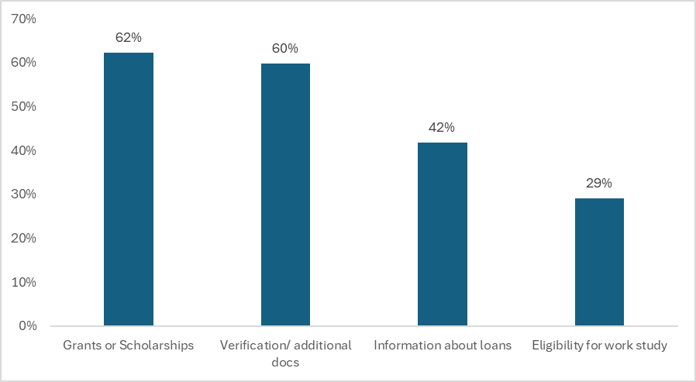
Note. What did the colleges contact you about regarding your financial aid offer? N=3,987. Categories do not add to 100% because students can select more than one category.

Survey respondents planned to use a variety of methods to pay for college tuition, fees, and other expenses associated with attendance (Figure 12). More than half of the respondents planned to work to pay for college regardless of where they planned to attend college.). About half of students expected to use grants to pay for college, with a higher proportion of students who planned to attend CSU, UC, and private 4-year institutions in California expecting to use grants. In contrast, those going to college outside of California were much less likely to depend on grants to pay for college. Students planning to attend private colleges, out-of-state colleges, and the UC were more likely to use scholarships to pay for tuition costs. A little over one-third of students planned to use their own savings, with those attending private institutions in California somewhat more likely to do so. Fewer than one-third of students planned to use loans to pay for college costs; those in community colleges were the least likely to do so, whereas those in private institutions or institutions outside California were more likely to do so. Students were unlikely to use credit cards, with approximately 5%-6% expecting to do so regardless of institution type.

Figure 12. Students rely on a variety of sources to pay for college tuition
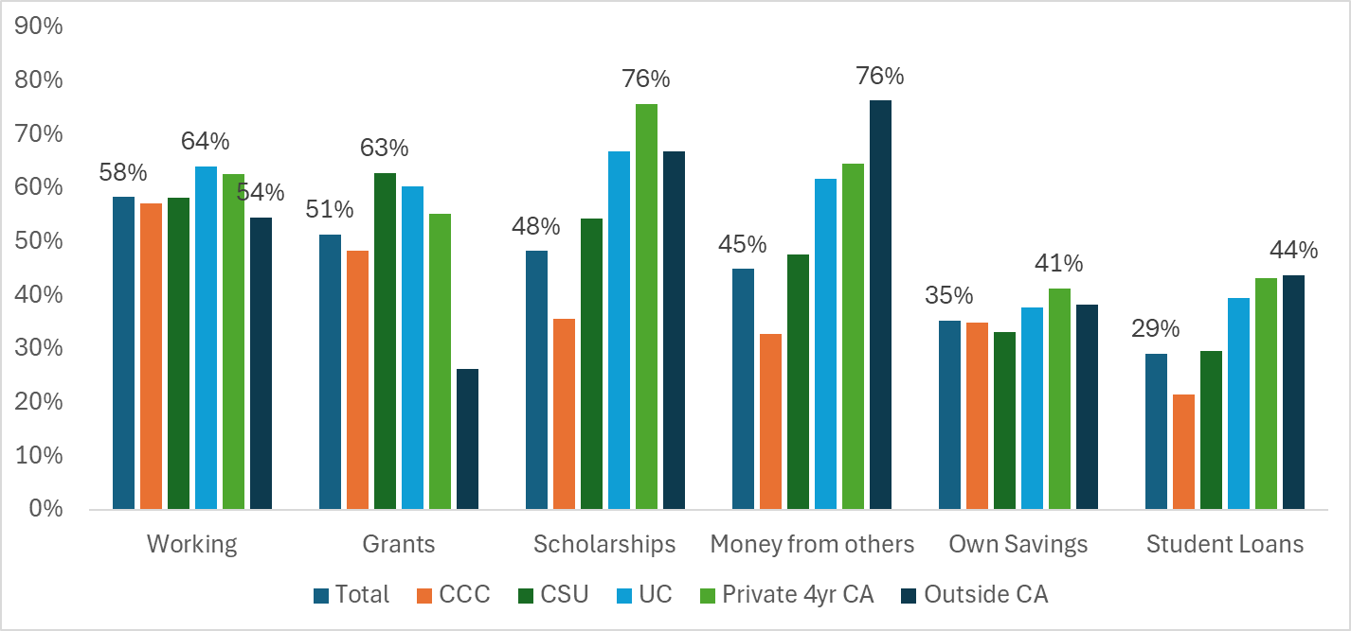
Note. How do you plan to pay for college tuition? Only students who selected a likely college destination are included in this sample. N=5,594. Categories do not add to 100% because students can mark multiple categories. About 5% of students planned to use credit cards and about 2% of students planned to use military benefits to pay for college, and those did not vary much across college types.

Worries about College

Students have many concerns about the transition to college (Figure 13). Students’ top concerns centered around affordability, with 42%of Respondents very worried about affording tuition and 39% very worried about affording living expenses. In contrast, about 1 in 5 students were not at all worried about affording college. Respondents tended to be less worried about other transition hurdles such as getting good grades (31%), balancing work obligations (30%), finding community (23%), finding support for their mental health (18%), balancing family obligations, (16%), and living away from home (14%).

Figure 13. Student concerns about the transition to college

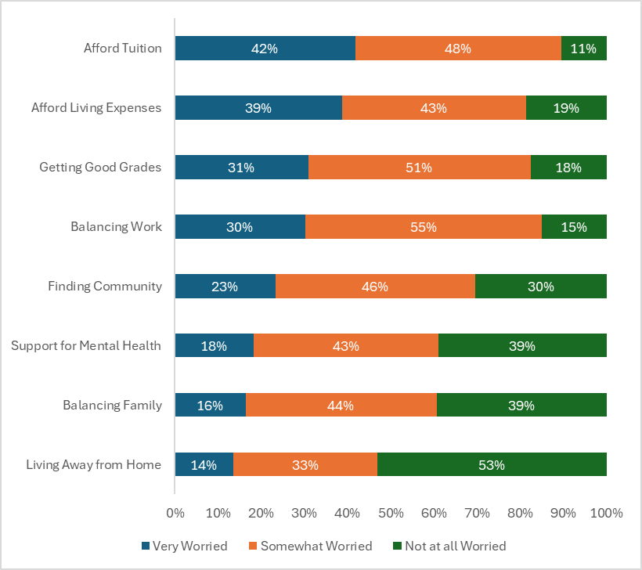
Note. When you think about college, how much are you worried about the following? N=5,497.

Student concerns differed somewhat by where students planned to attend college (Figure 14). Students who planned to attend private institutions in California were most likely to be very worried about affording tuition (48%) followed by those planning to attend UC (45%) and CSU (44%). While respondents who planned to attend a community college, vocational program or out-of-state institution were slightly less likely to be very worried, nearly 40% in each group were very worried about affording tuition. Respondents planning to attend a UC were more likely than respondents planning to attend other institutions to be concerned with affording living expenses. About a third of students were very worried about balancing work and college at all institution types, except those attending college out of state who were much less likely to be very worried.

Figure 14. Top Affordability Concerns by Application Destination
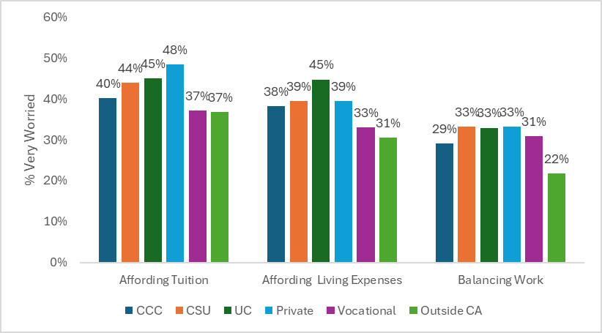
Note. How much are you concerned about the following? Percent of students who are very worried in each category. N=5,524

In open-ended questions, the cost of living and affordability were among the most frequently cited concerns among students. Despite receiving financial aid, many students are still expected to pay out of pocket for school supplies, transportation, utilities, etc., or take out student loans. In some cases, students worried about not being able to participate in activities or pursue goals due to financial constraints.

“The biggest challenge I will face is money problems. Whether that is having no money to be in clubs or hang out with friends, or having to take out loans to pay for overall college expenses.”

“My biggest challenge would be trying to afford college because FAFSA is not giving me a lot of money so I need to get a job to be able to pay off my school but I'm really grateful that I have my mom to help me pay half of my school.”

“Money. My parents work their hardest to maintain a good life for not only me and my sister but themselves too. We don't have money to spend and we don't have any savings. I want to accomplish all the things I've set out to its just hard because I might have to put some things off because I literally can't afford it.”

The transition to college may also stir anxiety, fear, and excitement. Respondents expressed concern over social, emotional, and academic challenges they anticipated facing in college. Similar to the Class of 2024, students worried about maintaining a healthy work-life balance and staying motivated throughout their degree.

“The biggest challenge I will face in college will be managing my time and trying to find a balance between academics, social life, work, and more. I fear that I will be overwhelmed by the pressures and responsibilities that I have to endure to achieve my goals and to become successful in college.”

“As I am attending community college, it may be difficult to stay motivated to continue pursuing my path towards attending a 4-year university, as roughly 80% of those who intend to transfer from a ccc to a csu or uc don't reach that goal. However, I am confident that I can stay motivated and continue to work towards my goals.”

Socialization was also a concern for students. They reported feeling nervous about making new friends and finding community in a new environment. Additionally, some English learners were also worried about improving their English language skills.

“I'm anxious about a multitude of things in regards to college; moving away from home, adapting to a new environment, finding new people, tackling every course, etc.. I know I am not alone in this experience and it is something I will need to remind myself while at college.”

“Una dificultad sería el idioma ya que el Inglés no es mi primer lenguaje y estos años de estudio han sido difí­ciles por el idioma pero aún así he podido cumplir mi escuela y otra dificultad serí­a el pago de el colegio ya que no tengo una economã­a estable con mi familia.”

[“One challenge would be the language since English is not my first language and these years of schooling have been difficult due to the language but I have still been able to complete my schooling. Another difficulty would be the college payment since my family is not financially stable.” ]

Some students were concerned about having a lack of support and having to navigate college alone. While high school provided structured support and readily available guidance from counselors and teachers, college independence requires students to seek out the information and resources they need to solve problems and complete processes on their own.

“Adjusting to needing to seek out information on my own, instead of being given what I need like in high school.”

“Managing my mental health - it's been a difficult ride for me in high school due to my dysthymia, panic disorder, autism, and ADHD, so I'm hoping that I'll have good resources that support my journey to mental wellness alongside my academic goals.”

“Doing it mostly alone. I have people who love and support me but this will be my first time away from anyone I know doing things by myself. I think having to keep everything running smoothly with only minimal support from afar will be my biggest challenge.”

Despite the numerous concerns that students describe, respondents from the 2025 graduating cohort were somewhat less likely to be very worried about each obstacle than those in the 2024 cohort (Figure 15).

Figure 15. How much are you concerned about the following? (2024 vs. 2025)

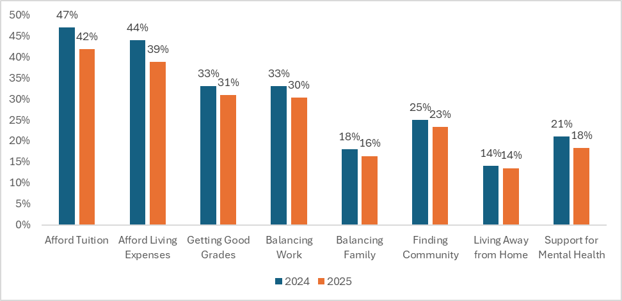
Note. How much are you concerned about the following? Percent of students who are very worried in each category. 2024 Survey N= 8,350; 2025 Survey N=5,530

Student Voices: Excitement about college

Overall, students were excited to embark on their college journey. Similar to the Class of 2024, students this year were excited to become independent and to grow academically and professionally. In some cases, students expressed excitement about the opportunity to be their authentic selves and explore their identity.

“What excites me most about college is the next step into what I have dreamt of pursuing my whole life. But while pursuing it, I find new ways to make use of myself and discover new opportunities to grow. I have learned in high school that everything is not given to you, you must work hard to earn this and along the way, there are many generous people will to help you get there. I’m so glad to be able to move on with my journey, and only he knows what’s next for me!”

“What excites me most about college is the opportunity to grow both personally and academically. I am also looking forward to the independence, new friendships and experiences that will help shape me into the person I am meant to become.”

“Lo que más me entusiasma de la universidad es que tendré un nuevo comienzo, lleno de oportunidades para mi crecimiento profesional y académico. La emoción de explorar diferentes campos de estudio, conocer gente nueva y participar en actividades.”

[“What excites me the most about college is that I’ll have a new start, full of opportunities for my professional and academic growth. The excitement of exploring different fields of study, meeting new people, and participating in activities.”]

"The transition. I'll be getting a car soon. I feel like learning to manage my time to be able to take myself to school plus drive my siblings around will be a lot. Overall, maintaining a healthy lifestyle between my friends, family, and my boyfriend but also myself will be the hardest. Not overly stressing myself out with all these plans plus studying and managing to keep a social life while working."

"By the time I get there I'll have a separated distance between me and my father, so I should theoretically be able to be more open about my gender identity in his absence — perhaps even being able to get an HRT prescription before the feds try to make it illegal."

First-generation and low-income college students looked forward to the benefits a college degree offers, including the opportunity to break cycles of poverty and serve as role models in their communities.

“What excites me the most about college is that I will be first generation and will be able to share this journey and experience with my family. Also, this is something completely new and out of my comfort zone so I am looking forward to challenging myself, learning new things, more activities, and meeting new people.”

“Being able to break the cycle of my family members believing they cannot and are not welcome in a college setting. I am excited to be a role model for the youth in my community and family.”

“All the financial help the school is giving me and being the first in my family to have the opportunity to attend college, and also the help the college staff is giving me as an immigrant student and having english as my second language.”

Finally, participants looked forward to the social aspect of college: making new friends, exploring new environments, and exploring extracurricular activities.

“I am excited to explore all that was out of reach for me before. both in and out of the classroom. I can't wait to learn more about topics I am passionate about, be able to be more involved in my school and local community and also meet new people.”

“I want to make new friends and learn a lot about my career choice, because I want to be able to support myself financially and have what I want without having to worry about money all the time.”

“Aprender sobre mi carrera y estar en una nueva etapa de mi vida y tener una buena comunidad ser aceptada en un nuevo lugar y poder cumplir una de mis metas que es terminar mis estudios.”
[Learn about my career and be in a new phase of my life and have a good community. Be accepted in a new place and be able to achieve my goals of finishing my studies.]

"I think being in an in-person class setting again. I attended high school through an online independent study school, so it will be exciting to be surrounded by peers again. Also, just being around people who have the same interests as me and who want to pursue the same things. The idea of college just is exciting in itself: making new friends, learning new things, experiencing new things, being more independent. It's the next chapter of my life and it excites me (and also scares me, but still)."

Overall, students’ excitement about college reflects their hopes for independence, growth, and new opportunities. Whether pursuing their passions, supporting their families as first-generation students, or building new communities, these students see college as a chance to shape their futures and discover who they want to become. Their eagerness highlights the transformative potential of higher education and the importance of supporting students as they pursue postsecondary degrees.

Discussion

The financial aid application process in 2025 showed significant improvements over the previous year. Survey results indicated fewer problems with the applications in 2025 compared to the initial roll-out in 2024 across almost all dimensions including technical difficulties, issues with financial contributors, and finding the application confusing. In addition, students who would be first-generation college students—and who found the FAFSA particularly difficult in 2024—were almost as likely to find it somewhat or very easy as their continuing generation peers in 2025.

Results also indicated that students are learning of the FAFSA/CADAA earlier in high school and even more so in 2025 compared to the class of 2024. It’s possibly a results of the state’s focus on financial aid through California’s statewide FAFSA policy. In addition, students reported being just as likely to fill out an aid application because it was a graduation requirement or school/class expectation as they were to explore eligibility for aid. The early information, expectations from schools, and the improved ease of the FAFSA may have helped increase statewide FAFSA completion rates for high school seniors, which increased 11 percentage point in 2025.

The survey also highlights some potential levers for improving student experiences with financial aid. Schools play important roles in getting students to fill out aid applications and supporting students through challenges with the applications. While, on average, students are learning about the FAFSA/CADAA earlier, a third of students still didn’t recall hearing about financial aid applications until their senior year, an experience that is more common among students who would be first in their family to attend college. This suggests opportunities for schools to further expand the information they provide to their students, especially traditionally underrepresented groups and those who otherwise may have difficulty obtaining accurate information.

Though the FAFSA had a much improved roll-out in 2025, about one third of respondents found the applications either somewhat or very difficult, and about 58% of respondents had at least one challenge with the FAFSA/CADAA. Students used support from several sources, including school or community-based people and workshops, as well as families, and online resources. Those who would be first-generation college students, along with Black, American Indian/Alaska Native and Hispanic/Latino students, were more likely to use school and community resources. There were also substantial differences in student experiences across regions. In particular, students in some regions (North and South San Joaquin Valley and the Central Coast) were more likely to rely on high school workshops, even when accounting for differences between first-generation and continuing-generation students, than students in other regions

These results inform how schools and education partners target efforts to support students during the financial aid process. To that end, there are multiple state- and community-based resource programs that aim to enhance financial aid literacy and postsecondary enrollment and financial aid literacy. For example, the California Student Opportunity and Access Program (Cal-SOAP) is a state-funded initiative working across 16 partnerships with school and community agencies to provide vital information about college costs and financial aid, and how it can help address the needs of underserved students and communities and foster greater equity in postsecondary access. Moreover, results suggest that students continue to rely on counselors and school-based workshops. As such, schools should plan for sustained FAFSA/CADAA support by expanding workshop offerings, potentially in multiple formats (e.g. in-person, virtual, on-demand) to help lower access barriers, and strengthening staff training. The higher use of school and community resources by first-generation students and those from traditionally underrepresented racial/ethnic groups underscores the importance of maintaining low-barrier supports, and the opportunity to proactively connect students who may otherwise have less assistance with resources.

While survey results around the improvement of the FAFSA and CADAA experience are promising, affordability and privacy continue to be a primary concern for high school students making the transition for college. Students reported that they were most worried about affording tuition and living expenses. This is especially true for students who planned to attend more expensive schools like University of California and private institutions, however, affordability concerns were widespread across all types of institutions. This underscores the need for continued and proactive support that goes beyond simply completing the application. For example, high schools and colleges could engage in efforts to help students translate financial aid information into clear understanding of their net costs, timelines for receiving the awards and disbursement, and practical plans for bridging any remaining gaps.

There is still work to be done getting students to apply for aid, as one quarter of high school students did not apply for aid, and therefore not able to take advantage of full information about what postsecondary options might be affordable for them. Respondents in 2025 were also more concerned about sharing their family’s financial information with state and/or federal governments than they were in 2024. Students may be responding to a political climate in which there is uncertainty about how the federal government will use sensitive information on students’ aid applications, especially if a student has mixed-status family members. Managing student concerns and protecting their information may be essential to ensuring all students have the opportunity and confidence to completing an application for financial aid. Providing students with the option of applying for state aid without federal financial aid may be one solution to ease students’ concerns. Without such protections or options, otherwise eligible students may have to forgo federal aid, including grants and loans, that make college affordable and accessible.

Acknowledgments

The California Education Lab thanks College Futures Foundation for its ongoing support of partnerships with state agencies and our collaborative research. We also thank the Office of Cradle to Career and the California Student Aid Commission for their continued partnership of this annual survey. The authors thank Sherrie Reed, Mary Ann Bates, Amyrose McCue Gill, Mark Briggs, Jessica Moldoff, and Ryan Fuller for assistance in developing the survey and report. Research findings are our own and do not necessarily reflect the views of our partners. Any errors or omissions are our own.

About the survey

Survey Construction and Administration

The online survey consisted of 58 total questions, although students did not see every question because some were displayed only after a specific prior answer was selected. The questions consisted of a combination of Likert scale questions, selected-response items, and open-ended text responses. The survey was created in Qualtrics and administered via an anonymous survey link emailed to students. The survey remained open from May 28 to July 11, 2025, to capture students who completed the FAFSA over the summer.

Population, Respondents, and Analytical Sample

The survey was sent to the population of students who filed and completed the FAFSA
or CADAA during the 2025–26 cycle. Students reported on various dimensions of their preparation and plans for the future. In response to open-ended questions, students described in their own words the challenges and excitement they anticipated before starting college.

We present data from the 6,980 survey respondents who indicated they were high school seniors at the beginning of the survey. Seniors were asked about their intent to enroll in college in fall 2025. Those who intended to enroll in college were then asked about their college plans; these students compose our sample for this report[CE1] . We also capture differences in student experience by self-reported race/ethnicity, gender identity, and parental education. This research builds on our prior reports[CE2] , several of which documented the obstacles that high school seniors and college students faced during the COVID-19 pandemic and another that examined students’ attitudes and behaviors following the first year of California’s statewide FAFSA/CADAA requirement.

It is important to note that our sample does not contain students who did not attempt to complete a financial aid application or were unable to apply for financial aid via the FAFSA or CADAA. Students may be less likely to complete a FAFSA or CADAA application if they do not plan to attend college or pursue postsecondary training. Additionally, some students may intend to apply for financial aid but are discouraged by the complexity of the application process or are hesitant to disclose their citizenship status to the federal government.

Although we were only able to obtain surveys from just over 2% of the graduating class, the large sample represents a diverse group of students from many different socioeconomic backgrounds and geographic regions throughout the state. Because of potential response bias, where survey participants’ experiences may differ significantly from those of nonrespondents, and the lack of random sampling in the survey design, the results presented in this brief are not statistically generalizable to the broader population of all high school graduates in California. Nevertheless, they capture a critical slice of recent California high school graduates.

Sample Description

The overall senior survey sample contains 6,980 students. In Table 1, we present the demographic characteristics of our sample, including race and ethnicity, and compare them to the overall population characteristics of the 2025 census of California public high school seniors. Our sample of respondents is diverse, and their race/ethnicity characteristics resemble the graduating class of 2025 as a whole. A majority (58%) of the students in our sample are Hispanic/Latino, similar to the cohort of 12th graders in 2024–25 (56.5%). In the survey, all subgroups are overrepresented, but the cross section of students covered by the survey proportionally reflects California’s high schools in the same year.

Table 1. Survey Sample by Race/Ethnicity
RACE/ETHNICITY | SENIOR SURVEY SAMPLE (N) | SENIOR SURVEY SAMPLE (%) | 2024–25 12TH-GRADE ENROLLMENT (%)
Hispanic/Latino | 3,116 | 58.0 | 56.5
White | 783 | 14.6 | 20.5
Asian | 673 | 12.5 | 9.7
Black | 366 | 6.8 | 5.0
Filipino | 168 | 3.1 | 2.6
Native American | 112 | 2.0 | 0.5
Pacific Islander | 29 | 0.5 | 0.4
Other race | 121 | 2.2 | -
Total sample (N) | 5,368 | - | -
Note. Percentages may not add to 100 due to rounding. Not all students answered the race/ethnicity question. We compared our survey sample to the racial composition of all 12th graders enrolled in California’s public high schools in the 2024–25 academic year, as reported by the California Department of Education’s DataQuest data reporting system (https://dq.cde.ca.gov/dataquest/dqcensus/EnrEthGrd.aspx?cds=00&agglevel=state&year=2024-25). Data on graduates were not available at the time of writing.

Students were asked to identify their gender from the options of woman, man, nonbinary, other (please specify), and prefer not to say. Comparing the distribution of gender in the sample to that of the 2025 high school graduating class, we can see that women are overrepresented in our sample (Table 3). About 60% of respondents identified as women while only 35% identified as men. Nonbinary students (2%), those who preferred not to say (2%), and those listing another gender (1%) made up the rest of the respondents. The graduating class of 2025 was more evenly split, with approximately 48% female, 52% male, and 0.2% nonbinary students.

As shown in Table 2, about 34% of our sample came from families where the highest reported education level of a parent is an associate’s degree (6%), a bachelor’s degree (14%), or a graduate or professional degree (14%). While we do not have a direct comparison of the survey sample to the population of high school graduates by parental education level, we do know that the current estimated degree-attainment rate is about 55% for working-age adults, including associate’s degrees, bachelor’s degrees, and beyond. We considered students from families where no parent attended college to be first-generation college students. Almost half of our sample (48%) have parents who did not complete high school (20%) or who did complete high school but did not attend college (28%). This enables us to delve deeper into the experiences and college plans of first-generation college students.

Table 2. Survey Sample by Parental Education Level
PARENTAL EDUCATION | N | Percentage
Did not complete high school | 1,082 | 20.1
High school diploma | 1,488 | 27.7
Some college | 607 | 11.3
Associate’s degree | 315 | 5.9
Bachelor’s degree | 757 | 14.1
Graduate/professional degree | 756 | 14.1
Don’t know | 372 | 6.9
Note. Percentages may not add to 100 due to rounding; N = 5,377.

A vast majority of respondents came from public schools (95%) while about 3% came from
private schools and 2% were homeschooled. Almost half of the respondents spoke a language
other than English at home (46%).

The demographic characteristics of the survey respondents suggest that we have a diverse sample of high school seniors in California on the cusp of transitioning to work and college.

Nonresponse to any given question can arise for several reasons: The question may not
have been shown to a subset of students based on their answers to previous questions
(i.e., conditionally displayed questions); a student may simply not have wanted to respond to a particular question (i.e., they skipped the question); and/or a student may have stopped
and exited the survey before the given question.

Table 3. Survey Sample by Gender
GENDER | N | Percentage
Women | 3,300 | 60
Men | 1,925 | 35
Nonbinary | 110 | 2
Prefer not to say | 130 | 2

Table 4. Survey Sample by Grade Distribution
GRADE DISTRIBUTION | N | Percentage
Mostly As | 1,645 | 28.2
Mostly As and Bs | 2,406 | 41.3
Mostly Bs and Cs | 1,474 | 25.3
Mostly Cs | 190 | 3.3

Table 5. Survey Sample by High School Region
REGION | N | Percentage | Counties
Superior | 516 | 7.5 | Butte, Colusa, El Dorado, Glenn, Lassen, Modoc, Nevada, Placer, Plumas, Sacramento, Shasta, Sierra, Siskiyou, Sutter, Tehama, Yolo, Yuba
North Coast | 105 | 1.5 | Del Norte, Humboldt, Lake, Mendocino, Napa, Sonoma, Trinity
San Francisco Bay Area | 622 | 9.0 | Alameda, Contra Costa, Marin, San Francisco, San Mateo, Santa Clara, Solano
North San Joaquin Valley | 173 | 2.5 | Alpine, Amador, Calaveras, Madera, Mariposa, Merced, Mono, San Joaquin, Stanislaus, Tuolumne
Central Coast | 347 | 5.0 | Monterey, San Benito, San Luis Obispo, Santa Barbara, Santa Cruz, Ventura, Riverside, San Bernardino
South San Joaquin Valley | 523 | 7.5 | Fresno, Inyo, Kern, Kings, Tulare
Inland Empire | 674 | 9.7 | Riverside, San Bernardino
Los Angeles County | 1,292 | 18.7 | LA County
Orange County | 373 | 5.4 | Orange County
San Diego -Imperial | 396 | 5.7 | San Diego, Imperial
Note. Regions from California Census 2020, https://census.ca.gov/regions/.

Table 6. Survey Sample by Locale

Locale | N | Percentage
City | 2,212 | 31.9
Suburb | 2,251 | 32.5
Town | 361 | 5.2
Rural | 321 | 4.6
Note. Locale classifications from National Center for Education Statistics, https://nces.ed.gov/programs/edge/Geographic/LocaleBoundaries.

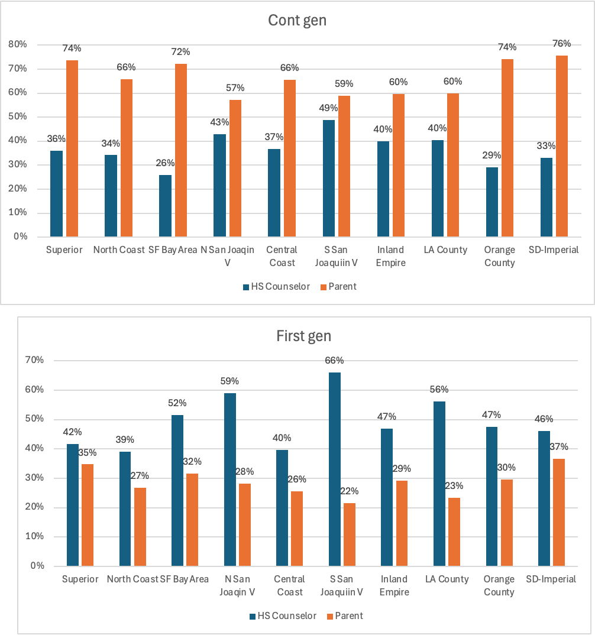

| firstgen_byattend
schoolregion | Not first Firstgen | Total
---------------------+----------------------+----------
Superior | 228 144 | 372
| 61.29 38.71 | 100.00
---------------------+----------------------+----------
North Coast | 41 41 | 82
| 50.00 50.00 | 100.00
---------------------+----------------------+----------
SF Bay Area | 310 155 | 465
| 66.67 33.33 | 100.00
---------------------+----------------------+----------
N San Joaquin Valley | 49 78 | 127
| 38.58 61.42 | 100.00
---------------------+----------------------+----------
Central Coast | 125 141 | 266
| 46.99 53.01 | 100.00
---------------------+----------------------+----------
S San Joaquin Valley | 156 220 | 376
| 41.49 58.51 | 100.00
---------------------+----------------------+----------
Inland Empire | 231 254 | 485
| 47.63 52.37 | 100.00
---------------------+----------------------+----------
LA County | 416 556 | 972
| 42.80 57.20 | 100.00
---------------------+----------------------+----------
Orange County | 155 118 | 273
| 56.78 43.22 | 100.00
---------------------+----------------------+----------
SD - Imperial | 164 139 | 303
| 54.13 45.87 | 100.00
---------------------+----------------------+----------
Total | 1,875 1,846 | 3,721
| 50.39 49.61 | 100.00

References
Nguyen, T. D., Kramer, J. W., & Evans, B. J. (2019). The effects of grant aid on student persistence and degree attainment: A systematic review and meta-analysis of the causal evidence. Review of educational research, 89(6), 831-874.

We report FAFSA and CADAA filers together, for the entirety of the paper. We will often just refer to the applications as FAFSA/CADAA.
https://www.csac.ca.gov/sites/default/files/2025-09/Sept-2-Press-Release-9.15.25.pdf
For a list of counties in each region see the appendix. For a map of the counties, see Figure 3.

