**Tourist Guide Website**

Name : Chetan Bhupendra Lohkare  
Div : K

Roll No : 20

GR NO : 11910486

Department of Engineering, Sciences and Humanities (DESH)

***Abstract*—: Nearly everyone goes on a vacation and a Tourism management system would play a vital role in planning the perfect trip. The tourism management system allows the user of the system access all the details such as weather, location, events, etc. The main purpose is to help tourism companies to manage customer and hotels etc. The system can also be used for both professional and business trips. The proposed system maintains centralized repository to make necessary travel arrangements and to retrieve information easily.**

***Keywords- HTML( HYPERTEXT MARKUP LANGUAGE),CSS,Bootstrap.***

* **Introduction**

First the customer visit our website. There are two options one is Search engine and another one like there are some pages below the search engine if they are click on the this page then they go directly at that information page which they need. In this page we put some images of that tourist places which is useful for customer. In information of that tourist places we give near about all information like open and close time, history, geography etc.

* **Flowchart**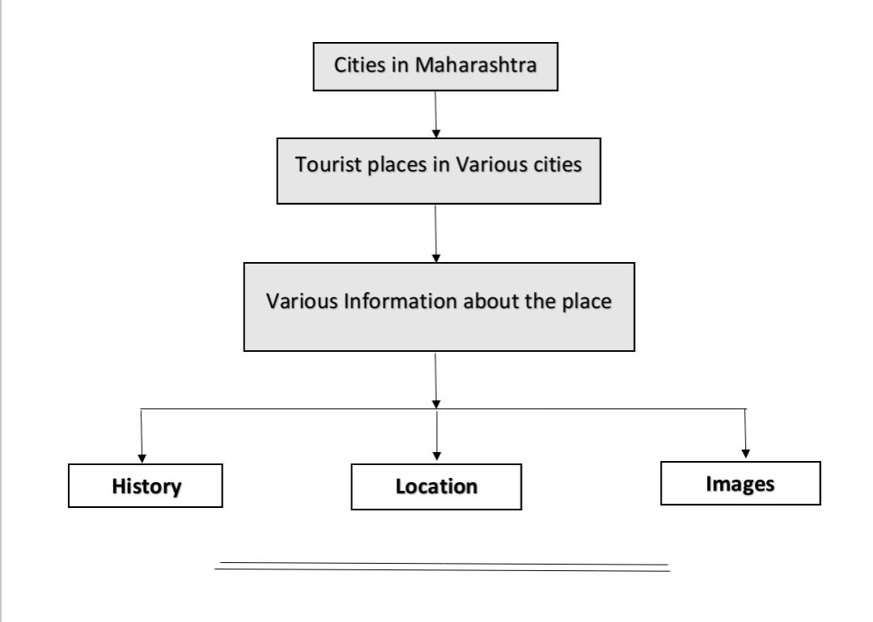
* **Code Screenshot**

Figure 1(HTML):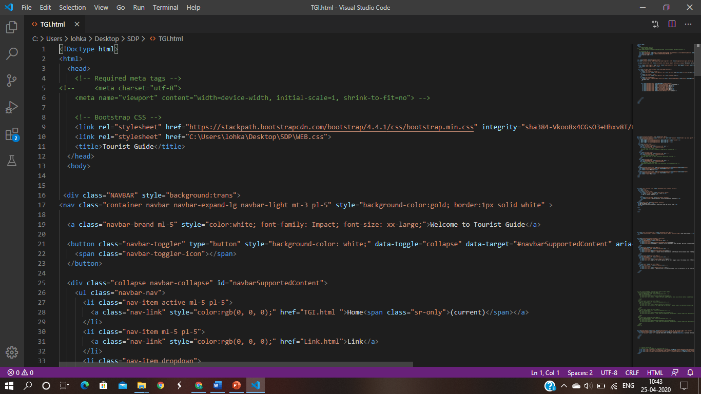

Figure 2(CSS):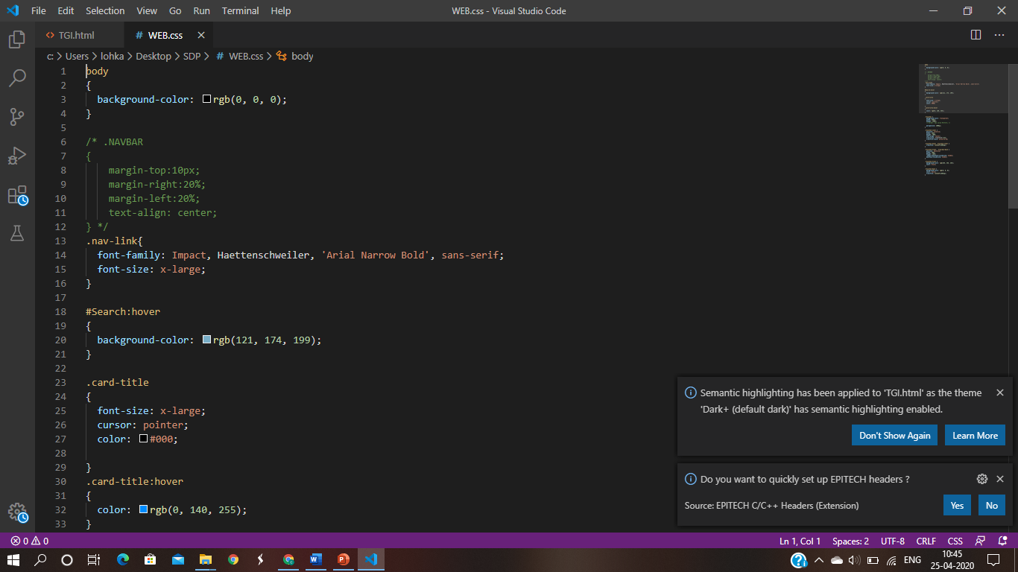

* **Execution Screenshot**

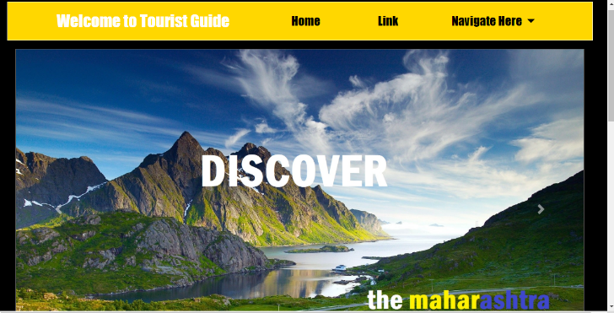

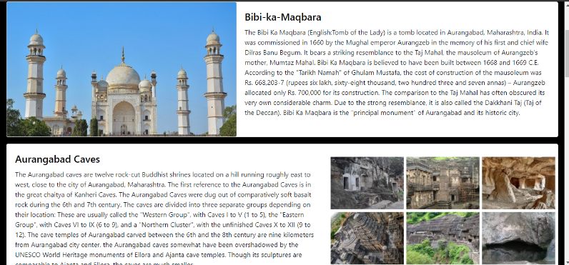

* **Functionalities of HTML tags :**
* <html> - The html element represent the root of an html document
* <head> - The head element represents a collection of metadata for the Document.
* <link> - The link element allows authors to link their document to other resources.
* <body> - The body element represents the content of the document.
* <div> - The div element has no special meaning at all. It represents its children. It can be used with the class, lang, and title attributes to mark up semantics common to a group of consecutive elements.
* <nav> - The nav element represents a section of a page that links to other pages or to parts within the page: a section with navigation links.
* <button> - The button element represents a button labeled by its contents.
* <a> - If the a element has an href attribute, then it represents a hyperlink labeled by its contents.
* <img> - An img element represents an image.
* <h> - The h element represents a section heading.
* **Results and discussion**

As the Internet has moved from a channel of technology to a channel of sales and customer relationship, the tourism industry has to revolutionize its website performance evaluation strategies with new approaches that can assist practitioners to evaluate customer preferences, and thus to improve the websites' business value. In other words, there is a pressing need for the tourism industry to go beyond the traditional methods of analyzing website performance. Although the preceding section provides adequate evidence for the interests and efforts of tourism researchers, prior studies widely dispersed into different regional or sector specific analyses instead of examining the issue for the tourism industry at large. In addition, the fact that no single method outperformed others in all aspects strongly indicates the need to develop more standardized approaches and evaluation criteria to measure performance of tourism websites. It further implies that both academic researchers and industry practitioners need to apply more innovative approaches in developing and analyzing website development for business purpose.

* **Conclusion and Future Scope**

. In conclusion, it is encouraging to know of the efforts spent by tourism researchers on website development and evaluations. The growth of interest in this area is evident by the fact that the theme of e-metrics or website evaluations has appeared in ENTER proceedings since 2004. Prior to that time, publications in the area were often grouped into the themes of marketing or success factors for tourism website. The introduction of a special issue on website evaluations in IT&T at a later time further hints of the increasing demand for research in the area.Tourism is considered to be an important aspect of economic growth and the development of a nation. According to the United Nations World Tourism Organization (UNWTO), global tourism is expected to reach 1.6 billion (in terms of international arrivals) by the year 2020. Tourism management is generally considered a bright and potential employment sector as it offers a wide variety of career opportunities in both the private and public sector.

* **References**
* [www.getbootstrap.com](http://www.getbootstrap.com/)
* <https://en.wikipedia.org/>
* <https://www.docsity.com/en/tours-and-travel-website/4233043/>
* [www.youtbe.com](http://www.youtbe.com/)