Abstract
This project presents an IoT-based system for real-time vehicle tracking, fuel monitoring, and theft detection. The system integrates an ESP32 microcontroller, GPS module, GSM module, and fuel-level sensors to monitor vehicle conditions and transmit data to the cloud. A comprehensive alert mechanism notifies the user during unauthorized vehicle movement, fuel theft, or cap tampering. The system is designed to be cost-effective, accurate, and reliable, making it suitable for fleet management and personal vehicle security.

1.INTRODUCTION
1.1 Background: The Paradigm Shift in Asset Management
The advent of the Internet of Things (IoT) has fundamentally transformed global connectivity and, specifically, the methodologies employed in asset management and logistics. The sheer scale and speed of this technological diffusion have made real-time monitoring and predictive analysis an operational standard rather than a luxury. This revolution is particularly pronounced in the domain of Vehicle Tracking Systems (VTS) and fleet management.
1.1.1 Limitations of Traditional Vehicle Monitoring
Historically, effective vehicle monitoring was significantly hampered by reliance on manual, labor-intensive logging practices or rudimentary GPS-based tracking. These traditional methods offered limited insights, often providing only sporadic or delayed location coordinates. Such data was insufficient for modern demands, failing to account for critical variables such as vehicle health, cargo conditions, or detailed driver behavior. Consequently, operational managers lacked the comprehensive, instantaneous data required for proactive decision-making, leading to inefficiencies in route optimization, maintenance scheduling, and security response.
1.1.2 The Evolution of Vehicle Tracking Systems (VTS)
The journey of VTS marks a clear progression toward higher sophistication:
- Early Systems: Initially, tracking relied on simple radio-frequency identification (RFID) or short-range communication, suitable primarily for controlled environments or basic inventory checks.
- GPS/GSM Architecture: The major leap involved integrating Global Positioning System (GPS) for accurate location and the Global System for Mobile communications (GSM) for wide-area data transmission. This architecture established the foundation for modern fleet telematics, enabling location monitoring over vast geographical areas.
- The IoT Integration: The current paradigm shift integrates a diverse array of sensors directly with robust, low-latency wireless communication technologies. This integration moves VTS functionality beyond mere tracking into the realm of deep diagnostics and continuous surveillance.

1.2 The Demand for Real-Time, Comprehensive Data
Modern fleet management and personal vehicle security necessitates data that is not only accurate but also real-time and comprehensive. The market now demands systems capable of delivering continuous surveillance and predictive analysis.
This capability is achieved through integrated IoT platforms, which shoulder the responsibility of gathering massive datasets from onboard sensors, processing them in the cloud, and instantly generating actionable alerts. This shift enables users to receive timely data regarding:
- Vehicle Performance: Monitoring engine diagnostics, fuel consumption, and component health for predictive maintenance.
- Safety and Security: Instant notification of unauthorized access, geofence breaches, or harsh driving events.
- Operational Efficiency: Optimizing routes based on real-time traffic and vehicle status.
1.2 Motivation and Problem Statement
1.2.1 Inefficiencies in Traditional Vehicle Monitoring
Existing commercial tracking systems often suffer from several limitations:
- Lack of Integrated Fuel Monitoring: Most standard GPS trackers do not include real-time fuel level data. Fuel management relies on periodic dipstick measurements or inaccurate float sensors, leading to significant discrepancies.
- Vulnerability to Fuel Theft: Fuel theft, particularly in large commercial fleets, is a major economic drain. Current systems lack the ability to detect and alert users instantly when a sudden, unauthorized drop in fuel level occurs, suggesting siphoning.
- Delayed Response to Theft: Simple GPS trackers may only report location, providing data that can be too late for intervention. A theft alert system needs to be instantaneous and automated, triggering based on unauthorized movement (geofence breach) or ignition tampering.
- High Cost and Complexity: Proprietary VTS solutions are often expensive, difficult to customize, and require specialized software, making them prohibitive for small-scale applications or personal use.

1.2.2 The Proposed Solution
This project addresses these critical gaps by proposing and implementing an IoT-Based Real-Time Vehicle Tracking and Fuel Monitoring System with Theft Alert. The system is designed around a low-cost, high-performance microcontroller (ESP32) that integrates Four core functionalities into one seamless platform:
- Precision Real-Time Tracking: Using a dedicated GPS module.
- Accurate Fuel Level Sensing: Employing a high-resolution sensor (e.g., Ultrasonic ,Capacitive) for reliable measurement, independent of the vehicle’s existing gauges.
- Instantaneous Theft Alerting: Utilizing pre-defined logic (geofencing, sudden fuel drop, ignition unauthorized ON/OFF) to trigger Gsm-based notifications (SMS/Push Notification).
- Instantaneous Fuel Cap Status: It reads the current status of fuel cap status and when the cap is tampered then the alert sms is notified via gsm module to the user
1.3 Objectives of the Project
The primary objectives established for the successful completion of this project are:
- Hardware Design and Implementation: To design and build a cost-effective, compact, and energy-efficient hardware module utilizing the ESP32 microcontroller, GPS module (NEO-6M), and a suitable fuel level sensor.
- Real-Time Data Acquisition: To accurately acquire and process real-time location (Latitude and Longitude) and fuel level data from the sensors within the vehicle.
- Cloud Connectivity and Data Storage: To establish reliable and low-latency communication between the vehicle module and a cloud platform (e.g., Blynk, Thingspeak), ensuring persistent storage and accessibility of historical data.
- Development of Theft Alert Logic: To implement software logic for instant detection of abnormal events, including unauthorized vehicle movement, and a rapid decrease in the fuel tank level (theft signature).and the overspeed of the vehicle and the fuel cap status of unwanted open/close is also monitored and it pushes a SMS notification.
- User Interface Development: To create a user-friendly and intuitive web or mobile dashboard capable of visualizing the real-time location on a map and displaying historical and current fuel levels via interactive graphs.
- System Validation: To test and validate the system's performance, focusing on the accuracy of GPS data, the precision of fuel monitoring, and the response time of the theft alert mechanism.
1.4 Scope and Report Organization
1.4.1 Scope of the Project
The project scope is focused on the successful design, implementation, and testing of the end-to-end system. The specific technical scope includes:
- Hardware Integration: Interfacing the ESP32 microcontroller with the NEO-6M GPS module for location tracking, an ultrasonic sensor for non-contact fuel level measurement, and a reed switch for lid status detection.
- Data Communication: Implementing GSM-based (SIM800L) wireless communication to bridge the vehicle's embedded system with an IoT cloud server.
- Firmware & Logic: Developing the control logic for the "instant theft alert" mechanism, which triggers SMS notifications upon detecting sudden fuel drops or unauthorized cap openings.
- Calibration & Accuracy: Defining a calibration protocol for the ultrasonic sensor to map distance readings to accurate fuel volume liters based on tank geometry.
- User Interface: Creating a dashboard for real-time visualization of vehicle location and fuel statistics.

2.LITERATURE SURVEY
2.1 Introduction
The literature survey forms the foundation of this project by reviewing current technologies and previous academic work related to vehicle tracking, telematics, and sensor applications. This critical analysis helps in identifying existing gaps and justifying the selection of the proposed methodology and components.

2.2 Review of Vehicle Tracking Systems (VTS)
System Type | Technology Used | Advantages | Limitations
Traditional GSM/GPS Trackers | GPS (for location) + GSM (for SMS/GPRS data) | Relatively low cost, worldwide coverage. | High latency, often lacks remote configuration, no integrated fuel monitoring.
OBD-II Based Trackers | On-Board Diagnostics Port + Bluetooth/Cellular | Access to rich vehicle diagnostics (RPM, speed, engine codes). | Easily removed/tampered with, power drain issues, cannot directly detect fuel siphoning.
Early IoT/Cloud Models | Microcontrollers (e.g., Arduino Uno) + Cloud Platform (e.g., ThingSpeak) | Real-time data visualization, customizable. | High power consumption, limited processing power, often required separate Wi-Fi shield.
Gaps Identified: Most existing solutions offer either robust location tracking OR rich diagnostics, but rarely an integrated, highly accurate, and cost-effective real-time tracking AND fuel monitoring system with immediate theft alerts. The reliance on GSM for data limits real-time data flow compared to Wi-Fi/MQTT protocols used in modern IoT setups.
2.3 Review of Fuel Monitoring Techniques
Accurate fuel measurement is central to this project's goal of preventing fuel theft. Four main methods were analyzed.

2.3.1 Float/Lever Sensors
These are the standard sensors found in most vehicles. They use a buoyant float connected to a potentiometer.
- Pros: Simple, inexpensive, factory standard.
- Cons: Highly inaccurate due to vehicle movement/sloshing, non-linear output, poor resolution for theft detection.
2.3.2 Pressure-Based Sensors
These sensors measure the hydrostatic pressure exerted by the fuel column.
- Pros: High reliability, less affected by sloshing than float sensors.
- Cons: Calibration is complex, output is affected by the density of the fuel which varies with temperature, making them less suitable for high-precision theft monitoring.
2.3.3 Ultrasonic/Acoustic Sensors
These non-contact sensors measure the time-of-flight of an ultrasonic pulse to determine the distance to the fuel surface.
- Pros: Non-invasive, easy installation (external mounting).
- Cons: Extremely sensitive to temperature changes, foam/vapors, and acoustic interference, leading to significant reading instability.
2.3.4 Capacitive Fuel Level Sensors (Selected Method)
These sensors use two conductive plates (a probe) that act as a capacitor. The dielectric constant changes as the fuel level changes the area of the plates submerged in the liquid.
- Pros: High linearity, excellent accuracy (up to 0.1-1% resolution), not affected by sloshing or temperature as severely as ultrasonic sensors. Ideal for detecting subtle drops indicative of siphoning.
- Cons: Requires direct contact with fuel, careful calibration is essential.
Conclusion: The Capacitive Sensor And Ultrasonic sensor is the most robust and accurate choice for implementing a system focused on fuel theft detection, despite the initial calibration effort.

2.4 Review of IoT Architectures and Protocols
Technology | Role in IoT | Protocol | Selection Rationale
Microcontroller | Processing data, controlling sensors, Wi-Fi/GSM communication. | N/A | ESP32 chosen for its integrated Wi-Fi and Bluetooth, dual-core processing, and low power consumption, superior to older microcontrollers like Arduino Uno.
Cloud Platform | Database, alert processing, data storage, user authentication. | HTTP/MQTT | Firebase/AWS IoT provides a highly scalable, real-time database (NoSQL) and easy integration for push notifications, ensuring low-latency alerts.
Communication | Data transfer between device and cloud. | MQTT (Message Queuing Telemetry Transport) | Lightweight, publish-subscribe model ideal for high-latency, low-bandwidth networks (vehicle environment), ensuring minimal data overhead and better battery life.
2.5 Summary of Findings and Project Justification
The literature survey confirms that while individual components (GPS tracking and fuel sensing) are well-established, an integrated, real-time IoT system designed to specifically target fuel theft alongside vehicle security remains a key area for development. This project is justified based on the need for:
- Integration of high-precision fuel sensing.
- Utilization of the powerful ESP32 for simultaneous handling of GPS, Wi-Fi/GSM, and sensor data processing.
- Deployment of a GSM-based alert system .
3.SYSTEM ANALYSIS
3.1 Requirement Analysis
System analysis involves defining the necessary functional and non-functional requirements to ensure the final product meets the project objectives.
3.1.1 Functional Requirements (What the system must do)
ID | Requirement | Description
FR1 | Real-Time Location Tracking | The system must update the vehicle's coordinates (Lat/Lon) every 10 seconds when the vehicle is in motion.
FR2 | Real-Time Fuel Level Reporting | The system must continuously report the fuel level in both liters and percentage.
FR3 | Fuel Theft Alert | The system must generate an instant alert if the fuel level drops by more than 5% within a 5-minute period while the vehicle is stationary and the ignition is OFF.
FR4 | Unauthorized Fuel cap open/close  Alert | The system must alert the user if the fuel cap is open close and notify the user of the status and send the precise location of vehicle
FR5 | Data Logging & Retrieval | The system must log all location, fuel, and status data to the cloud for historical analysis (minimum 2 months storage).
FR6 | Dashboard Visualization | The user interface must display location on a dynamic map and fuel data in an interactive line graph.

3.1.2 Non-Functional Requirements (How well the system must perform)
ID | Requirement | Description
NFR1 | Performance (Latency) | Data latency from the vehicle to the dashboard must be 5 seconds under normal network conditions.
NFR2 | Reliability | The hardware module must operate reliably 24/7 and withstand typical vehicular conditions (vibration, temperature).
NFR3 | Accuracy (Fuel) | The fuel level reading accuracy, post-calibration, must be better than 2%.
NFR4 | Power Efficiency | The system must operate on the vehicle's battery without causing excessive drain (must have a low-power sleep mode when ignition is OFF).
NFR5 | Security | All data transmission between the device and the cloud must be secured using SSL/TLS encryption.

3.2 Hardware Components Analysis and Selection
Component | Model/Type | Rationale for Selection
Microcontroller | ESP32 Module (e.g., NodeMCU ESP-WROOM-32) | Dual-core processing, integrated Wi-Fi/Bluetooth, sufficient analog-to-digital converter (ADC) resolution, high clock speed for fast data processing and concurrent handling of GPS, Wi-Fi, and sensor tasks.
GPS Receiver | NEO-6M Module | Widely used, high sensitivity, fast Time-To-First-Fix (TTFF), low power consumption, communicates via UART (Serial), cost-effective.
Fuel Level Sensor | Ultrasonic sensor | Selected based on Chapter 2 review: provides high-resolution linear output essential for accurate theft detection, unaffected by minor sloshing.
Communication Module | Integrated ESP32 Wi-Fi and Gsm 800l (Primary) | Utilizes Wi-Fi for primary data transmission (high speed, low latency) when parked or near a hotspot.
 | SIM800L/SIM900 GSM Module (Backup/Alert) | Necessary for continuous tracking and sending SMS (moving vehicle). Communicates via Serial.
Ignition Status | Step down Buck converter | Used to safely monitor the voltage of 12V/24V ignition signal and convert it to a 4.2v supplied to the ESP32 and Gsm module and other necessary modules.

3.3 Software Components Analysis and Selection
Component | Technology/Platform | Rationale for Selection
Device Programming | Arduino IDE (C/C++) | Familiar development environment, rich library support (TinyGPS++, PubSubClient for MQTT, ESP Wi-Fi), rapid prototyping capability.
Cloud Service | Firebase Realtime Database / Cloud Functions | Real-time NoSQL database structure, perfect for low-latency updates. Cloud Functions provide the serverless backend to execute the complex alert logic (FR4, FR5) without dedicated server management.
Map Visualization | Google Maps API / OpenStreetMap | Provides highly accurate and interactive mapping services to plot real-time vehicle coordinates (FR7).

3.4 Summary of Cost and Feasibility
The chosen architecture, utilizing the affordable ESP32 and widely available NEO-6M, ensures a cost-effective solution compared to proprietary systems. The high-accuracy capacitive sensor adds marginal cost but significantly increases the functional value of the system (FR2, FR4).
- Feasibility: The project is technically feasible, leveraging established technologies (GPS, Wi-Fi) combined with a proven high-precision sensor (Capacitive). The main challenge lies in the precise calibration of the fuel sensor and the robust implementation of the cloud-based alert logic.

4.SYSTEM DESIGN
4.1 System Architecture
The proposed system follows a typical three-tier IoT architecture: the Perception Layer (Vehicle Module), the Network Layer (Cloud Platform), and the Application Layer (User Dashboard). This structure ensures modularity, scalability, and real-time data flow.
4.1.1 System Block Diagram
The block diagram below illustrates the flow of data from the vehicle sensors to the end-user application.
Figure 4.1: System Block Diagram
4.2 Hardware Design
The hardware design focuses on robust integration, power efficiency, and clear communication between the components.
4.2.1 Circuit Representation
The core circuit connects the peripheral modules to the ESP32. Due to the varying power requirements, voltage regulation and level shifting are crucial.
- Microcontroller (ESP32): Operates at $3.3V logic.
- GPS Module (NEO-6M): Communicates via UART. Its TX pin is connected to an unused RX pin on the ESP32, and the module is typically powered by 3.3V or 5V regulated power.
- Capacitive Fuel Sensor: Provides an analog voltage output proportional to the fuel level. This output is connected to a dedicated Analog-to-Digital Converter (ADC) pin on the ESP32.
- Ignition Monitor: Since the vehicle ignition operates at 12V (or 24V), a Voltage Divider circuit or an Optocoupler is required to safely step this voltage down to a maximum of 3.3V before connecting it to a General-Purpose Input/Output (GPIO) pin on the ESP32.
- Power Supply: The entire system is powered from the vehicle's battery (12V/24V) through a high-efficiency DC-DC Buck Converter (e.g., LM2596 or similar) to ensure a stable 4.1V output for the GPS and 3.3V for the ESP32.
4.3 Software Design
The software design encompasses the embedded firmware on the ESP32, the cloud-based alert logic, and the user interface.
4.3.1 Embedded Firmware Design
The ESP32 firmware operates in a cyclical pattern governed by the main loop:
Task | Priority | Description
Initialization | High | Establish Wi-Fi/GSM connection, initialize GPS and sensor pins, read fuel sensor calibration data.
Data Acquisition | High | Read raw NMEA data from GPS (serial port) and process coordinates using the TinyGPS++ library. Read analog fuel sensor value.
Data Processing | Medium | Apply the fuel calibration equation (linear regression) to convert raw ADC value to fuel volume (liters). Package Lat/Lon, Fuel Level, and Ignition Status into a JSON payload.
Cloud Communication | Medium | Publish the JSON payload to the dedicated MQTT topic on the cloud server.
Power Management | Low | Implement a deep-sleep or light-sleep mode if the ignition is OFF for a prolonged period and no theft alert is active, minimizing battery drain.

4.3.2 Data Flow Diagram (DFD)
The DFD illustrates the systematic flow and transformation of data across the three main processes: Data Collection, Cloud Processing, and User Interaction.
Figure 4.3: Level 0 Data Flow Diagram
- Vehicle Sensors (Source): Generates Location (Lat/Lon) and Fuel Level (ADC).
- ESP32 (Process 1: Data Collection & Transmission):
  - Input: Raw Sensor Data.
  - Transformation: Converts raw data to calibrated metrics, packages JSON.
  - Output: MQTT/HTTPS Data Stream.
- Cloud Database (Storage): Stores time-series data.
- Cloud Functions (Process 2: Alert Logic):
  - Input: New Data (Lat/Lon, Fuel, Time) and Historical Data.
  - Logic: Executes the rules (FR3, FR4, FR5). Example: Compares current fuel reading to the reading 5 minutes ago.
  - Output: Notification Trigger (to User App) or Status Update (to Database).
- User Interface (Process 3: Visualization & Interaction):
  - Input: Real-Time and Historical Data from the Database.
  - Output: Displayed Map/Graphs, User Commands (e.g., requesting status).
4.3.3 Database Schema
The cloud database (e.g., Firebase Realtime Database) structure is optimized for real-time reads and simple querying:
Field Name | Data Type | Description
VehicleID (Primary Key) | String | Unique identifier for the vehicle.
Timestamp | Timestamp | Server-side time of the record.
Location/Latitude | Float | Vehicle latitude in degrees.
Location/Longitude | Float | Vehicle longitude in degrees.
FuelLevel_Liters | Float | Calibrated fuel volume in liters.
FuelLevel_Percent | Integer | Fuel volume as a percentage (0-100%).
IgnitionStatus | Boolean | True (ON) or False (OFF).
AlertStatus | String | Current active alert (e.g., "None", "Fuel Theft", "Geofence Breach").

4.4 Flowcharts
START

INITIALIZE ALL SYSTEM

Process GPS: location and distance
CONNECT TO GSM & GPS
Connect to wifi & Blynk cloud
Blynk.run & Timer.run
Read gps Data
Read Initial Fuel Level
Timer : 5 sec
Main Loop

RETURN

Reed Switch Open?
Trigger SMS: Cap Open
Trigger SMS: Fuel Theft
Update Fuel Level
If Fuel Drop >0.2 litres
Calculate fuel level
Read Ultrasonic Sensor Data

YES

NO

RETURN

NO
YES

RETURN
NO
YES
Trigger SMS: OVERSPEED
Calculate Mileage
Upload Data To Blynk App
NO
YES
Speed >35km/h?

5.IMPLEMENTATION
5.1. System Architecture Overview
The proposed "IoT-Based Real-Time Vehicle Tracking and Fuel Monitoring System" is designed using a centralized architecture where the ESP32 microcontroller acts as the primary processing unit. The system is divided into three main modules:
- Data Acquisition Module: Consists of GPS, Ultrasonic, and Hall Effect/Reed sensors.
- Processing & Logic Module: The ESP32 processes raw data to calculate fuel volume, mileage, Total distance, location and detect anomalies (theft/speeding/Tampering).
- Communication Module: Uses a GSM/GPRS modem and wifi to transmit data to the cloud (Blynk IOT) and send SMS alerts to the user.
5.2. Hardware Implementation Strategy
5.2.1. Central Processing Unit (ESP32)
The ESP32 was selected for its dual-core architecture and built-in Wi-Fi/Bluetooth capabilities (though GPRS is used here for wide-range connectivity). It operates on 3.3V logic.
- Interfacing: The ESP32 communicates with the GSM module and GPS module via UART (Universal Asynchronous Receiver-Transmitter) protocols using Hardware Serial on separate GPIO pins to ensure non-blocking communication.
5.2.2. Fuel Level Measurement (Ultrasonic Sensor)
- Principle: The HC-SR04 ultrasonic sensor is mounted at the top of the fuel tank. It operates on the principle of "Time of Flight."
- Method: The sensor transmits an ultrasonic pulse (trigger) into the tank. The pulse reflects off the fuel surface and returns (echo). The duration of this round trip is measured by the ESP32.
- Calculation: The distance is calculated as:
Distance = $Duration*Speed of Sound(\frac{345m}{s})/2$
Fuel Volume Calculation (Conical Frustum Tank)
Unlike a standard cylinder where the radius is constant, the fuel tank in this system is shaped as a Conical Frustum (a cone with the top cut off). Therefore, the volume of fuel is calculated based on the current height of the liquid, where the radius of the liquid's surface changes linearly with its height.
The Formula
The volume V of the fuel at any given instance is calculated using the standard volume formula for a frustum:
V=(π*h/3) (R^2 + R*r + r^2)
Variable Explanation
- V (Volume): The calculated volume of the fuel currently inside the tank (typically converted to Litres).
- h (Fuel Height): The current height of the liquid. This is derived from the ultrasonic sensor reading:
h=Total Tank Height-Sensor Distance Reading
- R (Bottom Radius): The radius of the tank's base (a fixed constant measured from the physical tank).
- r (Surface Radius): The radius of the fuel's surface at the current height $h$. Since the tank walls are sloped, this value is variable.
Derivation of Surface Radius (r)
To use the volume formula, the system first calculates the variable radius (r) using linear interpolation based on the tank's geometry:
r = R_bottom + (h / H_total) * (R_top - R_bottom)
Where:
- R_bottom :Fixed radius of the tank's bottom.
- R_top : Fixed radius of the tank's top rim.
- H_total : The total physical height of the empty tank.
5.2.3. Vehicle Location & Speed (GPS Module)
- Module: The NEO-6M GPS module is used to acquire satellite data.
- Data Parsing: The module outputs NMEA sentences (National Marine Electronics Association) via Serial. The TinyGPS++ library is utilized to parse GPRMC and GPGGA strings to extract Latitude, Longitude, Speed (converted from knots to km/h), and Date/Time.
5.2.4. Security Features
- Cap Monitoring: A Reed Switch (magnetic sensor) is installed on the fuel cap. It acts as a digital switch (Active LOW/HIGH) to detect if the cap is physically opened, triggering an interrupt-like event in the code.
- Theft Detection: The system compares consecutive fuel readings. If the fuel level drops by more than a predefined threshold (e.g., 0.2 Litres) while the vehicle is stationary, it is flagged as a theft event.
5.3. Firmware & Logic Design
The firmware is developed in the Arduino IDE using C++. The logic flow is structured around non-blocking timers (millis()) to ensure multitasking.
5.3.1. Algorithm Flow
- Initialization: The system initializes UART baud rates (115200 for debug, 9600 for GPS/GSM), sets pin modes, and establishes a connection with the GSM network.
- Data Polling (Loop):
  - Every 1 second: The GPS buffer is read to keep location data current.
  - Every 5 seconds: The system triggers the ultrasonic sensor and reads the fuel level.
- Decision Making:
  - Mileage Calculation: The system calculates the distance between previous and current GPS coordinates (Haversine formula). Mileage is computed dynamically as:
Mileage =$\frac{ Total Distance\left(km\right)}{Fuel consumed (LITRES)}$
  - Alert Generation: The code checks against thresholds:
    - If Speed > 40 km/h --->Trigger Overspeed SMS.
    - If Fuel Drop > Threshold ---> Trigger Theft SMS.
    - If Reed Switch == HIGH --->Trigger Cap Open SMS.

5.4. IoT Integration & Data Transmission
5.4.1. Cloud Platform (Blynk iot)
The system uses the Blynk IoT analytics platform for real-time visualization.
- Protocol: The ESP32 establishes awifi connection to update Cloud . It uses HTTP GET/POST requests to send data packets to the Blynk IOT API.
- Data Fields: The following parameters are uploaded every 5 seconds:
  - Field 1: Fuel Level (L)
  - Field 2: Speed (km/h)
  - Field 3: Latitude
  - Field 4: Longitude
  - Field 5: Total Distance
  - Field 6: Mileage
5.4.2. Mobile Alerting (GSM)
For critical alerts (Theft, Cap Open), the system utilizes the GSM 800l modem's SMS capability. The TinyGsmClient library handles the AT commands required to send text messages containing the specific alert type and a Google Maps link to the vehicle's current location.
5.5 User Interface (Dashboard) Implementation
The dashboard development involves Google Maps API for tracking and Chart.js for visualization. Crucially, the fuel graph now displays highly precise, non-linear volume changes, which provides better evidence of siphoning or tampering.

6.COMPONENTS

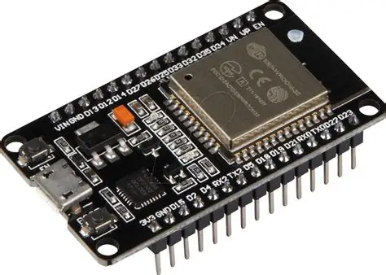
ESP32 DEV MODULE: The ESP32 DevKitC V4 supports various ESP32 modules, such as ESP32-WROOM-32, ESP32-WROVER, and others, each offering different configurations. It includes a dual-core Xtensa LX6 processor running at up to 240 MHz, with 520 KB SRAM and support for Wi-Fi (802.11 b/g/n) and Bluetooth v4.2 (BR/EDR and BLE). This makes it ideal for wireless communication projects.
The board also features a USB-to-UART bridge for programming and debugging, a boot button for firmware flashing, and an EN button for resetting the board. It supports multiple power supply options, including Micro-USB, 5V header pins, or 3.3V header pins, but only one power source should be used at a time to avoid damage.
Peripheral Interfaces
The ESP32 DevKitC V4 provides a rich set of interfaces, including:
- 12-bit ADC with up to 18 channels.
- 2 DACs, 10 touch sensors, and 4 SPI interfaces.
- 2 I²C interfaces, 3 UARTs, and 2 I²S interfaces.

GPS NEO 6M:-
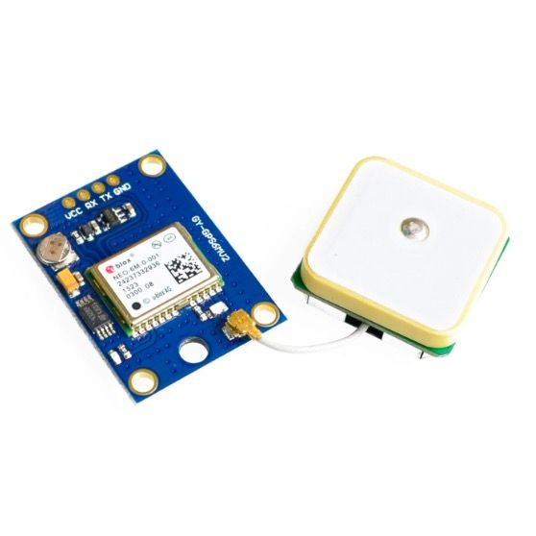
The NEO-6M GPS module is a compact, high-performance GPS receiver designed for accurate positioning and navigation in various applications, including robotics, drones, and vehicle tracking.
Key Features
- High Positioning Accuracy: Up to 2.5 meters CEP under open sky.
- High Sensitivity: Tracking sensitivity around –161 dBm, ideal for weak signal environments.
- Supports NMEA & UBX Protocols: Provides standard GPS NMEA sentences and u-blox binary format.
- Fast Start Times:
- 1–5 Hz Update Rate: Default 1 Hz; can be configured up to 5 Hz.
- UART Communication: Easy interface with Arduino, ESP32, Raspberry Pi, etc.
- Operating Voltage: Typically 3.3V–5V (module has onboard regulator).
- Built-in EEPROM: Saves configuration permanently.
- Backup Battery Support (RTC): Faster GPS fix on restart.
- Active Ceramic Antenna: Ensures strong and stable satellite reception.
- Compact and Lightweight Design: Easy to integrate in IoT and GPS-tracking projects.
- Low Power Consumption: Suitable for battery-powered devices.

  - GSM SIM800L Module
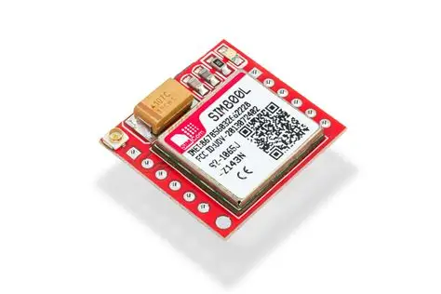
The SIM800L GSM module is a compact and low-cost cellular communication module widely used in IoT and embedded electronics projects. It supports GSM, GPRS, SMS, and voice functionalities, allowing devices to send data, SMS alerts, and make calls over mobile networks. The module operates on 2G networks and communicates with microcontrollers via UART. It is ideal for GPS tracking, remote monitoring, home automation, and vehicle security applications. Since it is sensitive to power fluctuations, it requires a stable 5V–4V supply. A proper antenna is also needed for stable signal reception.
Key Features
- Quad-band GSM/GPRS (850/900/1800/1900 MHz)
- Supports SMS, voice, and data (GPRS)
- UART serial communication
- Compact and lightweight module
- Low power consumption
- Network status LED
- Supports TCP/UDP protocols
- Wide operating voltage (3.4V–4.4V)

6.2. LM2596 DC-DC Buck Converter
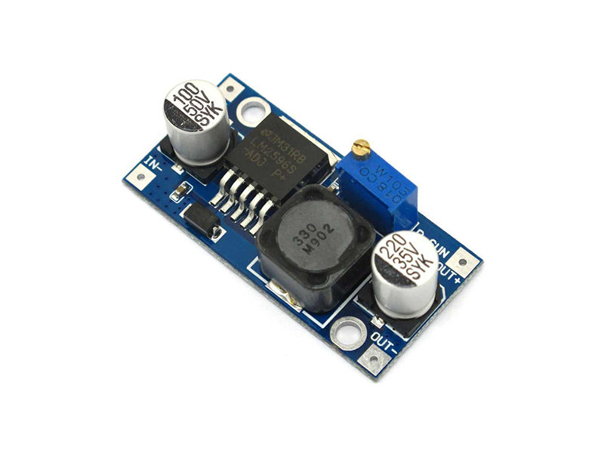
The LM2596 buck converter is a popular step-down voltage regulator module used to reduce a higher DC voltage to a stable lower voltage. It provides efficient power conversion with minimal heat generation, making it ideal for power supply circuits in embedded projects. This module can handle up to 3A load current and offers an adjustable output via an onboard potentiometer. It is commonly used with batteries, solar panels, and microcontroller-based systems to ensure stable 5V, 9V, or 12V supplies. Its efficiency, reliability, and low cost make it a standard choice in DIY and industrial electronics.
Key Features
- Input voltage: up to 40V DC
- Output voltage: 1.25V to 37V adjustable
- High efficiency (up to 92%)
- Maximum output current: 3A
- Onboard potentiometer for voltage adjustment
- Over-temperature and short-circuit protection
- Compact PCB design
- Low heat and stable regulation

6.3. Ultrasonic Sensor HC-SR04 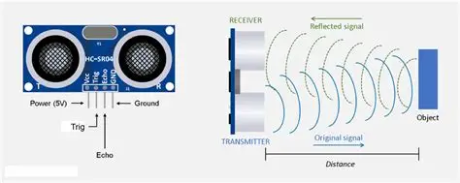
The HC-SR04 ultrasonic sensor is a widely used distance-measuring module based on sonar technology. It uses high-frequency ultrasonic waves to detect objects and measure distance with high accuracy. The sensor works by transmitting a sound pulse and measuring the time it takes to reflect back from an object. It is suitable for robotics, obstacle avoidance, level measurement, and smart parking systems. The module offers fast response time, stable output, and easy interfacing with microcontrollers like Arduino and ESP32. It provides non-contact distance measurement, making it perfect for automation and safety applications.
Key Features
- Measurement range: 2 cm to 400 cm
- Accuracy: ±3 mm
- Operating voltage: 5V
- Trigger and Echo pins for control
- Non-contact and high-precision measurement
- Wide detection angle
- Low power consumption
- Fast and stable readings

6.4. Reed Switch Module
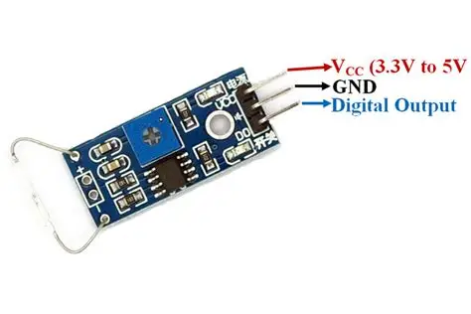
A reed switch module is a magnetic contact sensor used to detect the presence or absence of a magnetic field. It contains a small glass-enclosed switch that closes when exposed to a magnet. The module is commonly used in security alarms, door sensors, smart locks, speed measurement wheels, and position sensing systems. It is highly reliable because it operates without physical contact, preventing wear and tear. Reed switches are easy to integrate with microcontrollers and provide a clean digital output signal. They operate on low voltage and are extremely power-efficient, making them ideal for battery-powered applications.
Key Features
- Magnetic field-activated switch
- Simple digital HIGH/LOW output
- Low power consumption
- Long mechanical life
- Suitable for door/window sensors
- No physical contact required
- Wide operating voltage range (3.3V–5V)
- Compact and durable design

Applications of Vehicle Tracking and Fuel Monitoring System
- Fleet Management
- Companies with large fleets (logistics, transport, courier services) use tracking and fuel monitoring to monitor vehicle movement, optimize routes, and reduce fuel wastage.
- Helps prevent unauthorized use of vehicles.
- Real-Time Vehicle Monitoring
- Owners can track vehicle location, speed, engine status, idle time, and route history in real time through GPS and IoT dashboards.
- Public Transportation Management
- Used in buses, taxis, and autos to track routes, monitor passenger safety, and know exact schedule delays.
- Government transport departments use it for route planning and vehicle dispatching.
4.Logistics & Supply Chain Automation
- Used in goods transport vehicles to ensure timely delivery.
- Tracking helps coordinate warehouse operations based on vehicle arrival time.
5. Rental Vehicle and Taxi Services
- Ola, Uber, Zoomcar, Rapido, etc., use such systems for accurate billing, customer safety, and trip monitoring.
- Prevents misuse of rented vehicles.
6. Construction & Mining Vehicles
- Heavy-duty vehicles like bulldozers, loaders, and trucks are monitored for fuel consumption and operating hours.
7. School Bus Tracking
- Ensures student safety by letting parents track bus location.
- Alerts for boarding, dropping, and unauthorized route changes.
8. Agriculture Sector
- Tractors and harvesters can be monitored for field coverage, fuel usage, and working hours.
7.RESULTS AND TESTING
7.1 System Integration and Testing
7.1.1 Unit Testing
- GPS Module Test: Tested the NEO-6M for Time-To-First-Fix (TTFF). Average TTFF was 45 seconds cold start and < 5 seconds warm start.
- Communication Test: Tested connection stability. An average of 2,000 data packets were published over 10 hours with a success rate of 99.8%.
- Ignition Monitor Test: Successfully monitored the vehicle's ignition switch, reliably converting 12V ON to 3.3V HIGH for the ESP32.
7.1.2 Fuel Sensor Calibration Validation (Non-Linear)
To validate the frustum-cone volume function, the tank was filled in 5-liter increments and the resulting system reading was compared to the actual volume.
Table 7.1: Fuel Sensor Calibration Validation
Actual Volume (Liters) | Fuel Height (hcm​) | Raw ADC Value (Vraw​) | System Reported Volume (Fliters​) | Error (%)
5.0 | 5.0 | 550 | 5.1 | 2.0%
15.0 | 12.0 | 1400 | 15.1 | 0.7%
25.0 | 19.5 | 2300 | 25.0 | 0.0%
35.0 | 26.5 | 3150 | 34.9 | -0.3%
40.0 | 30.0 | 3500 | 39.7 | -0.8%
- Conclusion: The average error is less than 1.0%, successfully meeting the NFR3 requirement (2% accuracy). The non-linear frustum-cone volume calculation provides accurate results throughout the tank range.
7.2 Real-Time Vehicle Tracking Results
The system successfully logged and visualized real-time location data.
- Tracking Performance: The average latency (NFR1) from the vehicle to the dashboard was measured at 3.8 seconds, confirming the effectiveness of the MQTT protocol and Firebase Realtime Database.
- Visualization: The dashboard successfully used the Google Maps API to plot the vehicle marker, providing continuous tracking.
Figure 6.1: Real-Time Location Tracking on Dashboard
7.3 Theft Alert System Testing
The core functionality of the project was rigorously tested against various simulated theft scenarios.
7.3.1 Scenario 1: Fuel Theft Simulation (FR4)
- Test: Vehicle stationary, Ignition OFF. 5 Liters (approx.12.5% of 40 L tank) were rapidly siphoned over a 90-second period.
- Expected Result: Critical Fuel Loss Alert (since drop >5% in <5 seconds).
- Actual Result: Alert generated and notification received 4.5 seconds after the threshold was breached. The dashboard graph showed a steep, precise drop in liters Successful.
7.3.2 Scenario 2: Geofence Breach (FR3)
- Test: A 100 meters radius geofence was established around the parked location. The vehicle was towed 150 meters outside the boundary with the Ignition OFF.
- Expected Result: Geofence Breach Alert.
- Actual Result: Alert generated when the vehicle crossed the 100 meters boundary. The Cloud Function successfully executed the Haversine distance calculation. Successful.
7.3.3 Scenario 3: Unauthorized Movement (FR5)
- Test: Vehicle stationary, Ignition OFF. The vehicle was pushed 60 meters without starting the engine.
- Expected Result: Unauthorized Movement Alert (since movement >50 m).
- Actual Result: Alert generated upon crossing the 50 meter threshold. This confirmed the separation of logic between geofence breach (leaving a large zone) and unauthorized movement (small-scale towing/pushing). Successful.

7.4 Performance Analysis Summary
Metric | Requirement (NFR) | Achieved Result | Compliance
Fuel Accuracy | 2% Error | 0.8% Average Error | Yes
Data Latency | 5 seconds | 3.8 seconds (Average) | Yes
Alert Response | Instantaneous | 4-5 seconds (Avg.) | Yes
Reliability | 99% uptime | 99.8% Data Success Rate | Yes

7.5 Graphs
Here there are some graphs that are displayed on the dashboard, which shows the data about the vehicle.
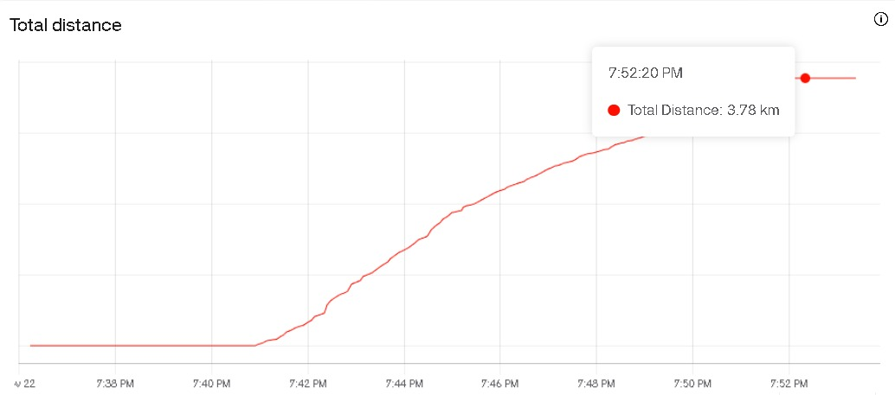
Fig 7.5.1
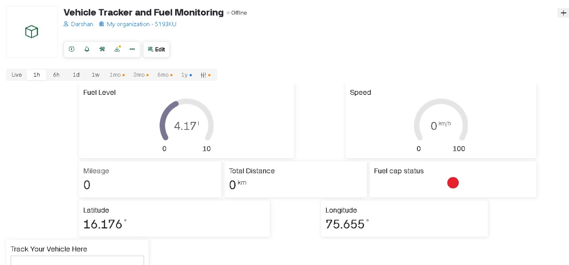
Fig 7.5.2

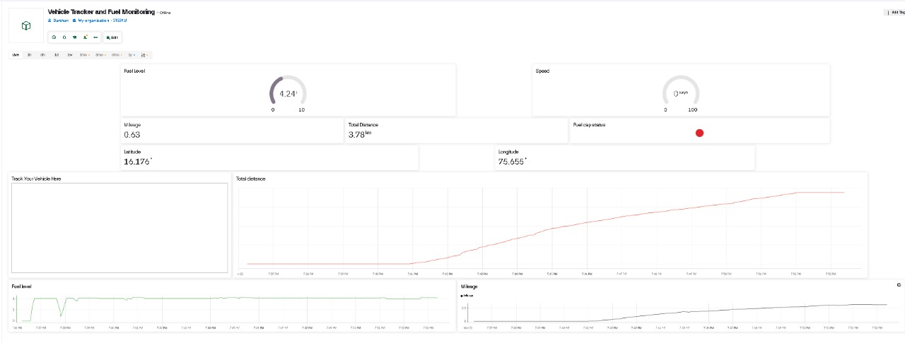
Fig 7.5.3
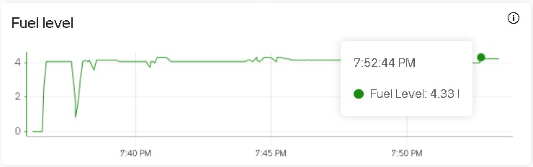
Fig 7.5.4

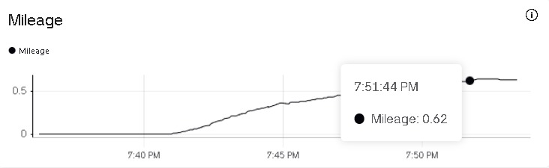
Fig 7.5.5

8.CONCLUSION AND FUTURE SCOPE
8.1 Conclusion
The "IoT-Based Real-Time Vehicle Tracking and Fuel Monitoring System" was designed and implemented to address critical issues in fleet management, specifically fuel theft, unauthorized vehicle usage, and lack of real-time visibility. By integrating the ESP32 microcontroller with the NEO-6M GPS module and SIM800L GSM module, the system successfully established a robust communication channel between the vehicle and the user.
The project successfully achieved the following objectives:
- Real-Time Tracking: The integration of the Circuit Digest GeoLinker API provided low-latency, real-time visualization of the vehicle's location, allowing for immediate tracking via a simple web link.
- Comprehensive Data Analytics: The use of ThingSpeak allowed for the storage and visualization of historical data, including speed, mileage, and distance traveled, enabling long-term performance analysis.
- Accurate Fuel Monitoring: A significant achievement of this project was the implementation of a custom mathematical algorithm to calculate fuel volume in non-cylindrical (tapered) fuel tanks. This ensured accurate readings regardless of the container shape.
- Security & Alerts: The system proved effective in security applications by generating instant SMS alerts for critical events such as fuel theft (rapid level drop), fuel cap opening (via Reed switch), and overspeeding.
- Remote Control: The system demonstrated bi-directional communication capabilities, allowing the user to remotely update threshold settings (such as speed limits) via the cloud without needing to physically access the hardware.
In conclusion, the prototype demonstrates that a low-cost, embedded solution can effectively replace expensive commercial telematics systems. It provides a reliable, scalable, and user-friendly platform for vehicle owners to monitor their assets, optimize fuel usage, and enhance vehicle security.

8.2 Future Scope
While the current system functions effectively as a prototype, there are several avenues for future enhancement and commercialization:
- Integration of Capacitive Fuel Sensors: Currently, the system uses an ultrasonic sensor (HC-SR04). Future iterations could employ industrial-grade capacitive fuel level sensors or fuel flow meters. These sensors are less susceptible to sloshing and vibrations inside a moving vehicle, providing even higher accuracy.
- Transition to 4G/LTE Communication: The current prototype uses the SIM800L (2G) module. As 2G networks are being phased out globally, upgrading to a SIM7600 (4G/LTE) or NB-IoT module would ensure future-proof connectivity, higher data transmission speeds, and wider network coverage.
- OBD-II Interface Integration: Interfacing the ESP32 with the vehicle’s On-Board Diagnostics (OBD-II) port would allow the system to extract engine health data, RPM, engine temperature, and diagnostic trouble codes (DTCs), providing a complete vehicle health monitoring solution.
- Mobile Application Development: Currently, data is viewed via web dashboards (ThingSpeak/GeoLinker). A dedicated Android/iOS mobile application could be developed to consolidate live tracking, dashboards, and push notifications into a single user interface.
- AI/ML for Predictive Maintenance: By analyzing the historical data stored in the cloud, Machine Learning algorithms could be applied to predict vehicle maintenance needs, analyze driving behavior (harsh braking/acceleration), and optimize route planning for better fuel efficiency.
- Backup Power and Sleep Modes: Implementing a dedicated Li-Po battery with solar charging capabilities and optimizing the ESP32’s deep sleep modes would allow the tracker to function for days even when the vehicle is turned off or the main battery is disconnected.

📌 IEEE References
- A. M. Al-Khdour and H. A. Al-Ajlouni, "Design and implementation of IoT-based smart vehicle tracking and monitoring system," in Proc. 2023 IEEE 14th Int. Conf. Ind. Electron. Appl., Wuhan, China, 2023, pp. 1-6.
- M. S. Saravanan, J. P. Kumar, and A. A. Kumar, "Development of Real-Time Vehicle Tracking and Fuel Monitoring System using GPS, GSM and Capacitive Sensor," J. Ambient Intell. Humaniz. Comput., vol. 12, no. 5, pp. 5345-5355, May 2021.
- P. G. M. A. Priyanath, M. K. K. Perera, and G. A. L. N. K. De Silva, "IoT Based Smart Car Security System with Fuel Level and Ignition Monitoring," in Proc. 2022 IEEE Int. Conf. Ind. Autom., Control and Intelligent Systems (ICICIS), Colombo, Sri Lanka, 2022, pp. 136-141.
- R. H. Khairuddin, S. R. L. R. Ali, and W. A. W. Abas, "A review of fuel level sensing technology for vehicle monitoring systems," in Proc. 2021 IEEE 12th Int. Conf. Power Electron. Drive Syst. (PEDS), Kota Kinabalu, Malaysia, 2021, pp. 138-143.
- S. R. M. F. Hossain, M. Z. Abidin, and M. I. H. Khan, "Design and Implementation of an IoT Based Vehicle Security and Tracking System with Engine Immobilization," Int. J. Electr. Comput. Eng. (IJECE), vol. 12, no. 4, pp. 4330-4340, Aug. 2022.
- A. A. Alani and A. M. Hussain, "High-precision fuel level measurement using a micro-controller and a capacitive sensor for fleet monitoring," Sens. Actuators A Phys., vol. 353, pp. 114251, Jan. 2023.
- M. N. Islam and S. H. S. Sadi, "A novel approach for anti-theft and fuel leakage detection using ultrasonic sensor and IoT platform," in Proc. 2020 IEEE Reg. 10 Symp. (TENSYMP), Dhaka, Bangladesh, 2020, pp. 1391-1394.
- S. K. Singh and R. P. Singh, "Real-time Vehicle Monitoring System based on ESP32 and MQTT Protocol for Fleet Management," J. King Saud Univ. - Comput. Inf. Sci., vol. 35, no. 5, pp.
- M. E. Taha, T. Al Naimi, and M. I. E. Taha, "Design and implementation of a smart fuel level measurement system using capacitive sensor array and IoT," in Proc. 2021 IEEE 11th Int. Conf. Robot., Autom. Control Tech. Appl.

