**1. Read events stored in JSON files**

**commands run -**

* val sqlc = new org.apache.spark.sql.SQLContext(sc)
* import spark.implicits._
* val clicks = sqlc.read.json("[file:///home/chetan/workstation/github/hadoop-training/final-assignment/input-data/min-clicks.json](../input-data/min-clicks.json)")
* val impressions = sqlc.read.json("file:///home/chetan/workstation/github/hadoop-training/final-assignment/input-data/min-impressions.json")

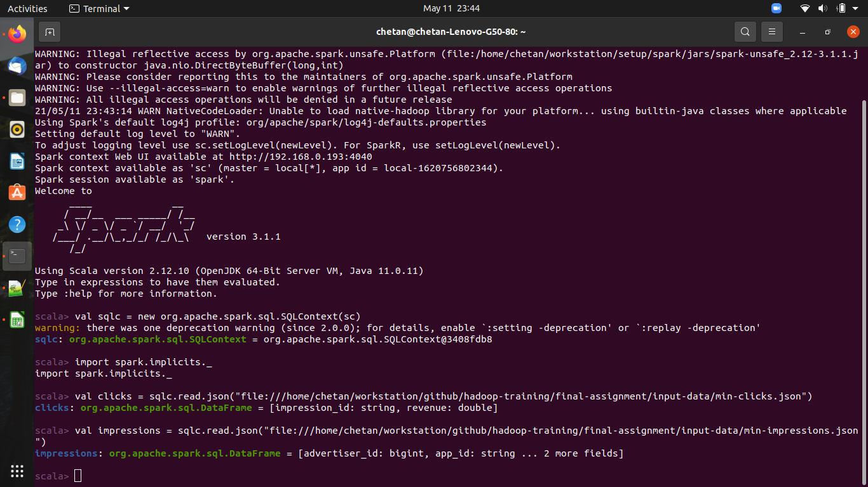

### 2. Calculate metrics for some dimensions

**commands run -**

* clicks.registerTempTable("temp_clicks")
* impressions.registerTempTable("temp_impressions")
* val metricsSQL = sqlc.sql("select m.app_id, m.country_code, count(m.id) as impression, count (c.impression_id) as clicks, sum (c.revenue) from temp_impressions m left join temp_clicks c on m.id = c.impression_id group by m.app_id, m.country_code")
* metricsSQL.write.format("json").mode("append").save("/home/chetan/workstation/github/hadoop-training/final-assignment/2-spark/goal-2-calculate-metrics/metrics.json")

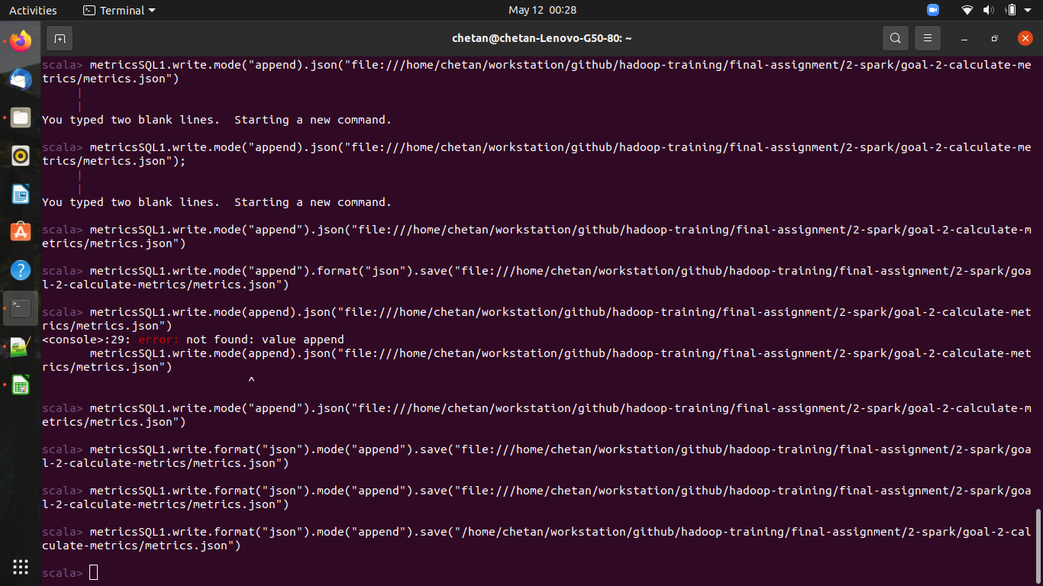

### **3. Make a recommendation for the top 5 advertiser_ids to display for each app and country combination.**

**commands run -**

* val recommendationSQL = sqlc.sql("select m.app_id, m.country_code, m.advertiser_id, sum (c.revenue) as t_revenue from temp_impressions m left join temp_clicks c on m.id = c.impression_id group by m.app_id, m.country_code, m.advertiser_id order by m.app_id, m.country_code , t_revenue desc")
* recommendationSQL.write.format("json").mode("append").save("/home/chetan/workstation/github/hadoop-training/final-assignment/2-spark/goal-3-top-recommendation")

