
VELLORE INSTITUTE OF TECHNOLOGY, VELLORE
School of Computer Science and Engineering (SCOPE)
BCSE306L – Artificial Intelligence
Slot: C1 + TC1 · Project Document (Digital Assignment)
VaktaAI
A Multimodal AI Speech Coach with Webcam Heart-Rate, Audience-Gaze, Emotional-Congruence and Rhetoric Analysis
Team Members
Name | Registration Number
Chetan Grover | 23BCE0063
Submitted to: Dr. Shashank Mouli Satapathy
16th October, 2026

1. Title Page
See the cover page of this document (VIT logo, school, course code and name, project title, team members and registration numbers).

2. Structured Abstract
Introduction: Public speaking skill depends on what is said, how it is voiced and how the speaker looks and feels, yet most practice tools score only one channel and give generic advice. Existing AI coaches rarely use physiological signals, ignore where the speaker looks in the room and cannot tell when voice and face send conflicting emotions.
Methods: VaktaAI turns one 30 s–5 min webcam recording into a report through three parallel streams. The audio stream uses Whisper ASR, Praat prosody and a wav2vec 2.0 valence–arousal model. The video stream uses MediaPipe Face Mesh, L2CS-Net gaze mapped to a 3×3 virtual audience grid, HSEmotion facial valence–arousal and webcam rPPG heart rate from a PhysNet/POS/CHROM consensus. The transcript stream performs rhetoric analysis with a QLoRA-tuned LLM or a heuristic fallback. A fusion engine produces trait scores, an emotional-congruence distance, a confidence timeline and targeted drills; a VAE clusters sessions into speaker personas.
Results: All 12 analysis modules ran end-to-end on a real 108 s recording on a laptop CPU in about 3.7 min, after optimisations cut stalled stages from over 10 min. The system flagged a weak opener, an abrupt close, low vocal variation, three neglected audience zones and three confidence dips, each linked to evidence segments and drills. 60 of 61 automated tests passed; one awaits a real face fixture video.
Conclusion: A modular, privacy-preserving multimodal pipeline can give explainable, segment-level speaking feedback on commodity hardware. Benchmark evaluation of the learned components on UBFC-rPPG, RAVDESS/CREMA-D and TED transcripts is the next milestone.
Keywords: multimodal fusion, speech analytics, remote photoplethysmography, gaze estimation, affective computing, large language models, public speaking

3. Introduction

3.1 Background and problem definition
Public speaking is consistently reported as one of the most feared everyday activities, and for students it directly affects placements, interviews, seminars and debates. Good delivery is multimodal: listeners judge confidence from pace, pauses and filler words, engagement from vocal and facial expressiveness, credibility from eye contact across the room, and persuasiveness from rhetorical structure. Human coaching is expensive and unavailable at the moment a student rehearses, while existing automated tools typically analyse only the audio track or a single camera-facing eye-contact cue, give one global score, and cannot explain which moment of the talk went wrong or why. The problem addressed by this project is therefore: given a short webcam recording of a speech, automatically produce an explainable, time-aligned assessment of verbal, vocal, visual and physiological delivery, detect moments where these channels contradict each other, and convert each weakness into concrete practice drills.

3.2 Objective and methodology
The objective is to build VaktaAI, an end-to-end web application that (i) records or accepts a 30 s–5 min speech video, (ii) analyses it with independent AI modules, (iii) fuses their outputs into trait scores (confidence, authoritativeness, engagement), an emotional-congruence score and a confidence-dip timeline, (iv) maps every detected weakness to one to three drills with the evidence segment attached, and (v) tracks progress and speaker persona across sessions. Five research enhancements extend a baseline coach: E1 webcam heart-rate and HRV estimation (rPPG), E2 spatio-temporal gaze against a 3×3 virtual audience grid, E3 audio–visual valence–arousal fusion with a congruence distance, E4 LLM-based rhetoric analysis (anaphora, ethos/pathos/logos, transitions), and E5 VAE-based persona clustering.
Methodologically the system is a modular pipeline: every analyser implements a common interface and writes its own JSON output, so modules run in three parallel streams (transcript, audio, video), can fail independently without breaking the report, and can be re-run in isolation. Pretrained models are used wherever they exist (Whisper, wav2vec 2.0, HSEmotion, L2CS-Net, PhysNet), each paired with a transparent fallback (POS rPPG, landmark gaze, prosody/landmark affect proxies, rule-based fusion, heuristic rhetoric, rule personas). Only three components are trained by the team—the E3 cross-attention head, the E4 QLoRA adapter and the E5 VAE—which keeps the compute budget within free Colab/Kaggle GPUs.

3.3 Results, outcomes and analysis
The complete system—FastAPI backend, React dashboard, 12 analysis modules, training notebooks and evaluation scripts—has been implemented and runs locally. On a real 108 s webcam recording, all modules completed with the learned models active (faster-whisper, wav2vec 2.0 V-A, HSEmotion, L2CS-Net, PhysNet), producing confidence 84.6, authoritativeness 82.4, engagement 83.1 and congruence 81.6, together with 6 evidence-linked weaknesses and drills. Engineering analysis on real data exposed and fixed issues that synthetic tests could not reveal—an ASR decoder incompatibility, CPU over-subscription that stalled gaze estimation beyond 10 minutes, Windows file-locking during progress updates, and motion-induced rPPG errors—bringing end-to-end analysis to roughly 2× real time on a CPU-only laptop. The rPPG analysis shows that single-method webcam heart rate is unreliable while the speaker moves, which motivated the multi-method consensus used in the final system.

4. Background / Related Work
The literature relevant to VaktaAI spans multimodal presentation feedback, speech recognition and affect, facial affect and gaze, remote physiological sensing, multimodal fusion and parameter-efficient LLM adaptation. Twelve research articles published from 2020 onwards and four tools/blogs were studied; their contributions and flaws are summarised below and in Table 1.
Multimodal presentation feedback. Ochoa and Dominguez [10] ran the first randomised controlled evaluation of an automated oral-presentation feedback system (RAP) with 180 students over a semester and found a small but significant improvement, with the effect uneven across presentation dimensions; feedback relied on hand-crafted rules over posture, gaze and voice and did not consider physiological arousal or emotional consistency. Rasipuram and Jayagopi [11] reviewed automatic multimodal assessment of soft skills such as interviews and presentations, concluding that most systems are trained on small, lab-collected corpora, generalise poorly and rarely give actionable, explainable feedback. Commercial tools such as Microsoft PowerPoint Speaker Coach [13] and Yoodli [14] make rehearsal feedback accessible but concentrate on verbal delivery metrics such as pace and filler words and provide no physiological or audience-coverage analysis.
Speech recognition and vocal affect. Radford et al. [1] trained Whisper on 680,000 hours of weakly supervised web audio, achieving robust zero-shot recognition across accents and noise, but the model tends to normalise away disfluencies such as “um”, which are exactly what a speaking coach must count, and its training data is not public. Baevski et al. [2] introduced wav2vec 2.0, a self-supervised speech representation that reaches strong word error rates with little labelled data, though large variants are expensive to run on CPUs. Building on it, Wagner et al. [3] showed that transformer-based models fine-tuned on MSP-Podcast substantially improve the prediction of valence from speech—historically the hardest emotion dimension—while noting sensitivity to domain shift and labelling subjectivity.
Facial affect and gaze. Savchenko et al. [4] proposed HSEmotion, a lightweight EfficientNet trained on AffectNet that predicts emotion classes and valence–arousal from a single face image fast enough for real-time use; being frame-based, it ignores temporal context and inherits AffectNet’s posed and demographic biases. Abdelrahman et al. [5] proposed L2CS-Net, which regresses gaze yaw and pitch with separate binned classification and regression losses and reports 3.92° error on MPIIGaze and 10.41° on Gaze360; its outputs are head-centric angles that need per-user calibration before they can be related to targets in a room. Cheong et al. [12] packaged face detection, landmarks, action units, emotion and gaze models into the open Py-Feat toolbox, which eases reproducibility but offers no speech or physiological channels; Google’s MediaPipe Face Landmarker [15] provides 478 dense 3-D landmarks in real time on CPUs and is used here for blink, head-pose and face-crop extraction.
Remote photoplethysmography. Liu et al. [6] released rPPG-Toolbox, a benchmark of classical (POS, CHROM) and deep (PhysNet, DeepPhys, TS-CAN, PhysFormer) methods on UBFC-rPPG, PURE, SCAMPS and MMPD, revealing large cross-dataset performance drops and that unsupervised methods remain competitive; almost all benchmark recordings feature still, well-lit subjects. Yu et al. [7] proposed PhysFormer, a temporal-difference transformer that improves accuracy on VIPL-HR and other datasets but is heavy to train and still sensitive to head motion. The open rPPG-Toolbox repository [16] supplies the pretrained PhysNet weights used in VaktaAI. None of these works studies a speaking person who moves while talking—the setting of this project.
Multimodal fusion and LLM adaptation. Praveen et al. [8] proposed joint cross-attention fusion of audio and visual features for dimensional emotion recognition, reaching concordance correlation of 0.374 (valence) and 0.363 (arousal) on the Aff-Wild2 test set; the model predicts a single fused emotion and does not quantify disagreement between modalities, which is the signal a speaking coach needs. Dettmers et al. [9] introduced QLoRA, which fine-tunes 4-bit quantised LLMs with low-rank adapters on a single GPU (their Guanaco model reaches 99.3% of ChatGPT’s performance on the Vicuna benchmark), enabling small instruction models to be specialised for structured tasks such as rhetoric labelling; evaluation relied heavily on GPT-4-based judgements and quantisation can reduce output reliability.
Table 1: Summary of the reviewed research articles (2020 onwards) and tools
Sl# | Articles | Work Done | Dataset | Gaps / Limitations
1 | Radford et al. [1]  ICML (PMLR), 2023 | - Problem: robust speech recognition across accents/noise.  - Method: encoder–decoder transformer trained on weakly supervised web audio.  - Result: near human-level zero-shot robustness on many benchmarks. | 680k h multilingual web audio (not released); evaluated on LibriSpeech etc.  github.com/openai/whisper | - Training data not public; cannot be audited.  - Drops disfluencies/fillers; word timestamps are heuristic.
2 | Baevski et al. [2]  NeurIPS, 2020 | - Problem: ASR with little labelled speech.  - Method: self-supervised contrastive learning over masked latent speech units.  - Result: low WER using only minutes–hours of labels. | LibriSpeech 960 h; LibriVox (LV-60k, ~53k h unlabelled)  openslr.org/12 | - Read English audiobooks; domain gap to spontaneous speech.  - Large model is slow on CPU.
3 | Wagner et al. [3]  IEEE TPAMI, IEEE, 2023 | - Problem: poor valence prediction from speech.  - Method: fine-tuned wav2vec 2.0/HuBERT for arousal, dominance, valence.  - Result: large valence gains; robustness analysed. | MSP-Podcast (naturalistic podcast segments, dimensional labels)  ecs.utdallas.edu/research/researchlabs/msp-lab | - Podcast domain differs from rehearsal speech.  - Labels subjective; model size high for CPUs.
4 | Savchenko et al. [4]  IEEE Trans. Affective Computing, IEEE, 2022 | - Problem: fast emotion/engagement recognition for e-learning.  - Method: EfficientNet trained on AffectNet with multi-task V-A head.  - Result: competitive AffectNet accuracy at real-time speed. | AffectNet (~1M web face images, ~half manually annotated; 8 emotions + valence/arousal)  mohammadmahoor.com/affectnet | - Frame-level; no temporal modelling.  - Posed/web images; demographic bias.
5 | Abdelrahman et al. [5]  arXiv preprint, 2022 | - Problem: gaze estimation in unconstrained settings.  - Method: ResNet-50 with separate binned yaw/pitch losses.  - Result: 3.92° (MPIIGaze), 10.41° (Gaze360). | MPIIGaze (213,659 images, 15 participants); Gaze360 (238 subjects, 360° range)  gaze360.csail.mit.edu | - Head-centric angles; needs calibration to scene targets.  - Per-frame; no temporal smoothing.
6 | Liu et al. [6]  NeurIPS Datasets & Benchmarks, 2023 | - Problem: fragmented, irreproducible rPPG research.  - Method: unified toolbox of classical + deep rPPG methods.  - Result: benchmark showing cross-dataset gaps. | UBFC-rPPG (42 subjects, 30 fps), PURE (10 subjects, 60 videos), SCAMPS (synthetic), MMPD  github.com/ubicomplab/rPPG-Toolbox | - Mostly still, frontal subjects.  - Limited skin-tone and motion diversity.
7 | Yu et al. [7]  CVPR, IEEE/CVF, 2022 | - Problem: long-range temporal rPPG modelling.  - Method: temporal-difference transformer (PhysFormer).  - Result: state-of-the-art HR on VIPL-HR, MAHNOB-HCI. | VIPL-HR, MAHNOB-HCI, MMSE-HR, OBF (access on request)  — | - Heavy model, needs large training data.  - Head motion and lighting still degrade accuracy.
8 | Praveen et al. [8]  CVPR Workshops, IEEE/CVF, 2022 | - Problem: audio–visual dimensional emotion recognition.  - Method: joint cross-attention fusion.  - Result: CCC 0.374 valence / 0.363 arousal (test). | Aff-Wild2 (~564 in-the-wild videos, V-A annotations)  ibug.doc.ic.ac.uk/resources/aff-wild2 | - Outputs a fused emotion only; no inter-modal disagreement score.  - Noisy in-the-wild labels; heavy backbones.
9 | Dettmers et al. [9]  NeurIPS, 2023 | - Problem: memory cost of LLM fine-tuning.  - Method: 4-bit NF4 quantisation + LoRA adapters (QLoRA).  - Result: Guanaco reaches 99.3% of ChatGPT on Vicuna benchmark. | OASST1 (~161k crowd-sourced messages) and other instruction sets  huggingface.co/datasets/OpenAssistant/oasst1 | - Evaluation largely via GPT-4 judgements.  - Quantisation may reduce reliability of structured output.
10 | Ochoa & Dominguez [10]  British J. Educational Technology, Wiley, 2020 | - Problem: unproven value of automated presentation feedback.  - Method: RCT of the RAP multimodal feedback system.  - Result: small but significant improvement; uneven by dimension. | In-house recordings of 180 students (not public)  — | - Rule-based features; no physiological or affect congruence.  - Single institution; feedback not time-aligned to moments.
11 | Rasipuram & Jayagopi [11]  Multimedia Tools and Applications, Springer, 2020 | - Problem: state of automatic soft-skill assessment.  - Method: systematic review of multimodal methods.  - Result: taxonomy of features, datasets and gaps. | Survey of existing interview/presentation corpora (no new dataset)  — | - Field relies on small lab datasets.  - Little work on explainable, actionable feedback.
12 | Cheong et al. [12]  Affective Science, Springer, 2023 | - Problem: hard-to-use facial expression tools.  - Method: open Python toolbox (Py-Feat) of pretrained detectors.  - Result: unified API for faces, AUs, emotions, gaze. | Models pretrained on public face datasets (e.g. AffectNet)  py-feat.org | - Vision only; no speech or physiology.  - Per-frame outputs; analysis left to the user.
13 | Microsoft Speaker Coach [13]  Tool / support page, Microsoft | - Problem: rehearsal feedback inside PowerPoint.  - Method: speech analysis during slide rehearsal.  - Result: summary report of delivery habits. | Proprietary  support.microsoft.com | - Focuses on verbal metrics; no physiology or audience-grid gaze.  - Closed; cannot be audited or extended.
14 | Yoodli [14]  Tool / product site, 2023+ | - Problem: on-demand AI speech coaching.  - Method: cloud analysis of recorded or live speech.  - Result: analytics on delivery and content. | Proprietary  yoodli.ai | - Video sent to the cloud (privacy).  - No webcam physiology or emotional-congruence analysis.
15 | MediaPipe Face Landmarker [15]  Tool / developer docs, Google | - Problem: real-time face geometry on CPUs/mobile.  - Method: lightweight landmark regression network.  - Result: 478 3-D landmarks incl. iris in real time. | Google internal training data  ai.google.dev/edge/mediapipe | - Landmarks only; no gaze target or emotion.  - Accuracy drops for extreme pose/occlusion.
16 | rPPG-Toolbox repo [16]  Tool / GitHub, ubicomplab | - Problem: reusable rPPG models.  - Method: released configs and pretrained weights.  - Result: PhysNet/TS-CAN weights for PURE, UBFC etc. | Weights trained on PURE, UBFC-rPPG, SCAMPS  github.com/ubicomplab/rPPG-Toolbox | - Pretrained on still subjects; motion untested.  - Research licence; datasets need requests.

5. Summary of Limitations / Gaps
The literature review reveals the following gaps, labelled G1–G6 for mapping to contributions:
- G1 – Single-channel feedback: practical coaching tools [10], [13], [14] focus on verbal metrics or a few rule-based cues; vocal affect, facial affect, gaze coverage and physiology are not combined.
- G2 – No physiological signal in speech coaching: rPPG research [6], [7] targets still subjects and has not been integrated into presentation feedback or tested on moving, talking speakers.
- G3 – Camera-only eye contact: gaze estimators [5], [12], [15] output angles, but feedback tools reduce gaze to “looking at the camera”, ignoring coverage of the whole audience.
- G4 – Fusion without disagreement: audio–visual emotion models [3], [4], [8] predict a fused emotion but do not measure when voice and face contradict each other.
- G5 – Shallow content feedback: tools count fillers and pace but rarely analyse rhetorical devices, appeals or transitions; LLM adaptation [9] has not been applied to this task in an open, validated way.
- G6 – Non-explainable, non-actionable, cloud-based output: most systems give global scores without time-aligned evidence or drills [11], and commercial tools upload video to the cloud [14].

6. Primary Contributions of the Project
- C1 – Unified multimodal pipeline (G1, G6). Twelve independent analysers across transcript, audio and video streams, each with a pretrained model and a transparent fallback, fused into confidence, authoritativeness and engagement scores with a one-line “why” per score.
- C2 – Webcam heart rate and stress for speakers (G2). PhysNet, POS and CHROM rPPG run together; a window is trusted only when at least two methods agree within 8 BPM away from the band edges, a consensus signal-quality index designed for moving speakers. The physiological curve is drawn on the same timeline as confidence.
- C3 – Virtual audience gaze grid (G3). L2CS-Net gaze is calibrated on the first 3 s of each recording and mapped to a 3×3 audience grid, producing dwell time, coverage and neglected-zone alerts instead of a single eye-contact percentage; a GRU smoother is trained on protocol-labelled clips.
- C4 – Emotional-congruence score (G4). Per-segment distance between voice and face valence–arousal, a rule baseline (e.g. smiling while giving bad news) and a cross-attention head trained on RAVDESS/CREMA-D with synthetic mismatched pairs, so incongruent moments are flagged on the timeline.
- C5 – Rhetoric analysis with a validated schema (G5). A QLoRA-tuned Llama-3.2-3B rhetoric model served locally behind a strict pydantic JSON schema with retry and a heuristic fallback, reporting devices, ethos/pathos/logos balance, transition quality and rewrite suggestions.
- C6 – Evidence-linked drills and persona tracking (G6). A YAML rule engine maps 21 weakness types (including E1, E2, E3 and E4 triggers) to a library of 39 drills with the worst evidence segment attached; a VAE + GMM places each session on a persona map to show progress.
- C7 – Privacy-preserving, reproducible deployment (G6). All processing runs locally; raw video is auto-deleted after 7 days; every report logs model and package versions and seeds; analyses are queued one at a time so the system runs on a CPU-only laptop.

7. Individual Contributions

Table 2: Individual contributions of team members
Member | Implementation | Documentation
Chetan Grover  23BCE0063 | - Backend architecture: FastAPI API, SQLModel database, job queue, Analyzer interface and parallel stream runner.  - Ingest, ASR (faster-whisper), voice/filler (incl. Hinglish) and face analysers.  - E1 rPPG module with PhysNet/POS/CHROM consensus; E2 L2CS gaze grid, calibration and GRU smoother.  - Performance work: CPU thread budgeting, batched gaze, quantised audio model, Windows-safe I/O.  - E3 audio/face valence–arousal analysers and congruence fusion; RAVDESS/CREMA-D training notebook for the cross-attention head.  - E4 rhetoric module: rubric prompt, pydantic schema, LLM serving and QLoRA notebook; TED silver-label pipeline and hand-checked gold set.  - Rule-based fusion (traits.yaml), timeline events and drill library (drills.yaml).  - React + TypeScript dashboard: recorder with calibration countdown, progress view, video-synced timeline, panels, history and persona map.  - E5 persona features, VAE + GMM training and inference with rule fallback.  - Evaluation scripts (ASR, rPPG, gaze, fusion, rhetoric, persona, latency) and the 61-test pytest suite. | - Requirement analysis, system architecture and methodology sections.  - Result analysis and latency study.  - Literature review (articles 1–4, 8, 9), dataset section.  - Comparative analysis.  - Literature review (articles 5–7, 10–12, tools), user manual with screenshots.  - References, PPT and demonstration video.

8. Tools and Technologies Used

8.1 Hardware requirements
Table 3: Hardware requirements
Component | Used for development and testing | Minimum / recommended
Processor | 8-core x86-64 laptop CPU | 4 cores minimum; 8 cores recommended
Memory | Laptop RAM (models: ~0.5 GB Whisper-small, ~1.3 GB wav2vec2, ~0.1 GB L2CS) | 8 GB minimum; 16 GB recommended (32 GB to serve the 3B LLM on CPU)
GPU | None locally; Google Colab / Kaggle NVIDIA T4 (16 GB) for training | Optional for inference; T4-class GPU for training and for < 3 min analysis
Camera / microphone | Built-in 720p webcam and microphone | 720p, 30 fps webcam; frontal lighting
Storage | ~3 GB for model weights + ~150 MB per recorded session | 10 GB free

8.2 Software requirements
Table 4: Software stack
Layer | Technology (version) | Purpose
Operating system | Windows 11 (also runs on Linux/macOS) | Development and deployment
Language runtimes | Python 3.12, Node.js 20 | Backend/ML and frontend tooling
Backend | FastAPI 0.115, Uvicorn, SQLModel + SQLite, Pydantic 2 | REST API, background jobs, storage, schema validation
Media | FFmpeg (imageio-ffmpeg), OpenCV 4.10, soundfile | Transcoding, frame sampling, audio I/O
Speech | faster-whisper 1.1 (Whisper small), Praat-Parselmouth 0.4.5, librosa | ASR with word timestamps, pitch and energy
Vision | MediaPipe 0.10.14 (Face Mesh), L2CS-Net (Gaze360), HSEmotion-ONNX | Landmarks, blinks, head pose, gaze, facial V-A
Deep learning | PyTorch 2.5, torchvision, Transformers 4.46, ONNX Runtime | PhysNet, wav2vec 2.0 V-A, fusion head, GRU, VAE
LLM | Llama-3.2-3B-Instruct, PEFT/bitsandbytes (QLoRA), OpenAI-compatible server | Rhetoric analysis (E4)
Analytics | scikit-learn (GMM, k-means), NumPy, SciPy | Persona clustering, signal processing
Frontend | React 18 + TypeScript, Vite 5, Tailwind CSS 3, Recharts 2 | Recorder, dashboard and charts
Testing / tools | pytest 8, Git, VS Code + Claude Code, Google Colab | Automated tests, version control, training

9. Methodology Used
Each technique below is implemented as an independent analyser that writes data/sessions/<id>/<module>.json, so it can be tested and re-run separately.

9.1 Speech recognition and voice analysis (F3–F5, S2)
Audio is transcribed with faster-whisper (a CTranslate2 port of Whisper [1]) with word-level timestamps; a disfluent initial prompt keeps fillers in the transcript and greedy decoding is used on CPU. Pitch is extracted every 10 ms with Praat via Parselmouth [22], and pitch variation is expressed in semitones relative to the speaker’s median so it is comparable across voices. Pace is computed per 5 s window, pauses are gaps above 0.4 s between words, and energy is RMS in dB over speech frames. Filler words are detected from a lexicon with context rules: hard fillers (um, uh) always count, soft fillers (like, so, basically) count only when set off by a pause or comma, and a Hinglish lexicon (matlab, toh, yaar, na) supports code-switched speech.

9.2 Face landmarks, blinks and head motion (F6, F8)
MediaPipe Face Mesh [21], [15] gives 478 landmarks per frame at 10 fps. Blinks use the eye aspect ratio (EAR) of Soukupová and Čech [20]; a blink is counted only when EAR dips below 75% of its 2 s rolling median and recovers within 0.5 s, so looking down at notes is not mistaken for blinking. Head pose is derived geometrically from the nose–eye configuration, and head steadiness is measured as jitter around a 1 s moving average so that deliberate turns toward the audience are not penalised. The landmark bounding box also defines a face-crop stream reused by the gaze, emotion and rPPG modules.

9.3 Gaze against a virtual audience grid (E2, F7, F18)
L2CS-Net [5] (ResNet-50, Gaze360 weights) estimates gaze yaw and pitch from face crops, batched at 3 fps and interpolated to the 10 fps timeline; landmark head pose plus iris offset is the fallback. The first 3 s of every webcam recording, during which the UI asks the speaker to look into the camera, define the centre of a 3×3 virtual audience grid. Angles beyond ±8° (yaw) and ±6° (pitch) select the outer columns and rows, and samples beyond ±45°/±35° are off-grid. A mode filter (or a bidirectional GRU trained on protocol-labelled clips) smooths cell sequences; dwell time, coverage, entropy, fixations and neglected cells (< 2% dwell) are reported.

9.4 Valence–arousal from voice and face (E3, F19)
Vocal valence and arousal come from the wav2vec 2.0 [2] dimensional model of Wagner et al. [3] (fine-tuned on MSP-Podcast [31]); the model runs once per 10 s chunk and 2 s windows are mean-pooled from its frame states, with dynamic int8 quantisation on CPU. Facial valence and arousal come from HSEmotion [4] (AffectNet [32]) on face crops at 2 fps. Both streams are mapped to [−1, 1] following Russell’s circumplex model [30]; if a model is unavailable, prosody- and landmark-based proxies are used and are excluded from absolute trait scoring.

9.5 Remote photoplethysmography with consensus (E1, F17)
Mean skin colour is sampled every frame from forehead and cheek regions. Three estimators produce a blood-volume pulse: PhysNet [19] (pretrained weights from rPPG-Toolbox [6], [16]), POS [17] and CHROM [18], each band-pass filtered to 0.7–3 Hz. Heart rate is the spectral peak in 10 s windows (5 s hop) and HRV is RMSSD from peak intervals. A window is reliable only when at least two methods agree within 8 BPM, lie away from the band edges and have adequate spectral signal-quality; RMSSD is kept only in the physiologically plausible 20–150 ms range. A stress index combines heart-rate rise over the opening baseline with RMSSD drop.

9.6 Multimodal fusion, traits and mismatch (F10–F12)
Speech is segmented into ~5 s windows snapped to sentence ends. For each segment, raw features (pace, fillers, pauses, pitch variation, relative energy, audience gaze, head jitter, blink rate, facial expressiveness, vocal arousal, facial warmth, heart-rate rise) are converted to 0–1 “goodness” values with trapezoidal bands, and traits are weighted means with weights renormalised when a modality is missing (traits.yaml). Congruence is the Euclidean distance between voice and face valence–arousal; segments are flagged when the distance exceeds a calibrated threshold or a rule fires. The learned E3 head is a two-layer cross-attention transformer [25], [8] over the audio and face embedding sequences that predicts emotion, fused V-A, per-modality V-A and a mismatch probability; it is trained on RAVDESS [26] and CREMA-D [27] with synthetic mismatched pairs.

9.7 Rhetoric analysis with an LLM (E4, F9, F20)
A rubric prompt asks the model for devices, appeals, transitions, a transition-quality score and rewrite suggestions as JSON. Llama-3.2-3B-Instruct is fine-tuned with QLoRA [9] (4-bit NF4, LoRA [24] rank 16) on TED transcript segments [29] labelled by a stronger teacher model and validated by the same pydantic schema; 100 hand-checked segments form the test set. Output is validated, retried with the validation error, and otherwise replaced by a heuristic analyser (sentence-initial repetition for anaphora, list patterns for tricolon, lexicons for appeals and transitions). Rule-based structure checks classify the opener and closer.

9.8 Timeline, drills and personas (F13, F14, E5)
The timeline aligns confidence, BPM, stress, valence and gaze cell per second and emits events: confidence dips, mismatches, heart-rate spikes, filler clusters, long pauses and neglected zones. The drill engine evaluates 21 YAML rules over all module metrics, ranks weaknesses by severity and attaches one to three drills plus the worst segment as evidence. For personas, each session becomes a 24-feature vector; a variational autoencoder [23] with a 2-D latent space and a Gaussian mixture model clusters sessions, and clusters are named from their centroid profiles (e.g. Fast Talker, Monotone Presenter). Until enough data exists, a transparent rule map (delivery energy × polish) is used.

10. Dataset Used
VaktaAI uses two kinds of data: (a) the speech sessions it records, from which it derives per-segment multimodal feature datasets, and (b) public benchmark datasets for training and evaluating the learned components.

10.1 VaktaAI session data (primary data)
Each session is a webcam recording (WebM, 30 s–5 min) normalised to 640-pixel-wide 30 fps H.264 video and 16 kHz mono audio. The pipeline converts it into a time-aligned dataset at three granularities: per frame (10 fps landmarks, gaze angles, EAR), per second (confidence, BPM, stress, valence/arousal, gaze cell, energy, pitch) and per segment (~5 s). The sample below comes from the analysed 108 s session (22 segments, 223 words).
Table 5: Sample of the per-segment feature dataset (first 8 segments of the real session)
Segment (s) | WPM | Fillers /min | Pause ratio | Pitch std (st) | On-grid | Zones | Head jitter (°) | Face val. | Voice val. | BPM | Confidence
0.0–5.2 | 35 | 0.0 | 0.09 | 4.62 | 1.00 | 3 | 2.7 | -0.13 | -0.15 | 70 | 85.0
5.2–10.2 | 168 | 0.0 | 0.12 | 0.50 | 1.00 | 3 | 6.3 | -0.10 | 0.39 | 70 | 94.5
10.2–15.2 | 166 | 0.0 | 0.09 | 0.77 | 1.00 | 4 | 1.8 | -0.22 | 0.34 | – | 99.7
15.2–20.2 | 132 | 12.0 | 0.26 | 2.12 | 1.00 | 4 | 5.8 | -0.06 | 0.16 | 56 | 70.8
20.2–25.2 | 96 | 36.0 | 0.49 | 1.54 | 1.00 | 4 | 5.6 | -0.08 | -0.07 | 55 | 57.2
25.2–30.2 | 168 | 0.0 | 0.00 | 0.54 | 1.00 | 5 | 6.9 | -0.18 | 0.30 | 52 | 91.5
30.2–35.2 | 120 | 0.0 | 0.00 | 1.73 | 1.00 | 6 | 7.5 | -0.23 | 0.22 | 50 | 91.3
35.2–40.2 | 192 | 0.0 | 0.00 | 1.40 | 1.00 | 2 | 6.0 | -0.30 | 0.24 | 53 | 87.2

Characteristics: segments are variable-length (5 s ± 1.5 s, snapped to sentence ends); WPM and fillers per minute come from word timestamps; pause ratio is the share of the segment in pauses ≥ 0.4 s; pitch std is in semitones around the speaker’s median; on-grid is the share of gaze samples inside the audience grid; zones is the number of distinct grid cells visited; head jitter is yaw deviation from its 1 s trend; valence values lie in [−1, 1]; BPM is the consensus rPPG estimate (blank when no reliable window covers the segment); confidence is the fused trait score (0–100). Missing values are expected and handled by weight renormalisation. Each session also yields a 24-dimensional persona vector (Section 9.8) used to train the E5 VAE.

10.2 Public datasets for training and evaluation
Table 6: Public and collected datasets
Dataset | Source / reference | Properties | Use in VaktaAI
RAVDESS | Livingstone & Russo [26]; zenodo.org/records/1188976 | 24 professional actors (12 F, 12 M); audio-visual speech at 1280×720, 30 fps; 8 emotions (neutral, calm, happy, sad, angry, fearful, disgust, surprised), 2 intensities; 1,440 speech files per modality | Train/test E3 head (actors 19–24 held out)
CREMA-D | Cao et al. [27]; github.com/CheyneyComputerScience/CREMA-D | 7,442 clips from 91 actors (48 M, 43 F, ages 20–74, diverse ethnicities); 12 sentences; 6 emotions (anger, disgust, fear, happy, neutral, sad) at several intensities | Additional E3 training data; speaker-independent split
UBFC-rPPG (DATASET_2) | Bobbia et al. [28]; sites.google.com/view/ybenezeth/ubfcrppg | 42 subjects, ~1–2 min each, 640×480 at 30 fps, uncompressed; ground-truth PPG and heart rate from a finger pulse oximeter | E1 MAE/RMSE of PhysNet vs POS/CHROM vs consensus
TED Talks transcripts | Banik [29]; kaggle.com/datasets/rounakbanik/ted-talks | Transcripts of ~2,500 TED talks (English) with URLs; cut into 120–220-word segments; labelled with the rhetoric JSON rubric | E4 QLoRA training (silver) and 100 hand-checked test labels
Own gaze clips | Recorded by the team (protocol in training/e2_gaze_smoother.py) | 20–30 clips: 3 s at the camera, then 3 s at each of 9 wall targets; labels derived from timing | Train/evaluate E2 GRU smoother

Sample rows from public datasets follow their published formats: a RAVDESS file name such as 01-01-03-01-01-01-12.mp4 encodes modality (01 = audio-video), vocal channel (01 = speech), emotion (03 = happy), intensity, statement, repetition and actor (12); a CREMA-D file name such as 1001_DFA_ANG_XX.flv encodes actor, sentence, emotion (ANG) and intensity; UBFC ground_truth.txt holds three rows: PPG signal, heart rate and timestamps.

11. Proposed Approach
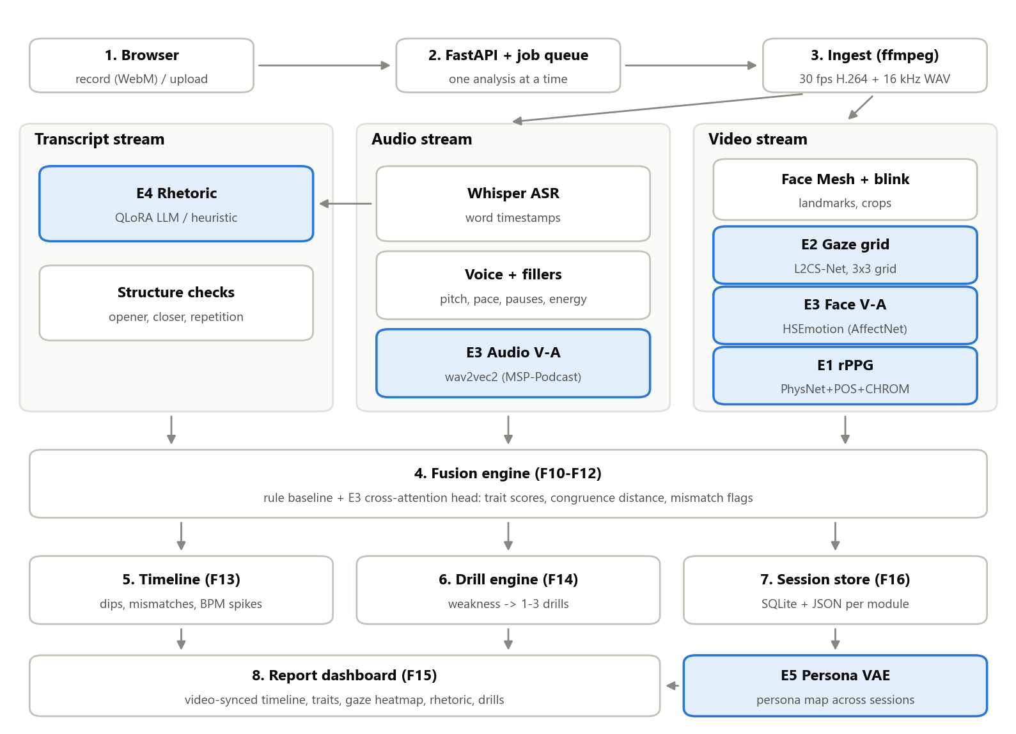
Figure 1: System architecture of VaktaAI (tinted boxes are the five research enhancements E1–E5)
The process flow shown in Figure 1 is as follows:
- Capture. The React app records the webcam and microphone with MediaRecorder (auto-gain disabled so loudness variation is real), shows a 3 s “look at the camera” countdown for gaze calibration, or accepts an MP4/WebM/MOV upload of up to 200 MB.
- API and queue. FastAPI stores the upload and metadata, creates a session row in SQLite and queues the job; jobs run one at a time and unfinished jobs resume after a restart. The UI polls per-stage progress.
- Ingest. FFmpeg normalises the video to 30 fps H.264 and extracts 16 kHz mono audio; duration limits (30 s–5 min) are checked.
- Three parallel streams. The audio stream runs ASR → voice and fillers → vocal V-A; the transcript stream starts as soon as ASR finishes and runs structure checks and E4 rhetoric; the video stream runs Face Mesh → E2 gaze → E3 facial V-A → E1 rPPG. Each module writes its own JSON and falls back gracefully if its model is missing.
- Fusion. Segment features from all modules are combined into trait scores with explanations, congruence distances and mismatch flags (rule baseline plus the learned E3 head when available).
- Timeline, drills and storage. Per-second channels and events are built, weaknesses are mapped to drills with evidence segments, and the report, persona vector and model versions are saved.
- Report and personas. The dashboard shows the video synchronised with the timeline (clicking any chart or event seeks the video), panels for each modality, drills that can be ticked off, and a history page with trends, session comparison and the E5 persona map.

12. Result Analysis & Discussion
The system was evaluated on a real 108 s webcam recording of a team member giving a self-introduction, analysed on a CPU-only Windows laptop, and by the automated test suite. Learned-component benchmarks (Section 13) are scheduled after the training runs; all numbers below are measured, not simulated.

12.1 Pipeline completeness and latency
Table 7: Final end-to-end run: modules, models and processing time
Stage | Model actually used | Time (s) | Status
Ingest (FFmpeg) | FFmpeg (libx264) | 24.0 | ok
Transcription | faster-whisper/small | 102.2 | ok
Voice + fillers | parselmouth | 0.9 | ok
Voice emotion (E3) | wav2vec2 dimensional (int8) | 95.5 | ok
Rhetoric (E4) | heuristic (LLM adapter pending) | 0.03 | ok
Face mesh + blinks | mediapipe-facemesh | 31.6 | ok
Audience gaze (E2) | l2cs-gaze360 + mode-filter | 83.1 | ok
Facial emotion (E3) | hsemotion/enet_b0_8_va_mtl | 22.4 | ok
Heart rate (E1) | consensus(physnet,pos,chrom) | 55.3 | ok
Fusion / timeline / drills | rule (E3 head pending) | 0.4 | ok

Table 7 shows that every module completed with its learned model active (except the E3 fusion head and E4 adapter, which are still being trained, so their fallbacks ran). Because the audio stream (~198 s) and video stream (~192 s) run in parallel, the 108 s recording was analysed in about 3.7 minutes, roughly 2× real time on a CPU.
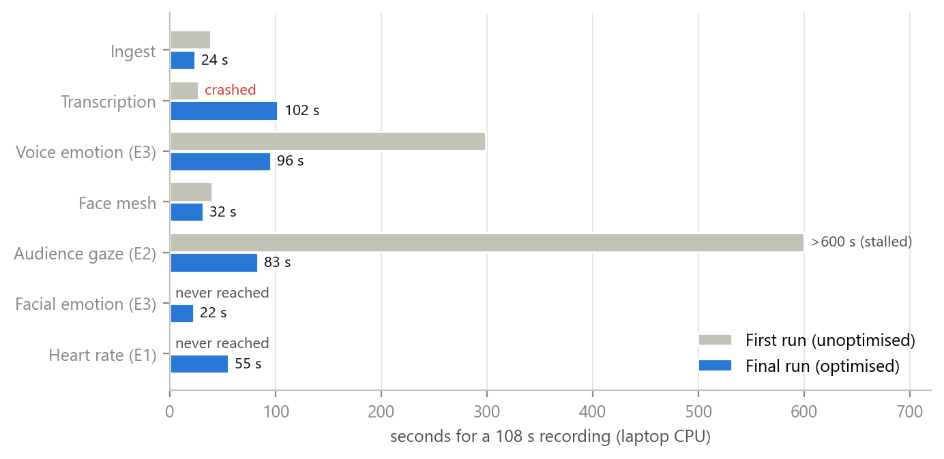
Figure 2: Per-stage processing time before and after optimisation (108 s recording, laptop CPU)
Figure 2 explains how this was achieved. In the first real run transcription crashed (a PyAV/faster-whisper incompatibility), the vocal-emotion model took 299 s because overlapping windows re-processed each second of audio four times, and gaze estimation stalled for over 10 minutes because L2CS processed frames one by one while competing with the audio model for all CPU cores. Passing decoded audio directly to Whisper, running wav2vec 2.0 once per 10 s chunk with int8 quantisation, batching L2CS at 3 fps and giving each stream half of the cores reduced these stages by 3–7× and allowed all stages to finish.

12.2 Trait scores and explanations
Table 8: Overall trait scores with their one-line explanations
Trait | Score (0–100) | Explanation generated by the system
Confidence | 84.6 | Head steadiness (6.05 deg jitter) held this back; filler words (3.32 /min) helped.
Authoritativeness | 82.4 | Head steadiness (6.05 deg jitter) held this back; vocal energy (0.0881 dB vs. your median) helped.
Engagement | 83.1 | Pitch variation (1.27 semitones) held this back; facial expressiveness (0.176 V-A std) helped.
Emotional congruence | 81.6 | Mean voice–face V-A distance 0.522 (threshold 0.9); 0 mismatch segments

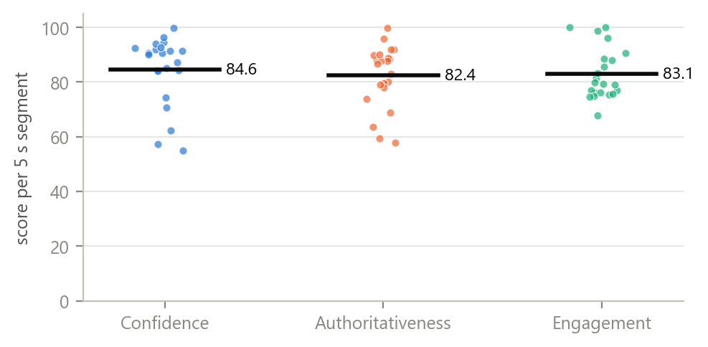
Figure 3: Distribution of per-segment trait scores (dots) and overall duration-weighted score (bar)
Figure 3 shows that the overall scores in Table 8 hide considerable variation: engagement ranges from about 60 to 100 across segments. This is why VaktaAI reports segment-level scores and a timeline rather than a single number. The explanations point to concrete, measurable causes (head jitter of 6.05°, pitch variation of 1.27 semitones), satisfying the requirement that every score has a one-line “why”.
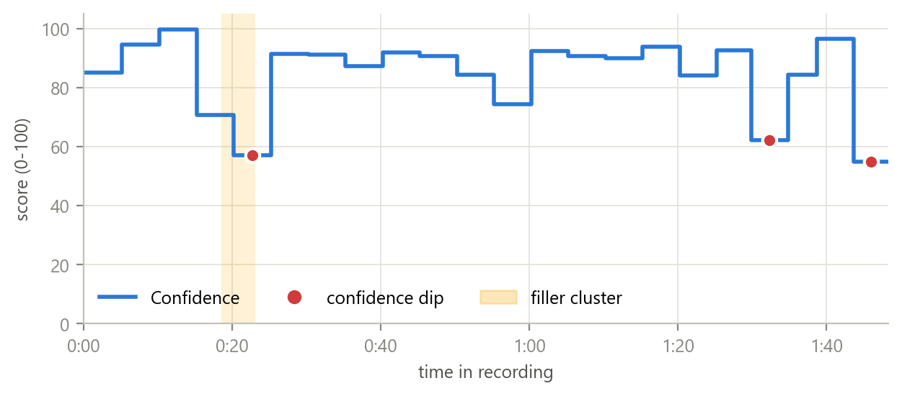
Figure 4: Confidence per segment over the recording with detected dips and filler cluster
In Figure 4 the first dip (about 0:20) coincides with a cluster of four fillers (“basically, uh, you know, uh”) and the last dip comes from the closing segment (“…so yeah, thank you”). This is exactly the moment-level evidence a speaker can replay from the dashboard.

12.3 Voice, gaze and content findings
Table 9: Key voice, gaze and content metrics of the analysed session
Metric | Value | Interpretation
Speaking rate | 130.5 wpm (±42 across windows) | Within the comfortable 120–165 wpm band, but uneven
Fillers | 6 (3.32 /min) | Slightly above the 2–3 /min target; clustered at 0:18–0:23
Pitch variation | 2.19 semitones (range 7.1 st) | Moderate; individual segments were flatter (persona: Monotone Presenter)
Loudness variation | 2.17 dB | Low; recorded before browser auto-gain was disabled, which compresses dynamics
Camera/centre gaze | 57% | Strong camera contact
Audience coverage | 44% of zones; neglected: back-left, mid-left, front-left | Left side of the room ignored
Opener / closer | weak-greeting / abrupt | Greeting-only opening and an abrupt close
Appeals (ethos/pathos/logos) | 56% / 11% / 33% | Self-introduction leans on credibility; little emotional appeal

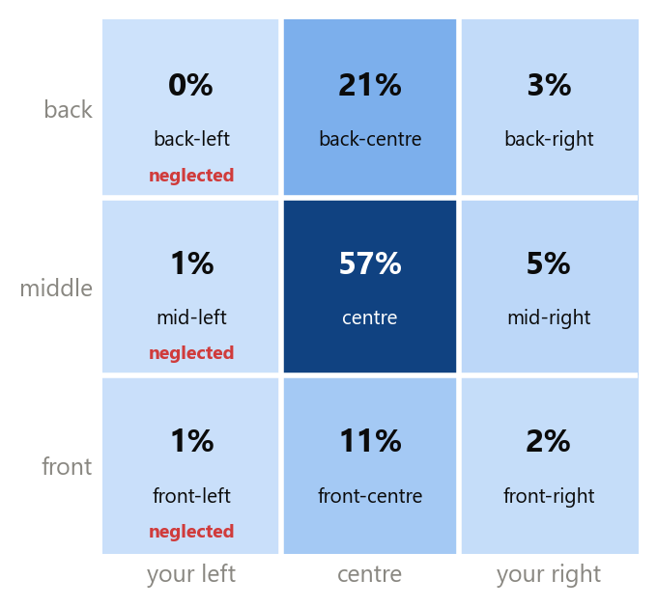
Figure 5: Virtual-audience gaze heatmap (dwell share per zone, speaker’s viewpoint)
Figure 5 illustrates the value of the audience grid over a single eye-contact percentage: although the speaker looked at the camera/centre 57% of the time, the whole left column received under 2% of attention, which the system reports as three neglected-zone alerts and a “lighthouse sweep” drill.

12.4 Webcam heart rate under motion
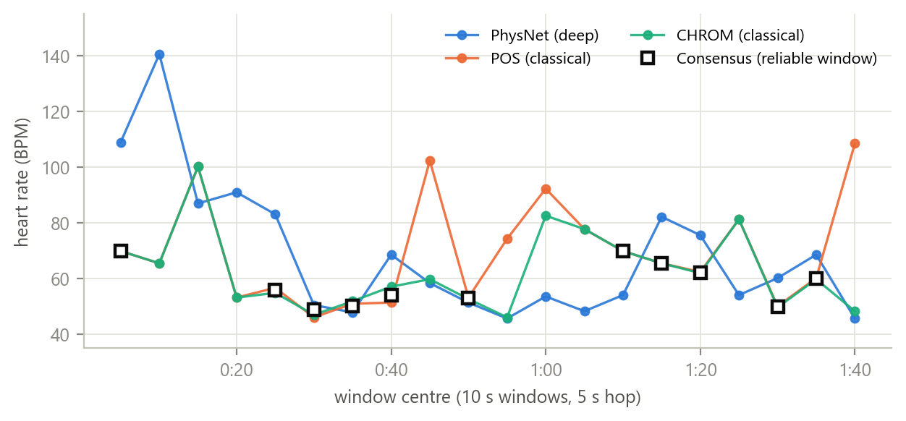
Figure 6: Per-window heart-rate estimates of PhysNet, POS and CHROM and the consensus estimate
Table 10: Agreement of rPPG methods on the real recording
Method | Median BPM | IQR (BPM) | Windows at band edge | Reliable windows
PhysNet (deep) | 58.4 | 31.7 | 10% | –
POS (classical) | 65.5 | 24.6 | 5% | –
CHROM (classical) | 59.8 | 18.0 | 5% | –
Consensus (≥2 agree) | 55.8 | 11.9 | 0% | 11 of 20 (55%)

Figure 6 and Table 10 show that a moving, talking speaker is a hard case for webcam rPPG: single methods jump between about 45 and 140 BPM, and many estimates sit at the lower edge of the band, a typical signature of head-motion artefacts. The consensus rule keeps 55% of windows, discards implausible spikes and reduces the spread of estimates. A limitation is visible as well: POS and CHROM are both colour-based and often agree with each other, so their agreement is weaker evidence than agreement with PhysNet. Ground-truth validation on UBFC-rPPG is therefore planned before heart-rate claims are made, and the dashboard labels the signal as indicative, not medical.
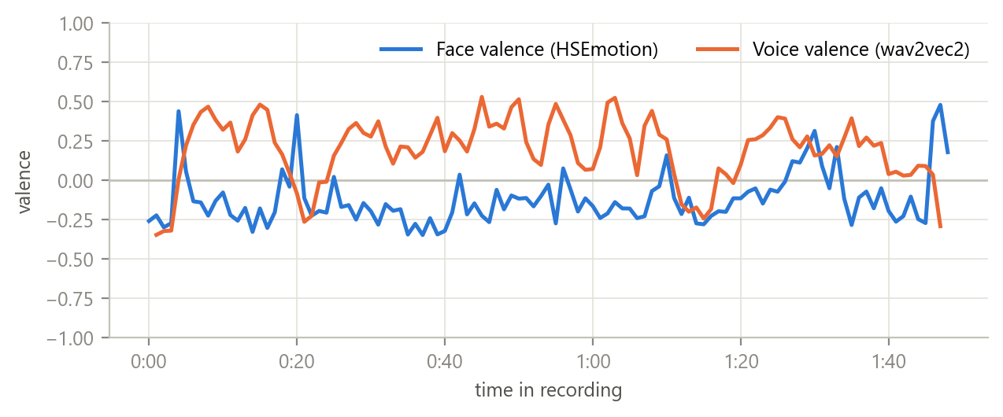
Figure 7: Per-second valence from the face (HSEmotion) and voice (wav2vec 2.0)
Figure 7 shows the two affect channels used for congruence. The voice was mildly positive while the face stayed slightly negative; the average distance of 0.52 stayed below the 0.9 threshold, so no segment was flagged, matching the speaker’s neutral self-introduction.

12.5 Drills and verification
Table 11: Weaknesses mapped to drills with evidence segments
Weakness detected | Measured value | Drills assigned | Evidence
Weak opening | 0.30 (threshold 0.7) | Hook rewrite, Cold open | 0.0–5.2 s
Abrupt ending | 0.35 (threshold 0.7) | Call-to-action close, Callback close | 103.7–108.3 s
Little variation in volume | 2.17 (threshold 4) | Volume dial, Project to the back wall | 55.2–60.2 s
Little emotional appeal | 0.11 (threshold 0.2) | Story injection, Sensory detail | whole talk
Very high blink rate | 42.11 (threshold 35) | Box breathing, Soft focus | 10.2–15.2 s
Restless head movement | 6.05 (threshold 4) | Grounding stance, Still point | 80.2–85.2 s

Table 12: Automated test suite results
Test area | Tests | What is verified
Ingest and I/O | 4 | Transcoding, 10 fps sampling, duration limits, Windows-safe atomic writes
Voice | 7 | Hard/soft/Hinglish fillers, pauses, WPM, pitch of a 200 Hz tone (±3 Hz)
Face | 7 | EAR, blink vs looking-down, yaw sign, face-track interpolation, real-face fixture (skipped until recorded)
Gaze | 5 | Grid mapping, calibration, mode filter, neglected-zone alerts
rPPG | 7 | POS/CHROM recover a synthetic 72/90 BPM pulse within 3 BPM; consensus rules; full analyser on synthetic video
Affect | 4 | Proxy fallbacks when learned models are unavailable
Content | 7 | Opener/closer, devices, appeals, schema validation, LLM retry, fallback
Fusion/timeline/drills | 5 | Segmentation, trait scores, mismatch rules, no inflation without ASR
Neural networks | 7 | PhysNet/L2CS/fusion-head/GRU shapes, checkpoint loading, learned-path switching
Personas | 4 | 24-feature vectors, rule personas, VAE + GMM training
API end-to-end | 4 | Upload → report → drills → history → delete, cancellation of deleted jobs
Total | 61 | 60 passed, 1 skipped (needs a real face fixture video)

13. Comparative Analysis
Table 13: Capability comparison with reviewed systems and tools (based on published descriptions)
Capability | VaktaAI | RAP [10] | Speaker Coach [13] | Yoodli [14] | Praveen et al. [8] | rPPG-Toolbox [6]
Speech content / fillers | Yes | Partial | Yes | Yes | No | No
Vocal prosody (pace, pitch) | Yes | Yes | Partial | Yes | No | No
Facial affect (valence–arousal) | Yes | No | No | No | Yes | No
Audience-wide gaze coverage | Yes (3×3 grid) | Partial | No | Partial | No | No
Physiology (webcam heart rate) | Yes (consensus) | No | No | No | No | Yes
Voice–face congruence score | Yes | No | No | No | No | No
Rhetoric (devices, appeals) | Yes | No | Partial | Partial | No | No
Time-aligned evidence + drills | Yes | Partial | Partial | Partial | No | No
Runs locally / open source | Yes | No | No | No | Yes | Yes

Table 13 shows that existing work covers individual channels well—research models for emotion fusion [8] or rPPG [6], and practical tools for verbal delivery [13], [14]—but no reviewed system combines physiology, audience-wide gaze, voice–face congruence and rhetoric with time-aligned evidence and drills. This integration, and the ability to run without uploading video to a third party, are VaktaAI’s main differentiators.
Table 14: Methodology and performance comparison with the literature
Component | Reported in literature | VaktaAI status / measured | Planned comparison
Gaze | L2CS-Net: 3.92° (MPIIGaze), 10.41° (Gaze360) [5] | L2CS-Net used for 9-zone mapping; calibrated per session | 9-cell accuracy vs head-pose-only and raw L2CS; target ≥ 75%
Audio–visual emotion | Joint cross-attention: CCC 0.374 / 0.363 on Aff-Wild2 [8] | Rule + distance baseline running; head trained next | Accuracy/CCC on RAVDESS held-out actors; learned vs rule
Webcam heart rate | Benchmarks on still subjects in rPPG-Toolbox [6] | Consensus keeps 55% of windows on a moving speaker | MAE/RMSE on UBFC-rPPG: PhysNet vs POS vs CHROM vs consensus; target ≤ 6 BPM
Rhetoric LLM | QLoRA close to ChatGPT on Vicuna benchmark [9] | Schema-validated heuristic fallback running | F1 per device and appeal MAE on 100 hand labels: QLoRA vs prompting
Feedback effect | Small significant gain in 180-student RCT [10] | Drills with evidence generated per session | Before/after study with 5–8 participants

Table 14 positions the project honestly: the pretrained components inherit published accuracies, while the novel parts (consensus rPPG for moving speakers, audience-grid gaze, congruence fusion and the tuned rhetoric model) are implemented and running, and their benchmark comparisons use the evaluation scripts already included in the repository (eval/).

14. User Manual

14.1 Installation and start-up
- Install Python 3.11+, Node.js 20+ and Git. Clone the repository and open it in VS Code.
- Create the environment: python -m venv .venv, then .venv\Scripts\pip install -r backend/requirements.txt (plus the torch and requirements-ml steps in README.md for learned models).
- Download the pretrained models once: python scripts/download_models.py --get whisper-small hsemotion physnet audio-va l2cs.
- Start the API from backend/: uvicorn app.main:app --reload; start the UI from frontend/: npm install, then npm run dev; open http://localhost:5173.

14.2 Using the application

Figure 8: Login screen: enter a display name to create or open your profile
Enter a name and press Continue. Sessions and progress are stored per name; no password is needed for local use.
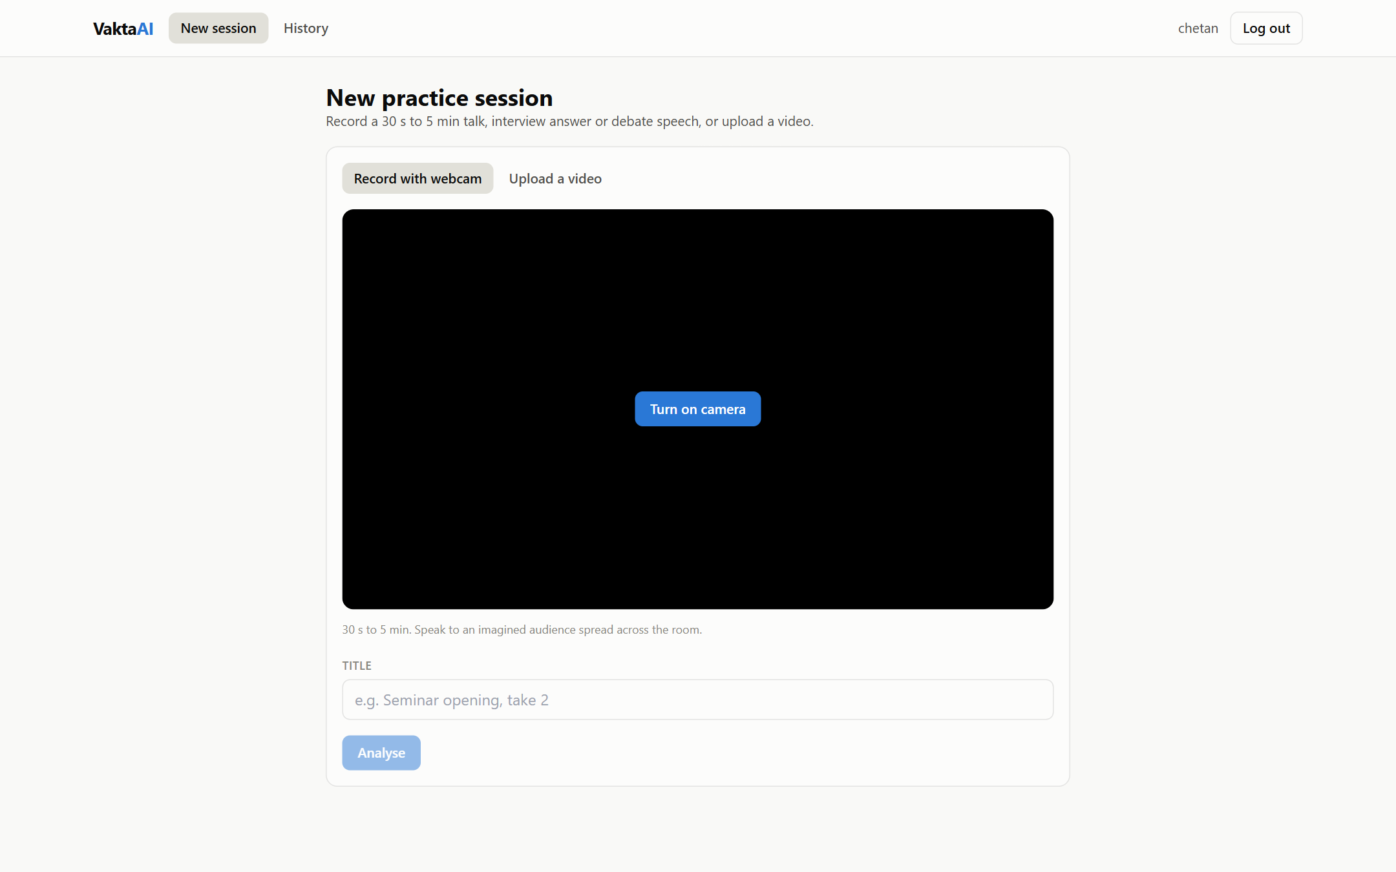
Figure 9: New session: record with the webcam or upload a video
Choose Record with webcam, turn on the camera and press Start recording. For the first 3 seconds look straight into the camera (gaze calibration), then speak for 30 s–5 min as if to an audience spread across the room. Alternatively choose Upload a video (MP4/WebM/MOV, max 200 MB). Give the session a title and press Analyse.
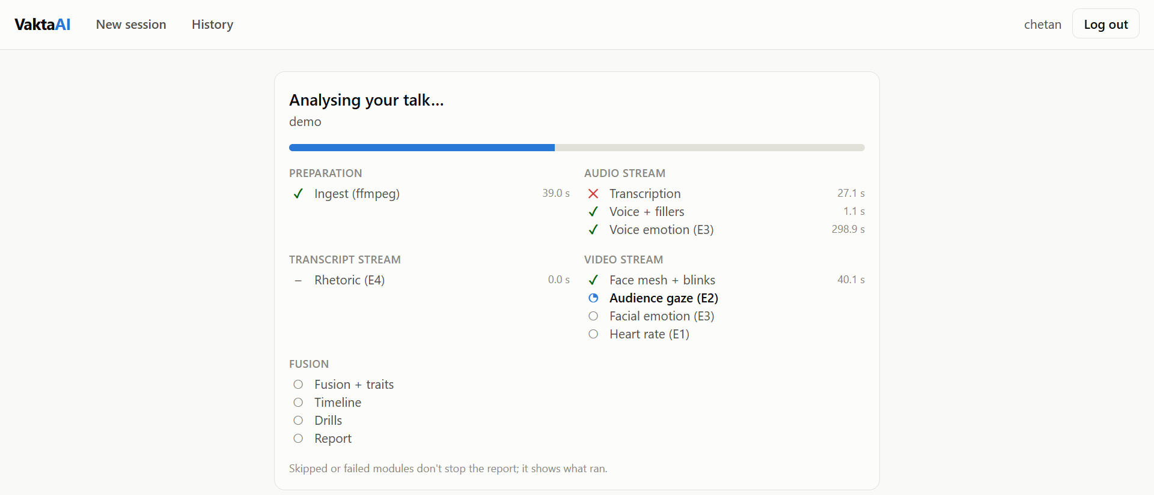
Figure 10: Progress view: live status of every analysis stage (captured during an early test run; the red cross shows how a failed module is reported while the rest of the analysis continues)
The progress view shows each stage of the preparation, audio, transcript, video and fusion streams with its running time. If another analysis is running, the session waits in the queue. Skipped or failed modules do not stop the report.
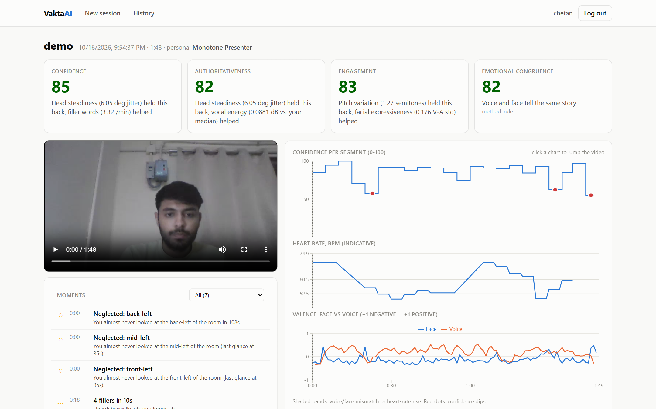
Figure 11: Report: trait cards with explanations, video synchronised with the confidence, heart-rate and valence timeline, and flagged moments
The report opens with the confidence, authoritativeness, engagement and emotional-congruence scores, each with a one-line explanation. Below, the video is synchronised with the timeline: click any point on a chart, or any item in the Moments list (dips, mismatches, heart-rate rises, filler clusters, neglected zones), to replay that moment. Further down are the drills (tick them off as you practise), voice, audience-gaze, heart-rate, valence–arousal and rhetoric panels, the clickable transcript with fillers underlined, and an Under-the-hood panel listing the models used, with buttons to re-analyse, delete the video or delete the session.
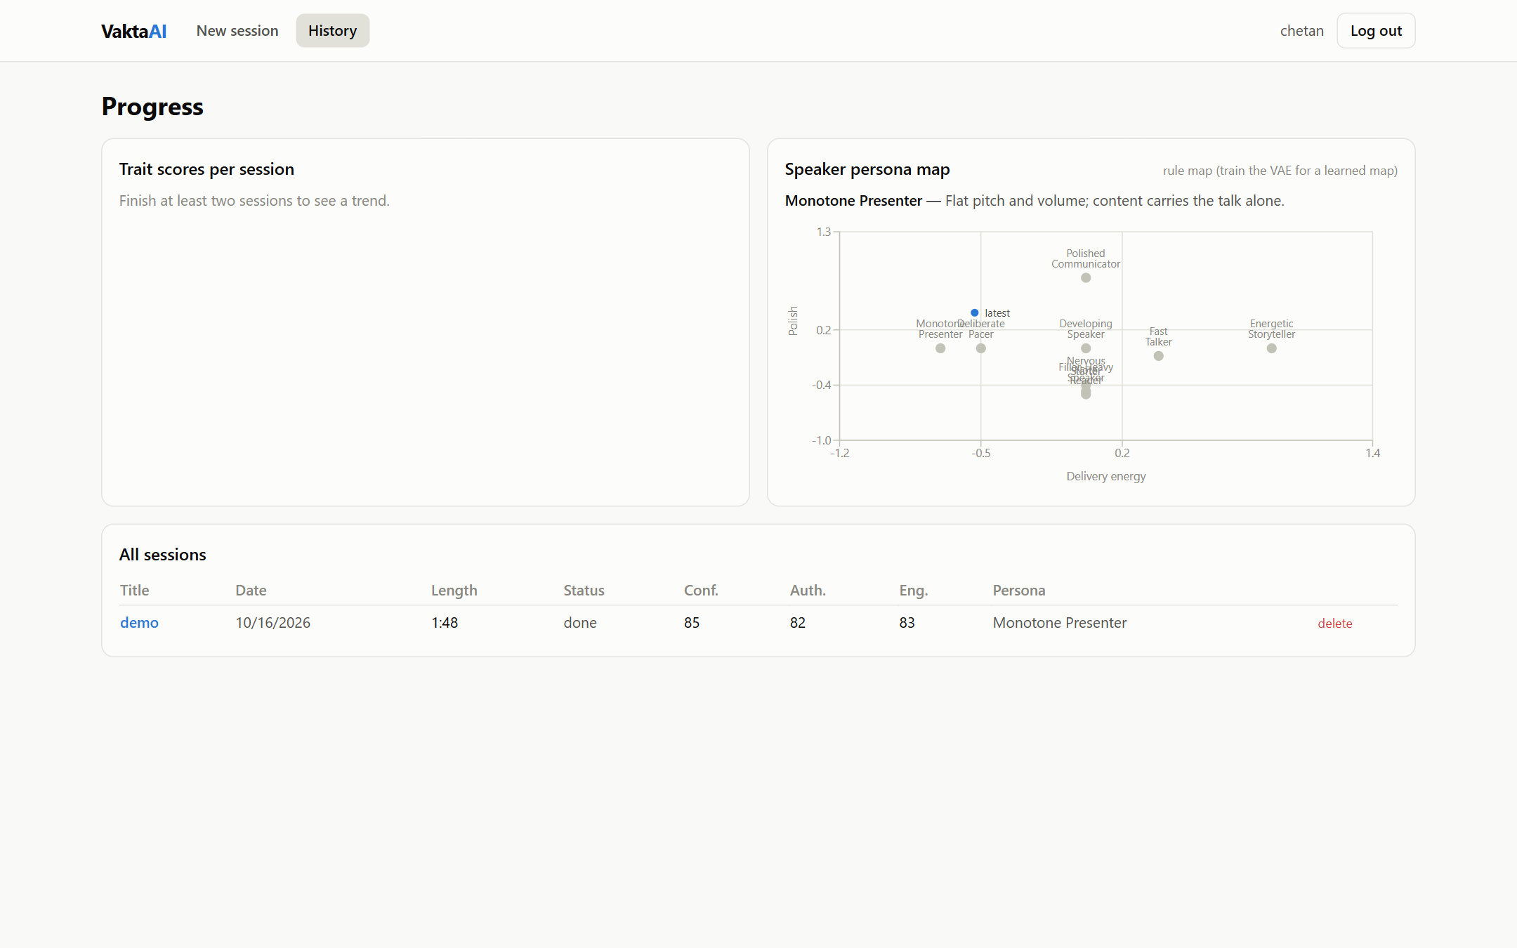
Figure 12: History: trait trends, speaker persona map and all sessions
The History page shows trait scores across sessions, a before/after comparison table, the speaker persona map with your trajectory and the list of all sessions, each of which can be opened or deleted.

15. References
[1] Radford, Alec, et al. "Robust Speech Recognition via Large-Scale Weak Supervision." Proceedings of the 40th International Conference on Machine Learning, PMLR, vol. 202, 2023.
[2] Baevski, Alexei, et al. "wav2vec 2.0: A Framework for Self-Supervised Learning of Speech Representations." Advances in Neural Information Processing Systems, vol. 33, 2020, pp. 12449–12460.
[3] Wagner, Johannes, et al. "Dawn of the Transformer Era in Speech Emotion Recognition: Closing the Valence Gap." IEEE Transactions on Pattern Analysis and Machine Intelligence, vol. 45, no. 9, 2023, pp. 10745–10759.
[4] Savchenko, Andrey V., Lyudmila V. Savchenko, and Ilya Makarov. "Classifying Emotions and Engagement in Online Learning Based on a Single Facial Expression Recognition Neural Network." IEEE Transactions on Affective Computing, vol. 13, no. 4, 2022, pp. 2132–2143.
[5] Abdelrahman, Ahmed A., et al. "L2CS-Net: Fine-Grained Gaze Estimation in Unconstrained Environments." arXiv preprint arXiv:2203.03339, 2022.
[6] Liu, Xin, et al. "rPPG-Toolbox: Deep Remote PPG Toolbox." Advances in Neural Information Processing Systems, Datasets and Benchmarks Track, vol. 36, 2023.
[7] Yu, Zitong, et al. "PhysFormer: Facial Video-Based Physiological Measurement with Temporal Difference Transformer." Proceedings of the IEEE/CVF Conference on Computer Vision and Pattern Recognition, 2022, pp. 4186–4196.
[8] Praveen, R. Gnana, et al. "A Joint Cross-Attention Model for Audio-Visual Fusion in Dimensional Emotion Recognition." Proceedings of the IEEE/CVF Conference on Computer Vision and Pattern Recognition Workshops, 2022, pp. 2486–2495.
[9] Dettmers, Tim, et al. "QLoRA: Efficient Finetuning of Quantized LLMs." Advances in Neural Information Processing Systems, vol. 36, 2023.
[10] Ochoa, Xavier, and Federico Dominguez. "Controlled Evaluation of a Multimodal System to Improve Oral Presentation Skills in a Real Learning Setting." British Journal of Educational Technology, vol. 51, no. 5, 2020, pp. 1615–1630.
[11] Rasipuram, Sowmya, and Dinesh Babu Jayagopi. "Automatic Multimodal Assessment of Soft Skills in Social Interactions: A Review." Multimedia Tools and Applications, vol. 79, 2020, pp. 13037–13060.
[12] Cheong, Jin Hyun, et al. "Py-Feat: Python Facial Expression Analysis Toolbox." Affective Science, vol. 4, 2023.
[13] Microsoft. "Rehearse Your Slide Show with Speaker Coach." Microsoft Support, support.microsoft.com. Accessed 16 Oct. 2026.
[14] Yoodli. "Yoodli: AI Speech Coach." yoodli.ai. Accessed 16 Oct. 2026.
[15] Google. "Face Landmark Detection Guide (MediaPipe Face Landmarker)." Google AI for Developers, ai.google.dev/edge/mediapipe/solutions/vision/face_landmarker. Accessed 16 Oct. 2026.
[16] Ubicomp Lab. "rPPG-Toolbox." GitHub, github.com/ubicomplab/rPPG-Toolbox. Accessed 16 Oct. 2026.
[17] Wang, Wenjin, et al. "Algorithmic Principles of Remote PPG." IEEE Transactions on Biomedical Engineering, vol. 64, no. 7, 2017, pp. 1479–1491.
[18] de Haan, Gerard, and Vincent Jeanne. "Robust Pulse Rate from Chrominance-Based rPPG." IEEE Transactions on Biomedical Engineering, vol. 60, no. 10, 2013, pp. 2878–2886.
[19] Yu, Zitong, Xiaobai Li, and Guoying Zhao. "Remote Photoplethysmograph Signal Measurement from Facial Videos Using Spatio-Temporal Networks." Proceedings of the British Machine Vision Conference, 2019.
[20] Soukupová, Tereza, and Jan Čech. "Real-Time Eye Blink Detection Using Facial Landmarks." 21st Computer Vision Winter Workshop, 2016.
[21] Kartynnik, Yury, et al. "Real-Time Facial Surface Geometry from Monocular Video on Mobile GPUs." arXiv preprint arXiv:1907.06724, 2019.
[22] Jadoul, Yannick, Bill Thompson, and Bart de Boer. "Introducing Parselmouth: A Python Interface to Praat." Journal of Phonetics, vol. 71, 2018, pp. 1–15.
[23] Kingma, Diederik P., and Max Welling. "Auto-Encoding Variational Bayes." International Conference on Learning Representations, 2014.
[24] Hu, Edward J., et al. "LoRA: Low-Rank Adaptation of Large Language Models." International Conference on Learning Representations, 2022.
[25] Vaswani, Ashish, et al. "Attention Is All You Need." Advances in Neural Information Processing Systems, vol. 30, 2017.
[26] Livingstone, Steven R., and Frank A. Russo. "The Ryerson Audio-Visual Database of Emotional Speech and Song (RAVDESS)." PLoS ONE, vol. 13, no. 5, 2018, e0196391.
[27] Cao, Houwei, et al. "CREMA-D: Crowd-Sourced Emotional Multimodal Actors Dataset." IEEE Transactions on Affective Computing, vol. 5, no. 4, 2014, pp. 377–390.
[28] Bobbia, Serge, et al. "Unsupervised Skin Tissue Segmentation for Remote Photoplethysmography." Pattern Recognition Letters, vol. 124, 2019, pp. 82–90.
[29] Banik, Rounak. "TED Talks." Kaggle, 2017, kaggle.com/datasets/rounakbanik/ted-talks.
[30] Russell, James A. "A Circumplex Model of Affect." Journal of Personality and Social Psychology, vol. 39, no. 6, 1980, pp. 1161–1178.
[31] Lotfian, Reza, and Carlos Busso. "Building Naturalistic Emotionally Balanced Speech Corpus by Retrieving Emotional Speech from Existing Podcast Recordings." IEEE Transactions on Affective Computing, vol. 10, no. 4, 2019, pp. 471–483.
[32] Mollahosseini, Ali, Behzad Hasani, and Mohammad H. Mahoor. "AffectNet: A Database for Facial Expression, Valence, and Arousal Computing in the Wild." IEEE Transactions on Affective Computing, vol. 10, no. 1, 2019, pp. 18–31.

16. Appendix
Table 15: Appendix links
Item | Link
a) Presentation (PPT) | https://drive.google.com/drive/folders/15StnCrW9IS8t8ZXndpSfqJMulk4SWxyI?usp=sharing
b) Pre-recorded demonstration video
c) Source code repository
c) Steps to execute the project

Repository structure
backend/ (FastAPI app, job worker and the analysis pipeline with configuration files traits.yaml and drills.yaml) · analytics/persona/ (E5) · training/ (e2_gaze_smoother.py, e3_fusion.ipynb, e4_qlora.ipynb, e5_vae.ipynb, serve_rhetoric.py) · eval/ (scripts for every evaluation metric) · frontend/ (React dashboard) · tests/ (61 automated tests) · scripts/download_models.py · docs/blueprint.md.

Ethics statement
Heart-rate, stress and emotion outputs are indicative only; they are not medical measurements and are never used for lie detection. Video is processed locally, raw recordings are deleted automatically after 7 days unless the user keeps them, and participants in the user study give informed consent.

