INTRODUCTION ABOUT THE PROJECT
In today’s fast-paced digital learning environment, students and educators require dynamic tools to assess knowledge, encourage healthy competition, and make learning engaging. Traditional examination and assessment methods are often time-consuming, monotonous, and fail to motivate students. The rapid growth of the internet has enabled new ways of interactive learning, yet very few platforms combine structured quiz competition with real-time leaderboards in an accessible web environment. This is where within academic institutions has become paramount. While traditional methods of campus interaction—such as notice boards and classroom discussions—remain valuable, they often lack the immediacy and breadth required by modern students. The rise of social platforms has transformed how information is consumed, yet many generic social media sites fail to offer a focused, academic-centric environment free from distractions. This is where Quiz by Shivam comes in.
Quiz by Shivam bridges the gap between learning and engagement by offering a comprehensive, feature-rich online quiz competition platform. Designed with a focus on community building, scalability, and user engagement, the platform provides a streamlined approach to collaborative learning. Students can explore various discussion quiz categories across categories such as Technology, Business, Science, and Music, with features like personalized quiz feeds, advanced tagging, and the ability to vote on content. Users can create engaging quizes, conduct quizes to gather opinions, and participate in meaningful debates through a robust commenting system.
The goal of Quiz by Shivam is to create a one-stop solution that makes learning fun, competitive, and accessible. By leveraging modern web technologies and best practices, the platform not only provides a seamless quiz-taking experience but also maintains a transparent leaderboard where top performers are recognized. This competitive approach motivates users to improve their scores and revisit categories where they performed poorly.
As educational trends shift towards hybrid and digital-first learning, Quiz by Shivam is built to meet these evolving needs. Its responsive design, dynamic search capabilities, and interactive features—such as timed question sets and real-time score calculation—make it a powerful tool for students and enthusiasts seeking to test and expand their knowledge beyond the classroom.
From a technical perspective, the platform’s development is rooted in modern full-stack web development principles, utilizing the WordPress (PHP, MySQL, HTML, CSS, and JavaScript) to create a scalable, dynamic quiz competition website. The project follows an iterative development approach, ensuring features like user registration, quiz management, scoring, and leaderboard display are implemented and refined continuously. The back-end architecture is powered by WordPress with custom PHP, ensuring security, ease of administration, and straightforward future enhancements.
By combining ease of use, gamified competition, and category-based learning, Quiz by Shivam seeks to stand out as a premier online quiz platform for students and knowledge enthusiasts. Whether an individual is looking to test their programming skills, revise networking concepts, or compete on the global leaderboard, Quiz by Shivam offers the tools and environment needed to learn and excel.

OBJECTIVE AND SCOPE OF PROJECT
The Quiz by Shivam has the following specific objectives:
- To provide an engaging and competitive quiz environment where users can test their knowledge across multiple academic categories (e.g., DBMS, Web Technologies, Artificial Intelligenceces" (e.g., Technology, Science, Business).
- To motivate continuous learning by maintaining a real-time global leaderboard that ranks users based on their quiz performance and scoresnswers rise to the top.
- To enhance user engagement through interactive features such as timed quizes, instant result display, and category-wise performance tracking.
- To provide a personalized user experience by allowing students to follow peers, track their own contributions (quizes/answers), and customize their profiles with avatars and bios.
- To facilitate easy navigation through a structured category-based quiz browser, allowing users to select subjects of interest and attempt quizes directlyry (Space) and tags.
- To ensure accessibility and ease of use via a responsive, mobile-friendly interface that works seamlessly across desktops, tablets, and smartphones.
The scope for developing the Quiz by Shivam includes:
- User Management: Implementing secure authentication (Login/Register) and comprehensive profile management, including tracking user statistics like "Top Contributors" and "Top Helpers."
- Content Management System: Developing a robust system for administrators to create, edit, and delete quiz questions across multiple categoriess.
- Interactive Community Features: Integrating a timed quiz engine with instant scoring and result feedback to keep users engaged and motivated.
- Advanced Search & Filtering: Creating a global leaderboard that ranks users based on their total scores, updated in real time after every quiz attempt Upvoted," and filtering content by specific quiz categories.
- Responsive User Interface: Utilizing the WordPress framework to ensure the platform adapts dynamically to different screen sizes.
- Data Security: Implementing secure backend architecture using WordPress (PHP and MySQL) to protect user data, quiz results, and leaderboard integrity.

INTRODUCTION OF HTML AND CSS
HTML (Hypertext Markup Language) and CSS (Cascading Style Sheets) are the foundational technologies of web development. In the context of Quiz by Shivam, these technologies are utilized within the WordPress framework to build a dynamic, visually engaging, and fully responsive quiz competition websitee Page Application (SPA).
HTML (Hypertext Markup Language): HTML serves as the structural backbone of the application. In this project, HTML is implemented using PHP templates (JavaScript XML) (PHP files). It defines the layout of components such as the Header, Navigation Menu, Quiz Category Cards, Quiz Forms, and the Leaderboard Table. Semantic HTML elements like forms, buttons, tables, and navigation links provide the structure necessary for accessibility and SEOyout of components such as the Header, Sidebar, Quiz Cards, and Competitive Features. It categorizes elements like input forms, buttons, text blocks, and navigation links, providing the semantic structure necessary for accessibility and SEO.
CSS (Cascading Style Sheets) & Bootstrap: CSS is responsible for the visual presentation of the platform. It controls the layout, colors, fonts, and spacing, ensuring a pleasing aesthetic.
- Custom CSS: The project utilizes custom stylesheets (App.css, leaderboard.css, Responsive.css) to define specific visual identities, such as the card layouts for quizes and the styling of voting buttons.
- Bootstrap Framework: To accelerate development and ensure responsiveness, the project integrates Bootstrap (via react-bootstrap). This framework provides pre-styled components and a grid system that automatically adjusts the quiz website's layout based on the user's device, ensuring a consistent experience whether on a laptop or a mobile phone.
Together, HTML (via WordPress templates) and CSS (enhanced by Elementor and custom styles) enable the rapid development of a user-friendly quiz interface that separates content structure from visual design, adhering to modern web standards.

INTRODUCTION OF JAVASCRIPT (FULL STACK)
JavaScript is a versatile and powerful programming language that serves as the core technology for the entire Quiz by Shivam stack. Unlike traditional web development where JavaScript was limited to the browser, this project utilizes client-side quiz logic to handle quiz timers, score calculation, and dynamic answer highlighting without full page reloads.
Key Features of JavaScript in this Project:
Quiz Timer Logic: JavaScript implements countdown timers for each quiz session. When the timer expires, the quiz is automatically submitted, ensuring fair and timed assessments for all participantsN). This allows for seamless data flow (JSON) between the frontend and backend, reducing context switching and simplifying the development process.
Client-Side Scripting: On the frontend, JavaScript is used to build interactive user interfaces. It handles:
- DOM Manipulation: Updating the view dynamically without reloading the page (e.g., highlighting selected answers, showing next questions, and displaying final scores).
- State Management: Using tools like WordPress state management to manage application state (user authentication, fetched quizes, UI loading states).
- Event Handling: Responding to user actions such as button clicks, form submissions, and keyboard shortcuts (e.g., Ctrl+Enter to submit).
AJAX & Dynamic Updates: On the backend, JavaScript runs on the server via Server-side PHP. It handles:
- API Logic: Processing requests from the frontend (e.g., fetching quizes, registering users).
- Database Interaction: Fetching updated leaderboard data from the WordPress database and rendering it dynamically via WordPress $wpdb to store and retrieve data.
- Authentication: Verifying user identities and managing secure sessions (WordPress nonces).
Asynchronous Programming: The project heavily relies on JavaScript's asynchronous features (async/await, Promises). This ensures non-blocking operations, such as waiting for database queries or API responses without freezing the user interface, resulting in a highly performant application.
Object-Oriented & Functional Paradigms: JavaScript supports both object-oriented and functional programming styles. This project utilizes modern ES6+ features (Arrow Functions, Destructuring, Modules), allowing for clean, modular, and maintainable code structure across both the client and server environments.

INTRODUCTION OF PHP AND WORDPRESS
PHP (Hypertext Preprocessor) is an open-source, server-side scripting language widely used for web development. WordPress, the world’s most popular Content Management System (CMS), is built on PHP and MySQL. Quiz by Shivam is developed using WordPress hosted on a custom subdomain (shivam.24x7ithub.com), leveraging the power of PHP for dynamic content generation and MySQL for data storage.
PHP runs on the web server and dynamically generates HTML pages sent to the user’s browser. WordPress extends PHP with a rich plugin architecture, theme system, and REST API that allow developers to build powerful web applications without building everything from scratch. This makes it uniquely suited for rapid application development like Quiz by Shivam, where quiz management, user registration, and leaderboard features are crucialng a new thread for every user request (as traditional web servers do), WordPress/PHP uses a single-threaded event loop to handle thousands of concurrent connections. This architecture makes it uniquely suited for data-intensive, real-time applications like Quiz by Shivam, where category-based quizes, instant scoring, and leaderboard updates are crucial.
While WordPress is primarily associated with blogging and CMS, it is a versatile platform capable of powering e-commerce stores, membership sites, and custom web applications. In the context of Quiz by Shivam, WordPress serves as the backbone, managing the quiz content, user accounts, and database interactions between the frontend quiz interface and the MySQL database.
The WordPress ecosystem is supported by a vast plugin repository with over 60,000 free plugins. This extensive library allows developers to integrate complex functionalities—such as user authentication, quiz engines, leaderboard management, and database connectivity—without building from scratch.
As of 2024, WordPress powers over 43% of all websites on the internet, proving its reliability and scalability. By providing a complete CMS with PHP backend, WordPress unifies web application development, streamlining the content creation and management process while significantly reducing the development learning curve reliability and scalability. By allowing the use of a single language (JavaScript) ducing the learning curve for developers.

Features of PHP & WordPress:
Asynchronous and Event-Driven: PHP runs entirely on the server, processing quiz logic, validating user inputs, and generating dynamic HTML before sending it to the browser. This ensures that quiz questions and leaderboard data are securely managed on the server without exposing sensitive data to the client an API to return data. The server moves to the next API after calling it, and a notification mechanism helps the server receive a response from the previous API call. This ensures high throughput and speed.
High Performance: WordPress supports multiple caching mechanisms (object caching, page caching via plugins like WP Super Cache) that reduce server load and ensure fast quiz page delivery, even under high traffic from simultaneous quiz takerse. This results in incredibly fast execution speeds, making it superior for tasks requiring high computation or frequent database operations.
Single-Threaded but Scalable: WordPress uses a modular plugin and hook system (actions and filters) that allows developers to extend functionality without modifying core files. This makes Quiz by Shivam highly scalable—new quiz categories or features can be added as plugins without disrupting existing functionalityand makes the server highly scalable as opposed to traditional servers which create limited threads to handle requests. This allows Quiz by Shivam to handle a large number of students simultaneously without crashing.
Unified Tech Stack (client-side quiz logic): WordPress uses MySQL through its built-in $wpdb class and custom post types, allowing developers to store quiz questions, user scores, and leaderboard data in a structured relational database with minimal configurationontend) and server-side (Backend). This eliminates the need to context-switch between languages (like PHP and JS), leading to cleaner, more consistent code and faster development cycles.
Cross-Platform: WordPress with PHP is completely cross-platform. It can run on shared hosting, VPS, or cloud servers running Windows, Linux, or macOS. Quiz by Shivam is hosted on a Linux-based server at shivam.24x7ithub.com, ensuring reliable and cost-effective hostingensures that the application can be deployed on virtually any server environment without modification.
No Buffering: WordPress has one of the largest open-source communities in the world. Extensive documentation, forums, tutorials, and professional support ensure that any development challenges encountered while building Quiz by Shivam can be resolved quickly and efficientlyor features like uploading large images or streaming video content, providing a smoother user experience.
Active Community and NPM: WordPress provides built-in security mechanisms including nonce verification, prepared SQL statements, and user capability checks. The platform also benefits from regular security updates, keeping Quiz by Shivam protected against common web vulnerabilities millions of open-source libraries and modules. This community support ensures that security patches, updates, and new features are continuously available, keeping the platform secure and modern.
JSON Support: WordPress includes a built-in REST API that allows JavaScript (AJAX) to interact with the database. This is used in Quiz by Shivam to submit quiz results and fetch leaderboard data asynchronously, ensuring a smooth and interactive user experience without full page reloadsge over other backend languages, as JSON is the standard format for API communication (REST APIs) and is also the native storage format of MySQL, ensuring seamless data flow throughout the application..

INTRODUCTION OF MYSQL AND WORDPRESS DATABASE
What is a Database? A database is a specialized application designed to store, manage, and organize data in a structured manner. It provides distinct APIs that allow users to create, access, manage, search, and replicate the data it contains. While traditional systems used tabular data structures, modern web applications like Quiz by Shivam often require more flexible data storage solutions to handle complex, unstructured data efficiently.
NoSQL Database Management System MySQL is a widely used open-source Relational Database Management System (RDBMS). Unlike NoSQL databases, MySQL organizes data into structured tables with rows and columns. WordPress uses MySQL (or its compatible fork MariaDB) as its database engine. This structure allows for: NoSQL (Not Only SQL) database. It is classified as a Document-Oriented Database. Instead of rows and columns, it stores data in flexible, JSON-like documents. This structure allows for:
- Dynamic Schemas: Data structures can change over time without modifying the entire database.
- High Scalability: Designed to handle massive amounts of data across many servers (horizontal scaling).
- Hierarchical Data Storage: Complex data structures (like arrays and nested objects) can be stored within a single document, reducing the need for complex joins.
MySQL Terminology Before exploring the specifics of MySQL as used in WordPress, it is important to understand the key terminology used in Relational databases: databases and how they differ from traditional RDBMS:
- Database: A physical container for collections. Each database gets its own set of files on the file system.
- Collection: WordPress uses the wp_users table for user accounts, wp_posts for quiz content, and custom tables for scores and leaderboards. A table is the equivalent of an RDBMS Table. A collection exists within a single database.
- Document: A document is a set of key-value pairs. It is the equivalent of an RDBMS Row (or record). Documents have dynamic schemas, meaning documents in the same collection do not need to have the same set of fields.
- Field: A field is a key-value pair in a document. It is the equivalent of an RDBMS Column.
- _id: Every table has a primary key (typically an auto-incremented integer) that uniquely identifies each row. WordPress uses this unique _id field to every document to ensure it can be uniquely identified.
- BSON: MySQL uses indexes to improve query performance. Indexes are used on user_id and category columns in the scores table to speed up leaderboard queriesypes and to be efficient for encoding and decoding.
- Embedding: The practice of nesting data (such as comments inside a quiz) directly within a document. This improves read performance by keeping related data together.
- Sharding: The process of storing data records across multiple machines to support big data deployments.
What is BSON and MQL? SQL (Structured Query Language) is the standard language for MySQL. WordPress provides the $wpdb class, allowing developers to use prepared SQL statements and stores data in BSON (Binary JSON).
BSON (Binary JSON): BSON is a binary-encoded serialization of JSON-like documents. It supports embedding of documents and arrays within other documents and records. BSON also contains extensions that allow representation of data types that are not part of the JSON spec, such as Date and BinData.
CRUD Operations (The Foundation of MQL): MySQL supports standard CRUD operations for managing quiz data:
- Create: insertOne(), insertMany() – Used to add new documents to a collection.
- Read: find(), findOne() (SELECT) -- Used to query data. MySQL supports rich queries including filtering by category, sorting by score, and joining tables for leaderboard displayn searches.
- Update: updateOne(), updateMany() – Used to modify existing documents. It supports atomic operators like $set, $inc (increment), and $push (add to array).
- Delete: deleteOne(), deleteMany() – Used to remove documents from a collection.
MySQL MySQL is a widely used, open-source relational database management system developed by Oracle Corporation. It is designed for reliability, performance, and ease of integration. WordPress uses MySQL to store all website and application data in a well-structured, normalized formated for modern application developers and the cloud era. As a document database, MySQL makes it easy for developers to store structured or unstructured data.
MySQL is a core component of the WordPress (LAMP) stack on which WordPress is built. It connects seamlessly with PHP through the WordPress $wpdb class, and data is retrieved and displayed dynamically through PHP templatespassed as JSON objects throughout the entire application lifecycle.
Advantages of MySQL with WordPress:
- Schema-less: MySQL enforces data schemas, ensuring that quiz data, user records, and leaderboard entries are stored consistently and can be queried reliablyows for rapid iteration during the development of features like Competitive Features and quiz categories in the Quiz by Shivam.
- Performance: MySQL is optimized for fast read queries, making it ideal for leaderboard generation where thousands of user scores must be ranked and displayed quicklyit ideal for real-time applications.
- Scalability: MySQL supports both vertical and horizontal scaling. For Quiz by Shivam, the database can be scaled on the hosting server as the number of registered users grows through Sharding, allowing the database to handle growing amounts of data by distributing it across multiple servers.
- Deep Querying: MySQL supports complex JOIN queries, aggregation functions (SUM, COUNT, AVG), and subqueries, enabling sophisticated leaderboard rankings and category-wise performance analytics.
- High Availability: The hosting server for Quiz by Shivam supports MySQL replication and regular automated backups, ensuring that quiz data and user records are protected against data losscation remains online even if a server fails.
- JSON Compatibility: MySQL integrates natively with WordPress through the $wpdb abstraction class, eliminating the need for complex database connection setup and providing secure, efficient database operations out of the boxge format eliminates the need for complex data translation layers, simplifying the codebase.

DEFINITION OF PROBLEM FOR QUIZ BY SHIVAM
The current landscape of online learning and knowledge assessment faces several challenges related to engagement, motivation, and accessibility. While students use various tools for studying, they often lack a competitive, structured platform dedicated to testing their knowledge through quizes. These problems impact the effectiveness of self-assessment and overall academic motivation. Below are the primary problems Quiz by Shivam addressesganization, and engagement. While students utilize various tools for communication, they often lack a centralized, structured platform dedicated to academic and co-curricular discussions. These problems impact the efficiency of knowledge transfer and the overall campus community experience. Below are the primary problems Quiz by Shivam addresses:
1. Lack of Engaging Knowledge Assessment Tools:
- Issue: Traditional quiz and exam tools are static, text-heavy, and lack gamification elements.
- Impact: Valuable information and solutions are lost over time, forcing students to ask the same questions repeatedly.
2. No Unified Category-Based Quiz Platform:
- Issue: Students must visit multiple websites to practice different subjects (DBMS, Networks, AI, etc.). A unified category-based quiz portal eliminates this fragmentationer.
- Impact: Students struggle to find relevant information quickly, leading to cluttered feeds and reduced engagement.
3. Absence of Real-Time Competitive Leaderboards:
- Issue: On general social media, it is difficult to distinguish between correct answers and misinformation.
- Impact: Without knowing their rank, students lack the motivation to improve. A global leaderboard fosters healthy competition and drives repeated engagementst solutions.
4. Poor Mobile Accessibility of Quiz Platforms:
- Issue: Static notice boards or read-only websites fail to engage the modern student.
- Impact: Low participation rates. The platform needs interactive features like Competitive Features and Real-time Commenting to foster active community participation.
5. Difficulty in Managing Quiz Content:
- Issue: As the number of quizes and comments grows, retrieving data efficiently becomes challenging.
- Impact: Slow loading times can deter users. The system needs optimized queries (e.g., pagination) to handle high volumes of text-based content.
6. User Registration and Personalisation:
- Issue: Students primarily access the internet via smartphones.
- Impact: A desktop-only interface would alienate the majority of users. The platform requires a fully responsive design to ensure seamless access on mobile devices.
7. Data Security and Result Integrity:
- Issue: Handling student data (emails, passwords) requires strict security measures.
- Impact: Potential vulnerability to unauthorized access. The system must implement robust authentication (WordPress nonces) and password encryption (WordPress password hashing) to safeguard user identities.

SYSTEM ANALYSIS
System analysis for Quiz by Shivam involves understanding the requirements of students and quiz enthusiasts. The system must provide a seamless quiz-taking experience while ensuring data security and efficient management of quiz results and leaderboards. The analysis phase includes identifying key functionalities that will make the platform an engaging and competitive hub for knowledge testing experience while ensuring data security and efficient management of discussion quizes. The analysis phase includes identifying key functionalities that will make the quiz platform a vibrant hub for learning.
1. Problem Identification:
- Existing online quiz tools lack a competitive leaderboard and category-based organisation.
- Students need a single platform to practise multiple academic subjects through quizes.
- There is no dedicated quiz competition platform that combines user registration, timed quizes, instant scoring, and a global leaderboard.
2. User Requirements:
- Students (Seekers): Need a platform to register, browse quiz categories, attempt timed quizes, view their score instantly, and check their rank on the leaderboardtions for replies.
- Contributors (Experts): Require a user-friendly WordPress admin panel to add, edit, and delete quiz questions, manage categories, and monitor user performancetion via scores and follower counts.
3. System Requirements:
- Functional:
  - User Authentication (Register/Login via WordPress).
  - Quiz Management (Create, Read, Update, Delete questions and categories) via WordPress admin.
  - Quiz Engine with timed questions and instant answer evaluation.
  - Category management for organising quizes by subject (DBMS, AI, Networks, etc.).
  - Global leaderboard with real-time score ranking and user performance tracking.
- Non-Functional:
  - Scalability: The ability to handle growing numbers of users and quiz attempts via WordPress and MySQL optimisation.
  - Performance: Fast page loads using WordPress caching plugins and optimised MySQL queries.
  - Security: Protection against common web vulnerabilities (XSS, NoSQL Injection) and secure session management.
4. System Architecture:
- The system is based on the WordPress (LAMP) architecture, separating the frontend (Client) from the backend (Server).
- Frontend (View): Developed using WordPress themes with custom HTML/CSS/JavaScript and WordPress state management, providing a dynamic, responsive user interface that communicates via APIs.
- Backend (Controller/Model): Developed using Server-side PHP and WordPress PHP, managing business logic and API routes.
- Database: Uses MySQL, a relational database, to store structured data like quiz questions, user scores, and leaderboard entries efficiently.
5. Data Flow:
- The system manages user input (e.g., selecting a quiz answer) through WordPress-rendered HTML forms.
- Data is sent via JSON requests to the WordPress backend (PHP).
- The server validates the WordPress nonce, evaluates the quiz answers, calculates the score, and stores the result in the MySQL database.
- The response is sent back to the client to display the score and update the leaderboard without a full page reload (via AJAX).
6. User Interface and Experience:
- The system emphasizes specific quiz categories (e.g., DBMS, AI, Programming in C) accessible via the homepage category grid.
- WordPress is used to ensure the layout is consistent and responsive across all devices.

SYSTEM REQUIREMENTS
Minimum Hardware Requirements for Development
- CPU: Intel Core i3 or equivalent (WordPress local development requires minimal processing power).
- Memory (RAM): 4 GB (2 GB is absolute minimum, but 4 GB is recommended for running MySQL, Backend, and Frontend servers simultaneously).
- Hard Disk: 256 GB SSD (Solid State Drive is preferred for faster compilation and database reads).
- System Type: 64-bit Operating System.
Minimum Software Requirements for Development
- Operating System: Windows 10/11, macOS, or Linux (Ubuntu 20.04+).
- Runtime Environment: XAMPP, WAMP, or LocalWP for running PHP and MySQL locally.
- Database: MySQL (Local installation or MySQL Atlas Cloud).
- Package Manager: PHP 7.4+ or PHP 8.x.
- Code Editor: Visual Studio Code (VS Code) with PHP Intelephense and WordPress Snippets extensions.
- API Testing: Postman or Thunder Client.
- Version Control: Git and GitHub.
- Browser: Google Chrome (with Web Developer Tools for debugging WordPress themes and plugins).
Minimum Hardware and Software Requirements for Running the Website (Client-Side)
On PCs (Desktops and Laptops)
- CPU: Intel Core i3 or equivalent.
- Memory (RAM): 4 GB or higher.
- Internet Connection: Broadband connection for loading dynamic content and real-time updates.
- Web Browser: Modern browsers supporting ES6 JavaScript features (Google Chrome, Mozilla Firefox, Microsoft Edge, Safari).
On Mobile Devices (Phones and Tablets)
- CPU: Quad-core processor (Snapdragon 600 series or equivalent) for smooth UI rendering.
- Memory (RAM): 3 GB or higher.
- Operating System: Android 10+ or iOS 14+.
- Browser: Chrome for Android, Safari, or Firefox Mobile.
- Screen Resolution: 720p HD or higher (The responsive design adjusts automatically to fit these screens).

SYSTEM DESIGN AND CODING
INTRODUCTION: Software design is a critical phase in the development of Quiz by Shivam, laying the architectural foundation for the entire website. It transcends basic coding by establishing a structured plan for how the WordPress (PHP, MySQL, JavaScript, HTML/CSS) components interact. Design is initiated after the system requirements (such as the need for quiz categories, timed questions, scoring, and leaderboard) have been specified and analyzedd plan for how the WordPress (PHP/MySQL) stack components (MySQL, Express, React, WordPress/PHP) interact. Design is initiated after the system requirements (such as the need for quiz categories, Competitive Features, and User Authentication) have been specified and analyzed. This step forms the core of the development phase and precedes the actual implementation of features. The primary goal of this phase is to create a scalable model of the quiz platform that ensures seamless data flow between the client and server.
The central focus of the design for Quiz by Shivam is User Experience (UX) and Data Integrity. Through the design process, the quality of the final platform is ensured by translating student requirements—like the need for categorized quizes, timed assessments, and real-time leaderboards—into a structured WordPress theme and plugin architecture. A robust design minimises the risk of bugs, ensures secure data handling (e.g., password hashing and nonce validation), and creates a system that is easy to maintain and expand in the futureneed for categorized discussions and real-time voting—into a structured framework of React Components and API Endpoints. A robust design minimizes the risk of bugs, ensures secure data handling (e.g., password encryption), and creates a system that is easy to maintain and expand in the future.
In this phase, detailed representations of data structures (MySQL table schemas), program structures (WordPress custom post types and shortcodes), and procedural steps (quiz evaluation logic, score storage, leaderboard generation) are defined and implemented. From both a technical and project management perspective, this system design plays a pivotal role in guiding the project toward its successful deployment.
INPUT DESIGN: Input design is the process of converting user-oriented input into a computer-readable format. In Quiz by Shivam, input design focuses on the various forms and interactive elements users engage with to create content. As a key component of the overall system design, this was executed with meticulous attention to detail to ensure that students can easily register, select a quiz category, answer questions, and submit results without technical frictionstomize their profiles without technical friction.
The primary objectives of input design in this project were:
- Efficiency: To create input processes (like One-Click Voting or Auto-complete Tags) that are fast and minimize user effort.
- Accuracy: To ensure high data integrity by implementing client-side validation (JavaScript) and server-side validation (PHP/WordPress) to prevent invalid quiz submissions or empty registration formsse) to prevent empty posts or invalid data.
- User-Friendliness: To ensure that complex actions, such as selecting answers under time pressure, are intuitive and straightforward with clear visual feedback.
Input Data Considerations in Quiz by Shivam: When designing the input interfaces, the goal was to create a process that is logical and error-free.
- Data Recording: Capturing raw data from users via WordPress HTML forms. This includes radio button inputs for quiz answers, text inputs for registration, and category selection dropdowns.
- Data Conversion: Converting user actions into JSON format. For example, when a user selects "Technology" from a dropdown, it is converted into a string value sent to the backend API.
- Data Verification: Checking inputs before submission. For instance, the quiz form prevents submission if no answer is selected, and the registration form validates email and password before processing.
- Interactive Input: The system features real-time interactive inputs, such as the "Search" bar which filters quizes instantly, and the "Vote" buttons which capture user feedback immediately.
Specific Input Interfaces Designed:
- Authentication Forms: Secure inputs for Email and Password with validation checks.
- Quiz Category Selection: A visual grid of category cards (DBMS, AI, Networks, etc.) that users click to begin a quiz in their chosen subjects.
- Quiz Answer Form: A dynamic question display where users select from multiple choice options with a countdown timer enforcing time limits.
- Profile Editing: Inputs for updating personal details, bio, and uploading profile pictures, which are then processed by Cloudinary.
OUTPUT DESIGN: Output design refers to the process of determining how the results of processing will be communicated to the users. In Quiz by Shivam, output design plays a crucial role in displaying quiz results, scores, and leaderboard rankings in a way that is clear, motivating, and engagingay that is readable and engaging.
The outputs of the system are categorized as follows:
- Interactive Outputs: The most common output type in this Single Page Application (SPA). This includes the Quiz Result, where data fetched from the database is dynamically rendered as a list of cards. When a user scores a quiz, the output (vote count) updates instantly without a page reload.
- Visual Outputs: The Quiz Results are a key visual output. Instead of just showing numbers, the system calculates percentages and renders them as animated progress bars, making the data easy to interpret at a glance.
- Operational Outputs: System feedback such as "Quiz Created Successfully" or "Invalid Password" (Toast Notifications) helps users understand the status of their actions.
- Turnaround Outputs: Data that allows for further action, such as the "Edit Profile" form which pre-fills with existing user data (Output) so the user can modify it (Input).
Key Output Design Principles Applied:
- Responsiveness: Using the Bootstrap Grid system, outputs are designed to adapt to any screen size. A quiz list that displays as a grid on desktop transforms into a vertical stack on mobile devices.
- Clarity: Information is structured hierarchically. The Quiz Title is prominent, followed by metadata (Author, Date, Space), and finally the content, ensuring users can quickly scan for relevant information.
- Navigation: The layout includes a dynamic Sidebar (Output) that lists active quiz categories and Top Contributors, allowing users to navigate through the system effectively based on the data presented.
CONCLUSION: In the software engineering process of Quiz by Shivam, system design was foundational for building a quality, reliable, and user-friendly academic platform. The rigorous Input Design ensures that student queries and quiz data are captured accurately and validated before storage. Meanwhile, the thoughtful Output Design guarantees that knowledge is presented in a well-structured, visually appealing manner that encourages engagement. By focusing on these design principles using the WordPress (PHP/MySQL) stack, the system successfully meets the needs of the modern student community, operating efficiently and remaining scalable for future enhancements.

DATABASE DESIGN
  - Users:
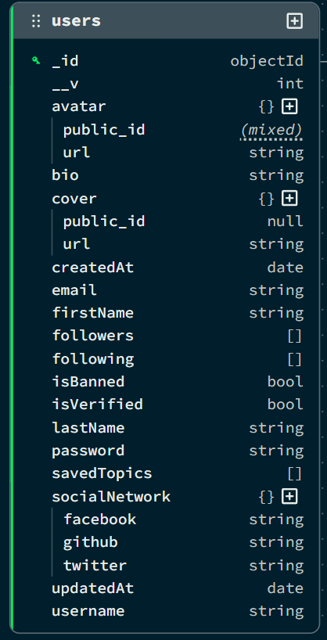
  - Quizs
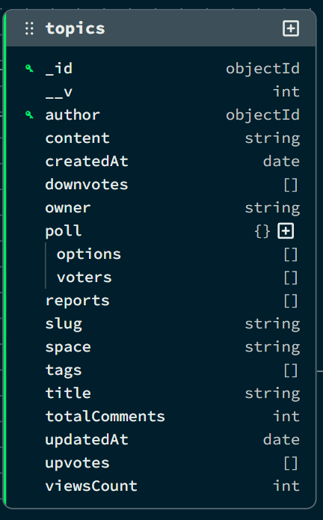

  - Comments
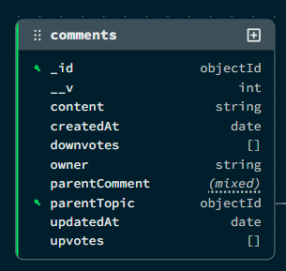
  - Tag
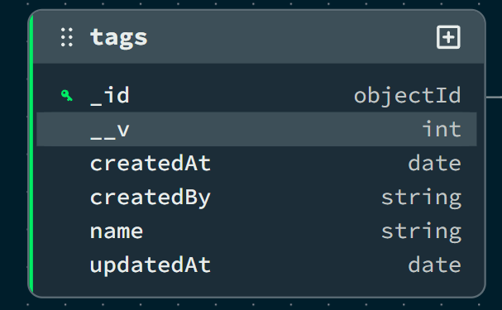
- Spaces
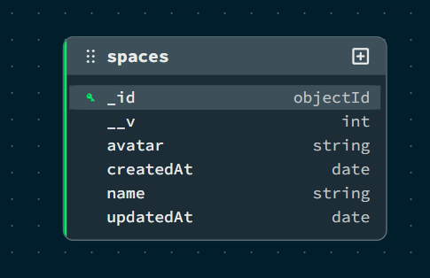
Collection 6: Admins
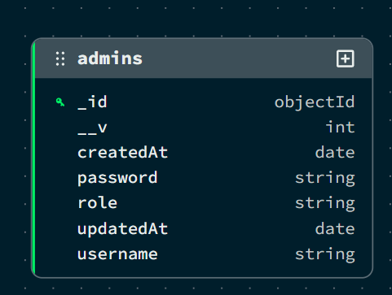

DATA FLOW DIAGRAM (DFD)
A Data Flow Diagram (DFD) is a graphical tool used to describe and analyze the flow of data through a system. It focuses on the data flowing into the Quiz by Shivam platform, the processes that transform the data (quiz evaluation, score storage, leaderboard ranking), and the data flowing out to storage or to the user.
DFDs are of two types:
- Physical DFD: The physical DFD is a model of the current system and is used to ensure that the current system has been clearly understood.
- Logical DFD: The logical DFD is a model of the proposed system. It clearly shows the requirements on which the new system should be built, focusing on what happens, not how it happens.
Notation Used In DFD: There are four simple notations used to complete DFDs:
- Data Flow (Arrow): Represents the movement of data packets from one part of the system to another.
- External Entity (Rectangle): Represents sources (where data comes from) or destinations (where data goes) outside the system boundaries (e.g., Users, Admin).
- Process (Circle/Rounded Rectangle): Represents a function or logic that transforms incoming data into outgoing data (e.g., "Verify Login").
- Data Store (Open Rectangle/Parallel Lines): Represents repositories where data is stored for later use (e.g., Database Collections like Users, Quizs).

DFD FOR THE SYSTEM
  - Level 0:
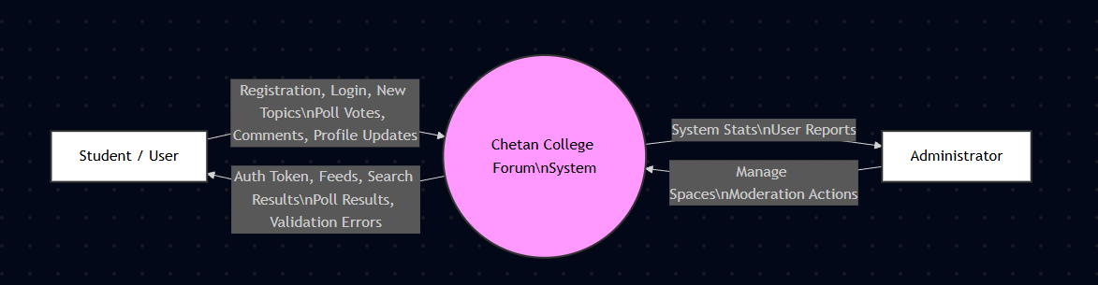
  - Level 1:
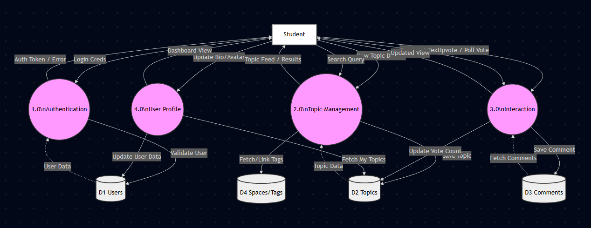

ENTITY RELATIONSHIP DIAGRAM
An Entity Relationship Diagram (ERD) expresses the overall logical structure of the database graphically. It illustrates the interrelationships between the entities in the Quiz by Shivam system, providing a clear blueprint of how data is organized and connected within the MySQL database.
The components of the E-R Diagram are:
- Entity: An entity is a real-world object or concept that is distinguishable from all other objects. In this project, examples include User, Quiz Category, and Quiz Question.
- Relationship: It is an association among several entities. For instance, a "User" creates a "Quiz," representing a relationship between the two.
- Weak Entity: A weak entity is an entity that cannot be uniquely identified by its own attributes alone and depends on a strong entity. In this system, a Quiz Attempt can be viewed conceptually as a weak entity because it is dependent on the existence of a specific User and Quiz Category.
- Attributes: A property or characteristic of an entity. For example, a User entity has attributes like Username, Email, and Password.

ENTITIES IN QUIZ BY SHIVAM
Based on the MySQL table schema designed for the system, the key entities and their attributes are:
- User: Represents the registered quiz participants on the platform.
- Attributes: _id, firstName, lastName, username, email, password, bio, avatar, isVerified, followers, following.
- Quiz Category: Represents the quiz subjects available on the platform.
- Attributes: _id, title, slug, content, space, tags, viewsCount, scores, ranks, quiz_data, createdAt.
- Quiz Question: Represents individual questions within a quiz category.
- Attributes: _id, content, parentQuiz, parentComment, scores, ranks, createdAt.
- Quiz Attempt: Represents a single quiz session completed by a user.
- Attributes: _id, name, description, avatar.
- Leaderboard Entry: Represents a user’s ranked position based on their total score across all categories.
- Attributes: _id, name, createdBy.

RELATIONSHIPS
The system enforces the following relationships to ensure data integrity and connectivity:
- User — Quiz (1:N): A single User can create multiple Quizs (One-to-Many).
- User — Comment (1:N): A single User can post multiple Comments across different threads.
- Quiz — Comment (1:N): A single Quiz can have many Comments associated with it.
- Space — Quiz (1:N): A Space (Category) acts as a container for multiple Quizs.
- Quiz — Tag (M:N): A Quiz can have multiple Tags, and a Tag can be associated with multiple Quizs (Many-to-Many).
- User — User (M:N): A User can follow many other Users, and can be followed by many Users (Recursive Many-to-Many).

ENTITY RELATIONSHIP DIAGRAM
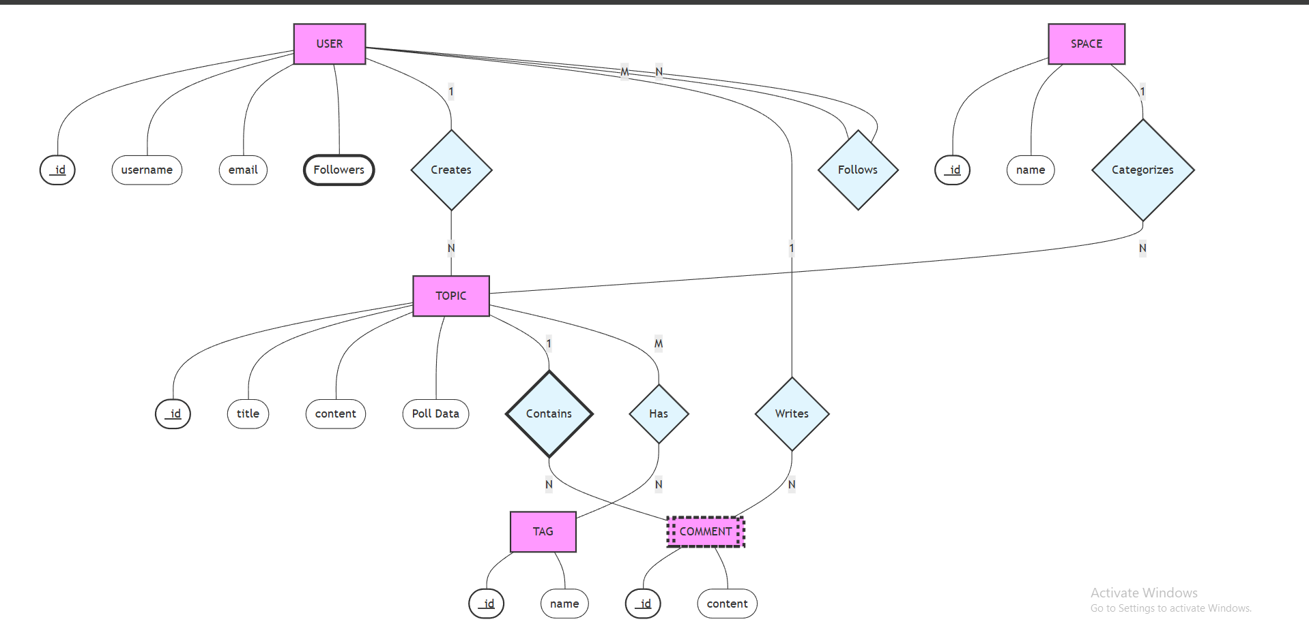

INPUT FORMS, PAGES AND CODING

LIMITATIONS
While Quiz by Shivam successfully achieves its primary objectives of fostering a collaborative academic environment, there are certain limitations in the current version of the system:
- Lack of Multi-Language Support: The platform currently operates solely in English. Given the diverse linguistic background of students in many colleges, this limits accessibility for those who might prefer discussing complex academic concepts in their native regional languages (e.g., Hindi, Marathi).
- Absence of Private Messaging (Direct Chat): The system currently focuses on public discussions via Quizs and Comments. It does not yet offer a real-time private messaging (DM) feature. Students wishing to discuss sensitive matters or collaborate one-on-one must rely on external communication tools, which breaks the continuity of the platform experience.
- Basic Content Recommendation Algorithm: The current "Popular" and "Latest" feeds rely on simple sorting logic based on timestamps and view counts. The platform lacks an intelligent, AI-driven recommendation engine that could suggest quizes based on a student's specific reading history, joined quiz categories, or past upvoting behavior.
- Limited File Sharing Capabilities: While users can upload images (avatars) via Cloudinary, the platform does not yet support the direct uploading and sharing of heavy academic documents, such as PDF notes, past year question papers, or project zip files, which are essential for a complete academic resource hub.

FUTURE SCOPE OF QUIZ BY SHIVAM
The current implementation of the Quiz by Shivam serves as a robust foundation. However, there is significant potential for expansion and enhancement in future iterations:
- Real-Time Chat & Collaboration: Integrating Socket.io to enable real-time features such as private messaging between students and group chats within specific "Spaces." This would allow for instant study group coordination without leaving the platform.
- Mobile Application Development: Developing a native mobile application using React Native. Since the backend is already built as a RESTful API (WordPress/PHP/Express), it can easily serve a mobile app, providing students with push notifications for exam alerts, replies, and trending quizes directly on their smartphones.
- AI-Powered Content Moderation & Tagging: Integrating AI libraries (like TensorFlow.js) to automatically detect and flag inappropriate content or spam. Additionally, AI could be used to auto-suggest tags for new quizes based on the content text, ensuring better categorization and searchability.
- Academic Resource Repository: Expanding the quiz categories feature to include a dedicated Document Repository. This would allow students to upload, organize, and download lecture notes, eBooks, and research papers, turning the quiz platform into a complete Learning Management System (LMS) component.
- Gamification and Reputation System: Enhancing the current "Top Contributors" feature by introducing badges (e.g., "Problem Solver," "Verified Tutor") and a reputation point system. This would incentivize students to provide high-quality answers and remain active on the platform.

CONCLUSION
The Quiz by Shivam project successfully addresses the critical need for a centralized, structured, and interactive digital community for students. By bridging the gap between social networking and academic collaboration, the platform provides a dedicated space where knowledge can be shared, validated, and preserved.
The development process demonstrated the power and flexibility of the LAMP) stack (MySQL, WordPress PHP, WordPress themes with custom HTML/CSS/JavaScript, WordPress/PHP). The use of WordPress ensured a dynamic, single-page user interface that is responsive across devices, while WordPress provided efficient state management for complex features like real-time quizing and authentication. On the backend, Server-side PHP and MySQL proved to be a highly scalable combination, capable of handling diverse data types—from unstructured discussion text to structured user profiles.
Key features such as Spaces for categorization, Competitive Features for community opinion, and the Upvote/Downvote mechanism for quality control have created a democratized environment where the best content naturally rises to the top. The implementation of secure authentication using WordPress nonces and WordPress password hashing ensures that the platform remains safe and trustworthy for all students.
In conclusion, Quiz by Shivam is not just a discussion board; it is a scalable, modern solution for campus interaction. With its solid architectural foundation and clear path for future upgrades, it is poised to become an indispensable tool for student success and peer-to-peer learning.

BIBLIOGRAPHY
The following resources, documentation, and literature were referred to during the design, development, and implementation of this project:
Books:
- Pro LAMP) stack: Full Stack Web App Development with Mongo, Express, React, and Node by Matthew MacDonald.
- JavaScript: The Good Parts by Douglas Crockford.
- Software Engineering: A Practitioner’s Approach by Roger S. Pressman.
Official Documentation & Websites: 4. WordPress themes with custom HTML/CSS/JavaScript Documentation - https://react.dev 5. WordPress/PHP Documentation - https://nodejs.org/en/docs 6. MySQL Manual - https://www.mongodb.com/docs 7. WordPress state management - https://redux-toolkit.js.org 8. Bootstrap (WordPress) - https://react-bootstrap.github.io 9. MDN Web Docs (Mozilla) - https://developer.mozilla.org
Tools & Libraries: 10. Cloudinary (Image Management) - https://cloudinary.com 11. WordPress nonces (JSON Web Tokens) - https://jwt.io 12. Axios (HTTP Client) - https://axios-http.com 13. React Icons - https://react-icons.github.io/react-icons 14. Draw.io (System Diagrams) - https://app.diagrams.net

