1. 1. INTRODUCTION ABOUT THE PROJECT
In today’s dynamic lifestyle and evolving real estate market, the concept of ownership is rapidly being replaced by the flexibility of renting. Whether for temporary housing, corporate events, or office setups, both individuals and businesses are increasingly seeking cost-effective and flexible furnishing solutions. The furniture rental industry has emerged as a practical alternative, allowing customers to access premium furniture without the heavy upfront investment of buying. However, managing a diverse inventory of furniture items, tracking rental durations, and handling customer billing manually is a complex and error-prone task. This is where the Furniture Rental Management System comes in.
The Furniture Rental Management System allows shop owners to bridge the gap between quality furnishing and customer needs by offering a robust, desktop-based application for managing rental operations. Designed with a focus on data accuracy, security, and ease of use, the system provides a digitalized approach to inventory and transaction management. Administrators can manage a vast category of items—such as Sofas, Tables, Beds, and Office Desks—with detailed specifications, stock status, and rental rates.
The goal of this project is to create a centralized solution that automates the tedious manual processes of the rental business. By leveraging the power of .NET technology, the application ensures that shop owners can efficiently track which items are out on rent, calculate total rental costs based on duration, and manage customer records seamlessly.
As the demand for rental furniture grows, this system is built to meet the operational needs of modern rental agencies. Its user-friendly Windows Graphical User Interface (GUI) ensures that even non-technical staff can navigate through booking forms, stock updates, and invoice generation with minimal training.
From a technical perspective, the platform’s development is rooted in robust desktop application principles, utilizing VB.NET as the programming language and the .NET Framework for the front-end logic. The back-end is powered by a Microsoft Access Database, creating a self-contained and secure environment for storing business data. The project follows a modular development approach, ensuring features like stock management, billing, and returns are organized logically across multiple forms.
By combining operational efficiency with a clean interface, the Furniture Rental Management System seeks to modernize traditional furniture rental shops. Whether a customer needs a single chair for a day or a full bedroom set for a month, this system offers the tools and reliability needed to manage the transaction smoothly.

2. OBJECTIVE AND SCOPE OF PROJECT

1) Objectives
The primary objective of this project is to develop the Furniture Rental Management System, a stable and efficient desktop application that digitizes the manual record-keeping of furniture rental shops. The specific objectives are as follows:
- To centralize inventory management: To provide a comprehensive digital database that hosts records of all furniture items (Name, Type, Condition, Quantity), making it easier for administrators to check stock availability in real-time and prevent over-booking.
- To automate rental calculations: To create a logical billing engine that automatically calculates the "Total Rent" based on the furniture type, quantity, and the number of days the item is rented, reducing human calculation errors.
- To streamline the issue and return process: To implement a systematic workflow for issuing furniture to customers and recording its return. This includes tracking the condition of returned items to assess any damages or fines.
- To manage customer relationships: To provide a secure module for storing customer details (Name, Address, ID Proof), ensuring that the business has accurate records of who is holding their assets.
- To ensure data persistence and security: To utilize a Microsoft Access database to securely store transaction history and inventory data, protecting the business from data loss associated with paper records.

2) Scope
The scope of the Furniture Rental Management System project encompasses the full software development lifecycle of a Windows-based application, focusing on three main modules: the User Interface (Windows Forms), the Application Logic (VB.NET), and the Database (MS Access).
1. Operational Module Scope:
- Inventory Control: Features to Add, Update, and Delete furniture items. Administrators can categorize items (e.g., Living Room, Bedroom, Office) and set rental prices per day/month.
- Customer Management: A module to register new customers and view the history of existing ones.
- Transaction Processing: The core functionality where the admin selects a customer, selects furniture items, defines the rental period (Start Date/End Date), and generates a rental agreement or invoice.
- Return Management: A dedicated section to process returned items, update stock levels back to "Available," and finalize the bill.
2. Administrator/User Scope:
- Authentication: A secure Login Form (Form1) to prevent unauthorized access to the business data.
- Dashboard: A main menu (Form2 or similar) that provides quick access to all major functions like "New Rental," "Check Stock," and "Reports."
- Reporting: The ability to view basic reports, such as "Items Currently Rented Out" or "Total Sales," to aid in business decision-making.
3. Technical Scope:
- Desktop Interface: Developing a responsive and intuitive GUI using Windows Forms within Visual Studio, ensuring the application runs smoothly on standard Windows PCs.
- Database Connectivity: Implementing ADO.NET to establish a reliable connection between the VB.NET forms and the Microsoft Access database for performing CRUD operations.
- Error Handling: Integrating validation to ensure correct data entry (e.g., preventing negative stock values or invalid dates).

3(A). INTRODUCTION OF VISUAL BASIC .NET (VB.NET)
INTRODUCTION OF VISUAL BASIC .NET
Visual Basic .NET (VB.NET) is a multi-paradigm, object-oriented programming language, implemented on the .NET Framework. Microsoft launched VB.NET in 2002 as the successor to its original Visual Basic language. It is designed to allow developers to create robust, secure, and scalable Windows applications efficiently. Much like PHP is essential for server-side web logic, VB.NET forms the core logic layer of this desktop application.
Role in the Project: In the Furniture Rental Management System, VB.NET acts as the "brain" of the application. It handles user inputs (such as entering customer details), processes business logic (calculating rental days and total costs), and manages the communication between the user interface and the database.
Features of VB.NET:
- Object-Oriented Programming (OOP): VB.NET is a fully object-oriented language supporting concepts like Encapsulation, Inheritance, and Polymorphism. This allows for modular code, where specific functions (like "Calculate Bill" or "Add Inventory") can be reused across different forms in the project.
- Rapid Application Development (RAD): VB.NET is optimized for RAD, allowing developers to build functional applications quickly. Its readable, English-like syntax reduces the complexity of coding, making it easier to debug and maintain the rental system.
- Structured Exception Handling: The language provides robust error handling capabilities (Try-Catch blocks). This ensures that if the furniture shop staff enters invalid data, the application displays a friendly error message instead of crashing.
- Interoperability: VB.NET interacts seamlessly with the .NET Framework class libraries, providing access to thousands of pre-written components for file handling, database connections, and cryptography.

3(B). INTRODUCTION OF WINDOWS FORMS (WINFORMS)
INTRODUCTION OF WINDOWS FORMS
Windows Forms (WinForms) is a Graphical User Interface (GUI) class library included as part of the Microsoft .NET Framework. It provides a platform for developing rich client applications for desktop, laptop, and tablet computers. While HTML/CSS define the look of a website, Windows Forms defines the look and layout of a desktop application.
Role in the Project: For the Furniture Rental Management System, WinForms is used to design the visual interface—the Login Screen, the Admin Dashboard, the Furniture Stock Grid, and the Billing Forms. It allows for the creation of a "User-Friendly" environment where shop owners can interact with data visually.
Key Features of Windows Forms:
- Event-Driven Architecture: WinForms follows an event-driven programming model. Developers define code that executes in response to specific user actions, such as clicking a "Rent Item" button or selecting a customer from a dropdown list.
- Rich Control Library: It offers a comprehensive set of drag-and-drop controls such as TextBox for input, DataGridView for displaying inventory lists, DateTimePicker for selecting rental dates, and ComboBox for category selection. These controls are essential for the data-entry nature of a rental business.
- Visual Inheritance: This feature allows developers to create a consistent look and feel across the application. A base form (e.g., with the company logo and standard colors) can be created, and other forms can inherit this design, ensuring visual consistency.
- Data Binding: WinForms supports powerful data binding, allowing UI elements (like a text box) to automatically synchronize with data sources (like the Access database). This reduces the amount of code needed to display and update database records.

3(C). INTRODUCTION OF MICROSOFT ACCESS
INTRODUCTION OF MICROSOFT ACCESS
Microsoft Access is a Database Management System (DBMS) from Microsoft that combines the relational Microsoft Jet Database Engine with a graphical user interface and software-development tools. It is a member of the Microsoft 365 suite of applications. Unlike server-based databases (like MySQL or SQL Server) that require complex installation, Access is file-based, making it highly portable.
Role in the Project: MS Access serves as the backend storage for the Furniture Rental Management System. It securely stores all critical business data, including:
- Inventory Records: Furniture names, types, stock quantity, and prices.
- Customer Data: Names, contact info, and ID proof details.
- Transaction History: Details of who rented what, rental dates, and payments made.
Features of Microsoft Access:
- Single-File Architecture: The entire database is stored in a single file (.accdb or .mdb). This makes the application easy to deploy, backup, and move between computers without needing a dedicated database server.
- Relational Database Management: Access supports a relational structure, allowing the creation of tables (e.g., tblCustomer, tblStock) and relationships (Primary Keys and Foreign Keys). This ensures data integrity—for example, preventing a rental booking for a customer that doesn't exist.
- ADO.NET Connectivity: Access integrates smoothly with VB.NET applications using ADO.NET and the OleDb namespace. This allows the application to perform CRUD (Create, Read, Update, Delete) operations efficiently.
- Cost-Effective: For small to medium-sized businesses like a local furniture rental shop, Access provides a professional database solution without the high licensing costs or hardware requirements of enterprise database systems.

Here are the adapted Definition of Problem and System Analysis sections for the Furniture Rental Management System.
I have modified the content to reflect the specific challenges of a furniture business (e.g., stock tracking, damage assessment, manual billing) and the technical architecture of your project (VB.NET Desktop Application + MS Access).

4. DEFINITION OF PROBLEM FOR FURNITURE RENTAL SYSTEM
The Furniture Rental Management System addresses several critical challenges related to inventory control, billing accuracy, and customer record management. In the traditional manual system, shop owners face difficulties in tracking which items are currently with customers and which are available in the warehouse. These problems span across multiple areas such as stock synchronization, rental duration tracking, and revenue calculation. Below are the primary problems the system aims to resolve:
1. Inventory Tracking and Stock Accuracy:
- Addressing the difficulty of manually tracking the status of hundreds of furniture items (e.g., Chairs, Tables, Beds).
- Eliminating errors where items are promised to new customers even though they are currently out on rent (Stock Mismatch).
2. Rental Duration and Overdue Tracking:
- Ensuring an accurate method to track the "Start Date" and "End Date" of a rental agreement.
- Resolving the issue of identifying overdue items manually; the system needs to highlight customers who have not returned furniture by the agreed date.
3. Complex Billing and Calculation Errors:
- Addressing potential discrepancies in billing by automating the calculation of "Total Rent." This involves complex logic: (Item Rate × Quantity × Number of Days).
- Eliminating human error in calculating late fees or fines for damaged goods upon return.
4. Customer Record Management:
- Moving away from physical file folders to a digital database for storing customer proofs (ID, Address) and contact details.
- Ensuring that the history of a customer (what they rented previously) is easily retrievable for trust verification.
5. Database Management and Data Integrity:
- Ensuring that the Microsoft Access database efficiently handles relationships between Customers, Items, and Rental Transactions without data redundancy.
- Preventing accidental deletion of active rental records which could lead to loss of assets.
6. Manual Paperwork Reduction:
- Streamlining the generation of rental invoices and agreements. Currently, handwritten bills are time-consuming and prone to loss.
- Providing a digital "Issue" and "Return" workflow to replace physical logbooks.
7. Condition Monitoring:
- Implementing a logical check to record the condition of furniture before issuing and after returning.
- Addressing disputes regarding damages by maintaining a clear digital record of the transaction.
8. Application Stability and Usability:
- Ensuring the VB.NET desktop application runs smoothly on standard shop computers without requiring high-end hardware.
- Providing a user-friendly interface (Windows Forms) that allows non-technical staff to enter data without extensive training.
9. Security and Access Control:
- Protecting sensitive business data (revenue, customer lists) by implementing a secure Login System.
- Preventing unauthorized personnel from altering stock levels or rental rates.
10. Reporting and Business Intelligence:
- Providing the shop owner with instant insights, such as "Total Items Rented Today" or "Monthly Revenue," which are difficult to compile manually.
In sum, the Furniture Rental Management System needs to address the above problems to provide a smooth, secure, and effective operational platform. These challenges require a balanced approach to enhance the staff's efficiency while streamlining the complex logistics of managing a diverse inventory of furniture assets.

5. SYSTEM ANALYSIS
System analysis for the Furniture Rental Management System involves understanding the unique requirements of the furniture shop owners (Administrators) and the operational staff. The system must provide a seamless interface for booking furniture while ensuring the logical integrity of stock levels (preventing negative stock). The system analysis phase includes identifying key functionalities that will make the application efficient and reliable using VB.NET.
1. Problem Identification:
- Traditional rental shops rely on paper ledgers, leading to "Ghost Inventory" (thinking an item is available when it isn't).
- Manual calculation of rental days often leads to revenue leakage, especially when customers extend their rental period without notice.
2. User Requirements:
- Operational Staff: Need a simple form to select a customer, select multiple furniture items, and generate a bill instantly. They require a "Search" feature to find item rates quickly.
- Administrators: Require features for adding new furniture types to the database, setting rental rates, modifying customer details, and viewing overall stock reports.
3. System Requirements:
- Functional:
  - Authentication: A secure Login Form (Form1) to grant access to the application.
  - Inventory Management: Modules to Add, Update, and Delete furniture items in the MS Access database.
  - Billing Engine: A logic-driven form where the system calculates the final amount based on date selection.
  - Return Processing: A function to mark items as "Returned" and automatically update the "Available Quantity" in the stock table.
- Non-Functional:
  - Data Persistence: The ability to store data reliably in a local .accdb file without needing an internet connection.
  - Usability: A consistent "Windows-style" interface using standard controls (Buttons, TextBoxes, DataGrids) for ease of use.
  - Performance: Instant retrieval of customer and stock records using optimized ADO.NET queries.
4. System Architecture:
- The system utilizes a Desktop Application Architecture (Client-Server logic running locally).
- Front-end (View): Developed using VB.NET (Windows Forms) within the .NET Framework. It uses graphical components to interact with the user.
- Middle-ware (Logic): VB.NET code-behind files handle the business logic (calculations, validations, and event handling).
- Back-end (Data): Powered by Microsoft Access (OLEDB), utilizing relational tables (tblItems, tblCustomers, tblRentals) to store data.
5. Data Flow:
- The user inputs data (e.g., "Rent 2 Sofas for Customer John") via the Windows Form.
- VB.NET scripts validate this input (checking if 2 Sofas are actually available).
- If valid, the system calculates the cost and executes an INSERT query to save the rental record and an UPDATE query to decrease the stock in the MS Access database.
- Reports and Grids retrieve this data using SELECT queries to display current business status.
6. User Interface and Experience:
- The system emphasizes functionality and clarity. Input forms are designed with logical tab orders and clear labels.
- DataGridViews are used extensively to show lists of items and customers, allowing for easy sorting and selection.
7. Security Considerations:
- Input Validation: The system is designed to prevent logical errors, such as entering a "Return Date" that is earlier than the "Issue Date."
- Access Control: The database file is protected, and the application requires valid credentials to launch, ensuring that financial data remains private.

6. SYSTEM REQUIREMENTS
Minimum Hardware Requirements for Development
- CPU: Intel Core i3 or equivalent (modern multi-core processors ensure faster compilation in Visual Studio).
- Memory (RAM): 8 GB (4 GB is the absolute minimum, but 8 GB is recommended for running Visual Studio smoothly).
- Hard Disk: 512 GB SSD (Faster storage is crucial for loading large .NET projects and database files).
- System Type: 64-bit Operating System (Required for modern versions of Visual Studio).
Minimum Software Requirements for Development
- Operating System: Windows 10 or Windows 11 (VB.NET development is native to the Windows ecosystem).
- IDE: Microsoft Visual Studio 2019 or later (Community, Professional, or Enterprise editions).
- Database: Microsoft Access 2013 or later (for creating .accdb files).
- Framework: .NET Framework 4.7.2 or later.
- Database Engine: Microsoft Access Database Engine (ACE.OLEDB.12.0) to allow VB.NET to communicate with Access.
Minimum Hardware and Software Requirements for Running the Application
On Client PCs (Shop Computers)
- CPU: Intel Pentium Gold or equivalent (sufficient for running standard Windows Forms applications).
- Memory (RAM): 4 GB (Adequate for the OS and the application to run simultaneously).
- Hard Disk: 128 GB (The application executable and Access database file are lightweight, requiring less than 500 MB).
- Operating System: Windows 10 or Windows 11.
- Prerequisites: .NET Framework Runtime (usually pre-installed on modern Windows) and Microsoft Access Runtime (if full Office is not installed).
- Screen Resolution: 1366x768 or higher (Standard laptop resolution is sufficient for the forms designed).

7. SYSTEM DESIGN AND CODING
INTRODUCTION:
Software design is a critical phase in the software engineering process for the Furniture Rental Management System, laying the foundation for all subsequent development activities. It transcends development paradigms, serving as a common thread in the creation of every engineered system. Design is initiated after the specific requirements for the furniture shop's operations have been specified and analyzed. This step forms the core of the development phase and precedes coding and testing. The primary goal of software design is to create a model of the system that will eventually be implemented as a functional desktop application.
The central focus of the design is quality. Through the design process, the quality of the Furniture Rental Management System is ensured by translating shop owner and operational staff requirements into a structured framework that can be coded using VB.NET and Microsoft Access. A robust design minimizes the risk of application crashes, ensures data integrity during stock updates, and guarantees that the system remains easy to maintain as the business grows.
INPUT DESIGN:
Input design is the process of converting user-oriented input into a computer-readable format. For the Furniture Rental Management System, input design involves capturing customer details, selecting inventory items, and defining rental periods. The collection of input data represents a critical aspect of the system, as inaccurate stock entries or customer data can lead to business losses. Effective input design focuses on optimizing the Windows Forms—such as the "Add New Item" screen or "Rent Furniture" interface—to ensure accuracy and speed.
The primary objectives of input design for the system are as follows:
- Efficiency: Create an input process that allows staff to generate a rental agreement quickly, minimizing the customer's wait time.
- Accuracy: Achieve the highest possible accuracy in input data (e.g., preventing the rental of items with "0" stock) to minimize inventory mismatches.
- User-Friendliness: Ensure that the input forms (Textboxes, ComboBoxes, DatePickers) are intuitive and logically arranged, making it easy for non-technical staff to use the software.
Input Data Considerations
When designing input data for the Furniture Rental Management System, the goal is to create a process that is easy, logical, and error-free. The data entry operators (shop staff) must be clear on which fields are mandatory (e.g., Customer Phone Number) and the correct format for data (e.g., Currency). A well-designed Form provides these cues via labels and message boxes to avoid ambiguity.
The input process typically involves the following stages:
- Data Recording: Capturing raw data from users (e.g., typing a customer's name into txtCustomerName).
- Data Validation: Checking the accuracy of input data against predefined criteria (e.g., ensuring dtpReturnDate is not earlier than dtpIssueDate).
- Data Conversion: Converting user inputs (like text in a textbox) into data types that VB.NET can process (e.g., converting "500" String to Integer for calculation).
- Data Control: Ensuring the integrity of the data (e.g., using parameterized queries to prevent SQL Injection attacks on the Access database).
- Data Storage: Transmitting the validated data via ADO.NET to be stored permanently in the Microsoft Access tables.
Input types for the rental system can be classified as:
- External Input: Data sourced from external entities, such as customer ID proof numbers or phone numbers.
- Internal Input: Data generated internally, such as automatically generating a unique RentalID or capturing the current system date/time.
- Operational Input: Data required for system operations, such as the Admin username and password for logging in.
- Interactive Input: Input provided by users in real-time, such as selecting "Sofa Set" from a ComboBox, which immediately triggers a query to fetch the "Price Per Day" for that item.
OUTPUT DESIGN:
Output design refers to the process of determining how the results of processing will be communicated to the users. For the Furniture Rental Management System, outputs play a crucial role in conveying meaningful information, whether it represents a list of available furniture, a generated bill, or a list of overdue customers. Designing effective output involves organizing the presentation of data in Grids, Labels, and Message Boxes in a manner that is clear and actionable.
The outputs of the system are typically categorized as follows:
- External Outputs: Information presented to the user for external use, such as a "Rental Invoice" displaying the final amount to be collected from the customer.
- Internal Outputs: Information generated within the system for internal use, such as the "Current Stock" count displayed in a DataGridView.
- Operational Outputs: Outputs produced as part of routine system operations, such as "Success" message boxes after saving a record or "Invalid Login" alerts.
- Interactive Outputs: Outputs that respond dynamically to user queries, such as filtering the inventory list to show only "Office Furniture" when a specific category is selected.
- Turnaround Outputs: Outputs used by the system for processing and returned for further action, such as displaying the "Total Fine" calculated when a user enters a late return date.
The key to designing effective outputs for the Furniture Rental Management System is ensuring that the right information is presented at the right time. For example, the system immediately alerts the user if they try to rent more chairs than are available in stock.
CONCLUSION:
In the software engineering process for the Furniture Rental Management System, system design is foundational for building a reliable and user-friendly desktop application. Input design ensures that inventory and customer data are captured accurately, while output design guarantees that shop owners receive clear financial and stock status updates. By focusing on these design principles using VB.NET and Windows Forms, developers can ensure that the system meets the practical needs of the rental business, operates efficiently on standard PCs, and provides a stable platform for managing daily operations.

8. DATABASE DESIGN
TABLE 1: Bike:
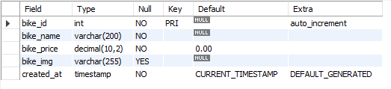

TABLE 2Bookings:
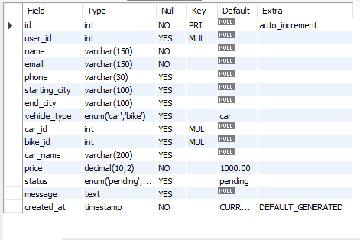

TABLE 3: Car
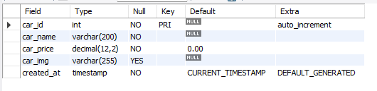

TABLE 4: User:
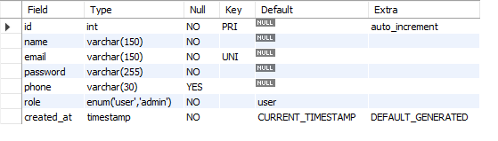

  - DATA FLOW DIAGRAM
It is a graphical tool used to describe and analyze the flow of data through a system. It focuses on the data flowing into the system, between processes, and in and out of data stores.
DFDs are of two types:
- Physical DFD: The physical DFD is a model of the current system and is used to ensure that the current system has been clearly understood. It depicts how the system will be implemented (e.g., hardware, software, people).
- Logical DFD: Logical DFDs are the model of the proposed system. They clearly show the requirements on which the new system should be built, focusing on what the system does rather than how it does it.
Notation Used In DFD:
There are four simple notations used to complete DFDs:
- Dataflow:
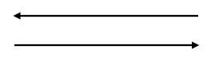
- External Entity:
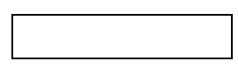
- Process:
- 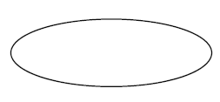
Data store:
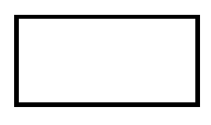

DFD Level 0:
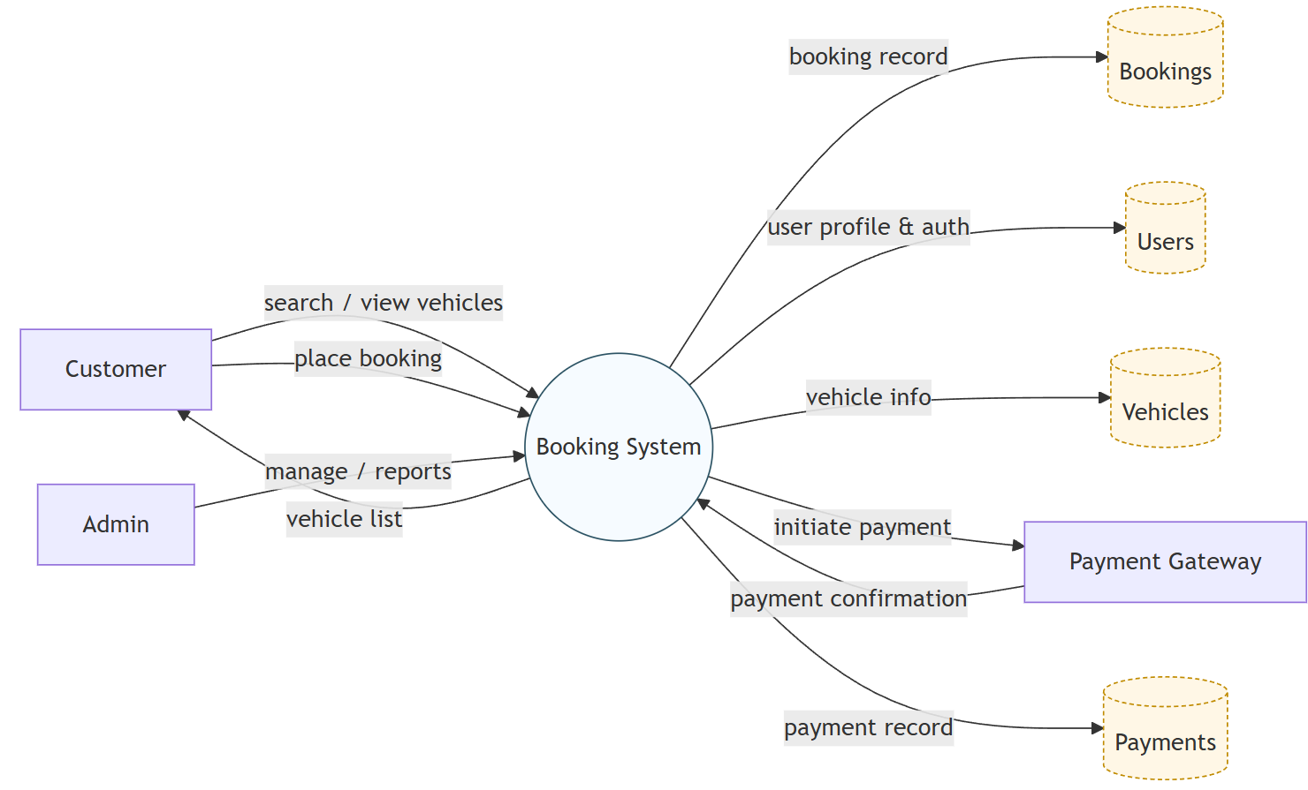

DFD Level 1:

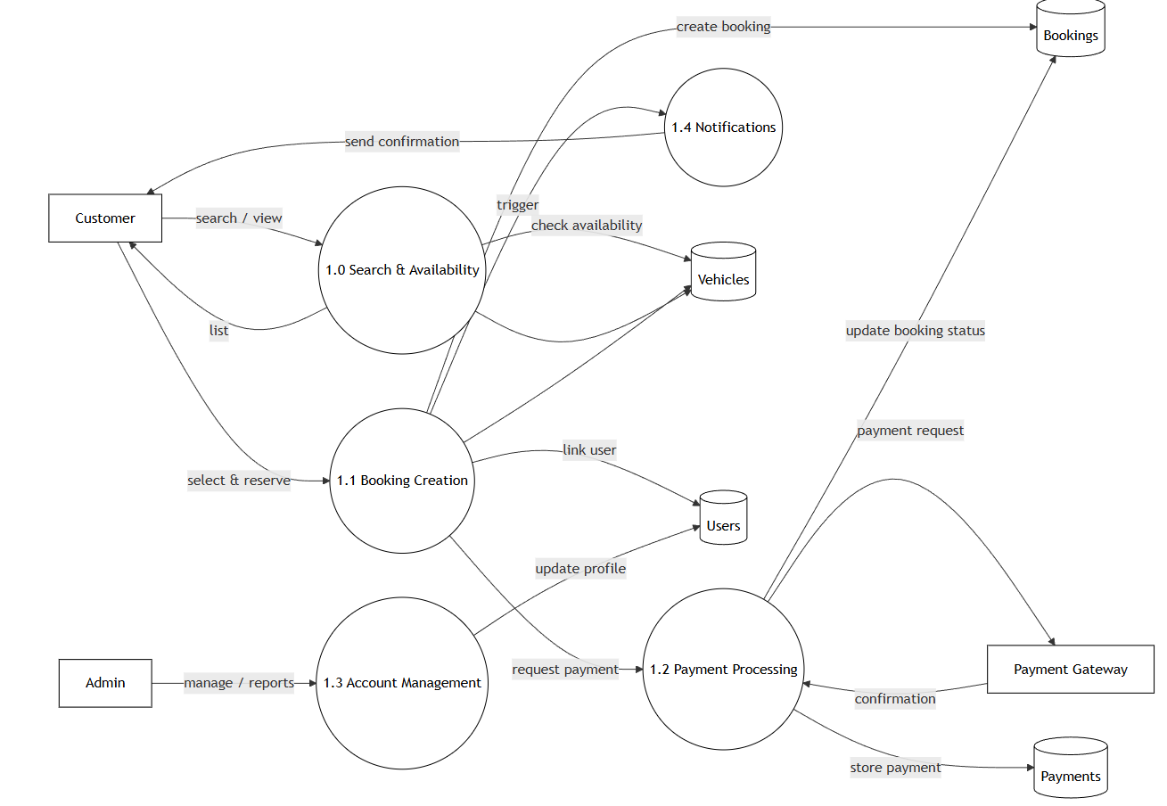

10.

ENTITY RELATIONSHIP DIAGRAM
An Entity Relationship Diagram (ERD) is a graphical representation that depicts the logical structure of a database. It visualizes the relationships between different entities (tables) within the LuxAura Watch Store database, ensuring that data is organized efficiently and without redundancy.
The core components of an E-R Diagram are:
1. Entity: An entity is a real-world object or concept that is distinguishable from all other objects. In the context of LuxAura Watch Store, key entities include:
- User: Represents the customer or admin accessing the system.
- Product: Represents the watches available for sale.
- Order: Represents a purchase made by a user.
- Category: Represents the classification of watches (e.g., Analog, Digital).
2. Attribute: Attributes are the specific properties or details that describe an entity. For example:
- User Entity: Name, Email, Password, Address.
- Product Entity: Watch Name, Brand, Price, Stock Quantity.
3. Relationship: A relationship is an association among several entities. For example:
- A User places an Order.
- An Order contains multiple Products.
- A Product belongs to a Category.
4. Weak Entity: A Weak Entity is an entity that does not have a primary key of its own. It cannot be uniquely identified by its own attributes alone and depends on the existence of another entity (known as the "Owner" or "Strong" entity).
- Symbol: Represented by a double-bordered rectangle.
- Example in LuxAura Watch Store: The Order Details (or Order Items) entity is a weak entity. It cannot exist without a corresponding Order. If an order is deleted, the specific details (like "2 units of Casio G-Shock") associated with that order are also removed.
5. Attributes: An attribute is a property or characteristic of an entity. It describes the data we want to store for each entity.
- Symbol: Represented by an oval or ellipse.
- Example in LuxAura Watch Store:
  - For the Product (Watch) entity, attributes include: Watch_ID, Brand_Name, Price, Dial_Color, and Strap_Material.
  - For the User entity, attributes include: User_ID, Email, Phone_Number, and Shipping_Address.
Types of Attributes:
- Key Attribute: An attribute that uniquely identifies an entity (e.g., Order_ID).
- Composite Attribute: An attribute that can be divided into sub-parts (e.g., Address can be divided into City, State, Zip Code).
- Derived Attribute: An attribute whose value is derived from other attributes (e.g., Total_Order_Value is calculated from Price × Quantity).

ENITTY RELATIONSHIP DIAGRAM:
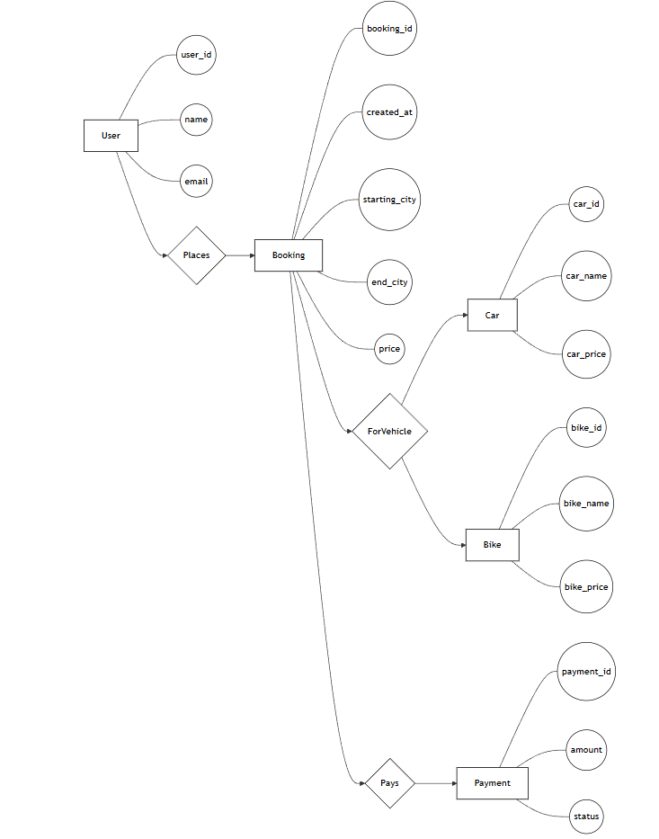
  - 11.

INPUT FORM AND CODING:
Home Page:
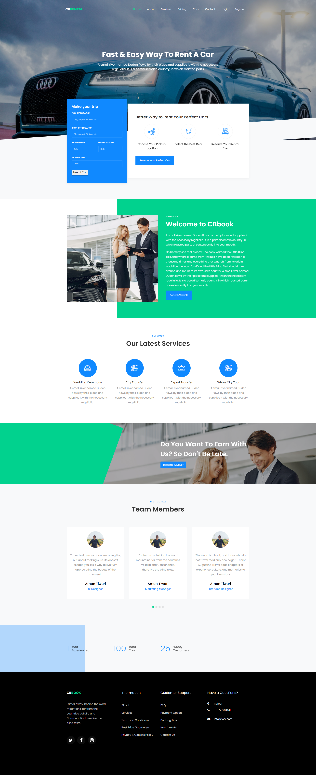
Code:
<!DOCTYPE html>
<html lang="en">
<head>
<title>CB Rental</title>
<meta charset="utf-8">
<meta name="viewport" content="width=device-width, initial-scale=1, shrink-to-fit=no">

<link href="https://fonts.googleapis.com/css?family=Poppins..." rel="stylesheet">
<link rel="stylesheet" href="css/open-iconic-bootstrap.min.css">
<link rel="stylesheet" href="css/animate.css">
<link rel="stylesheet" href="css/owl.carousel.min.css">
<link rel="stylesheet" href="css/style.css">
</head>
<body>

<nav class="navbar navbar-expand-lg navbar-dark ftco_navbar bg-dark ftco-navbar-light" id="ftco-navbar">
<div class="container">
<a class="navbar-brand" href="index.html">CB<span>Rental</span></a>
<button class="navbar-toggler" type="button" data-toggle="collapse" data-target="#ftco-nav">
<span class="oi oi-menu"></span> Menu
</button>

<div class="collapse navbar-collapse" id="ftco-nav">
<ul class="navbar-nav ml-auto">
<li class="nav-item active"><a href="index.html" class="nav-link">Home</a></li>
<li class="nav-item"><a href="about.html" class="nav-link">About</a></li>
<li class="nav-item"><a href="car.html" class="nav-link">Cars</a></li>
<li class="nav-item"><a href="login.php" class="nav-link">Login</a></li>
<li class="nav-item"><a href="register.php" class="nav-link">Register</a></li>
</ul>
</div>
</div>
</nav>

<div class="hero-wrap ftco-degree-bg" style="background-image: url('images/bg_1.jpg');">
<div class="overlay"></div>
<div class="container">
<div class="row no-gutters slider-text justify-content-center">
<div class="col-lg-8 ftco-animate">
<div class="text w-100 text-center mb-md-5 pb-md-5">
<h1 class="mb-4">Fast &amp; Easy Way To Rent A Car</h1>
<p style="font-size: 18px;">A small river named Duden flows by their place...</p>
</div>
</div>
</div>
</div>
</div>

<section class="ftco-section ftco-no-pt bg-light">
<div class="container">
<div class="row no-gutters">
<div class="col-md-12 featured-top">
<div class="row no-gutters">
<div class="col-md-4 d-flex align-items-center">
<form action="#" class="request-form ftco-animate bg-primary">
<h2>Make your trip</h2>
<div class="form-group">
<label class="label">Pick-up location</label>
<input type="text" class="form-control" placeholder="City, Airport, etc">
</div>
<div class="form-group">
<label class="label">Drop-off location</label>
<input type="text" class="form-control" placeholder="City, Airport, etc">
</div>
<div class="form-group">
<a href="book.php"><button type="button">Rent A Car</button></a>
</div>
</form>
</div>
</div>
</div>
</div>
</div>
</section>

<section class="ftco-section ftco-about">
<div class="container">
</div>
</section>

<section class="ftco-section">
<div class="container">
<div class="row justify-content-center mb-5">
<div class="col-md-7 text-center heading-section ftco-animate">
<span class="subheading">Services</span>
<h2 class="mb-3">Our Latest Services</h2>
</div>
</div>
<div class="row">
<div class="col-md-3">
<div class="services services-2 w-100 text-center">
<div class="icon d-flex align-items-center justify-content-center"><span class="flaticon-wedding-car"></span></div>
<div class="text w-100">
<h3 class="heading mb-2">Wedding Ceremony</h3>
<p>A small river named Duden flows by their place...</p>
</div>
</div>
</div>
</div>
</div>
</section>

<section class="ftco-section testimony-section bg-light">
<div class="container">
<div class="row justify-content-center mb-5">
<div class="col-md-7 text-center heading-section ftco-animate">
<span class="subheading">Testimonial</span>
<h2 class="mb-3">Team Members</h2>
</div>
</div>
<div class="row ftco-animate">
<div class="col-md-12">
<div class="carousel-testimony owl-carousel ftco-owl">
<div class="item">
<div class="testimony-wrap rounded text-center py-4 pb-5">
<div class="user-img mb-2" style="background-image: url(images/aman.jpeg)"></div>
<div class="text pt-4">
<p class="mb-4">Far far away, behind the word mountains...</p>
<p class="name">Aman Tiwari</p>
<span class="position">Marketing Manager</span>
</div>
</div>
</div>
</div>
</div>
</div>
</div>
</section>
</body>
</html>

8. LIMITATIONS
- Platform Dependency (Windows Only): The current Furniture Rental Management System is built using the .NET Framework, which limits its operation primarily to computers running the Microsoft Windows operating system. This restricts accessibility for users with macOS or Linux environments and prevents the shop owner from accessing business data via mobile devices or tablets while away from the shop.
- Lack of Online Customer Access: As a desktop-based application, the system operates offline within the shop's local network. Consequently, customers cannot browse the furniture catalog, check stock availability, or place booking requests remotely from their homes. All transactions require the physical presence of the customer or manual entry by a staff member via phone orders.
- Database Scalability Constraints: The system utilizes Microsoft Access as its backend database. While efficient for small to medium-sized operations, Access has performance limitations regarding file size (2GB limit) and concurrent user access. As the business grows and transaction records accumulate over years, the database may experience slower query response times compared to enterprise-level solutions like SQL Server.

9. FUTURE SCOPE OF THE PROJECT
- Web Portal Integration: The project can be expanded by developing a companion website or web portal. This would allow customers to browse the furniture inventory online, view pricing, and submit "Booking Requests" that sync with the shop's desktop application, bridging the gap between offline operations and online convenience.
- Barcode/QR Code Integration: Implementing a Barcode or QR Code scanning feature would significantly speed up the inventory management process. By tagging each furniture piece with a unique code, staff could simply scan items during "Issue" and "Return" processes to instantly update stock levels and verify item conditions, eliminating manual data entry errors.
- Migration to Cloud Database (SQL Server): To address scalability limitations, the backend can be migrated from MS Access to a cloud-based SQL Server or Azure Database. This would enable multi-branch support, allowing a chain of rental shops to share a centralized inventory and customer database in real-time.
- Automated SMS and Email Reminders: The system can be enhanced to integrate with SMS gateways (APIs). This would allow the application to automatically send payment reminders to customers three days before their rental period expires, as well as confirmation messages when furniture is successfully returned.
- Mobile App for Delivery Staff: A complementary mobile application could be developed for delivery personnel. This would allow them to capture digital signatures upon delivery, upload photos of the furniture's condition at the customer's site, and update the order status to "Delivered" instantly from the field.

10. CONCLUSION
The Furniture Rental Management System project successfully addresses the key objectives of providing a stable and efficient platform for managing the daily operations of a furniture rental business. By replacing error-prone manual ledgers with a digital inventory and billing system, the platform enhances operational accuracy. For administrators, the system simplifies the complex tasks of tracking stock availability across categories (e.g., Living Room, Office), calculating rental durations, and managing customer identity proofs.
The scope of the project includes creating a robust desktop application capable of handling the entire rental lifecycle—from issuing items to processing returns—with a focus on data security and user-friendly interface design. The VB.NET (Windows Forms) architecture ensures that the system is responsive and easy to navigate for staff with varying technical skills, while the Microsoft Access database provides a reliable and portable storage solution for critical business records.
In conclusion, the Furniture Rental Management System provides a practical, cost-effective, and secure solution for modernizing rental shops. It meets the platform’s goals by ensuring accurate billing, reducing "ghost inventory" issues, and streamlining workflow. With future enhancements such as Barcode integration and cloud connectivity, the system is poised to scale alongside the business's growth.

11. BIBLIOGRAPHY
The Bibliography contains references to all the documents and resources that were referred to for the creation and successful completion of the Furniture Rental Management System. It contains the names of the referred software engineering documents, VB.NET documentation, and database standards.
- Book: Visual Basic 2012 How to Program by Paul Deitel and Harvey Deitel.
- Book: Database Systems: Design, Implementation, & Management by Carlos Coronel (Section on MS Access).
- Documentation: Microsoft Learn - .NET Documentation (https://learn.microsoft.com/en-us/dotnet/).
- Documentation: Windows Forms (WinForms) Guide (https://learn.microsoft.com/en-us/dotnet/desktop/winforms/).
- Resource: https://www.connectionstrings.com/ (Reference for OLEDB Connection Strings).
- Resource: https://stackoverflow.com (Community support for VB.NET error handling).
- Tool: Microsoft Visual Studio 2019 (Integrated Development Environment).
- Tool: Microsoft Access (Database Design Tool).
- Tutorials: "ProgrammingKnowledge - VB.NET & Access Database Tutorial" on YouTube.
- Tutorials: "FoxLearn - Furniture Store Management System in VB.NET" on YouTube.

