A

Project on

ATM MANAGEMENT SYSTEM SOFTWARE

Submitted

In

Partial Fulfillment of the Requirement for the Award of the Degree of

Bachelor of Computer Application

(BCA- III)

For

Session:- 2025-26


Submitted To: Submitted by:

MR. PELE SENGUPTA MANISH SAHU

(ASST.PROFESSOR) ROLL NO- ……

At

CENTRAL COLLEGE OF IT FAFADIH

AFFIlLIATED TO

PT. RAVISHANKAR SHUKLA UNIVERSITY, RAIPUR (C.G.)

Central College of IT
PT. RAVISHANKAR SHUKLA UNIVERSITY, RAIPUR (C.G.)

CERTIFICATE OF APPROVAL

This is to certify that the Project work entitled "ATM Management SYSTEM PROJECT " is carried out by MANISH KUMAR SAHU a student of BCA-III year at CENTRAL COLLEGE OF IT is here by approved as a credible work in the discipline of Computer Science & Information Technology for the award of degree of BACHELOR OF COMPUTER APPLICATIONS during the year 2025-26 from PT. RAVISHANKAR SHUKLA UNIVERSITY, RAIPUR (C.G.).

PRINCIPAL
MR. JOGRAJ SINGH
CENTRAL COLLEGE OF IT,
FAFADIH, RAIPUR (C.G.)

CERTIFICATE OF APPROVAL

This is to certify that the Project work entitled "ATM Management System Project" is carried out by MANISH KUMAR SAHU a student of BCA-III year at CENTRAL COLLEGE OF IT is here by approved as a credible work in the discipline of Computer Science & Information Technology for the award of degree of BACHELOR OF COMPUTER APPLICATIONS during the year 2025-26 from PT. RAVISHANKAR SHUKLA UNIVERSITY, RAPUR (C.G.).

COORDINATOR
MRS. SEEMA BHATT
CENTRAL COLLEGE OF IT,
FAFADIH, RAIPUR (C.G.)

CERTIFICATE

This is to certify that the Project work entitled “ATM MANAGEMENT SYSTEM" submitted to the CENTRAL COLLEGE OF IT by Manish Kumar Sahu, Roll No .........., in partial fulfillment for the requirements relating to nature and standard of the award of Bachelor of Computer Application- III Year degree by,
Pt. Ravishankar Shukla University, Raipur (C.G.)
for the academic year 2025-2026.
This project work has been carried out under my guidance.

Guided By

MR. PELE SENGUPTA
(Asst. Professor)
Central College of IT
FAFADIH, RAIPUR (CG)

CERTIFICATE OF EVALUATION

This is to certify that the project work entitled "ATM MANAGEMENT SYSTEM" is carried out by Manish Kumar Sahu, a student of BCA III YEAR at CENTRAL COLLEGE OF IT, after proper evaluation and examination, is hereby approved as a credible work in the discipline of Computer Science & Information Technology and is done in a satisfactory manner for its acceptance as a requisite for the award of degree of BACHELOR OF COMPUTER APPLICATION- III Year during the year 2025-2026 from Pt. Ravishankar Shukla University, Raipur(C.G.).

Internal Examiner External Examiner

DECLARATION

This to certify that the project report entitled "ATM MANAGEMENT SYSTEM" which is submitted by me in the partial fulfillment for the award of the degree BACHELOR OF COMPUTER APPLICATION, CENTRAL COLLEGE OF IT, comprises the original work carried out by me.

Place: MANISH KUMAR SAHU

Date: ROLL NO :-……………..

ACKNOWLEDGEMENT

Success is the manifestation of diligence, perseverance, inspiration, motivation and innovation. The completion of any interdisciplinary project depends on co-operation, co-ordination and combined efforts of several sources of knowledge, energy and time. Hence, I approach this matter of acknowledgement through these lines trying my best to give full credit wherever it is due,
I take immense pleasure in thanking COORDINATOR of Computer Department for having permitted me to carry out this project work
I wish to express my deep sense of gratitude to my Guide, Mr. Pele Sengupta (Asst. Professor), who had been a source of inspiration and for his timely guidance and useful suggestions, which helped me in completing the project work, in time.

Words are inadequate in offering my thanks to the teachers, Project Trainees and Project Assistants, for their encouragement and cooperation in carrying out the project work.

Finally, yet importantly, I would like to express my heartfelt thanks to my beloved parents for their blessings, my friends/classmates for their help and wishes for the successful completion of this project and as always, nothing in my life would be possible without God, Thank You!

MANISH KUMAR SAHU

Table of Content
S. No. | Content | Page No.
1. | INTRODUCTION | 1
2. | SYSTEM OVERVIEW | 16
3. | SYSTEM ANALYSIS | 18
4. | SYSTEM DESIGN | 29
5. | STRUCTURE DESIGN | 36
6. | MODULE DESCRIPTION | 39
7. | DESGIN STRATEGY | 40
8. | DFD (DATA FLOW DIAGRAM) | 42
9. | ER-DIAGRAM | 44
10. | PROGRAM SPECIFICATION | 47
11. | IMPLEMENTATION | 51
12. | TESTING | 62
13. | APPLICATION OF PROJECT | 65
14. | FUTURE SCOPE | 67
15. | CONCLUSION | 69
16. | REFERENCE | 70

INTRODUCTION
The Blood Bank Management System is a software application designed to streamline critical blood bank operations such as donor registration, blood stock management, donation requests, and patient blood requisition. It provides users and administrators with a simple and secure way to access blood availability information and manage life-saving resources.
This system reduces manual paperwork and improves accuracy in blood inventory tracking. It helps administrators to complete requests quickly while maintaining proper records of donors and recipients. The project also gives a clear idea of how modern blood banks operate in a computerized environment to ensure timely medical support.
ABOUT PROJECT
The Blood Bank Management System is developed to automate common blood bank operations in an easy and efficient manner. The project allows users to perform essential activities like registering as a donor, searching for blood availability, requesting blood units, and viewing donation history.
This system ensures faster processing, better accuracy, and secure handling of sensitive medical data. It is designed to simulate the working of a real blood center and helps in understanding practical healthcare management system operations.

Objectives of the Project:
- To develop a simple and user-friendly Blood Bank Management System.
- To provide secure operations like donor screening and stock allocation.
- To reduce manual work and save time during emergencies.
- To maintain accurate records of blood stock, donors, and patients.
- To improve efficiency in blood distribution services.
System Features:
- User-friendly interface (Admin & User Panels)
- Secure login and registration system
- Real-time blood stock inventory visualization
- Digital blood donation screening (Health Check)
- Patient blood request facility
- Admin announcements board for urgent needs
- Fast and accurate transaction processing
Project Overview:
The Blood Bank Management System is a desktop-based software application developed to simulate the working of a modern Blood Distribution Center. This project is designed to provide users with basic services such as checking blood availability, scheduling donations, requesting blood for patients, and viewing announcements in a secure and user-friendly environment.
The main purpose of this system is to reduce manual record-keeping operations and provide fast, reliable, and accurate services to donors and patients. The system stores critical data such as user blood groups, medical history, stock units, and transaction details in a database and retrieves the information whenever required.
Each user can securely access their dashboard and perform transactions without the need to physically visit the blood bank for inquiries. The Blood Bank Management System ensures proper validation at every step (e.g., weight and health checks) to avoid ineligible donations and unauthorized access.
It checks stock details, verifies donor eligibility, and updates inventory records automatically after every completed transaction. This helps in maintaining data accuracy and consistency. The application is easy to use and designed in such a way that even non-technical users can operate it comfortably.
It provides a simple graphical interface that guides the user through each operation step by step. Overall, this project demonstrates how healthcare operations can be computerized using software, making medical services more efficient, secure, and accessible. It is suitable as a major academic project and helps in understanding real-world healthcare IT functionality.
Frontend (Visual Basic .NET)
- The frontend of the Blood Bank Management System is developed using Visual Basic .NET (VB.NET).
- It provides a graphical user interface for users to interact with the system.
- The frontend includes forms such as Login Form, User Dashboard, Admin Dashboard, Donate Blood Form, Request Blood Form, and Inventory Charts.
- Users enter data using modern text boxes and select options using buttons and dropdowns (enhanced by the ReaLTaiizor library for a professional look).
- Labels are used to display blood group information and system messages.
- Message boxes are used to show alerts, errors, and successful transaction messages.
- VB.NET helps in creating a simple, attractive, and user-friendly interface.
Backend (MySQL)
- The backend of the Blood Bank Management System is developed using MySQL (or SQLite for portability).
- It is used to store and manage all the database records of the system.
- The database contains tables for Users, BloodStock, DonationRequests, ReceiveRequests, and Announcements.
- MySQL stores user data securely and efficiently. It helps in retrieving and updating inventory information during transactions.
- Backend logic ensures correct stock calculation (adding donations, subtracting requests) and data consistency.
- The database provides reliable data storage for smooth system performance.

PROGRAMMING PROCESS
The development of the Blood Bank Management System follows a systematic programming process to ensure smooth and reliable performance.
- Requirement Analysis: In this phase, all system requirements are identified, such as user login, donor registration, blood stock management, donation requests, and patient blood requisition. User needs (donors and recipients) and system objectives (admin control) are clearly analyzed before development begins.
- System Design: The complete structure of the system is designed in this phase. User-friendly forms are designed using labels, text boxes, and buttons (enhanced with the ReaLTaiizor library). The database structure (ER Diagram) and data flow are planned using MySQL/SQLite to ensure data integrity.
- Development: In the development phase, the actual coding of the system is done. The frontend is developed using Visual Basic .NET, while MySQL (or SQLite) is used as the backend database. All modules (User Dashboard, Admin Panel, Inventory) are integrated properly.
- Testing: The system is tested to ensure accuracy and reliability. Crucial functions—such as checking if a donor is eligible based on weight/health or ensuring stock decreases correctly after a request—are checked to remove errors.
- Deployment: After successful testing, the software is deployed for use. The system becomes ready for real-time blood bank operations.
- Maintenance: Maintenance is performed regularly to fix issues, improve performance, and update features (like adding SMS notifications) for future requirements.

PROBLEM DEFINITION
- Manual blood bank systems are time-consuming and may cause delays in emergencies where every second counts.
- Maintaining donor records and blood stock levels manually in registers is difficult and prone to human error.
- Existing manual systems lack proper privacy security for donor medical history and patient data.
- Recipients do not get quick access to information regarding the availability of specific blood groups.
- Transaction details (who donated, who received) are not stored and managed efficiently, making auditing difficult.
- There is a need for a fast, secure, and user-friendly Blood Bank Management software.

EXISTING SYSTEM
- The existing blood bank system mostly depends on manual filing or disparate spreadsheet (Excel) processes.
- User authentication is non-existent or weak; anyone with access to the physical files can see sensitive medical data.
- Searching for a specific donor or blood group during an emergency takes a significant amount of time.
- Data is not properly stored and managed in a centralized database, leading to redundancy.
- There are higher chances of human error (e.g., recording the wrong blood type) during manual entry.
- The system is not user-friendly and generating monthly reports on stock levels is difficult.

LIMITATIONS OF EXISTING SYSTEM
- Time-Consuming: Retrieving donor records physically is slow and inefficient.
- Low Security: Paper records can be easily lost, damaged, or accessed by unauthorized personnel.
- High Error Rate: Manual calculation of blood stock increases the chances of errors (e.g., promising blood that isn't actually in stock).
- No Backup: Data backup and recovery facilities are not properly available for physical registers.
- Lack of Transparency: Donors and patients cannot view the status of their requests without physically visiting the center.
- Maintenance Issues: Updating donor contact details or medical history in paper files is messy and difficult.
Every Blood Bank Administrator faces a lot of minor and major problems LIKE:
- Handling large amounts of donor data manually.
- Maintaining accuracy in daily blood collection and distribution.
- Ensuring proper security of user information.
- Managing time efficiently for multiple simultaneous requests.
- Monitoring expiration dates of blood units.
- Reducing operational errors and stock discrepancies.

PROPOSED SYSTEM
The proposed system is a Blood Bank Management System software designed to overcome the limitations of the existing manual and semi-manual systems. This system automates all major blood bank operations and provides a secure, fast, and user-friendly environment.
The system allows users to perform essential operations such as registering as a donor, checking blood availability, requesting blood for patients, viewing donation history, and checking eligibility through a single integrated platform. It ensures accurate data handling, reduces human errors, and improves the speed of locating blood units.
The proposed system enhances data security, maintains proper transaction records, and supports easy monitoring of inventory details via graphical charts. It also reduces the workload on hospital staff and improves the overall efficiency and reliability of blood bank operations, ultimately serving the goal of saving lives faster.

SYSTEM
OVERVIEW

SYSTEM OVERVIEW
The Blood Bank Management System is a computerized application developed to perform essential healthcare operations in a simple, secure, and user-friendly manner. This system is designed to automate blood bank-related activities and provide donors and patients with quick access to blood availability without physically visiting a blood bank center.
The system allows users to perform various operations such as registering as a donor, checking blood stock, requesting blood for patients, viewing donation history, and checking eligibility criteria. Each transaction is processed securely by validating user details (like weight and health status) and maintaining accurate records in the database. This helps in reducing manual work, saving time during emergencies, and minimizing errors in blood typing and recording.
The Blood Bank Management System improves efficiency by ensuring fast request processing and better data management of perishable blood stocks. It provides a smooth interface where users can easily navigate through different options like "Donate" or "Request." The system also maintains the confidentiality of donor medical data and supports reliable transaction handling.
Overall, this project demonstrates how healthcare operations can be managed digitally with improved speed, accuracy, and security, making it useful for donors, recipients, and administrators.

SYSTEM
ANALYSIS

SYSTEM ANALYSIS
System analysis is the process of examining the system requirements and understanding how the Blood Bank Management System will work. It helps in identifying user needs (donors and recipients), system functions (admin controls), and data processing methods.
The Blood Bank Management System is designed to provide users with basic blood bank services such as blood availability inquiry, donor registration, patient blood requisition, profile updates, and service information via announcements. The system ensures that only authorized users can access their accounts through secure login credentials.
The system interacts with the backend database (MySQL/SQLite) to fetch and update donor details, blood stock inventory, and transaction records. Each transaction is validated to maintain accuracy and security—for example, ensuring a donor is not sick before accepting a request. Error handling is included to manage invalid inputs (like negative weight) or insufficient stock situations.
Through proper system analysis, the Blood Bank Management System becomes reliable, efficient, and user-friendly, making life-saving operations faster and more convenient for users.

SYSTEM
DESIGN

SYSTEM DESIGN

The system design of the Blood Bank Management System explains how the system is structured and how different modules work together. The system is designed in a simple and user-friendly manner so that users can perform blood bank operations easily.
The application follows a modular approach where each function—such as Login, Stock Inquiry, Donation Processing, Request Management, and User Profile—works as an independent module. This makes the system easy to manage and maintain.
- Frontend: The frontend of the system is developed using Visual Basic .NET (VB.NET), which provides an interactive graphical user interface using forms, buttons, labels, and text boxes. It is enhanced with the ReaLTaiizor library to provide a modern, clean look. Proper validations are used to ensure correct input from users (e.g., preventing empty fields).
- Backend: The backend is designed using MySQL (or SQLite for portability), which stores all customer and account-related information such as User Details, Blood Stock Counts, Donation History, and Announcements. The system securely connects with the database using ADO.NET to fetch and update records instantly.
Security is ensured through password protection and controlled access to data (Admins see different screens than Users). Error handling is implemented to display appropriate messages for invalid inputs or failed operations. Overall, the system design focuses on simplicity, security, and efficient performance to ensure the system is always ready for emergencies

STRUCTURE
DESIGN

STRUCTURE DESIGN
The structure design of the Blood Bank Management System defines the overall framework of the system and the relationship between its components. The system is structured in a hierarchical manner to ensure a smooth flow of operations and easy control for both Administrators and Users.
The application consists of multiple forms such as Login Form, Admin Dashboard, User Dashboard, Donate Blood Form, Request Blood Form, Inventory Form, and Announcements Form. Each form is connected through intuitive navigation buttons and events, allowing proper flow within the system.
The system follows a robust Client-Server architecture. The front-end handles user interaction through Visual Basic .NET forms enhanced with the ReaLTaiizor library for a modern look. The back-end manages data storage using MySQL (or SQLite) database. Communication between the forms and the database is done using secure ADO.NET connections via a centralized Helper class.
Each module performs a specific task (e.g., validating a donor's weight) and shares data only when required. This modular structure improves system performance, reduces complexity, and makes future enhancements—like adding SMS features—easier.
Overall, the structured design ensures better organization, data consistency, and reliable operation of the Blood Bank Management System.
.

MODULE
DESCRIPTION

MODULE DESCRIPTION
The Blood Bank Management System is divided into several modules to perform different healthcare operations efficiently. Each module is designed to handle a specific function of the system.
- Login & Registration Module: This module is used to authenticate the user by verifying their Email and Password. It differentiates between "Admin" and "User" roles to ensure secure access to the system and prevents unauthorized usage. It also handles new user registration.
- Dashboard Module (Main Menu): After a successful login, this module displays the user's specific interface.
- User Dashboard: Shows "Last Donation Date," Blood Group, and Announcements.
- Admin Dashboard: Shows total blood stock charts and pending request counts. It acts as a central control panel for the system.
- Blood Inventory Module: This module allows the Admin to check the current blood stock levels. It retrieves unit counts for all 8 blood groups (A+, B-, etc.) from the database and displays them visually using Bar Charts for quick analysis.
- Donation Management Module This module enables users to submit a request to donate blood. It includes a Medical Screening Checklist that validates the user's weight and health status. On the Admin side, it allows for the approval of these requests and the scheduling of appointments.
- Request (Recipient) Module This module allows users to request blood units for a patient. It collects details such as Hospital Name, Doctor Name, and Urgency Level. The Admin uses this module to allocate stock to patients in need.
- User Management Module: This module allows the Admin to view all registered users. It includes search functionality and a "Cascade Delete" feature to safely remove users and their associated history from the system.
- Announcements Module: This module allows the Admin to broadcast urgent messages (e.g., "Urgent Need for O- Blood") to all users. Users can view these alerts on their dashboard to respond quickly.

DESIGN
STRATEGY

DESIGN STRATEGY
- The system is designed using a Modular Approach for better organization and code reusability.
- Each module (Donation, Inventory, User Mgmt) performs a specific function independently.
- User-Friendly Interface is created using the ReaLTaiizor library to provide a modern, flat UI experience.
- Frontend is developed using Visual Basic .NET (Windows Forms).
- Backend database is managed using MySQL (for server use) or SQLite (for portable use).
- Secure Login and Password Encryption are implemented to protect user data.
- Proper Input Validation (e.g., preventing negative values for weight) is used to avoid errors.
- Automatic Stock Updates are triggered after every successful "Completed" transaction.
- Error Handling (Try-Catch blocks) ensures smooth system operation even if the database disconnects.
- The design supports easy maintenance and future enhancements, such as adding mobile app integration.

DATA
FLOW
DIAGRAM
DFD (DATA FLOW DIAGRAM)
DFD Level 0 (Context Diagram)
- User/Admin enters login credentials into the Blood Bank Management System.
- The system verifies user details from the Database.
- User selects services such as Donate Blood, Request Blood, View History, or Check Stock.
- Admin manages Users, Inventory, Donations, and Requests.
- The system processes the request and interacts with the Database to fetch or update records.
- Final result (e.g., "Request Accepted", "Stock Updated") is displayed to the user.
DFD Level 1 (Detailed Process)
- Login Process
- User/Admin provides Email and Password.
- System validates credentials using Users table records.
- Donation Process
- User submits a donation request with health details.
- System validates eligibility (Weight > 50kg, Health Check).
- Admin approves and sets an appointment date.
- Upon completion, system updates BloodStock (+1 unit).
- Request (Recipient) Process
- User enters Patient Name, Hospital, and Blood Group needed.
- System checks BloodStock availability.
- Admin approves request and allocates stock.
- System updates BloodStock (-1 unit) and notifies user.
- Inventory Management Process
- System fetches current stock counts from BloodStock.
- Data is visualized as a bar chart for the Admin.
- User Management Process
- Admin searches for users or deletes accounts.
- System performs a "Cascade Delete" to remove user history safely.

DFD LEVEL 0 (CONTEXT DIAGRAM)

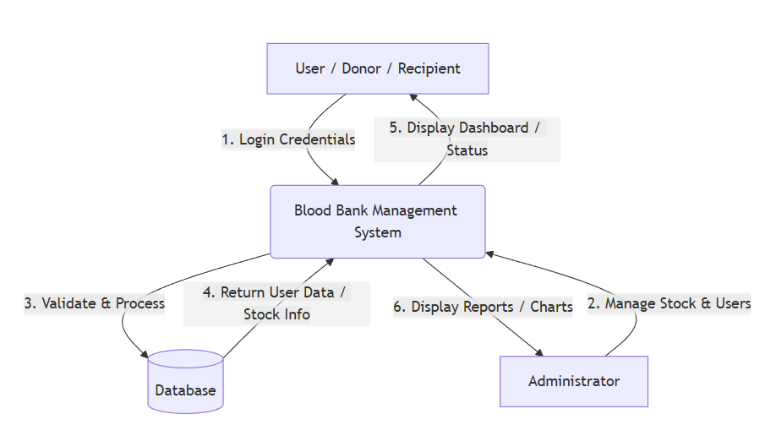

DFD LEVEL 1 (DETAILED DIAGRAM)

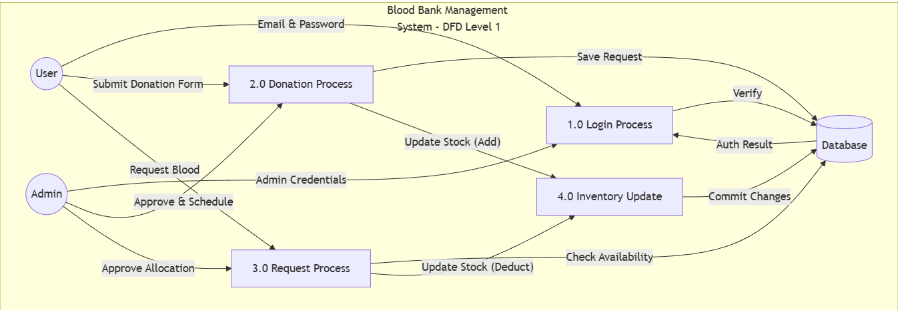

ER-DIAGRAM

ER-DIAGRAM EXPLANATION
- User (Donor/Recipient): Entity stores user details such as Name, Email, Password, Blood Group, and Role (Admin/User).
- BloodStock (Inventory): Entity stores blood group type and total units available. Each blood group acts as a distinct inventory record.
- DonationRequest: Entity records all donation activities such as donor weight, health notes, status, and appointment date. One user can have many donation requests.
- ReceiveRequest: Entity records all blood requisitions for patients, including hospital details and urgency. One user can have many receive requests.
- Announcements: Entity stores broadcast messages posted by the Admin.
Relationships:
- One User can make Many Donation Requests.
- One User can make Many Receive Requests.
- One Admin manages All Blood Stock and Announcements.

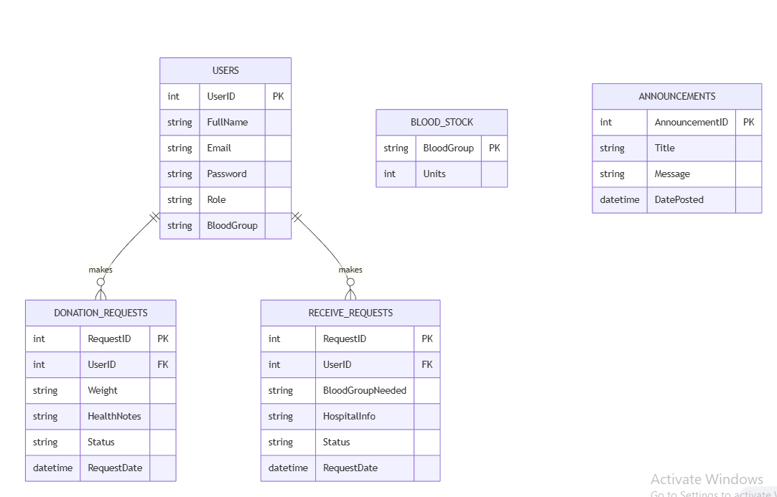

PROGRAM
SPECIFICATION

PROGRAM SPECIFICATION
The Blood Bank Management System is designed to provide secure, fast, and reliable healthcare services to donors and patients through an automated platform. This system allows users to perform essential blood bank operations such as registering as a donor, checking blood availability, requesting blood units, and viewing donation history without manual administrative assistance.
The system begins with user authentication, where the user enters their Email and Password. After successful verification, the system displays a dashboard of available services based on their role (User or Admin). Each selected operation is processed according to predefined business rules to ensure accuracy and security (e.g., verifying donor weight before acceptance).
The system maintains proper validation checks such as sufficient stock verification during a blood request, correct donor eligibility details, and duplicate entry prevention. All transactions are recorded with the date and time to maintain transparency and data consistency.
The Blood Bank Management System is developed using a modular approach, where each function (Donation, Request, Inventory) is handled by a separate program module. This improves system performance, simplifies debugging, and allows easy future enhancements. The system also ensures data integrity by updating blood stock automatically after every completed transaction.
Overall, the system reduces manual work, minimizes human errors, and improves user convenience by providing 24x7 access to blood availability information.

Functional Specifications
- User login using Email and Password.
- Real-time Blood Stock inquiry facility.
- Blood Donation Request with health validation.
- Patient Blood Requisition functionality.
- Transaction History display (Past Donations/Requests).
- Secure Logout after session completion.

Non-Functional Specifications
- User-friendly interface: Intuitive design using modern UI controls.
- Fast response time: Instant database retrieval for stock checks.
- Secure data handling: Password encryption and role-based access.
- Reliable transaction processing: ACID properties maintained for stock updates.
- Easy maintenance and scalability: Modular code structure allows adding new features easily.

Input Specifications
- User Details: Name, Email, Blood Group, Phone.
- Donation Details: Weight, Last Donation Date, Health Conditions.
- Request Details: Patient Name, Hospital Name, Blood Group Required.
- Admin Inputs: Status Updates (Accepted/Rejected), Announcements.

Output Specifications
- Dashboard Stats: Total Donations, Last Visit Date.
- Transaction Status: "Pending", "Accepted", or "Completed" messages.
- Inventory Charts: Visual bar graphs of blood stock.
- Announcements: List of urgent admin messages.

Error Handling
- Invalid Login: Displays "Incorrect Email or Password" message.
- Insufficient Stock Warning: Alerts admin if a request exceeds available units.
- Eligibility Failure: Prevents donation if weight < 50kg or recent illness is checked.
- Database Connection Error: Displays a friendly message if the database is unreachable.

This program specification ensures that the Blood Bank Management System works efficiently, securely, and accurately to meet the critical requirements of healthcare management.

IMPLEMENTATION

IMPLEMENTATION
The Blood Bank Management System is implemented using Visual Basic .NET as the front-end and MySQL (or SQLite) as the back-end database. The system follows a structured and modular programming approach to ensure simplicity, reliability, and ease of maintenance.
The front-end is developed in Visual Basic .NET, utilizing the ReaLTaiizor library to provide a modern, user-friendly graphical interface. Forms are designed for Login, User Dashboard, Admin Dashboard, Donate Blood, Request Blood, and Inventory Management. Proper input validation is applied to avoid incorrect data entry such as invalid email formats, underweight donors (< 50kg), or incomplete medical history.
The back-end database is created using MySQL. It contains tables such as Users, BloodStock, DonationRequests, ReceiveRequests, and Announcements. These tables are connected using primary keys and foreign keys to maintain data integrity and avoid redundancy (e.g., ensuring a Donation Request is always linked to a valid User). Database connectivity is established using ADO.NET for smooth and secure data communication between the application and the database.
During implementation, each module is coded separately. The Login Module verifies user credentials and role (Admin vs. User). The Donation Module validates donor eligibility (weight and health status) before allowing a request. The Request Module checks available blood stock before approving a patient's requisition. The Inventory Module automatically updates the stock count—incrementing units upon donation completion and decrementing them upon request fulfillment. Every transaction is stored in the respective tables with a timestamp for future reference.
Exception handling techniques are implemented to manage runtime errors such as database connection timeouts, invalid inputs, or insufficient stock warnings. After completing a transaction, the system displays a confirmation message and updates the dashboard statistics in real-time.
Overall, the implementation ensures secure transaction processing, accurate data management of life-saving resources, and efficient system performance.

TOOLS AND TECHNOLOGIES USED
- Frontend: Visual Basic .NET (Windows Forms)
- UI Library: ReaLTaiizor (For Material Design controls)
- Backend: MySQL Server (or SQLite for portability)
- Database Connectivity: ADO.NET (MySql.Data / System.Data.SQLite)
- Platform: Windows Operating System
- Development IDE: Microsoft Visual Studio 2022

The implementation phase successfully converts the system design into a fully functional Blood Bank Management System.

LOGIN WINDOW:

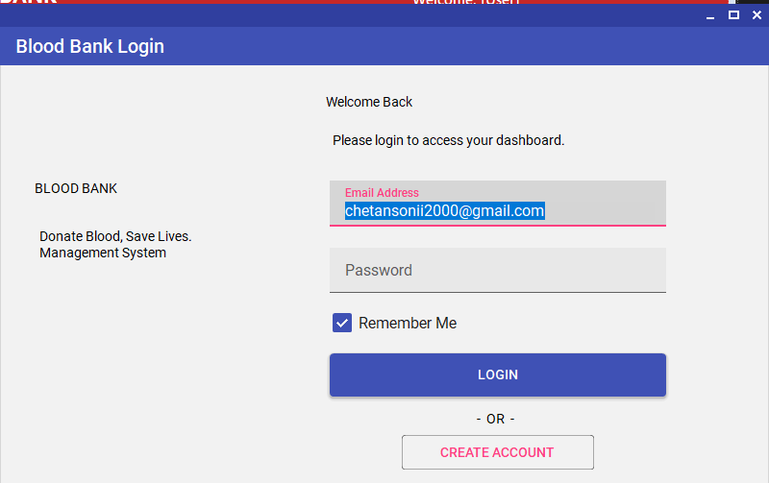

REGISTRATION WINDOW:

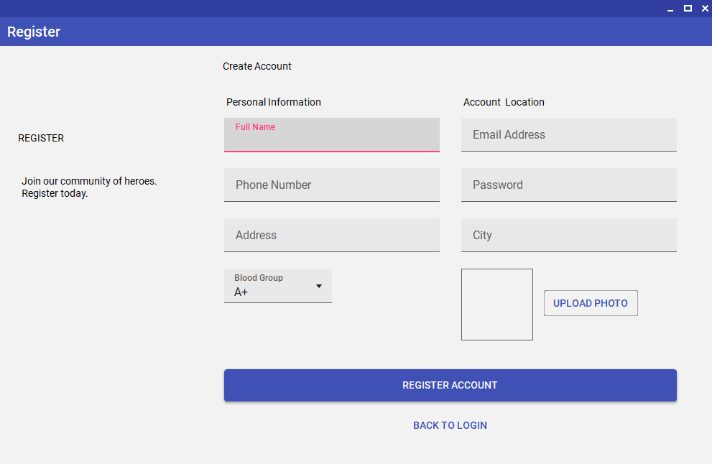

USER DASHBAORD:

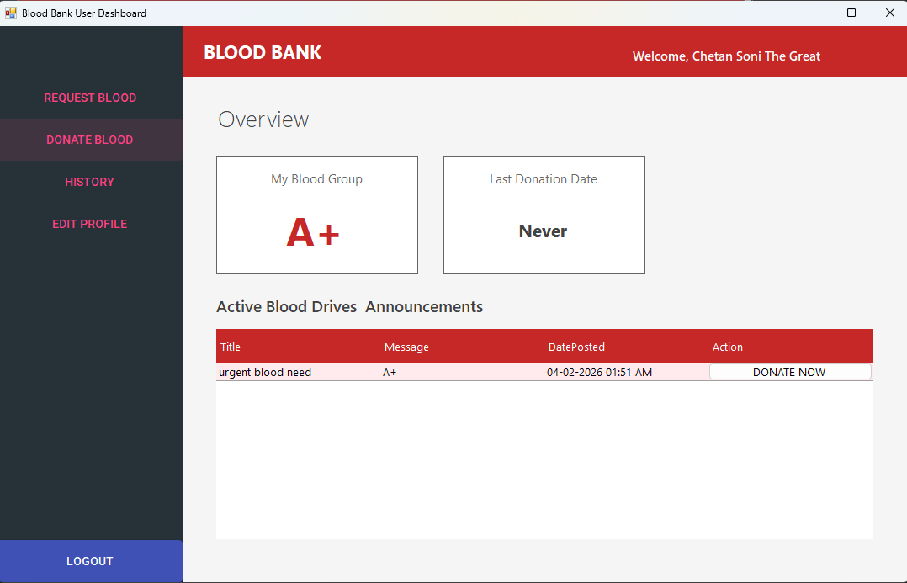

REQUEST BLOOD FORM:

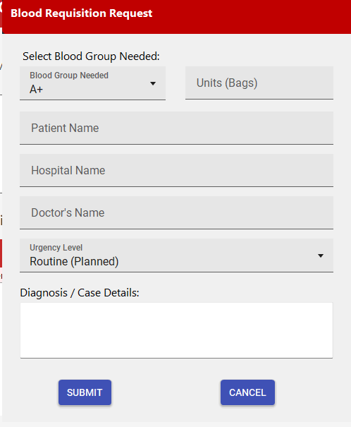

DONATE BLOOD FORM:

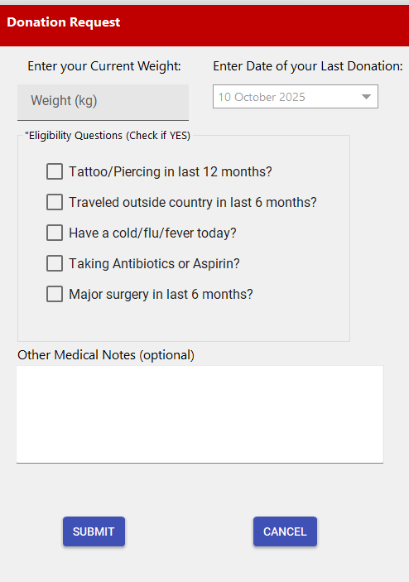

HISTORY FORM:

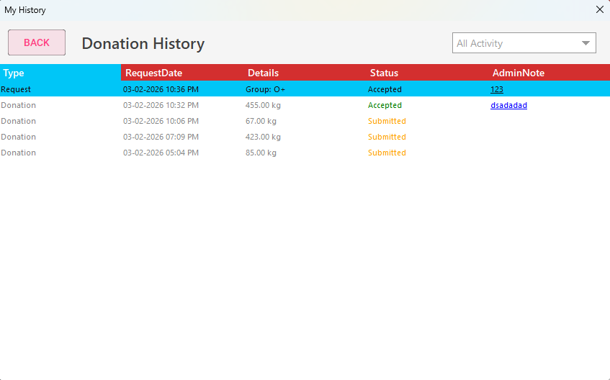

EDIT PROFILE:

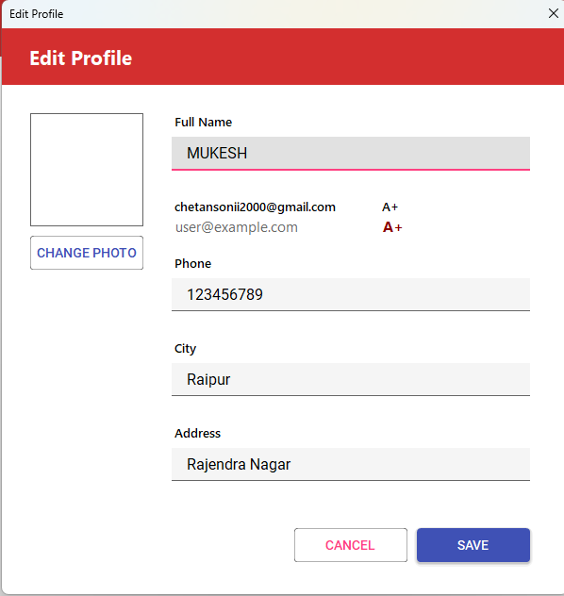

ADMIN BLOOD INVENTORDASHBOARD:

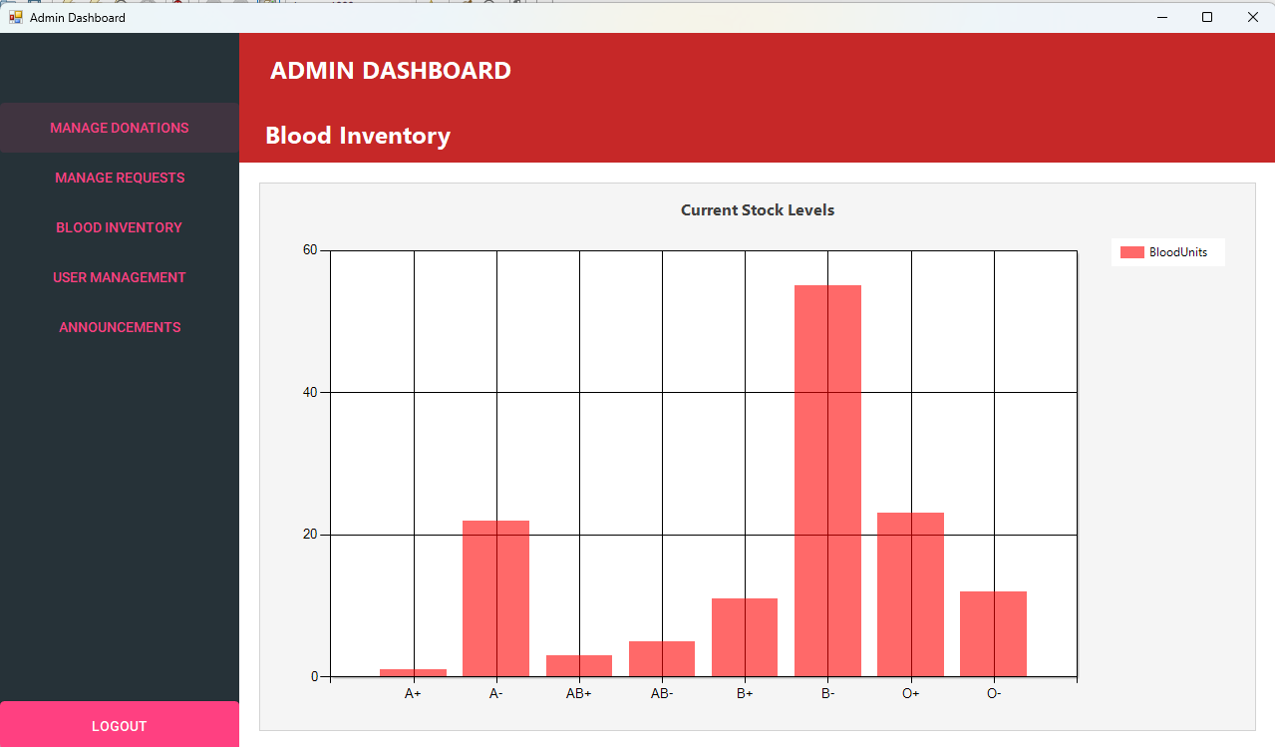

ADMIN MANAGE BLOOD DONATIONS:

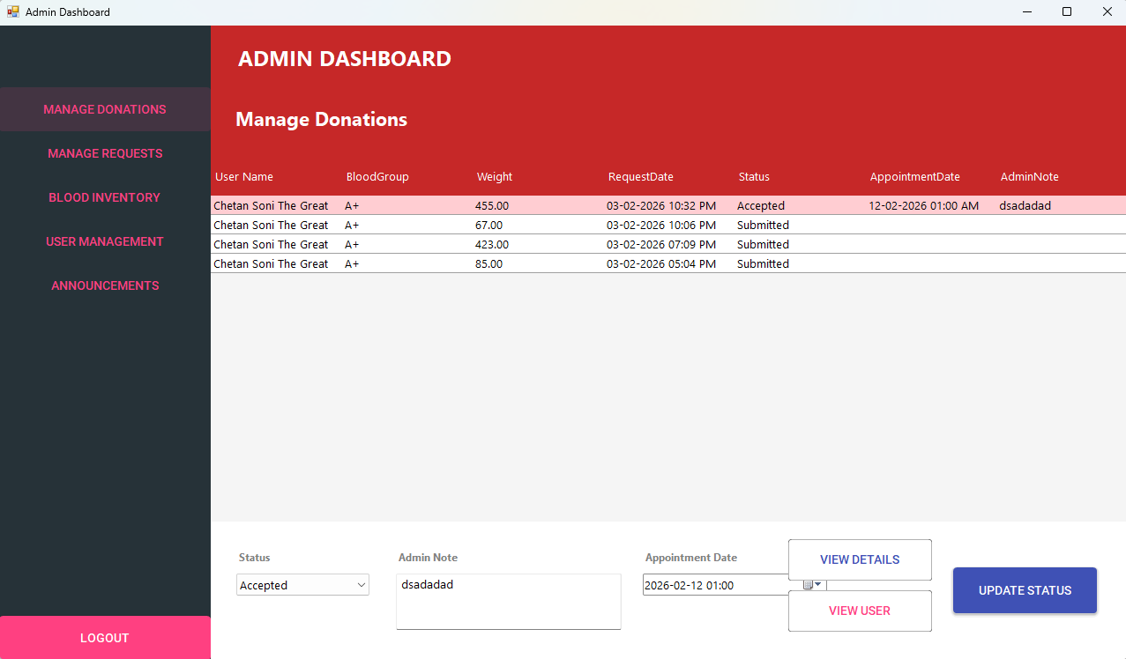

ADMIN MANAGE BLOOD REQUESTS:

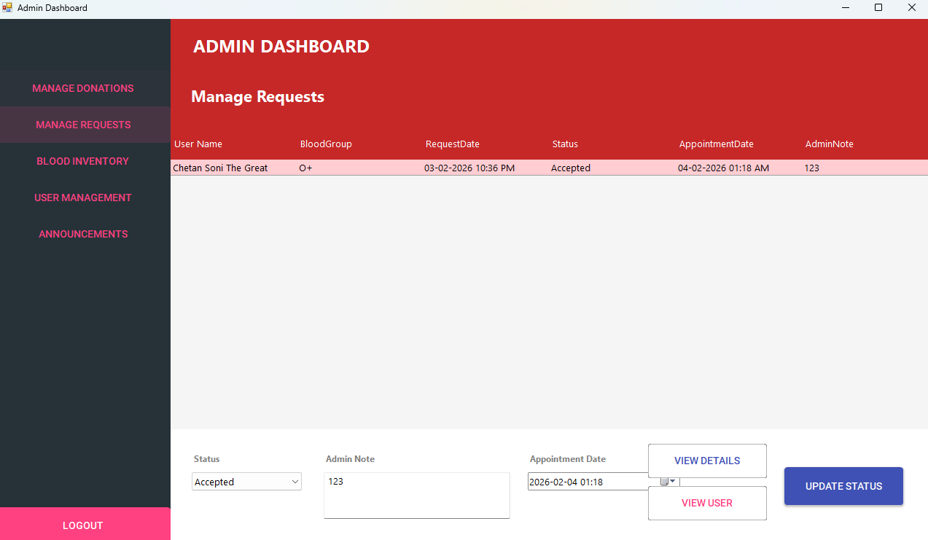

ADMIN MANAGE USERS:

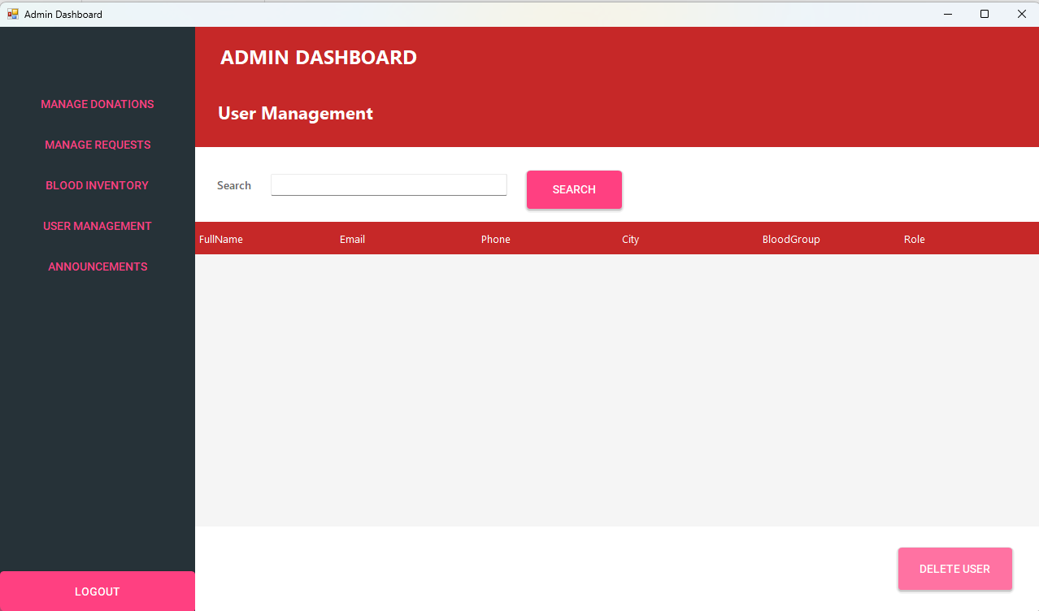
ADMIN ANNOUNCEMENTS:

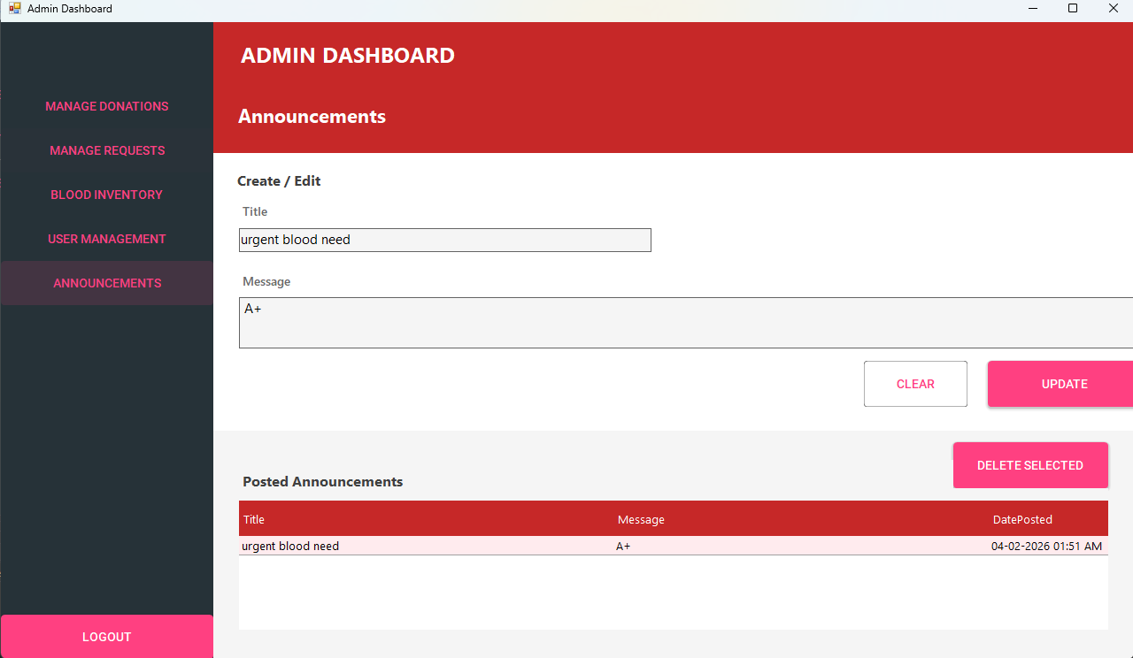
DATABASE DESIGN

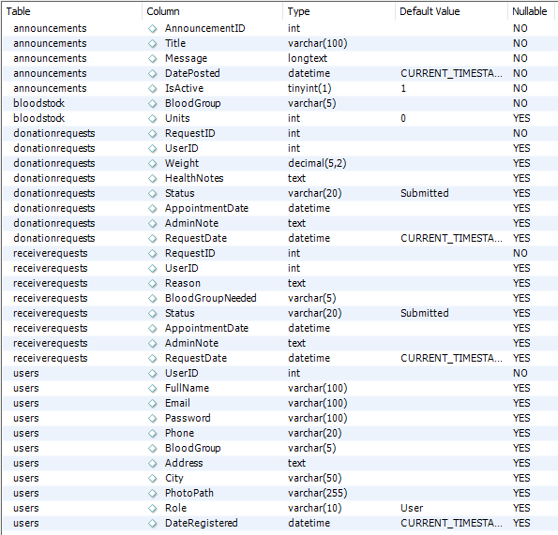

TESTING

TESTING
Testing is an important phase of the Blood Bank Management System development which ensures that the system works correctly and securely. All modules of the system were tested to identify and remove errors before final deployment. The testing process helps in verifying that the system meets the required functionality and provides accurate results regarding blood availability.
Different types of tests were performed such as Login Verification, Donor Eligibility Testing, Stock Update Testing, and Request Processing Testing.
- Input Validation: Each input was checked to ensure proper validation (e.g., ensuring a donor's weight is not entered as negative or below 50kg).
- Inventory Logic: The system was tested to confirm that when a donation is marked "Completed," the stock count increases by exactly 1 unit, and when a patient request is fulfilled, it decreases.
- Security Testing: Incorrect inputs (like wrong passwords) were tested to confirm that the system displays appropriate error messages and denies access.
The system was tested using real-time mock data stored in the database to verify data accuracy, security, and performance. After successful testing, the system was found to be reliable, user-friendly, and free from major errors.

APPLICATION
OF
PROJECT
Application of Project

The Blood Bank Management System is mainly used to perform healthcare operations in an easy and secure way. This system allows Blood Banks, Hospitals, and Donation Centers to manage their resources efficiently without relying on physical registers.
Key Applications:
- Blood Banks: To maintain an accurate count of available blood units and manage donor records.
- Hospitals: To quickly request blood for patients in emergencies by checking real-time availability.
- Donors: To view their donation history, eligibility status, and upcoming blood donation camps via announcements.
The project can be used to reduce manual work and improve efficiency in saving lives. It helps in maintaining accurate donor records, medical history, and inventory balances in the database. The system also ensures security by validating user credentials before allowing access to sensitive medical data.
This project is useful for educational purposes as well as for understanding real-time healthcare IT systems. It provides a basic model of how medical inventory software works in real hospital environments.

FUTURE
SCOPE

FUTURE SCOPE
The Blood Bank Management System can be enhanced in the future by adding several advanced and modern features to make it a fully commercial product.
- SMS & Email Notifications: Integration with APIs (like Twilio) can allow users to receive real-time SMS alerts when their donation request is approved or when a specific blood group is urgently needed.
- GPS Integration: A map feature can be added to show donors the location of the nearest blood bank or donation camp.
- Mobile Application: The system can be converted into a mobile app (Android/iOS) so donors can request appointments from their phones.
- Cloud Database: Upgrading to a centralized cloud database (like Azure SQL or AWS) would allow multiple blood bank branches across the city to share the same inventory data in real-time.
- Biometric Scanning: Fingerprint authentication could be added for staff login to prevent unauthorized access to the inventory.
- AI-Based Prediction: Artificial Intelligence could be used to predict blood shortages based on seasonal trends (e.g., predicting higher demand for platelets during dengue season).

CONCLUSION
The Blood Bank Management System has been successfully designed and developed to automate essential blood bank operations in a secure and efficient manner. The system provides key services such as Inventory Tracking, Donor Management, Patient Request Processing, and Admin Announcements, which reduces manual effort and improves operational accuracy.
During the development of this project, several real-world software engineering challenges were addressed. These include:
- Data Integrity: Ensuring that the blood stock count is always accurate (critical for medical safety).
- Validation Logic: Implementing strict rules (e.g., "Donors must be > 50kg") to ensure compliance with medical standards.
- User Experience: Creating a modern UI using the ReaLTaiizor library to replace the traditional, outdated Windows interface.
The project follows a structured and modular approach, which makes the system easy to maintain and scalable for future enhancements. Overall, the Blood Bank Management System meets all project objectives and provides a strong foundation for developing advanced, real-world healthcare applications.

REFERENCES
Books & Documentation:
- Microsoft Visual Basic .NET Documentation https://learn.microsoft.com/en-us/dotnet/visual-basic/
- MySQL Database Documentation https://dev.mysql.com/doc/
- ReaLTaiizor UI Library (GitHub) https://github.com/Taiizor/ReaLTaiizor
- Software Engineering – Roger S. Pressman https://www.mheducation.com/
Online Tutorials:
- VB.NET Tutorials – TutorialsPoint https://www.tutorialspoint.com/vb.net/
- Database Management Systems – GeeksforGeeks https://www.geeksforgeeks.org/dbms/
Online Resources:
- Stack Overflow (For debugging SQL queries)
- Google & YouTube (For UI design inspiration)
- Gemini & ChatGPT (For code optimization and documentation support)

