A

Project on

Hotel Management System Software

Submitted

In

Partial Fulfillment of the Requirement for the Award of the Degree of

Bachelor of Computer Application

(BCA- III)

For

Session:- 2025-26


Submitted To: Submitted by:

MR. PELE SENGUPTA MANISH SAHU

(ASST.PROFESSOR) ROLL NO- ……

At

CENTRAL COLLEGE OF IT FAFADIH

AFFIlLIATED TO

PT. RAVISHANKAR SHUKLA UNIVERSITY, RAIPUR (C.G.)

Central College of IT
PT. RAVISHANKAR SHUKLA UNIVERSITY, RAIPUR (C.G.)

CERTIFICATE OF APPROVAL

This is to certify that the Project work entitled "ATM Management SYSTEM PROJECT " is carried out by MANISH KUMAR SAHU a student of BCA-III year at CENTRAL COLLEGE OF IT is here by approved as a credible work in the discipline of Computer Science & Information Technology for the award of degree of BACHELOR OF COMPUTER APPLICATIONS during the year 2025-26 from PT. RAVISHANKAR SHUKLA UNIVERSITY, RAIPUR (C.G.).

PRINCIPAL
MR. JOGRAJ SINGH
CENTRAL COLLEGE OF IT,
FAFADIH, RAIPUR (C.G.)

CERTIFICATE OF APPROVAL

This is to certify that the Project work entitled "ATM Management System Project" is carried out by MANISH KUMAR SAHU a student of BCA-III year at CENTRAL COLLEGE OF IT is here by approved as a credible work in the discipline of Computer Science & Information Technology for the award of degree of BACHELOR OF COMPUTER APPLICATIONS during the year 2025-26 from PT. RAVISHANKAR SHUKLA UNIVERSITY, RAPUR (C.G.).

COORDINATOR
MRS. SEEMA BHATT
CENTRAL COLLEGE OF IT,
FAFADIH, RAIPUR (C.G.)

CERTIFICATE

This is to certify that the Project work entitled “ATM MANAGEMENT SYSTEM" submitted to the CENTRAL COLLEGE OF IT by Manish Kumar Sahu, Roll No .........., in partial fulfillment for the requirements relating to nature and standard of the award of Bachelor of Computer Application- III Year degree by,
Pt. Ravishankar Shukla University, Raipur (C.G.)
for the academic year 2025-2026.
This project work has been carried out under my guidance.

Guided By

MR. PELE SENGUPTA
(Asst. Professor)
Central College of IT
FAFADIH, RAIPUR (CG)

CERTIFICATE OF EVALUATION

This is to certify that the project work entitled "ATM MANAGEMENT SYSTEM" is carried out by Manish Kumar Sahu, a student of BCA III YEAR at CENTRAL COLLEGE OF IT, after proper evaluation and examination, is hereby approved as a credible work in the discipline of Computer Science & Information Technology and is done in a satisfactory manner for its acceptance as a requisite for the award of degree of BACHELOR OF COMPUTER APPLICATION- III Year during the year 2025-2026 from Pt. Ravishankar Shukla University, Raipur(C.G.).

Internal Examiner External Examiner

DECLARATION

This to certify that the project report entitled "ATM MANAGEMENT SYSTEM" which is submitted by me in the partial fulfillment for the award of the degree BACHELOR OF COMPUTER APPLICATION, CENTRAL COLLEGE OF IT, comprises the original work carried out by me.

Place: MANISH KUMAR SAHU

Date: ROLL NO :-……………..

ACKNOWLEDGEMENT

Success is the manifestation of diligence, perseverance, inspiration, motivation and innovation. The completion of any interdisciplinary project depends on co-operation, co-ordination and combined efforts of several sources of knowledge, energy and time. Hence, I approach this matter of acknowledgement through these lines trying my best to give full credit wherever it is due,
I take immense pleasure in thanking COORDINATOR of Computer Department for having permitted me to carry out this project work
I wish to express my deep sense of gratitude to my Guide, Mr. Pele Sengupta (Asst. Professor), who had been a source of inspiration and for his timely guidance and useful suggestions, which helped me in completing the project work, in time.

Words are inadequate in offering my thanks to the teachers, Project Trainees and Project Assistants, for their encouragement and cooperation in carrying out the project work.

Finally, yet importantly, I would like to express my heartfelt thanks to my beloved parents for their blessings, my friends/classmates for their help and wishes for the successful completion of this project and as always, nothing in my life would be possible without God, Thank You!

MANISH KUMAR SAHU

Table of Content
S. No. | Content | Page No.
1. | INTRODUCTION | 1
2. | SYSTEM OVERVIEW | 16
3. | SYSTEM ANALYSIS | 18
4. | SYSTEM DESIGN | 29
5. | STRUCTURE DESIGN | 36
6. | MODULE DESCRIPTION | 39
7. | DESGIN STRATEGY | 40
8. | DFD (DATA FLOW DIAGRAM) | 42
9. | ER-DIAGRAM | 44
10. | PROGRAM SPECIFICATION | 47
11. | IMPLEMENTATION | 51
12. | TESTING | 62
13. | APPLICATION OF PROJECT | 65
14. | FUTURE SCOPE | 67
15. | CONCLUSION | 69
16. | REFERENCE | 70

INTRODUCTION

The Hotel Management System is a software application designed to perform essential hospitality operations such as room booking, guest registration, check-in, check-out, and billing. It provides users with a simple and secure way to access room inventory and guest information.
This system reduces manual work and improves accuracy in hotel administration activities. It helps users to complete transactions quickly while maintaining proper records. The project also gives a clear idea of how real-life hotel systems work in a computerized environment.

ABOUT PROJECT:-

The Hotel Management System is developed to automate common hotel operations in an easy and efficient manner. The project allows users to perform transactions like room allocation, guest details entry, billing, and status updates.
This system ensures faster processing, better accuracy, and secure handling of user data. It is designed to simulate the working of a real hotel front desk and helps in understanding practical hospitality system operations.

Objectives of the Project :
- To develop a simple and user-friendly Hotel Management System.
- To provide secure operations like guest data management and billing.
- To reduce manual work and save time.
- To maintain accurate records of guest transactions and room history.
- To improve efficiency in hotel services.

System Features :
- User-friendly interface
- Secure login system
- Room availability check
- Check-in and Check-out features
- Guest record management
- Room status updates (Available/Occupied)
- Fast and accurate billing

Project Overview :
The Hotel Management System is a desktop-based software application developed to simulate the working of a computerized hotel front desk.
This project is designed to provide users with basic hospitality services such as checking room availability, registering guests, booking rooms, managing check-outs, and customer support services in a secure and user-friendly environment.
The main purpose of this system is to reduce manual record-keeping operations and provide fast, reliable, and accurate services to users.
The system stores customer data such as guest name, contact details, ID proof, room number, and transaction details in a database and retrieves the information whenever required.
Each authorized user (Admin/Receptionist) can securely access the system and perform transactions without the need for physical ledgers.
The Hotel Management System ensures proper validation at every step to avoid incorrect bookings and unauthorized access. It checks room details, verifies availability, and updates records automatically after every transaction. This helps in maintaining data accuracy and consistency.
The application is easy to use and designed in such a way that even non-technical users can operate it comfortably. It provides a simple graphical interface that guides the user through each operation step by step.
Overall, this project demonstrates how hospitality operations can be computerized using software, making services more efficient, secure, and accessible. It is suitable as a major academic project and helps in understanding real-world database management functionality.
Frontend (Visual Basic 2026)

- The frontend of the Hotel Management System is developed using Visual Basic .NET.
- It provides a graphical user interface (GUI) for users to interact with the system.
- The frontend includes forms such as Login Form, Main Dashboard, Room Management, Guest Management, Booking/Rental, Check-Out, and Pending Requests.
- Users enter data using text boxes and select options using buttons and combo boxes.
- Labels are used to display room information and system messages.
- Message boxes are used to show alerts, errors, and successful transaction messages.
- The Metro Framework (ReaLTaiizor) helps in creating a simple, attractive, and user-friendly interface with a modern look.

Backend (MySQL Database)

- The backend of the ATM Management System is developed using MS Access 2007.
- It is used to store and manage all the database records of the system.
- The database contains tables for account details, PIN numbers, balance, and transactions.
- MS Access 2007 stores user data securely and efficiently.
- It helps in retrieving and updating account information during transactions.
- Backend logic ensures correct balance calculation and data consistency.
- MS Access 2007 provides reliable data storage for smooth system performance.

Programming Process :

The development of the Hotel Management System follows a systematic programming process to ensure smooth and reliable performance.
- Requirement Analysis: In this phase, all system requirements are identified, such as Admin Login, Room Availability Check, Guest Registration, Booking (Check-In), Check-Out, and Billing. User needs and system objectives are clearly analyzed before development begins to ensure the software meets the operational demands of a modern hotel.
- System Design: The complete structure of the system is designed in this phase. User-friendly forms are created using the Metro Framework (Tiles, Labels, Textboxes, and Buttons) to give a modern look. The database structure (Tables for Rooms, Guests, Bookings) and data flow are planned using MySQL.
- Development: In the development phase, the actual coding of the system is done. The frontend is developed using Visual Basic .NET, while MySQL is used as the backend database. All modules (Room Management, Guest Management, Booking System) are integrated properly to ensure seamless data flow.
- Testing: The system is tested to ensure accuracy and reliability. Each function—such as calculating the total bill based on room price and duration—is checked to remove errors and ensure correct output.
- Deployment: After successful testing, the software is deployed for use. The system becomes ready for real-time hotel administration operations.
- Maintenance: Maintenance is performed regularly to fix issues, improve performance, and update features (like adding new room types) for future requirements.

Problem Definition :

- Manual Hotel Management systems are time-consuming and may cause errors in room allocation (e.g., double-booking).
- Maintaining guest records, ID proofs, and booking history manually in physical ledgers is difficult and risky.
- Existing manual systems lack proper security for admin authentication and sensitive guest data.
- Receptionists do not get quick access to "Available Room" status, leading to delays during check-in.
- Transaction details and billing records are not stored and managed efficiently, making financial auditing hard.
- Conclusion: There is a need for fast, secure, and user-friendly Hotel Management software.

Existing System :

- The existing hotel system mostly depends on manual (paper-based) or semi-automatic (Excel spreadsheet) processes.
- User authentication is often missing or weak, meaning unauthorized personnel can access guest data.
- Checking room availability and calculating bills manually takes more time and is prone to calculation errors.
- Data is not properly stored in a centralized database; it is often scattered across different files or books.
- There are higher chances of human error, such as assigning a dirty/occupied room to a new guest.
- The system is not user-friendly and searching for past guest records is difficult and slow.

Limitations of Existing System :

- Time-Consuming: Retrieving guest history or checking room status manually takes too long.
- Low Security: Physical registers can be lost, damaged, or accessed by unauthorized people.
- High Error Rate: Manual calculations for billing often lead to financial discrepancies.
- No Backup: Data backup and recovery facilities are not properly available in manual systems.
- Scalability Issues: System performance drops or becomes unmanageable when the number of rooms/guests increases.
- Maintenance: Updating records manually is difficult and costly.
Every Hotel Manager faces a lot of minor and major problems LIKE:

- Handling large amounts of guest data manually.
- Maintaining accuracy in daily bookings and revenue.
- Ensuring proper security of guest contact information.
- Managing time efficiently during peak check-in/check-out hours.
- Monitoring live room occupancy status.
- Reducing operational errors and double-booking failures.

Proposed System

The proposed system is a Hotel Management System software designed to overcome the limitations of the existing manual and semi-manual systems. This system automates all major front-desk operations and provides a secure, fast, and user-friendly environment.
The system allows administrators to perform essential hospitality operations such as Room Inventory Management, Guest Registration, Booking (Check-In), Check-Out, and Billing through a single integrated platform. It ensures accurate data handling, reduces human errors, and improves transaction speed.
The proposed system enhances data security via login authentication, maintains proper booking records in a MySQL database, and supports easy monitoring of "Live" room status (Available vs. Occupied). It also reduces the workload on hotel staff and improves the overall efficiency and professional image of the hotel.

SYSTEM
OVERVIEW

System overview :

The ATM Management System is a computerized application developed to perform essential banking operations in a simple, secure, and user-friendly manner. This system is designed to automate ATM-related activities and provide customers with quick access to their bank accounts without visiting a bank branch.
The system allows users to perform various operations such as cash withdrawal, balance inquiry, fund transfer, PIN change, and viewing service information. Each transaction is processed securely by validating account details and maintaining accurate records in the database. This helps in reducing manual work, saving time, and minimizing errors.
The ATM Management System improves efficiency by ensuring fast transaction processing and better data management. It provides a smooth interface where users can easily navigate through different options. The system also maintains confidentiality of user data and supports reliable transaction handling.
Overall, this project demonstrates how banking operations can be managed digitally with improved speed, accuracy, and security, making it useful for both users and administrators.

SYSTEM
ANALYSIS

System Analysis :

System analysis is the process of examining the hospitality requirements and understanding how the Hotel Management System will work. It helps in identifying user needs, system functions, and data processing methods.
The Hotel Management System is designed to provide administrators with essential hospitality services such as Room Availability Check, Guest Registration, Booking (Check-In), Check-Out, and Billing. The system ensures that only authorized administrators can access the dashboard and sensitive guest data through secure login credentials.
The system interacts with the backend database to fetch and update Room Inventory, Guest Details, and Booking Records. Each transaction (such as booking a room or processing a return) is validated to maintain accuracy and security. Error handling is included to manage invalid inputs (like negative prices) or conflicting actions (like double-booking a room).
Through proper system analysis, the Hotel Management System becomes reliable, efficient, and user-friendly, making hotel administration operations faster and more convenient for staff.

SYSTEM
DESIGN

System Design :
The system design of the Hotel Management System explains how the application is structured and how different modules work together. The system is designed in a simple and user-friendly manner so that receptionists can perform operations easily.
The application follows a modular approach where each function such as Login, Dashboard Overview, Room Management, Guest Management, Booking, and Return/Check-Out works as an independent module. This makes the system easy to manage and maintain.
- Frontend: The frontend of the system is developed using Visual Basic .NET, which provides an interactive graphical user interface (GUI) using modern "Metro-style" forms, tiles, buttons, and labels. Proper validations are used to ensure correct input from users.
- Backend: The backend is designed using MySQL Database, which stores all hotel-related information such as Room Types, Guest Contact Info, Booking Dates, and Fees. The system securely connects with the database using the MySql.Data library to fetch and update records.
Security is ensured through User Authentication (Login Form) and controlled access to data. Error handling is implemented to display appropriate messages for database connection failures or invalid entries. Overall, the system design focuses on simplicity, security, and efficient performance.

STRUCTURE
DESIGN

Structure Design :

The structure design of the Hotel Management System defines the overall framework of the system and the relationship between its components. The system is structured in a hierarchical manner to ensure smooth flow of operations and easy control.
The application consists of multiple interconnected forms:
- Login Form: The entry point for authentication.
- Main Dashboard: The central hub displaying live stats (Available Rooms, Active Bookings).
- Room Management Form: For adding or modifying room inventory.
- Guest Management Form: For registering and managing guest details.
- Booking (Rental) Form: For processing new check-ins.
- Return Form: For processing check-outs and billing.
- Requests Form: For managing pending booking requests.
Each form is connected through navigation tiles and buttons, allowing proper flow within the system.
The system follows a Front-End and Back-End Architecture. The front-end handles user interaction through VB.NET Forms, while the back-end manages data storage using MySQL. Communication between the forms and the database is handled by a centralized DatabaseConnection module.
Each module performs a specific task and shares data only when required (e.g., the Booking form pulls data from both the Rooms and Guests tables). This modular structure improves system performance, reduces complexity, and makes future enhancements easier.
Overall, the structured design ensures better organization, data consistency, and reliable operation of the Hotel Management System.

MODULE
DESCRIPTION

Module Description

The Hotel Management System is divided into several modules to perform different hospitality operations efficiently. Each module is designed to handle a specific function of the system.
- Login Module: This module is used to authenticate the administrator by verifying the Username and Password against the database. It ensures secure access to the system and prevents unauthorized usage of sensitive guest and financial data.
- Main Dashboard Module: After successful login, this module displays a live overview of the hotel. It acts as a central control panel, showing real-time tiles for "Available Rooms", "Total Guests", "Active Bookings", and "Pending Requests". It allows navigation to all other modules.
- Room Management Module: This module allows the administrator to manage the hotel's inventory. The admin can Add new rooms, Edit existing room details (like Room Type, Bed Type, Price), and Delete rooms that are no longer in service. It also displays the current availability status of each room.
- Guest Management Module: This module handles the registration of guests. The admin can enter guest details such as Name, Address, Phone Number, and Email. The system saves this data securely in the database, allowing for quick retrieval during future visits.
- Booking (Check-In) Module: This is the core transaction module. It enables the admin to book a room for a guest. The system validates that the selected room is "Available," calculates the estimated fee based on duration, and updates the room status to "Occupied" upon confirmation.
- Return (Check-Out) Module: This module manages the guest departure process. It allows the admin to select an active booking, verify the stay duration, and finalize the transaction. Once processed, the system automatically updates the room status back to "Available" for the next guest.
- Requests Module: This module handles pending booking requests (if applicable). It allows the admin to view requests and either Approve (converting them into active bookings) or Reject them.

DESIGN
STRATEGY

Design Strategy

The system is designed using a modular approach for better organization and efficiency.
- The system is divided into independent modules (Login, Inventory, Billing).
- Each module performs a specific function independently but shares a common database.
- A User-friendly interface is created using the Metro Framework for modern navigation.
- Frontend is developed using Visual Basic .NET.
- Backend database is managed using MySQL.
- Secure login prevents unauthorized access to the admin panel.
- Proper input validation is used to avoid errors (e.g., preventing negative prices).
- Database is updated immediately after every successful Booking or Check-out.
- Error handling ensures smooth system operation even during invalid inputs.
- The design supports easy maintenance and future enhancements like online booking integration.

DATA
FLOW
DIAGRAM
DFD (Data Flow Diagram) LEVEL 0
- Admin enters Username and Password into the Hotel Management System.
- The system verifies credentials from the User Database.
- Admin selects a service such as Room Management, Guest Registration, Booking, or Check-Out.
- The system processes the request and interacts with the MySQL Database.
- Final result (e.g., "Booking Confirmed" or "Room Added") is displayed to the Admin.

DFD Level 1
- Login Process
  - Admin provides credentials.
  - System validates credentials using tbl_users records.
- Room Management Process
  - Admin enters Room details (Type, Price).
  - System saves or updates the data in tbl_rooms.
- Guest Registration Process
  - Admin enters Guest details (Name, Phone).
  - System stores the profile in tbl_guests.
- Booking (Check-In) Process
  - Admin selects a Guest and an Available Room.
  - System calculates fees, creates a record in tbl_bookings, and updates tbl_rooms status to "Occupied".
- Check-Out Process
  - Admin selects an active booking.
  - System calculates final amount, updates tbl_bookings to "Returned", and updates tbl_rooms status back to "Available".

DFD LEVEL 0 (CONTEXT DIAGRAM)

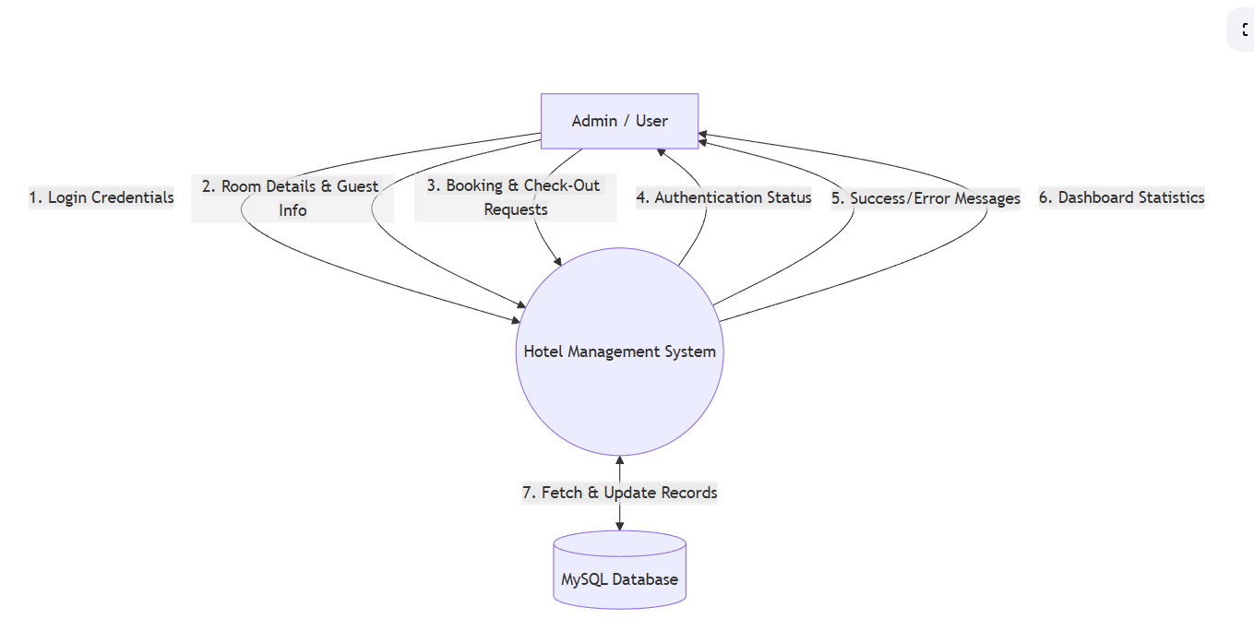
DFD LEVEL 1 (DETAILED DIAGRAM)

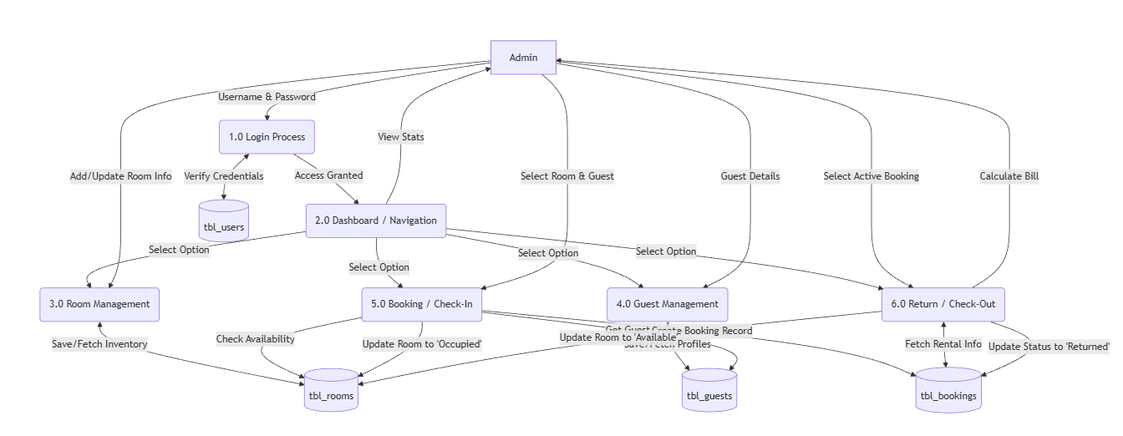

ER-DIAGRAM

ER-Diagram Explanation

- User Entity: Stores admin login details such as username and password for secure access control.
- Room Entity: Stores room inventory details such as room number, room type (Deluxe/Standard), bed type, price per day, and current availability status.
- Guest Entity: Stores customer personal details such as name, address, phone number, and email.
- Booking Entity: Records all transactions, linking a specific Guest to a specific Room for a duration (Check-in/Check-out dates) and calculating the total fee.

Relationships :

- One Guest can have Many Bookings (over different dates).
- One Room can have Many Bookings (historically, but only one active booking at a time).
- One Booking links exactly One Guest and One Room.

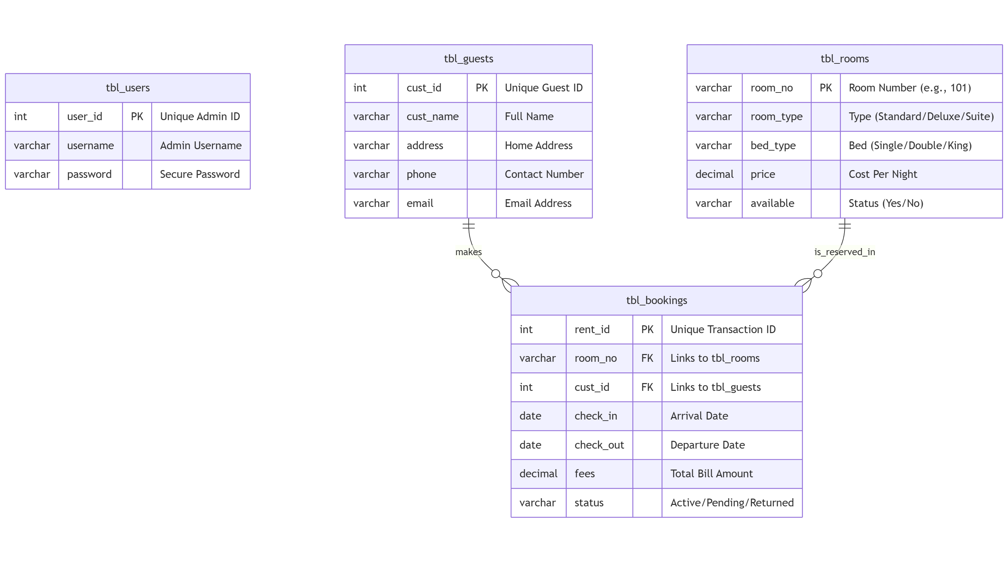

PROGRAM
SPECIFICATION

PROGRAM SPECIFICATION

The Hotel Management System is designed to provide secure, fast, and reliable hospitality administration services through an automated platform. This system allows administrators to perform essential operations such as room availability checking, guest registration, room booking, and check-out billing without manual ledger maintenance.
The system begins with User Authentication, where the administrator enters a secure username and password. After successful verification, the system displays a "Main Dashboard" with real-time statistics. Each selected operation (like booking a room) is processed according to predefined business rules to ensure no double-bookings occur.
The system maintains proper validation checks such as ensuring the "Check-out Date" is after the "Check-in Date," validating room availability before confirmation, and ensuring price fields contain only numbers. All transactions are recorded with timestamps to maintain transparency and data consistency.
The Hotel Management System is developed using a modular approach, where each function (Rooms, Guests, Bookings) is handled by a separate program form. This improves system performance, simplifies debugging, and allows easy future enhancements. The system also ensures data integrity by automatically updating the room status (Available ↔ Occupied) after every transaction.
Overall, the system reduces manual paperwork, minimizes human calculation errors, and improves the professional efficiency of the hotel front desk.

---

- Functional Specifications

  - User login using account number and PIN
  - Balance inquiry facility
  - Cash withdrawal with balance validation
  - Cash deposit functionality
  - Transaction history display
  - Secure logout after transaction

---

- Non-Functional Specifications

  - User-friendly Interface: Modern Metro-style design (ReaLTaiizor).
  - Fast Response Time: Instant database retrieval for room status.
  - Secure Data Handling: Password-protected admin access.
  - Reliable Processing: Prevents logical errors like double-booking.
  - Scalability: Easy to add new rooms or amenities in the future.

---

- Input Specifications

  - Admin Credentials (Username, Password).
  - Room Details (Number, Type, Price).
  - Guest Details (Name, Phone, Address).
  - Booking Details (Selected Room, Guest, Dates).

---

- Output Specifications

- Authentication Status (Success/Fail).
- Total Bill Calculation (Price × Days).
- Booking Confirmation Message.
  - Live Dashboard Counters.

---

- Error Handling

  - "Invalid Credentials" message on login failure.
  - "Room Already Occupied" warning during booking.
  - "Invalid Date Range" error if Check-out is before Check-in.
  - Database connection failure notifications.

---

This program specification ensures that the Hotel Management System works efficiently, securely, and accurately to meet administration requirements.

IMPLEMENTATION

IMPLEMENTATION

The Hotel Management System is implemented using Visual Basic .NET as the front-end and MySQL as the back-end database. The system follows a structured and modular programming approach to ensure simplicity, reliability, and ease of maintenance.
The front-end is developed in Visual Basic .NET, utilizing the Metro Framework (ReaLTaiizor) to provide a clean, modern, and user-friendly graphical interface. Forms are designed for Login, Main Dashboard, Room Inventory, Guest Management, Booking Transactions, and Check-Outs. Proper input validation is applied to avoid incorrect data entry, such as preventing empty fields or non-numeric prices.
The back-end database is created using MySQL. It contains normalized tables such as tbl_users, tbl_rooms, tbl_guests, and tbl_bookings. These tables are connected using Primary Keys and Foreign Keys to maintain data integrity and avoid redundancy. Database connectivity is established using the MySql.Data library for seamless and fast data communication between the application and the server.

During implementation, each module is coded separately:
- The Login Module verifies credentials against the user table.
- The Booking Module checks if a room available='Yes' before allowing a reservation.
- The Return Module calculates the final fee and resets the room status to 'Available'.
- Every transaction is persistently stored in the MySQL database for future reporting.
Exception handling techniques (Try-Catch blocks) are implemented to manage runtime errors such as database connection timeouts or invalid user inputs. After completing any critical action, the system displays a confirmation message box (e.g., "Booking Confirmed Successfully").
Overall, the implementation ensures secure transaction processing, accurate inventory management, and efficient system performance.
.
---
Tools and Technologies Used

- Frontend: Visual Basic .NET (Framework 4.8 / .NET 6+)
- UI Framework: ReaLTaiizor (Metro UI)
- Backend: MySQL Database
- Database Connectivity: MySql.Data.MySqlClient
- Platform: Windows Operating System

---

The implementation phase successfully converts the system design into a fully functional Hotel Management System software.

LOGIN SCREEN
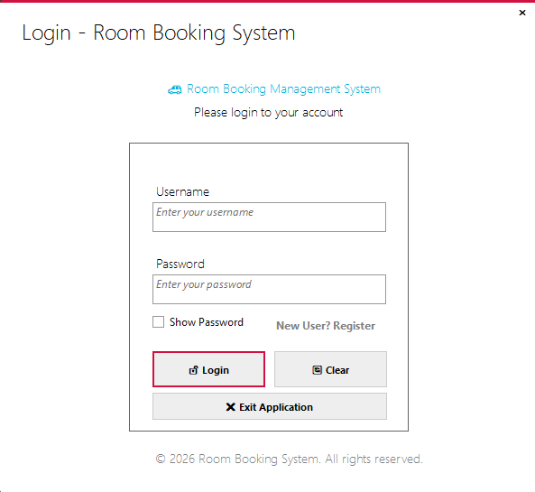

REGISTER FORM:

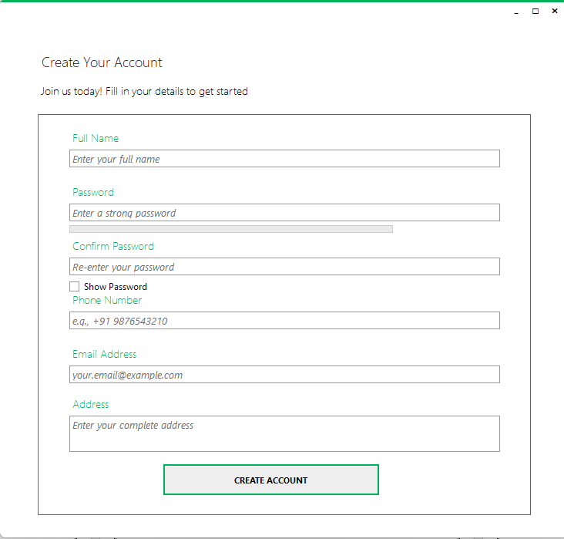
HOME PAGE

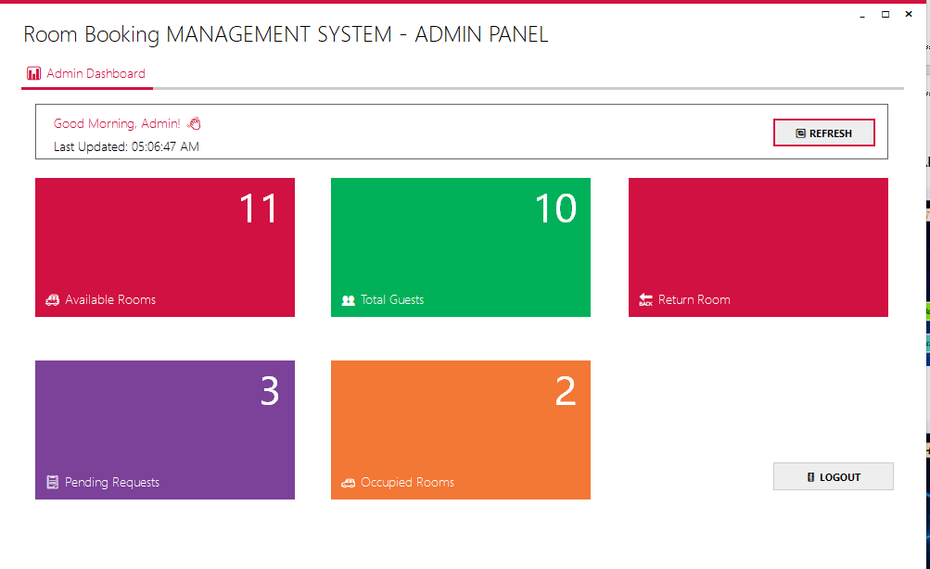

ROOM BOOKIN FORM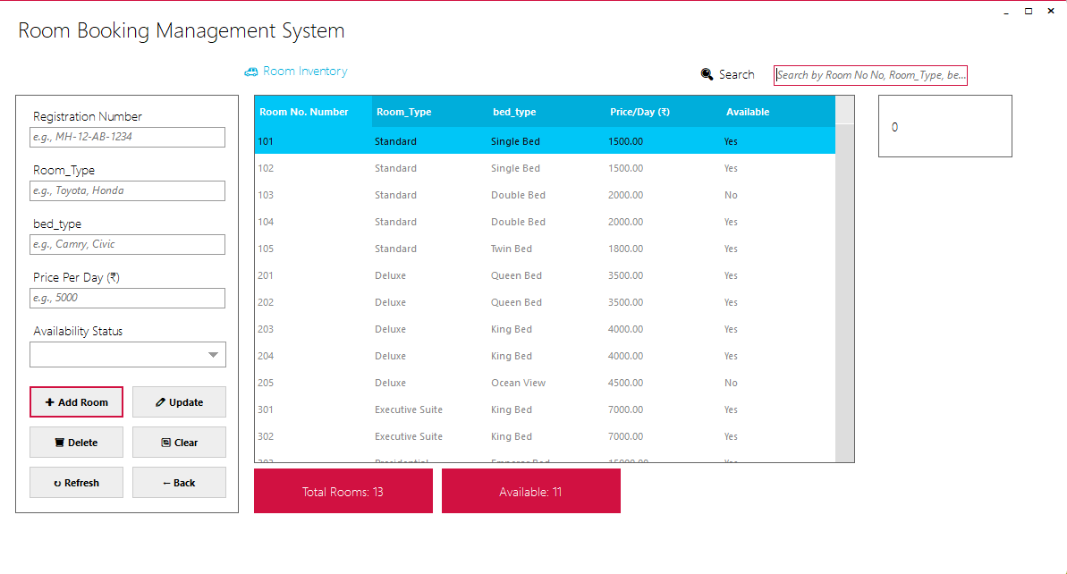
ROOM RETURN FORM
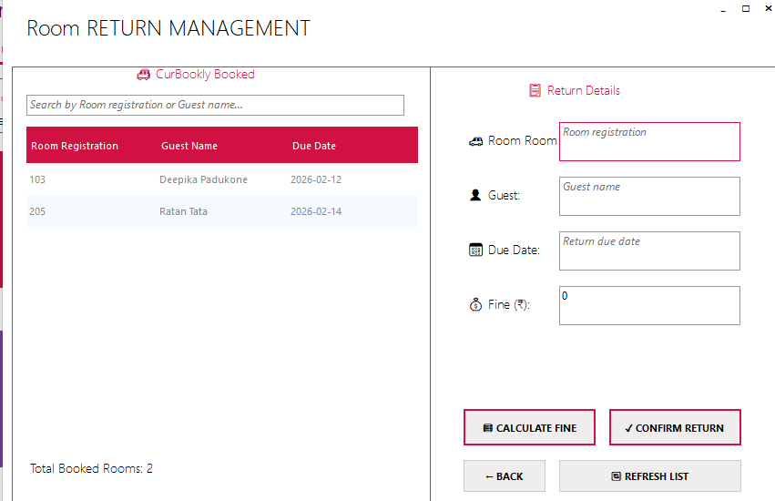

ROOM REQUESTS FORM

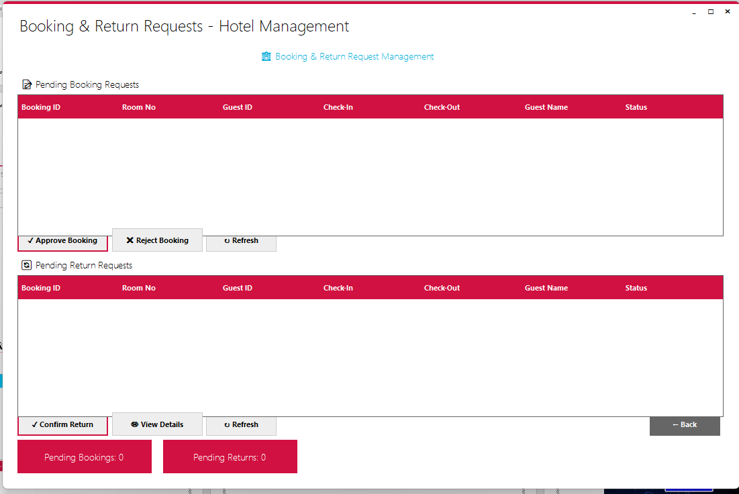
OCCUPIED ROOM FORM
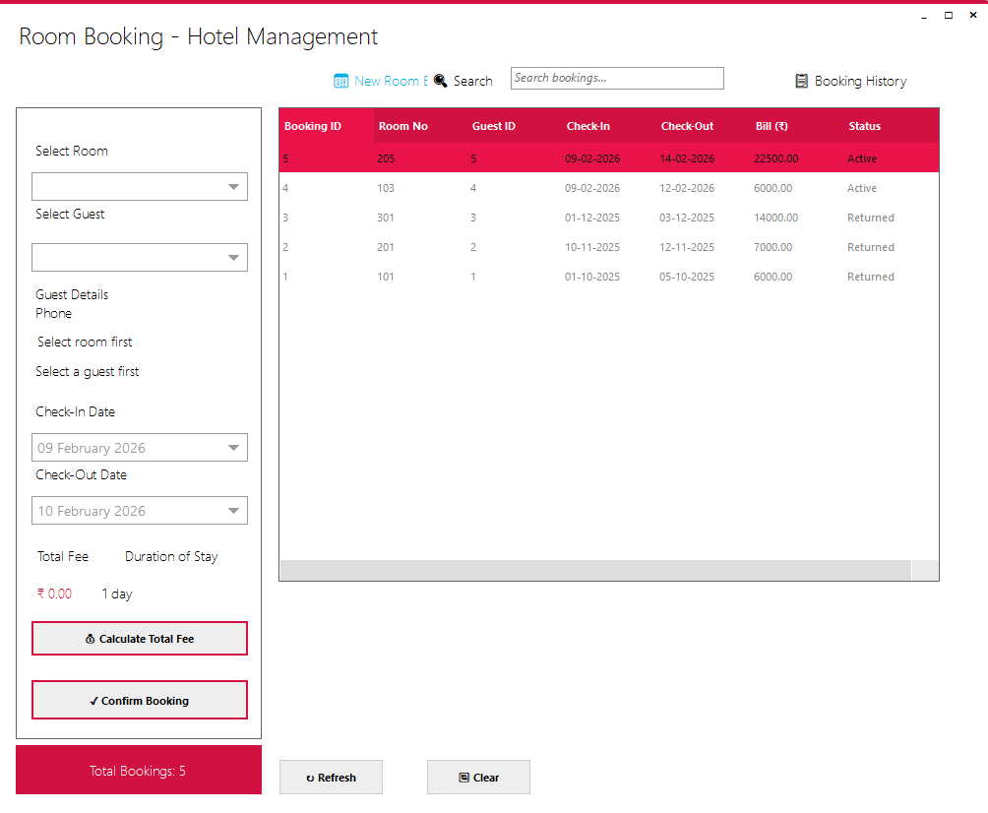

USER ROOM BOOKING FORM

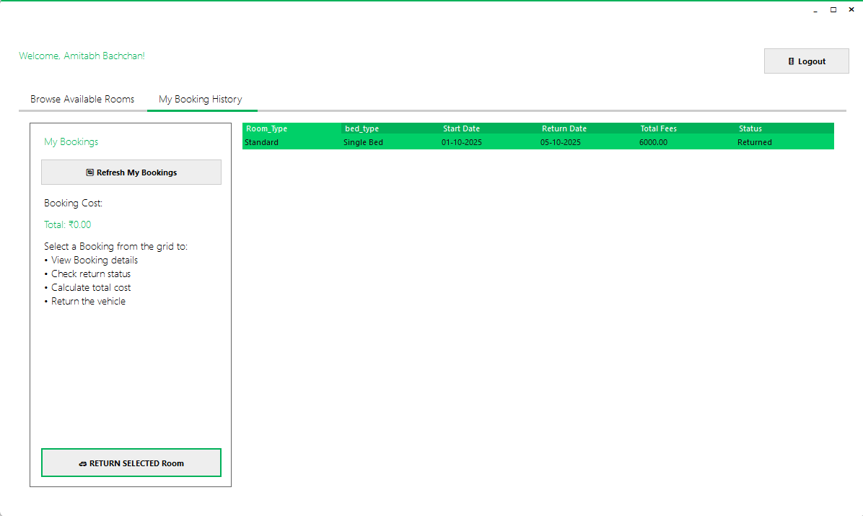

USER ROOM HISTORY FORM
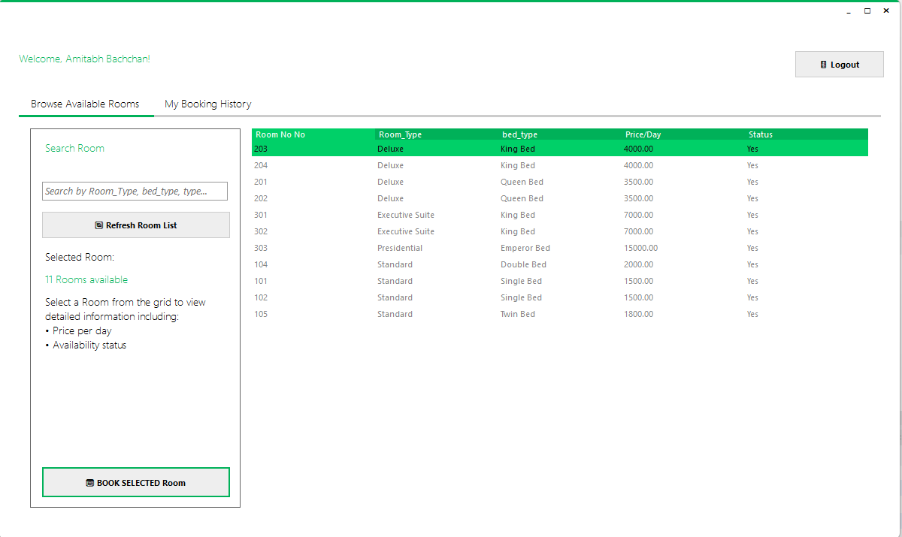
DATABASE DESIGN

DATABASE TABLE DESIGN

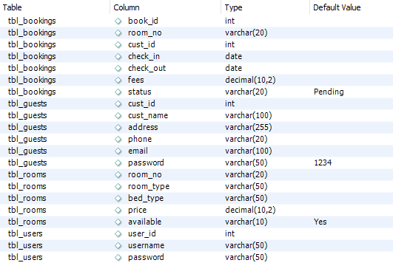

TESTING

Testing

Testing is an important phase of the Hotel Management System which ensures that the software works correctly, securely, and efficiently. All modules of the system were rigorously tested to identify and remove errors before final deployment. The testing process helps in verifying that the system meets the required functionality and provides accurate billing and inventory results.
Different types of tests were performed, such as:
- Login Testing: Verifying that only valid admin credentials grant access to the dashboard.
- Inventory Testing: Ensuring that adding a room updates the "Available Rooms" count immediately.
- Booking Testing: Confirming that a room marked "Occupied" cannot be double-booked.
- Billing Testing: Verifying that the total fee is calculated correctly based on the Room Price and Duration.
- Database Validation: Ensuring guest and booking records are stored and retrieved correctly from MySQL.
Each input was checked to ensure proper validation and error handling (e.g., preventing negative prices). Incorrect inputs were also tested to confirm that the system displays appropriate error messages.
The system was tested using real-time mock data stored in the MySQL database to verify data accuracy, security, and performance. After successful testing, the system was found to be reliable, user-friendly, and free from major operational errors.

APPLICATION
OF
PROJECT
Application of Project
The Hotel Management System is mainly used to perform hospitality administration operations in an easy and secure way. This system allows hotel administrators and receptionists to manage their daily workflow by using a centralized digital platform.
Key Applications:
- Hotel Administration: Used by receptionists to perform Check-in, Check-out, and Guest Registration without manual paperwork.
- Inventory Management: Helps in maintaining an accurate count of Available, Occupied, and Maintenance rooms.
- Record Keeping: It maintains accurate digital records of guest details, booking history, and revenue generation in the database for future auditing. software engineering concepts are applied in the hospitality industry.
- Efficiency Improvement: The project significantly reduces manual effort, calculation errors, and the time taken to process a guest's arrival or departure.
- Educational Use: This project is useful for academic purposes as well as for understanding how real-time database management systems work in a business environment. It provides a practical model of how

FUTURE
SCOPE

Future Scope

The Hotel Management System can be enhanced in the future by adding several advanced and modern features to meet the growing demands of the hospitality industry.
- Online Booking Integration: The system can be upgraded to integrate with a web portal, allowing guests to book rooms remotely from their phones or computers.
- Payment Gateway: Integration with UPI, Credit Card, and Net Banking systems can be added to allow cashless billing and advance payments.
- Housekeeping Module: A dedicated module can be added to track the cleaning status of rooms (e.g., "Dirty", "Cleaning in Progress", "Ready") and assign tasks to staff.
- Multi-User Roles: The system can be expanded to support different user roles such as Manager (Full Access), Receptionist (Booking Only), and Housekeeping (Status View Only).
- Mobile Application: Creating a mobile version of the dashboard would allow managers to monitor hotel occupancy and revenue from anywhere.
- AI & Analytics: In the future, data analytics can be added to predict peak seasons, analyze guest preferences, and adjust room pricing dynamically to maximize revenue.
- Cloud Deployment: Moving the local MySQL database to a cloud server would allow multiple branches of a hotel chain to share data in real-time.

Conclusion

The Hotel Management System has been successfully designed and developed to automate essential hospitality operations in a secure and efficient manner. The system provides key services such as Room Inventory management, Guest registration, and Booking transactions, which reduces manual effort and improves operational accuracy.
During the development of this project, several real-world software engineering challenges were addressed. These include ensuring data consistency (ensuring rooms aren't double-booked), validating financial calculations (billing accuracy), handling runtime errors, and managing smooth communication between the VB.NET frontend and the MySQL backend.
The project follows a structured and modular approach, making it easy to maintain and scale. The user-friendly interface, built with the Metro Framework, ensures that even non-technical staff can operate the system comfortably. Overall, the Hotel Management System meets all project objectives and provides a strong foundation for developing advanced, real-world hospitality applications.

References

- Microsoft Visual Basic .NET Documentation https://learn.microsoft.com/en-us/dotnet/visual-basic/
- MySQL Database Documentation https://dev.mysql.com/doc/
- Software Engineering – Roger S. Pressman https://www.mheducation.com/
- VB.NET Tutorials – TutorialsPoint https://www.tutorialspoint.com/vb.net/
- Database & Software Engineering Concepts – GeeksforGeeks https://www.geeksforgeeks.org/
- ReaLTaiizor (UI Framework) Documentation https://github.com/Taiizor/ReaLTaiizor
- ONLINE RESOURCES: Black-Box AI, GEMINI, GOOGLE, YOUTUBE.

