A

Project on

Hotel Management System Software

Submitted

In

Partial Fulfillment of the Requirement for the Award of the Degree of

Bachelor of Computer Application

(BCA- III)

For

Session:- 2025-26


Submitted To: Submitted by:

MR. PELE SENGUPTA MANISH SAHU

(ASST.PROFESSOR) ROLL NO- ……

At

CENTRAL COLLEGE OF IT FAFADIH

AFFIlLIATED TO

PT. RAVISHANKAR SHUKLA UNIVERSITY, RAIPUR (C.G.)

Central College of IT
PT. RAVISHANKAR SHUKLA UNIVERSITY, RAIPUR (C.G.)

CERTIFICATE OF APPROVAL

This is to certify that the Project work entitled "ATM Management SYSTEM PROJECT " is carried out by MANISH KUMAR SAHU a student of BCA-III year at CENTRAL COLLEGE OF IT is here by approved as a credible work in the discipline of Computer Science & Information Technology for the award of degree of BACHELOR OF COMPUTER APPLICATIONS during the year 2025-26 from PT. RAVISHANKAR SHUKLA UNIVERSITY, RAIPUR (C.G.).

PRINCIPAL
MR. JOGRAJ SINGH
CENTRAL COLLEGE OF IT,
FAFADIH, RAIPUR (C.G.)

CERTIFICATE OF APPROVAL

This is to certify that the Project work entitled "ATM Management System Project" is carried out by MANISH KUMAR SAHU a student of BCA-III year at CENTRAL COLLEGE OF IT is here by approved as a credible work in the discipline of Computer Science & Information Technology for the award of degree of BACHELOR OF COMPUTER APPLICATIONS during the year 2025-26 from PT. RAVISHANKAR SHUKLA UNIVERSITY, RAPUR (C.G.).

COORDINATOR
MRS. SEEMA BHATT
CENTRAL COLLEGE OF IT,
FAFADIH, RAIPUR (C.G.)

CERTIFICATE

This is to certify that the Project work entitled “ATM MANAGEMENT SYSTEM" submitted to the CENTRAL COLLEGE OF IT by Manish Kumar Sahu, Roll No .........., in partial fulfillment for the requirements relating to nature and standard of the award of Bachelor of Computer Application- III Year degree by,
Pt. Ravishankar Shukla University, Raipur (C.G.)
for the academic year 2025-2026.
This project work has been carried out under my guidance.

Guided By

MR. PELE SENGUPTA
(Asst. Professor)
Central College of IT
FAFADIH, RAIPUR (CG)

CERTIFICATE OF EVALUATION

This is to certify that the project work entitled "ATM MANAGEMENT SYSTEM" is carried out by Manish Kumar Sahu, a student of BCA III YEAR at CENTRAL COLLEGE OF IT, after proper evaluation and examination, is hereby approved as a credible work in the discipline of Computer Science & Information Technology and is done in a satisfactory manner for its acceptance as a requisite for the award of degree of BACHELOR OF COMPUTER APPLICATION- III Year during the year 2025-2026 from Pt. Ravishankar Shukla University, Raipur(C.G.).

Internal Examiner External Examiner

DECLARATION

This to certify that the project report entitled "ATM MANAGEMENT SYSTEM" which is submitted by me in the partial fulfillment for the award of the degree BACHELOR OF COMPUTER APPLICATION, CENTRAL COLLEGE OF IT, comprises the original work carried out by me.

Place: MANISH KUMAR SAHU

Date: ROLL NO :-……………..

ACKNOWLEDGEMENT

Success is the manifestation of diligence, perseverance, inspiration, motivation and innovation. The completion of any interdisciplinary project depends on co-operation, co-ordination and combined efforts of several sources of knowledge, energy and time. Hence, I approach this matter of acknowledgement through these lines trying my best to give full credit wherever it is due,
I take immense pleasure in thanking COORDINATOR of Computer Department for having permitted me to carry out this project work
I wish to express my deep sense of gratitude to my Guide, Mr. Pele Sengupta (Asst. Professor), who had been a source of inspiration and for his timely guidance and useful suggestions, which helped me in completing the project work, in time.

Words are inadequate in offering my thanks to the teachers, Project Trainees and Project Assistants, for their encouragement and cooperation in carrying out the project work.

Finally, yet importantly, I would like to express my heartfelt thanks to my beloved parents for their blessings, my friends/classmates for their help and wishes for the successful completion of this project and as always, nothing in my life would be possible without God, Thank You!

MANISH KUMAR SAHU

Table of Content
S. No. | Content | Page No.
1. | INTRODUCTION | 1
2. | SYSTEM OVERVIEW | 16
3. | SYSTEM ANALYSIS | 18
4. | SYSTEM DESIGN | 29
5. | STRUCTURE DESIGN | 36
6. | MODULE DESCRIPTION | 39
7. | DESGIN STRATEGY | 40
8. | DFD (DATA FLOW DIAGRAM) | 42
9. | ER-DIAGRAM | 44
10. | PROGRAM SPECIFICATION | 47
11. | IMPLEMENTATION | 51
12. | TESTING | 62
13. | APPLICATION OF PROJECT | 65
14. | FUTURE SCOPE | 67
15. | CONCLUSION | 69
16. | REFERENCE | 70

INTRODUCTION

The Car Rental System is a software application designed to perform essential vehicle rental operations such as car booking, customer registration, rental issuance, return processing, and billing. It provides administrators with a simple and secure way to access fleet inventory and customer information.
This system reduces manual paperwork and improves accuracy in rental agency administration activities. It helps staff to complete transactions quickly while maintaining proper records of vehicle usage and revenue. The project also gives a clear idea of how real-life transport management systems work in a computerized environment.

- ABOUT PROJECT:-

The Hotel Management System is developed to automate common hotel operations in an easy and efficient manner. The project allows users to perform transactions like room allocation, guest details entry, billing, and status updates.
This system ensures faster processing, better accuracy, and secure handling of user data. It is designed to simulate the working of a real hotel front desk and helps in understanding practical hospitality system operations.

- Objectives of the Project:
- To develop a simple and user-friendly Car Rental System.
- To provide secure operations like customer data management and billing.
- To reduce manual work and save time during vehicle pickup and drop-off.
- To maintain accurate records of active rentals and vehicle history.
- To improve the overall efficiency of fleet services.
- System Features:
- User-friendly Interface: Modern Metro-style design.
- Secure Login System: Password-protected admin access.
- Fleet Availability Check: Instant status of available vs. rented cars.
- Rental and Return Features: Streamlined workflow for issuing and receiving cars.
- Customer Record Management: Secure storage of driving license and contact info.
- Status Updates: Automatic updates of vehicle status (Available/Rented/Maintenance).
- Fast and Accurate Billing: Automatic calculation of fees based on duration.
- PROJECT OVERVIEW
The Car Rental System is a desktop-based software application developed to simulate the working of a computerized rental agency.
This project is designed to provide users with basic fleet services such as checking car availability, registering customers, booking vehicles, managing returns, and calculating final dues in a secure and user-friendly environment.
The main purpose of this system is to reduce manual record-keeping operations and provide fast, reliable, and accurate services to customers.
The system stores customer data such as Name, Phone Number, Driving License Number, and Address, along with Vehicle Details (Brand, Model, Registration Number) in a database and retrieves the information whenever required.
Each authorized user (Admin/Staff) can securely access the system and perform transactions without the need for physical logbooks.
The Car Rental System ensures proper validation at every step to avoid incorrect bookings and unauthorized access. It checks car details, verifies availability (preventing double-booking), and updates records automatically after every transaction. This helps in maintaining data accuracy and consistency.
The application is easy to use and designed in such a way that even non-technical users can operate it comfortably. It provides a simple graphical interface that guides the user through each operation step by step.
Overall, this project demonstrates how rental operations can be computerized using software, making services more efficient, secure, and accessible. It is suitable as a major academic project and helps in understanding real-world database management functionality.
4. FRONTEND (Visual Basic .NET)
- The frontend of the Car Rental System is developed using Visual Basic .NET (VB.NET).
- It provides a graphical user interface (GUI) for users to interact with the system.
- The frontend includes forms such as Login Form, Main Dashboard, Car Management, Customer Management, Rental Issue, Return Process, and Pending Requests.
- Users enter data using text boxes and select options using buttons and combo boxes (e.g., selecting Car Brand).
- Labels are used to display live fleet statistics (e.g., "5 Cars Available").
- Message boxes are used to show alerts, errors, and successful transaction messages.
- The Metro Framework (ReaLTaiizor) helps in creating a simple, attractive, and user-friendly interface with a modern look similar to Windows 10/11.

- BACKEND (MySQL Database)
- The backend of the Car Rental System is developed using MySQL Database.
- It is used to store and manage all the database records of the system.
- The database contains tables for Users, Cars, Customers, and Rentals.
- MySQL stores user data securely and efficiently.
- It helps in retrieving and updating car information during rental and return transactions.
- Backend logic ensures correct fee calculation based on (Price Per Day × Days Rented) and data consistency.
- MySQL provides reliable relational data storage for smooth system performance.

- PROGRAMMING PROCESS
- The development of the Car Rental System follows a systematic programming process to ensure smooth and reliable performance.
- Requirement Analysis: In this phase, all system requirements are identified, such as Admin Login, Vehicle Availability Check, Customer Registration, Rental Processing (Issue), Vehicle Return, and Billing. User needs and system objectives are clearly analyzed before development begins to ensure the software meets the operational demands of a modern rental agency.
- System Design: The complete structure of the system is designed in this phase. User-friendly forms are created using the Metro Framework (Tiles, Labels, Textboxes, and Buttons) to give a modern look. The database structure (Tables for Cars, Customers, Rentals) and data flow are planned using MySQL.
- Development: In the development phase, the actual coding of the system is done. The frontend is developed using Visual Basic .NET, while MySQL is used as the backend database. All modules (Fleet Management, Customer Management, Rental System) are integrated properly to ensure seamless data flow.
- Testing: The system is tested to ensure accuracy and reliability. Each function—such as calculating the total rental fee based on the price per day and duration—is checked to remove errors and ensure correct output.
- Deployment: After successful testing, the software is deployed for use. The system becomes ready for real-time rental agency operations.
- Maintenance: Maintenance is performed regularly to fix issues, improve performance, and update features (like adding new Car Models) for future requirements.
- PROBLEM DEFINITION
- Manual Car Rental Systems are time-consuming and may cause errors in vehicle allocation (e.g., double-booking the same car for the same dates).
- Maintaining customer records, driving license details, and vehicle history manually in physical ledgers is difficult and risky.
- Existing manual systems lack proper security for admin authentication and sensitive customer data.
- Agency staff do not get quick access to "Available Car" status, leading to delays when attending to customers.
- Transaction details and rental revenue records are not stored and managed efficiently, making financial auditing hard.
- Conclusion: There is a need for fast, secure, and user-friendly Car Rental Management software.
- EXISTING SYSTEM
- The existing rental system mostly depends on manual (paper-based) or semi-automatic (Excel spreadsheet) processes.
- User authentication is often missing or weak, meaning unauthorized personnel can access business data.
- Checking vehicle availability and calculating final bills manually takes more time and is prone to calculation errors.
- Data is not properly stored in a centralized database; it is often scattered across different files or logbooks.
- There are higher chances of human error, such as renting out a car that is already booked or under maintenance.
- The system is not user-friendly and searching for past rental records is difficult and slow.

- LIMITATIONS OF EXISTING SYSTEM
- Time-Consuming: Retrieving customer rental history or checking vehicle availability status manually takes too long, leading to long queues at the counter.
- Low Security: Physical rental agreements and logbooks can be lost, damaged, or accessed by unauthorized people, putting customer data at risk.
- High Error Rate: Manual calculations for rental fees, penalties for late returns, and taxes often lead to financial discrepancies.
- No Backup: Data backup and recovery facilities are not properly available in manual filing systems. If a logbook is lost, the data is gone forever.
- Scalability Issues: System performance becomes unmanageable when the fleet size increases or during peak holiday seasons.
- Maintenance: Updating vehicle maintenance records and status manually is difficult and costly.
Every Rental Agency Manager faces a lot of minor and major problems LIKE:
- Handling large amounts of customer and driving license data manually.
- Maintaining accuracy in daily rental logs and revenue generation.
- Ensuring proper security of sensitive customer contact information.
- Managing time efficiently during peak vehicle pickup and drop-off hours.
- Monitoring live fleet availability (Available vs. Rented cars).
- Reducing operational errors such as double-booking the same vehicle.
- PROPOSED SYSTEM
The proposed system is a Car Rental System software designed to overcome the limitations of the existing manual and semi-manual systems. This system automates all major agency operations and provides a secure, fast, and user-friendly environment.
The system allows administrators to perform essential transport operations such as Fleet Inventory Management, Customer Registration, Rental Processing (Issue), Vehicle Return, and Billing through a single integrated platform. It ensures accurate data handling, reduces human errors, and improves transaction speed.
The proposed system enhances data security via login authentication, maintains proper rental records in a MySQL database, and supports easy monitoring of "Live" Fleet Status (Available vs. Rented). It also reduces the workload on agency staff and improves the overall efficiency and professional image of the car rental business.

SYSTEM
OVERVIEW

System overview :

The Car Rental System is a computerized application developed to perform essential vehicle rental operations in a simple, secure, and user-friendly manner. This system is designed to automate agency-related activities and provide administrators with quick access to fleet inventory and customer records without relying on manual logbooks.
The system allows users to perform various operations such as Checking Vehicle Availability, Registering New Customers, Processing Car Rentals, Managing Returns, and Calculating Final Bills. Each transaction is processed securely by validating customer driving licenses and maintaining accurate records in the MySQL database. This helps in reducing manual paperwork, saving time, and minimizing calculation errors.
The Car Rental System improves efficiency by ensuring fast booking processing and better fleet data management. It provides a smooth interface (built with VB.NET) where staff can easily navigate through different options like "Issue Car" or "Return Car." The system also maintains the confidentiality of sensitive customer data and supports reliable transaction handling.
Overall, this project demonstrates how transport agency operations can be managed digitally with improved speed, accuracy, and security, making it useful for both business owners and staff.

SYSTEM
ANALYSIS

System Analysis :

System analysis is the process of examining the transportation business requirements and understanding how the Car Rental System will work. It helps in identifying user needs, system functions, and data processing methods.
The Car Rental System is designed to provide administrators with essential fleet services such as Vehicle Availability Check, Customer Registration, Car Rental (Issue), Vehicle Return, and Billing. The system ensures that only authorized administrators can access the dashboard and sensitive customer data through secure login credentials.
The system interacts with the backend database to fetch and update Fleet Inventory, Customer Details, and Rental Records. Each transaction (such as renting out a car or processing a return) is validated to maintain accuracy and security. Error handling is included to manage invalid inputs (like negative pricing) or conflicting actions (like renting a car that is already out with another customer).
Through proper system analysis, the Car Rental System becomes reliable, efficient, and user-friendly, making agency operations faster and more convenient for staff.

SYSTEM
DESIGN

System Design :
The system design of the Car Rental System explains how the application is structured and how different modules work together. The system is designed in a simple and user-friendly manner so that agency staff can perform operations easily.
The application follows a modular approach where each function such as Login, Dashboard Overview, Car Management, Customer Management, Rental, and Return works as an independent module. This makes the system easy to manage and maintain.
- Frontend: The frontend of the system is developed using Visual Basic .NET, which provides an interactive graphical user interface (GUI) using modern "Metro-style" forms, tiles, buttons, and labels. Proper validations are used to ensure correct input from users (e.g., verifying Driving License formats).
- Backend: The backend is designed using MySQL Database, which stores all agency-related information such as Car Brands/Models, Customer Contact Info, Rental Dates, and Fees. The system securely connects with the database using the MySql.Data library to fetch and update records.
Security is ensured through User Authentication (Login Form) and controlled access to data. Error handling is implemented to display appropriate messages for database connection failures or invalid entries. Overall, the system design focuses on simplicity, security, and efficient performance.

STRUCTURE
DESIGN

Structure Design :

The structure design of the Car Rental System defines the overall framework of the system and the relationship between its components. The system is structured in a hierarchical manner to ensure smooth flow of operations and easy control.
The application consists of multiple interconnected forms:
- Login Form: The entry point for authentication.
- Main Dashboard: The central hub displaying live stats (Available Cars, Active Rentals).
- Car Management Form: For adding, modifying, or deleting vehicle inventory.
- Customer Management Form: For registering and managing customer details and license info.
- Rental (Issue) Form: For processing new vehicle rentals.
- Return Form: For processing vehicle returns, checking for delays, and billing.
- Requests Form: For managing pending rental requests.
Each form is connected through navigation tiles and buttons, allowing proper flow within the system.
The system follows a Front-End and Back-End Architecture. The front-end handles user interaction through VB.NET Forms, while the back-end manages data storage using MySQL. Communication between the forms and the database is handled by a centralized DatabaseConnection module.
Each module performs a specific task and shares data only when required (e.g., the Rental form pulls data from both the Cars and Customers tables). This modular structure improves system performance, reduces complexity, and makes future enhancements easier.
Overall, the structured design ensures better organization, data consistency, and reliable operation of the Car Rental System.

MODULE
DESCRIPTION

Module Description

The Car Rental System is divided into several modules to perform different agency operations efficiently. Each module is designed to handle a specific function of the system.
- Login Module: This module is used to authenticate the administrator by verifying the Username and Password against the database. It ensures secure access to the system and prevents unauthorized usage of sensitive customer and financial data.
- Main Dashboard Module: After successful login, this module displays a live overview of the agency. It acts as a central control panel, showing real-time tiles for "Available Cars", "Total Customers", "Active Rentals", and "Pending Requests". It allows navigation to all other modules.
- Car Management Module: This module allows the administrator to manage the fleet inventory. The admin can Add new cars, Edit existing vehicle details (like Brand, Model, Registration Number, Price Per Day), and Delete cars that are sold or scrapped. It also displays the current availability status of each vehicle.
- Customer Management Module: This module handles the registration of customers. The admin can enter customer details such as Name, Address, Phone Number, Email, and Driving License Number. The system saves this data securely in the database, allowing for quick retrieval during future rentals.
- Rental (Issue) Module: This is the core transaction module. It enables the admin to rent out a car to a registered customer. The system validates that the selected car is "Available", calculates the estimated fee based on the rental duration (days), and automatically updates the car status to "Rented" upon confirmation.
- Return Module: This module manages the vehicle return process. It allows the admin to select an active rental, verify the return date (checking for late delays), and finalize the billing. Once processed, the system automatically updates the car status back to "Available" for the next customer.
- Requests Module: This module handles pending rental requests (if applicable). It allows the admin to view requests and either Approve (converting them into active rentals) or Reject them.

DESIGN
STRATEGY

Design Strategy
The system is designed using a modular approach for better organization and efficiency.
- The system is divided into independent modules (Login, Fleet Inventory, Billing).
- Each module performs a specific function independently but shares a common database.
- A User-friendly interface is created using the Metro Framework for modern navigation.
- Frontend is developed using Visual Basic .NET.
- Backend database is managed using MySQL.
- Secure login prevents unauthorized access to the admin panel.
- Proper input validation is used to avoid errors (e.g., preventing negative prices or duplicate license numbers).
- Database is updated immediately after every successful Rental or Return.
- Error handling ensures smooth system operation even during invalid inputs.
- The design supports easy maintenance and future enhancements like GPS tracking integration.

DATA
FLOW
DIAGRAM
DFD LEVEL 0
- Admin enters Username and Password into the Car Rental System.
- The system verifies credentials from the User Database.
- Admin selects a service such as Car Management, Customer Registration, Rental Issue, or Return.
- The system processes the request and interacts with the MySQL Database.
- Final result (e.g., "Rental Confirmed" or "Car Added") is displayed to the Admin.
DFD LEVEL 1
- Login Process
    - Admin provides credentials.
    - System validates credentials using tbl_users records.
- Car Management Process
    - Admin enters Vehicle details (Brand, Model, Price).
    - System saves or updates the data in tbl_cars.
- Customer Registration Process
    - Admin enters Customer details (Name, Driving License).
    - System stores the profile in tbl_customers.
- Rental (Issue) Process
    - Admin selects a Customer and an Available Car.
    - System calculates fees, creates a record in tbl_rentals, and updates tbl_cars status to "Rented".
- Return Process
    - Admin selects an active rental.
    - System calculates final amount, updates tbl_rentals to "Returned", and updates tbl_cars status back to "Available".

DFD LEVEL 0 (CONTEXT DIAGRAM)

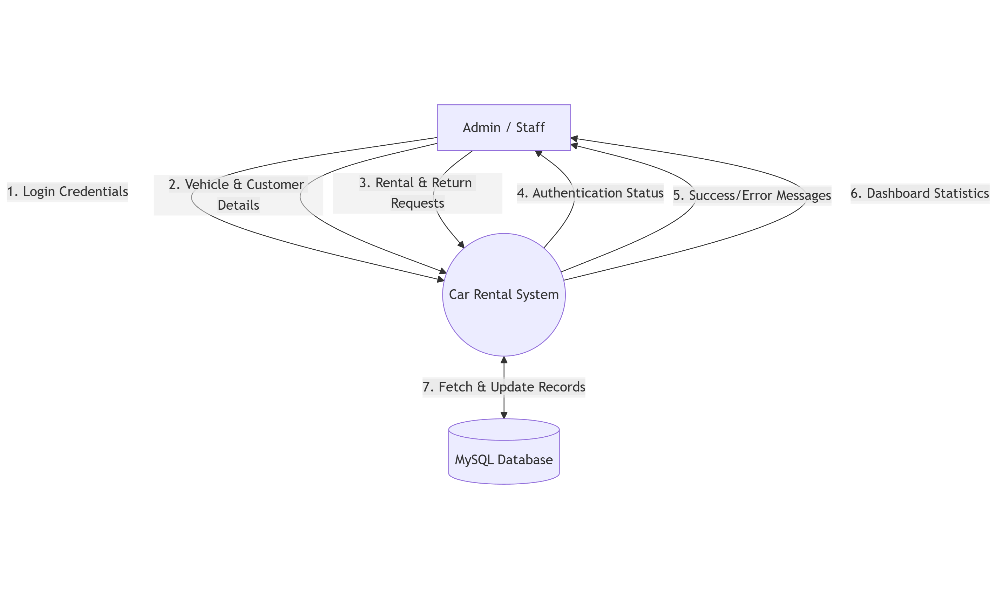
DFD LEVEL 1 (DETAILED DIAGRAM)

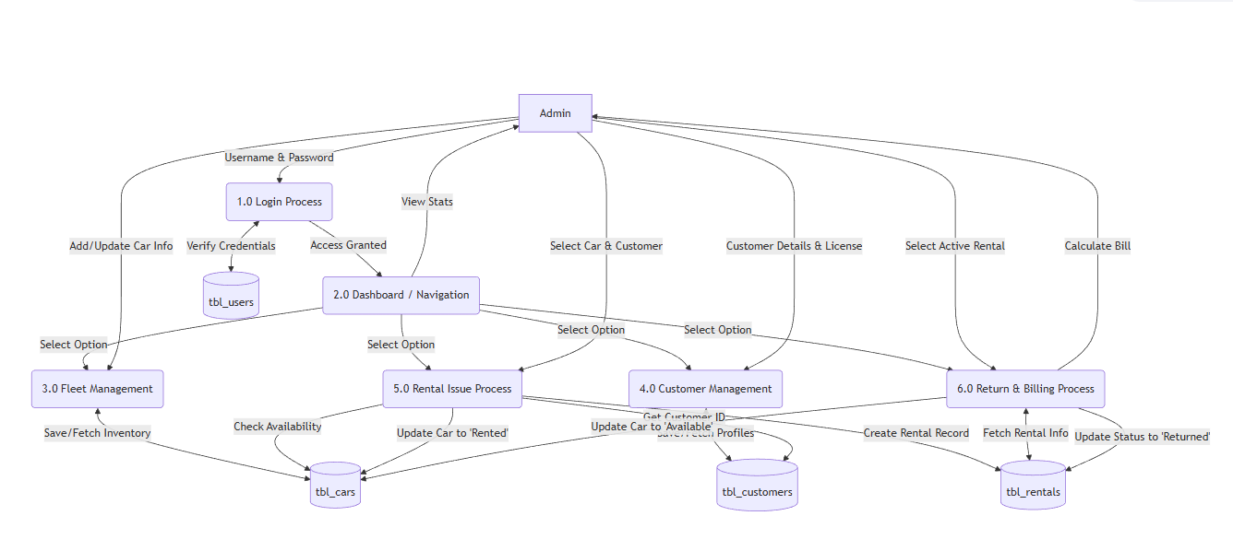

ER-DIAGRAM

20. ER-DIAGRAM EXPLANATION
- User Entity: Stores admin login details such as username and password for secure access control to the system.
- Car Entity: Stores fleet inventory details such as vehicle registration number, brand (e.g., Toyota), model (e.g., Corolla), price per day, and current availability status (Available/Rented).
- Customer Entity: Stores customer personal details such as full name, address, phone number, and driving license number.
- Rental Entity: Records all rental transactions, linking a specific Customer to a specific Car for a duration (Rent Date/Return Date) and calculating the total rental fee.
Relationships:
One Customer can have Many Rentals (history of different trips over time).
One Car can have Many Rentals (used by different customers historically, but only one active rental at a time).
One Rental links exactly One Customer and One Car (representing a specific transaction).

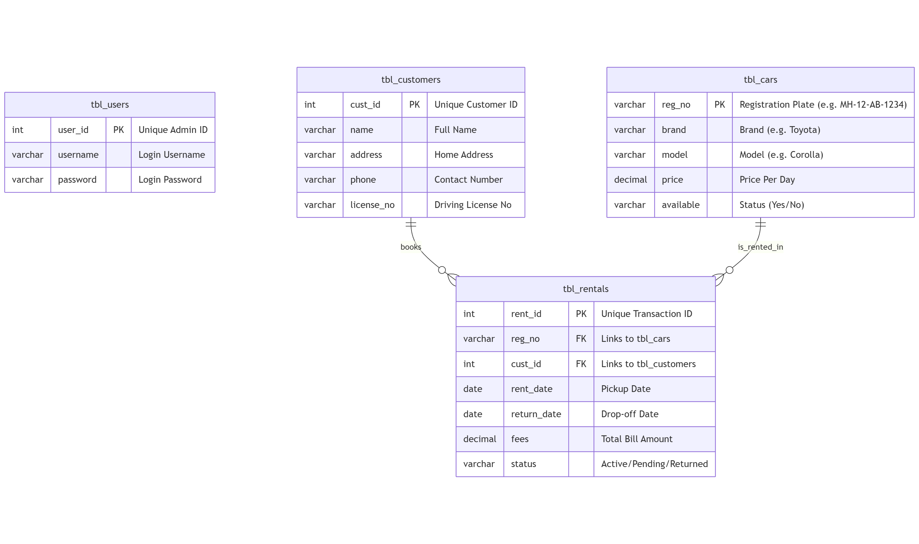

PROGRAM
SPECIFICATION

PROGRAM SPECIFICATION
The Car Rental System is designed to provide secure, fast, and reliable transport administration services through an automated platform. This system allows administrators to perform essential operations such as vehicle availability checking, customer registration, car rental processing, and return billing without manual logbook maintenance.
The system begins with User Authentication, where the administrator enters a secure username and password. After successful verification, the system displays a "Main Dashboard" with real-time statistics. Each selected operation (like renting a car) is processed according to predefined business rules to ensure no double-booking of the same vehicle occurs.
The system maintains proper validation checks such as ensuring the "Return Date" is after the "Rent Date," validating car availability before confirmation, and ensuring price fields contain only numbers. All transactions are recorded with timestamps to maintain transparency and data consistency.
The Car Rental System is developed using a modular approach, where each function (Fleet, Customers, Rentals) is handled by a separate program form. This improves system performance, simplifies debugging, and allows easy future enhancements. The system also ensures data integrity by automatically updating the car status (Available ↔ Rented) after every transaction.
Overall, the system reduces manual paperwork, minimizes human calculation errors, and improves the professional efficiency of the rental agency desk.
Functional Specifications
- Secure Admin Login using Username and Password.
- Real-time Fleet Availability inquiry facility.
- Customer Registration with Driving License validation.
- Car Rental Processing with automatic status updates.
- Vehicle Return functionality with late fee calculation (if applicable).
- Rental History display for specific customers or cars.
- Secure logout after transaction completion.

Non-Functional Specifications
- User-friendly Interface: Modern Metro-style design (ReaLTaiizor framework).
- Fast Response Time: Instant database retrieval for vehicle status.
- Secure Data Handling: Password-protected admin access to prevent unauthorized use.
- Reliable Processing: Logical checks to prevent renting a car that is currently out or in maintenance.
- Scalability: Easy to add new vehicle models or brands in the future.

Input Specifications
- Admin Credentials: (Username, Password).
- Car Details: (Registration Number, Brand, Model, Price Per Day).
- Customer Details: (Name, Phone, Address, Driving License Number).
- Rental Details: (Selected Car, Selected Customer, Rent Date, Return Date).
Output Specifications
- Authentication Status: (Login Success/Fail).
- Total Bill Calculation: (Price Per Day × Number of Days).
- Rental Confirmation Message: (Success Alert).
- Live Dashboard Counters: (e.g., "5 Cars Available").
Error Handling
- "Invalid Credentials" message on login failure.
- "Car Already Rented" warning if attempting to book an occupied vehicle.
- "Invalid Date Range" error if the Return Date is selected before the Rent Date.
- Database connection failure notifications to alert the admin of network issues.

This program specification ensures that the Car Rental System works efficiently, securely, and accurately to meet agency business requirements.

IMPLEMENTATION

IMPLEMENTATION

The Car Rental System is implemented using Visual Basic .NET as the front-end and MySQL as the back-end database. The system follows a structured and modular programming approach to ensure simplicity, reliability, and ease of maintenance.
The front-end is developed in Visual Basic .NET, utilizing the Metro Framework (ReaLTaiizor) to provide a clean, modern, and user-friendly graphical interface. Forms are designed for Login, Main Dashboard, Fleet Inventory, Customer Management, Rental Transactions, and Vehicle Returns. Proper input validation is applied to avoid incorrect data entry, such as preventing empty fields or entering text in price fields.
The back-end database is created using MySQL. It contains normalized tables such as tbl_users, tbl_cars, tbl_customers, and tbl_rentals. These tables are connected using Primary Keys and Foreign Keys to maintain data integrity and avoid redundancy. Database connectivity is established using the MySql.Data library for seamless and fast data communication between the application and the server.
During implementation, each module is coded separately:
- The Login Module verifies credentials against the user table to ensure secure access.
- The Rental Module checks if a car's status is available='Yes' before allowing a new rental agreement.
- The Return Module calculates the final fee based on the number of days rented and automatically resets the car status to 'Available'.
- Every transaction is persistently stored in the MySQL database for future reporting and auditing.
Exception handling techniques (Try-Catch blocks) are implemented to manage runtime errors such as database connection timeouts or invalid user inputs. After completing any critical action, the system displays a confirmation message box (e.g., "Car Rented Successfully").
Overall, the implementation ensures secure transaction processing, accurate fleet management, and efficient system performance.

Tools and Technologies Used
- Frontend: Visual Basic .NET (Framework 4.8 / .NET 6+)
- UI Framework: ReaLTaiizor (Metro UI)
- Backend: MySQL Database
- Database Connectivity: MySql.Data.MySqlClient
- Platform: Windows Operating System

The implementation phase successfully converts the system design into a fully functional Car Rental System software.
LOGIN SCREEN
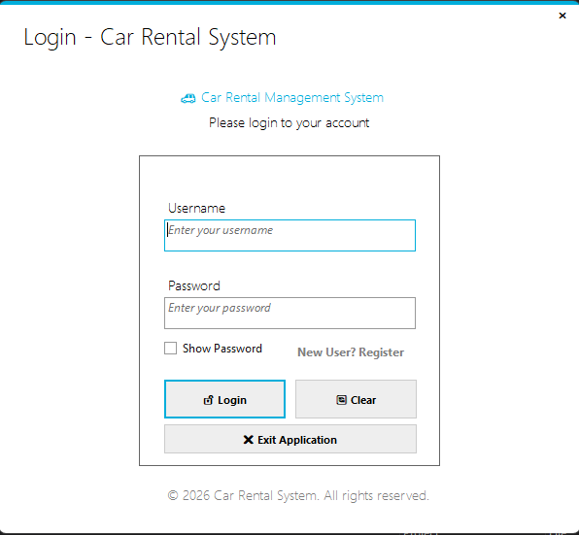

REGISTER FORM:

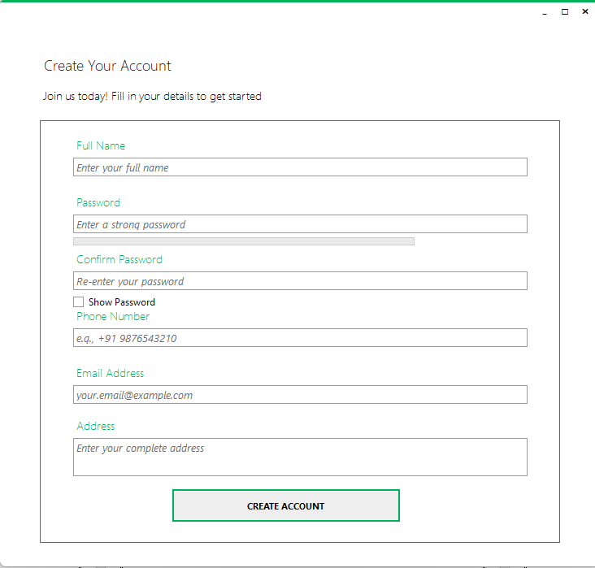
HOME PAGE

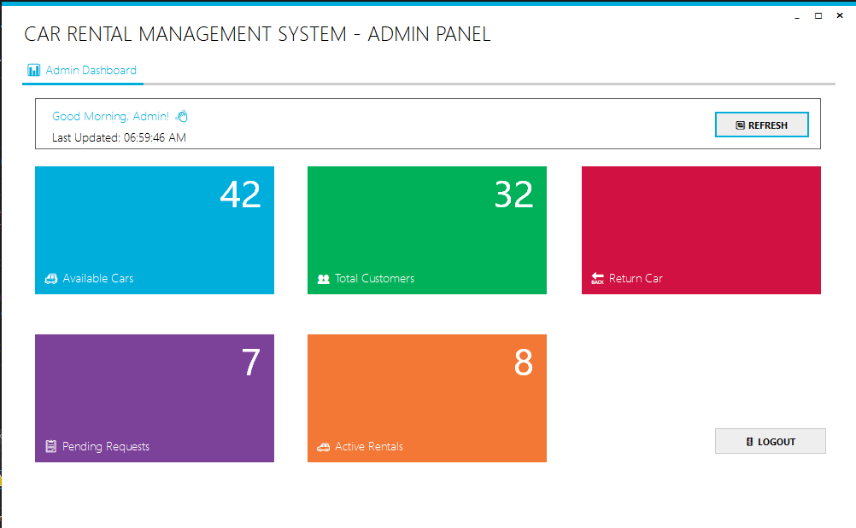

CAR BOOKIN FORM

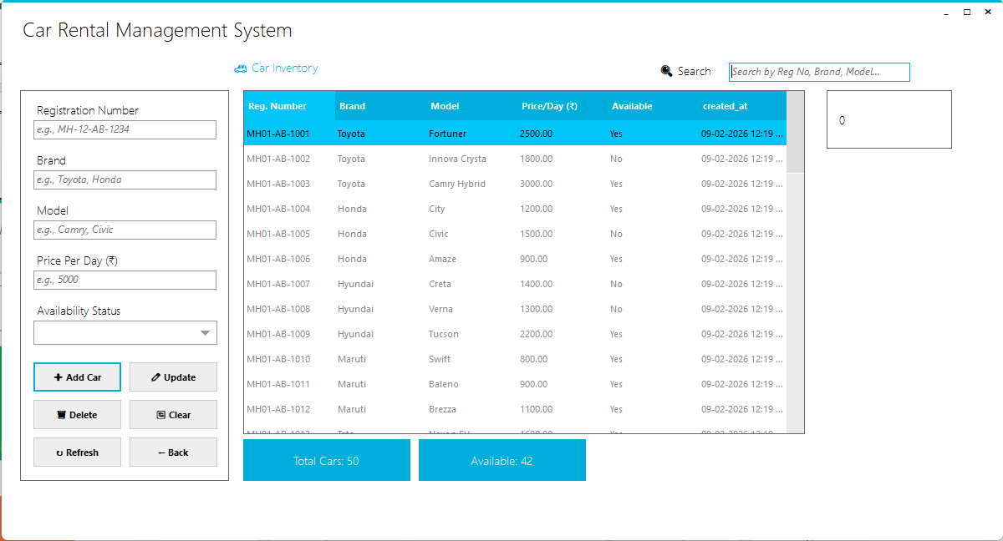

CAR RETURN FORM
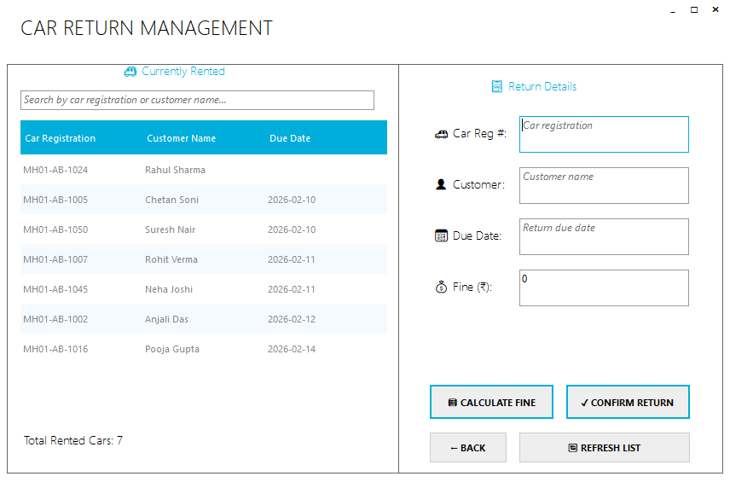

RENTAL REQUESTS FORM

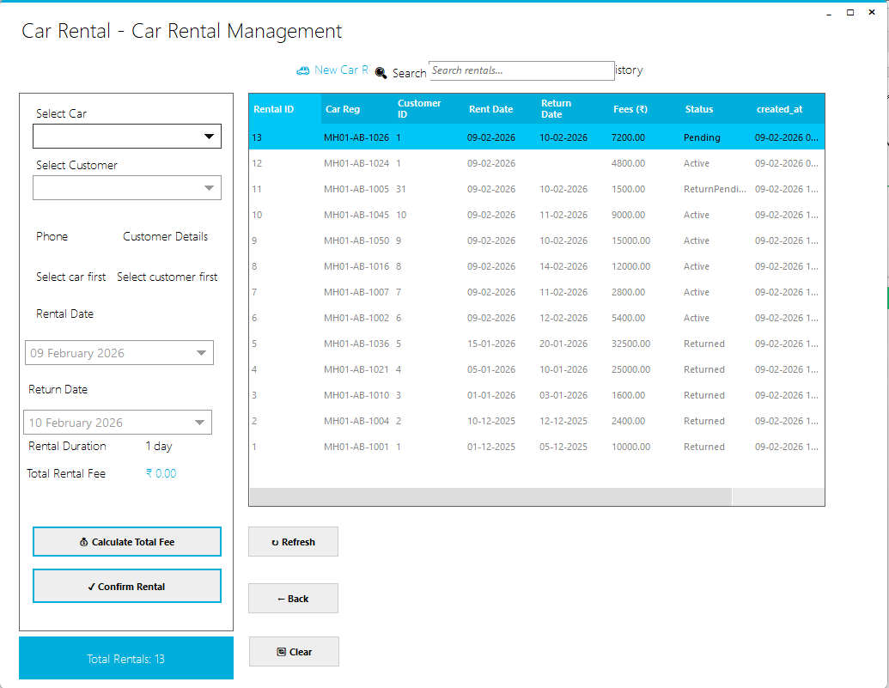
ACTIVE RENTAL FORM

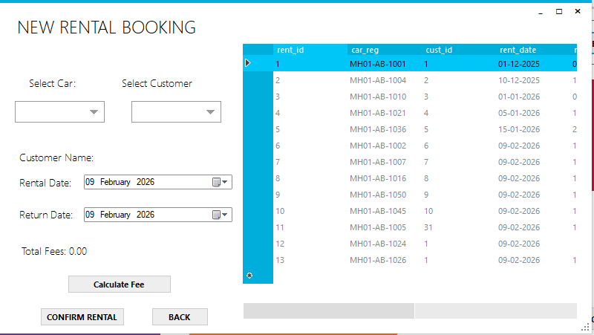

USER ROOM BOOKING FORM

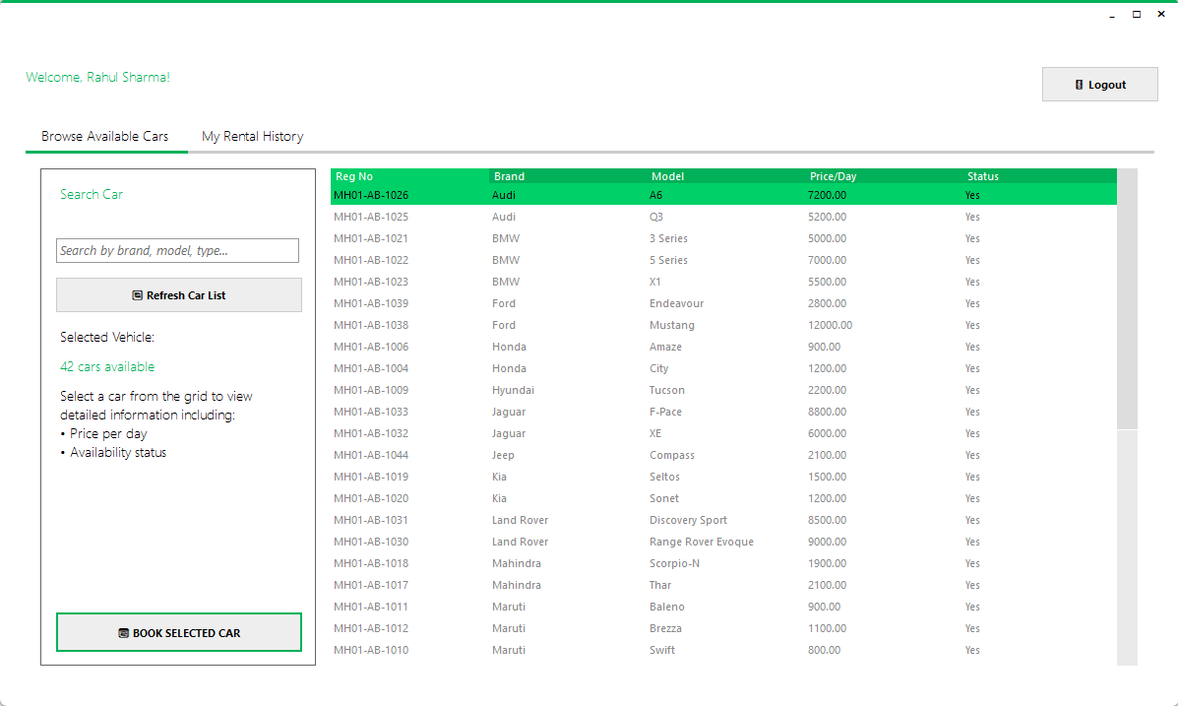

USER RENTAL HISTORY FORM

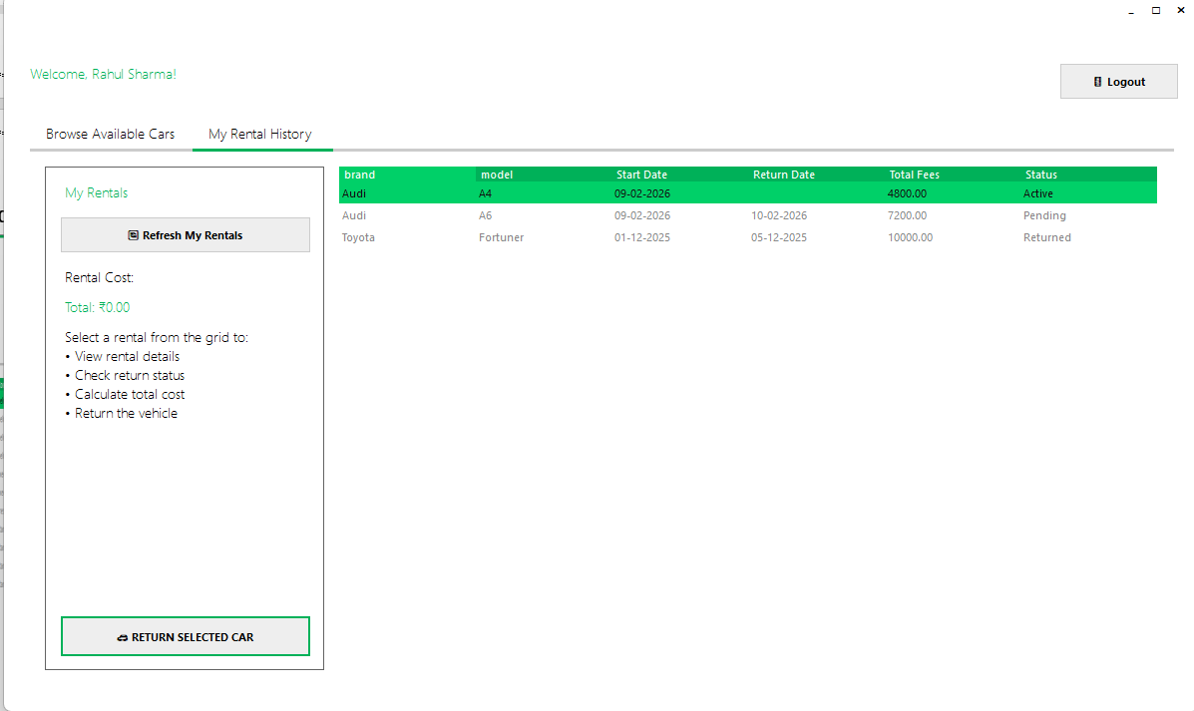
DATABASE DESIGN

DATABASE TABLE DESIGN

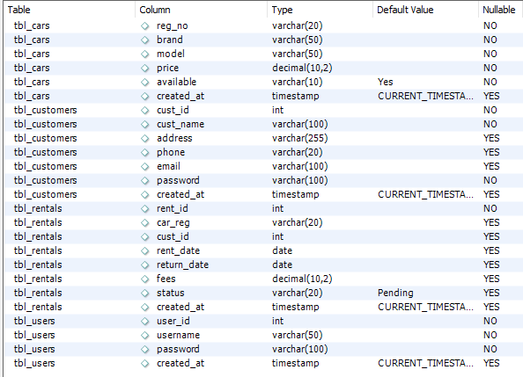

TESTING

Testing

Testing is an important phase of the Car Rental System which ensures that the software works correctly, securely, and efficiently. All modules of the system were rigorously tested to identify and remove errors before final deployment. The testing process helps in verifying that the system meets the required functionality and provides accurate billing and inventory results.
Different types of tests were performed, such as:
- Login Testing: Verifying that only valid admin credentials grant access to the dashboard.
- Inventory Testing: Ensuring that adding a new car updates the "Available Cars" count immediately.
- Rental Testing: Confirming that a car marked "Rented" cannot be rented again to another customer until it is returned.
- Billing Testing: Verifying that the total rental fee is calculated correctly based on the Price Per Day and Duration.
- Database Validation: Ensuring customer and rental records are stored and retrieved correctly from the MySQL database.
Each input was checked to ensure proper validation and error handling (e.g., preventing negative prices or invalid driving license formats). Incorrect inputs were also tested to confirm that the system displays appropriate error messages.
The system was tested using real-time mock data stored in the MySQL database to verify data accuracy, security, and performance. After successful testing, the system was found to be reliable, user-friendly, and free from major operational errors.

APPLICATION
OF
PROJECT
Application of Project
The Car Rental System is mainly used to perform transport agency administration operations in an easy and secure way. This system allows agency administrators and staff to manage their daily workflow by using a centralized digital platform.
Key Applications:
- Agency Administration: Used by staff to perform Vehicle Issue (Rent), Vehicle Return, and Customer Registration without manual paperwork.
- Fleet Management: Helps in maintaining an accurate count of Available, Rented, and Maintenance vehicles.
- Record Keeping: It maintains accurate digital records of customer driving licenses, rental history, and revenue generation in the database for future auditing.
- Efficiency Improvement: The project significantly reduces manual effort, calculation errors, and the time taken to process a vehicle pickup or drop-off.
- Educational Use: This project is useful for academic purposes as well as for understanding how real-time database management systems work in a business environment. It provides a practical mode

FUTURE
SCOPE

FUTURE SCOPE
The Car Rental System can be enhanced in the future by adding several advanced and modern features to meet the growing demands of the transport industry.
- Online Booking Integration: The system can be upgraded to integrate with a web portal, allowing customers to reserve cars remotely from their phones or computers.
- GPS Tracking: Integration with vehicle GPS systems can be added to track the real-time location of rented cars for security purposes.
- Payment Gateway: Integration with UPI, Credit Card, and Net Banking systems can be added to allow cashless billing and advance security deposits.
- Maintenance Module: A dedicated module can be added to track the service history of cars (e.g., "Oil Change Due", "Tire Replacement", "In Repair") and assign tasks to mechanics.
- Multi-User Roles: The system can be expanded to support different user roles such as Manager (Full Access), Desk Staff (Rental Only), and Mechanic (Status View Only).
- Mobile Application: Creating a mobile version of the dashboard would allow managers to monitor fleet occupancy and revenue from anywhere.
- AI & Analytics: In the future, data analytics can be added to predict peak travel seasons, analyze customer car preferences, and adjust daily pricing dynamically to maximize revenue.
CONCLUSION
The Car Rental System has been successfully designed and developed to automate essential agency operations in a secure and efficient manner. The system provides key services such as Fleet Inventory Management, Customer Registration, and Rental Transactions, which reduces manual effort and improves operational accuracy.
During the development of this project, several real-world software engineering challenges were addressed. These include ensuring data consistency (ensuring cars aren't double-rented), validating financial calculations (billing accuracy), handling runtime errors, and managing smooth communication between the VB.NET frontend and the MySQL backend.
The project follows a structured and modular approach, making it easy to maintain and scale. The user-friendly interface, built with the Metro Framework, ensures that even non-technical staff can operate the system comfortably. Overall, the Car Rental System meets all project objectives and provides a strong foundation for developing advanced, real-world transport applications.

REFERENCES
- Microsoft Visual Basic .NET Documentation https://learn.microsoft.com/en-us/dotnet/visual-basic/
- MySQL Database Documentation https://dev.mysql.com/doc/
- Software Engineering – Roger S. Pressman https://www.mheducation.com/
- VB.NET Tutorials – TutorialsPoint https://www.tutorialspoint.com/vb.net/
- Database & Software Engineering Concepts – GeeksforGeeks https://www.geeksforgeeks.org/
- ReaLTaiizor (UI Framework) Documentation https://github.com/Taiizor/ReaLTaiizor
- ONLINE RESOURCES: Black-Box AI, GEMINI, GOOGLE, YOUTUBE.

