**1. CONCAT**

The **CONCAT()** function of Pig Latin is used to concatenate two or more expressions of the same type.

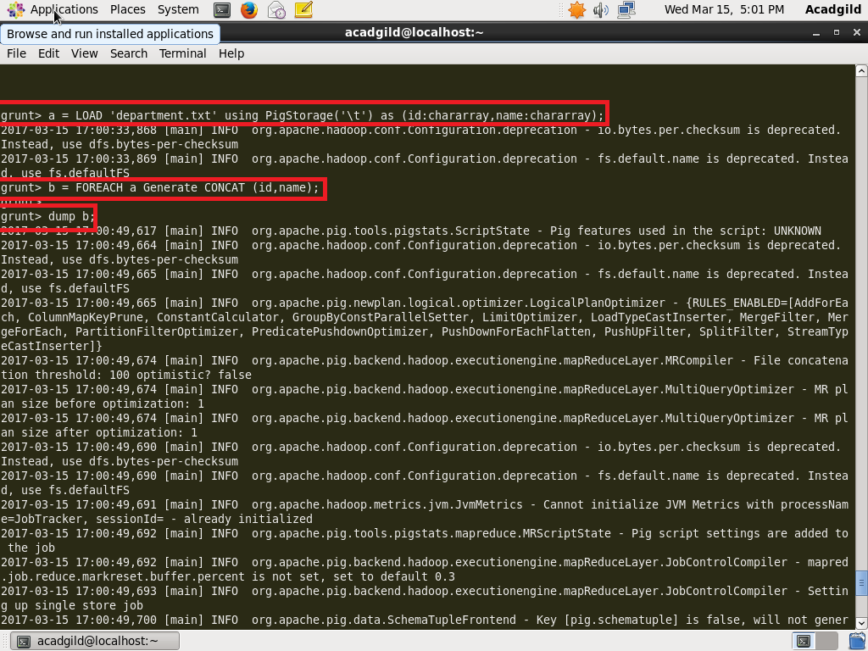

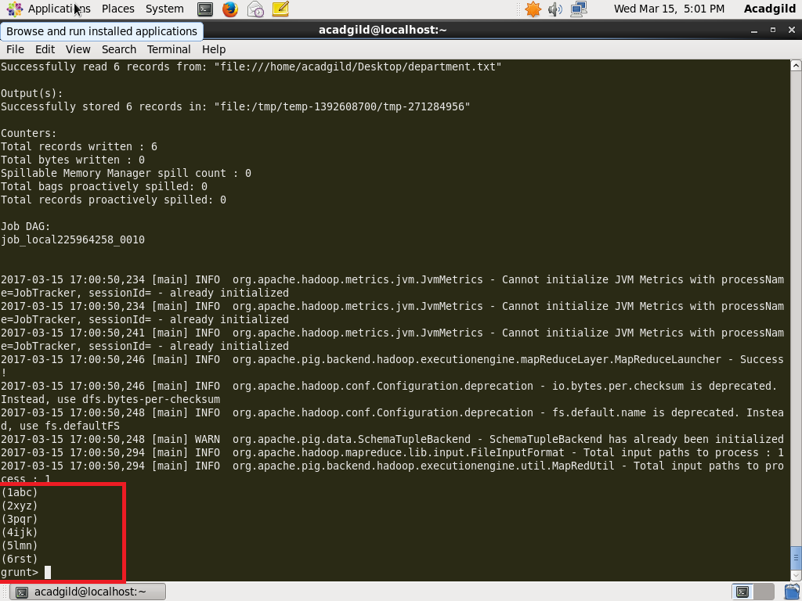

**2. TOKENIZE**

The **TOKENIZE()** function of Pig Latin is used to split a string (which contains a group of words) in a single tuple and returns a bag which contains the output of the split operation.

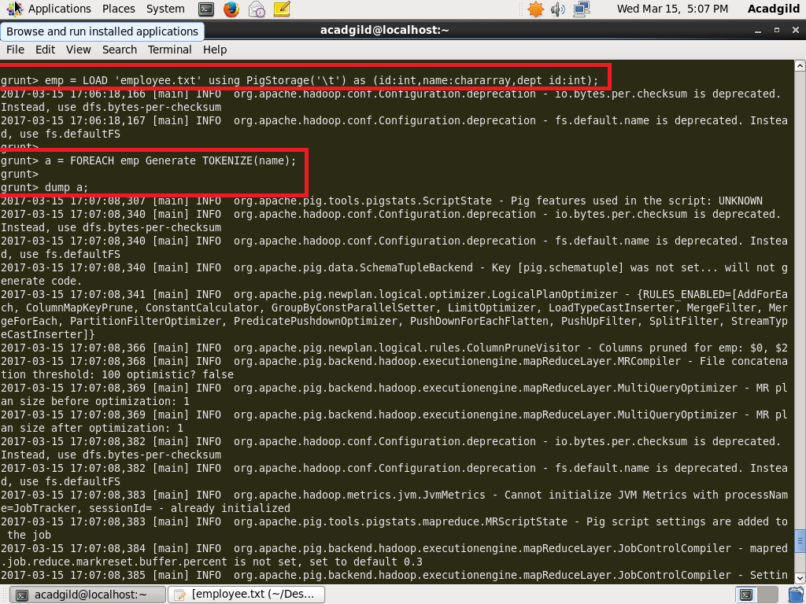

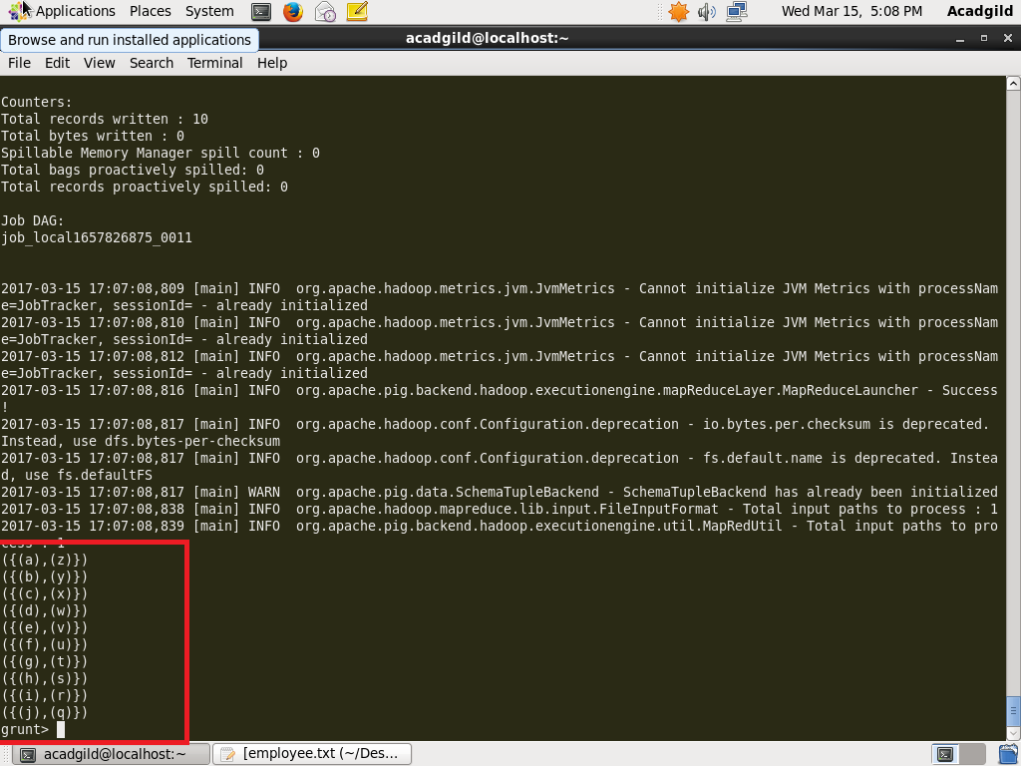

**3. SUM**

You can use the **SUM()** function of Pig Latin to get the total of the numeric values of a column in a single-column bag. While computing the total, the **SUM()** function ignores the NULL values.

* To get the global sum value, we need to perform a **Group All** operation, and calculate the sum value using the SUM() function.
* To get the sum value of a group, we need to group it using the **Group By** operator and proceed with the sum function

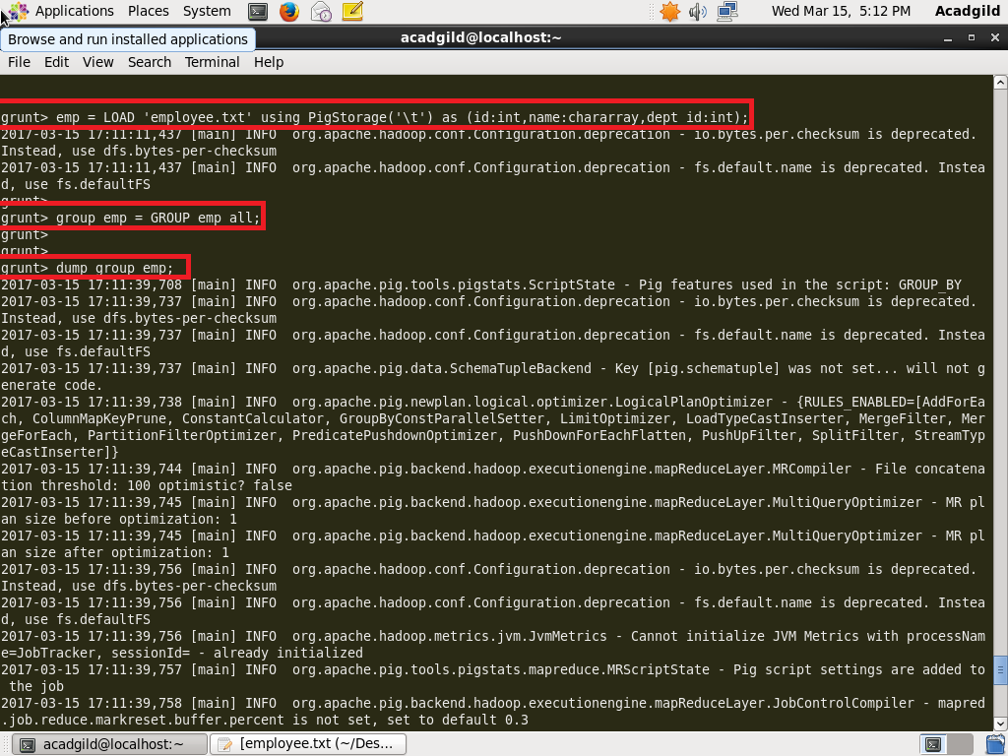

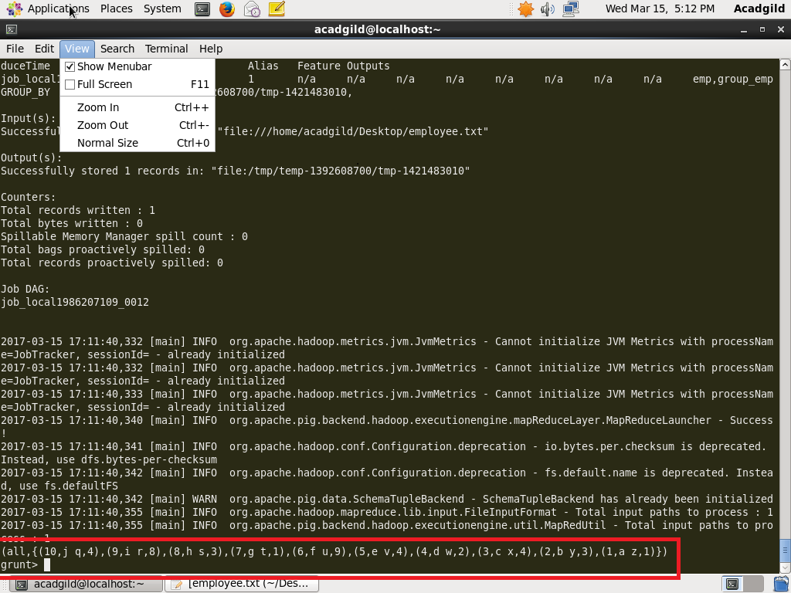

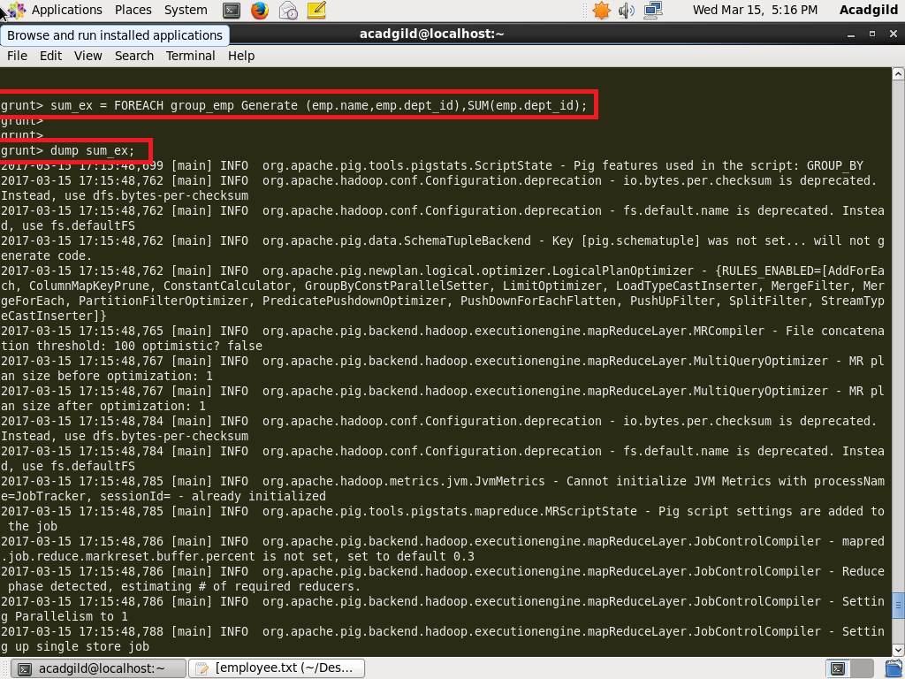

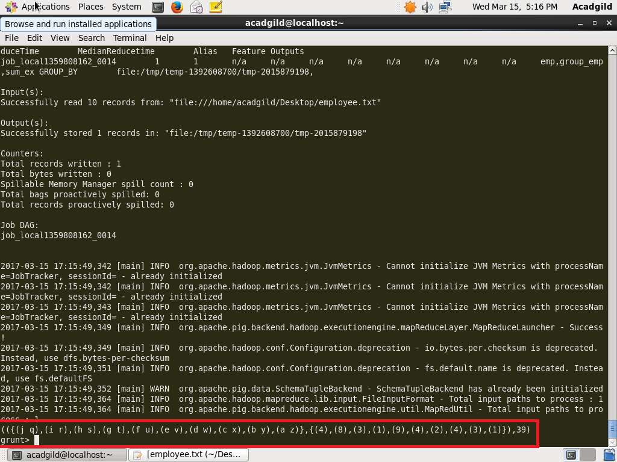

**4. MIN**

The **MIN()** function of Pig Latin is used to get the minimum (lowest) value (numeric or chararray) for a certain column in a single-column bag. While calculating the minimum value, the **MIN()** function ignores the NULL values.

* To get the global minimum value, we need to perform a **Group All** operation, and calculate the minimum value using the MIN() function.
* To get the minimum value of a group, we need to group it using the **Group By** operator and proceed with the minimum function.

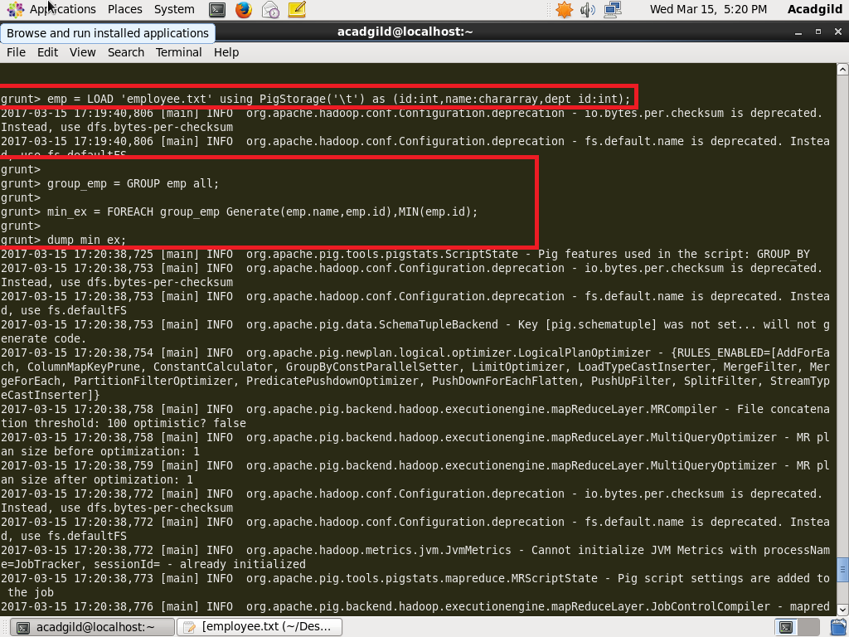

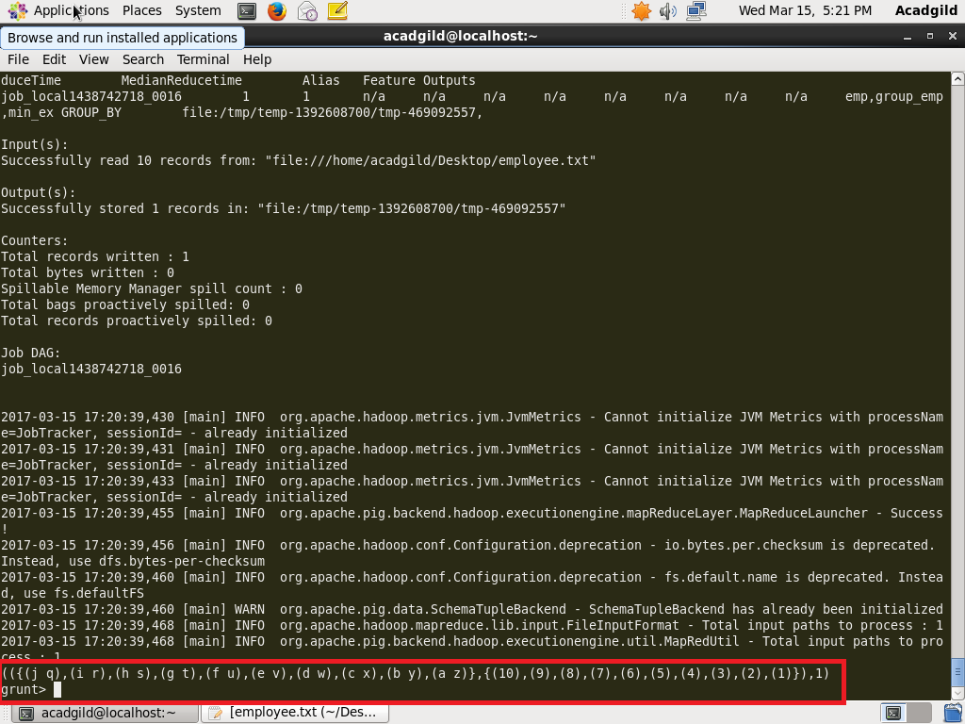

**5. MAX**

The Pig Latin MAX() function is used to calculate the highest value for a column (numeric values or chararrays) in a single-column bag. While calculating the maximum value, the Max() function ignores the NULL values.

* To get the global maximum value, we need to perform a Group All operation, and calculate the maximum value using the MAX() function.
* To get the maximum value of a group, we need to group it using the Group By operator and proceed with the maximum function.

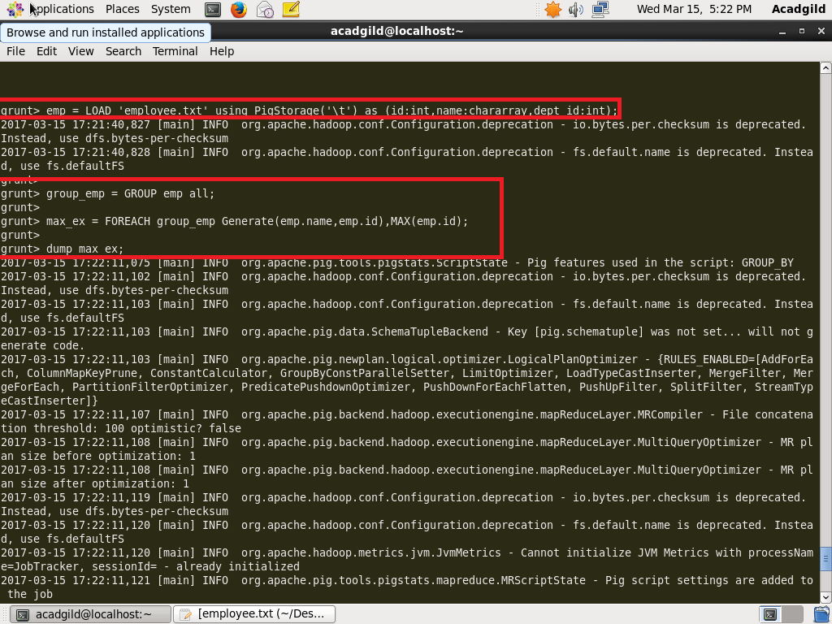

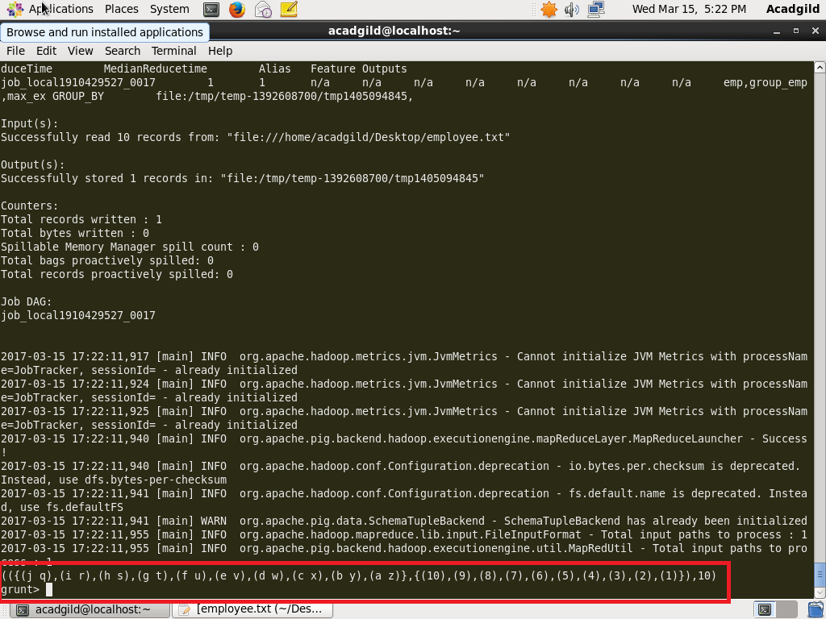

**6. LIMIT**

The **LIMIT** operator is used to get a limited number of tuples from a relation.

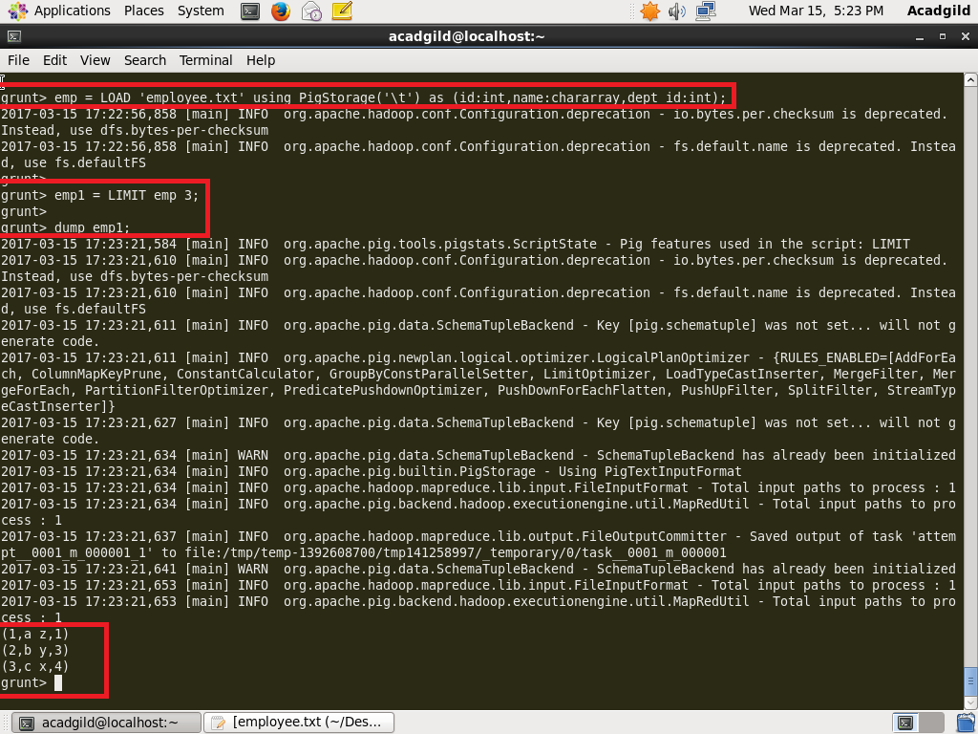

**7. STORE**

You can store the loaded data in the file system using the **store** operator.

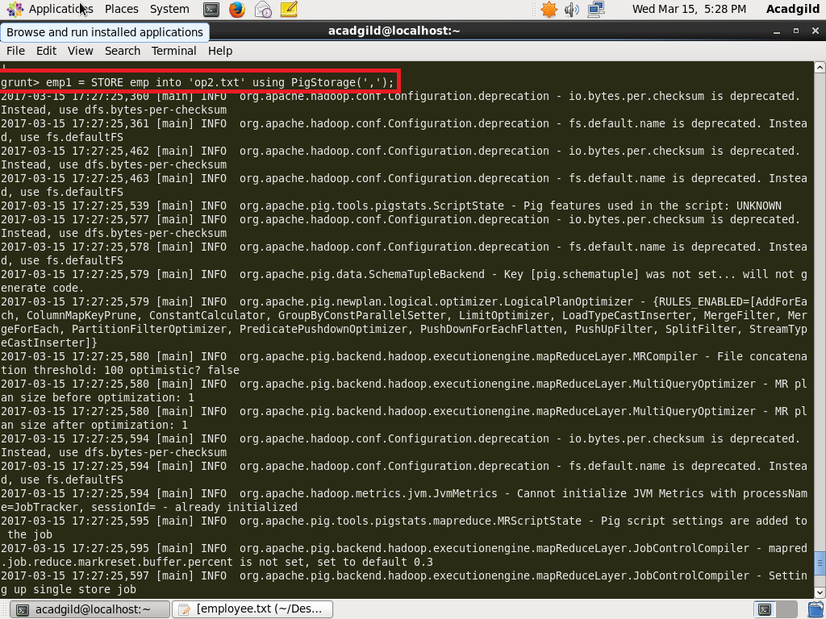

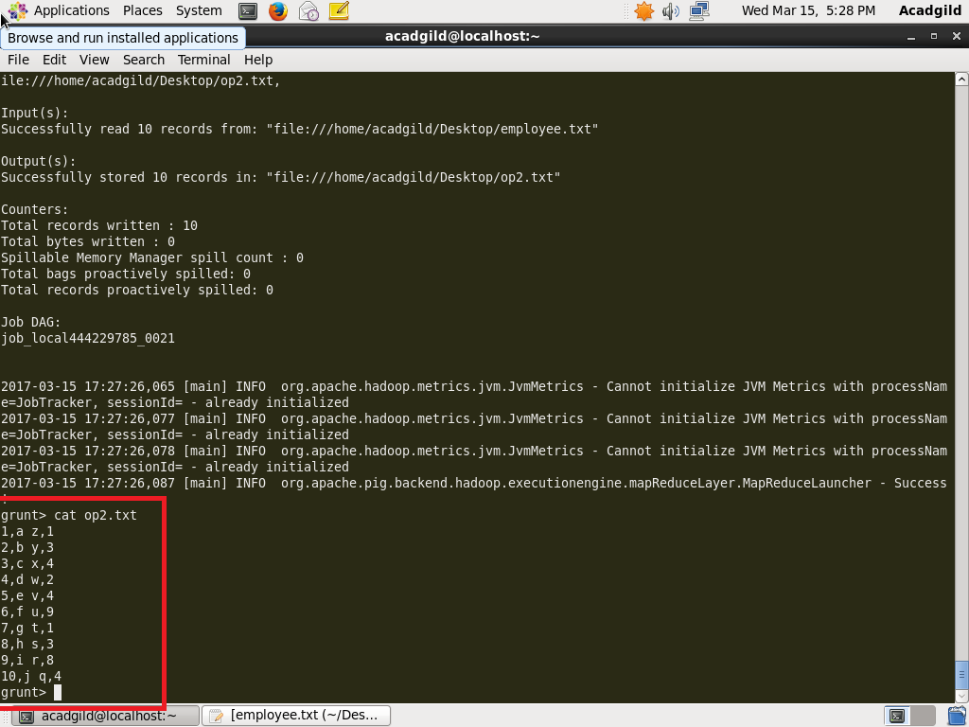

**8. DISTINCT**

The **DISTINCT** operator is used to remove redundant (duplicate) tuples from a relation.

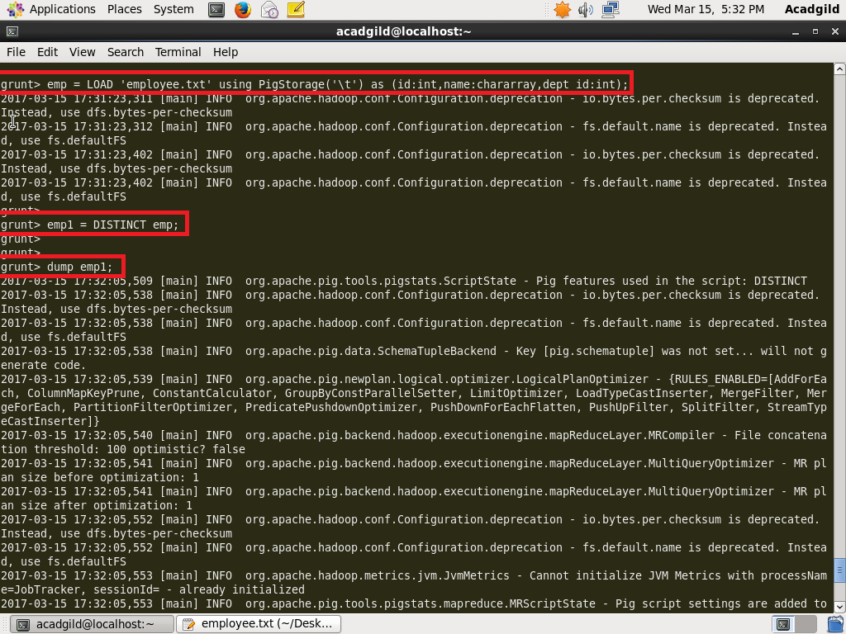

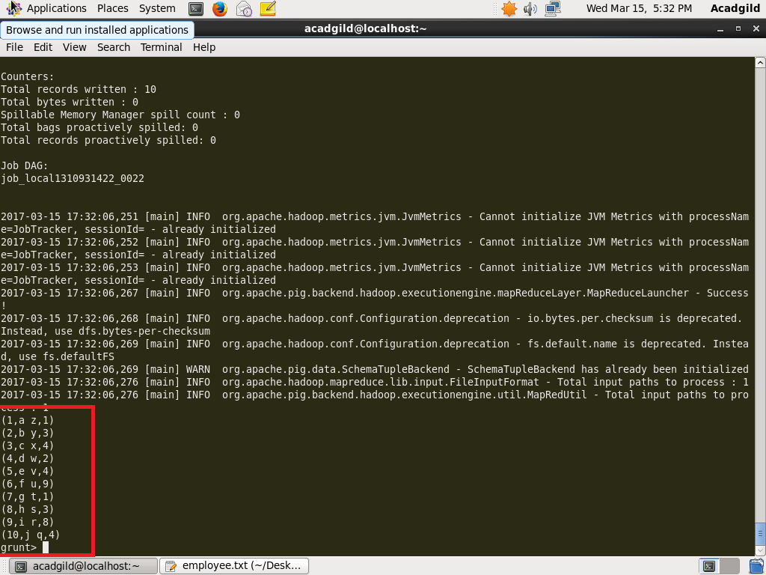

**9. FLATTEN**

