PROBLEM STATEMENT

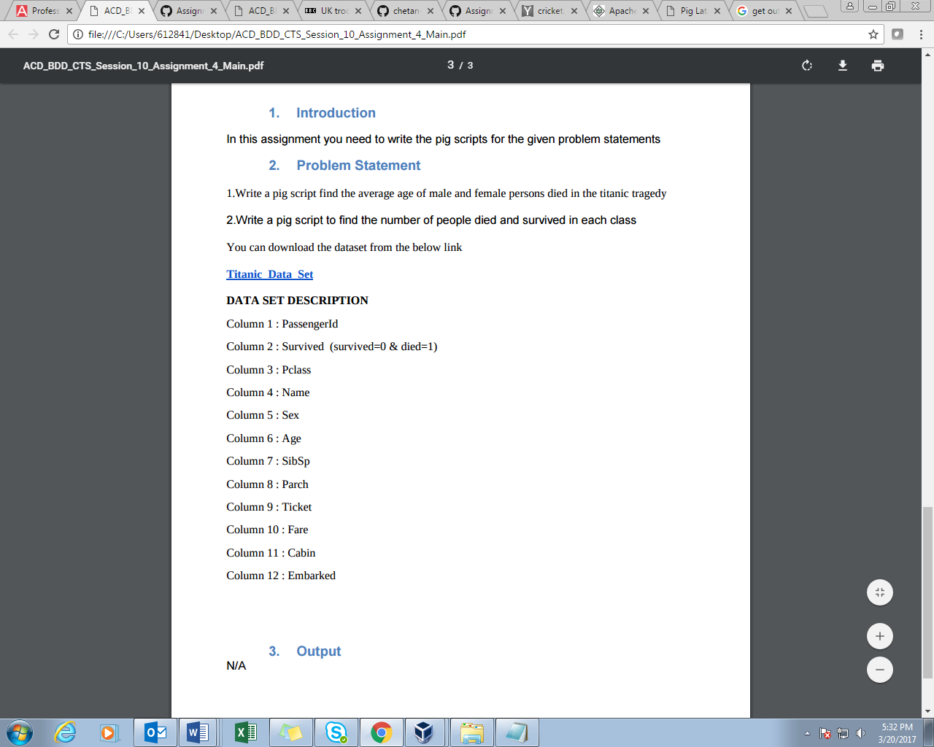

Q1- Write a pig script find the average age of male and female persons died in the titanic tragedy.

Program:

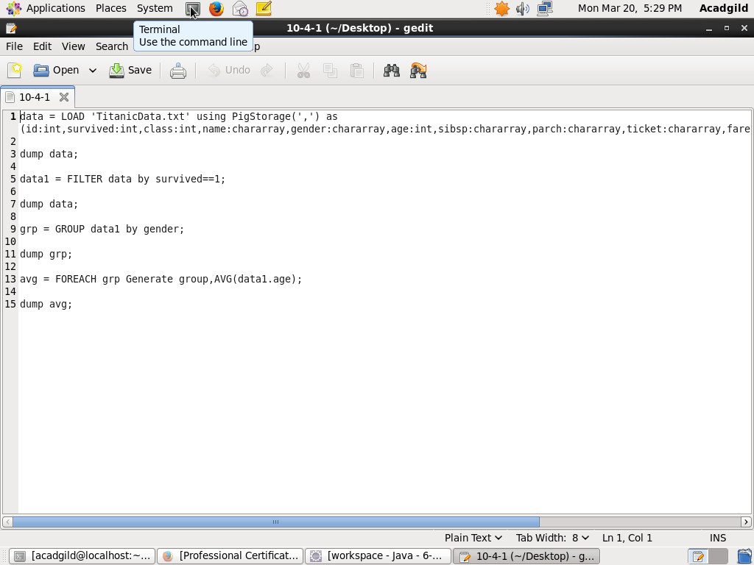

Output:

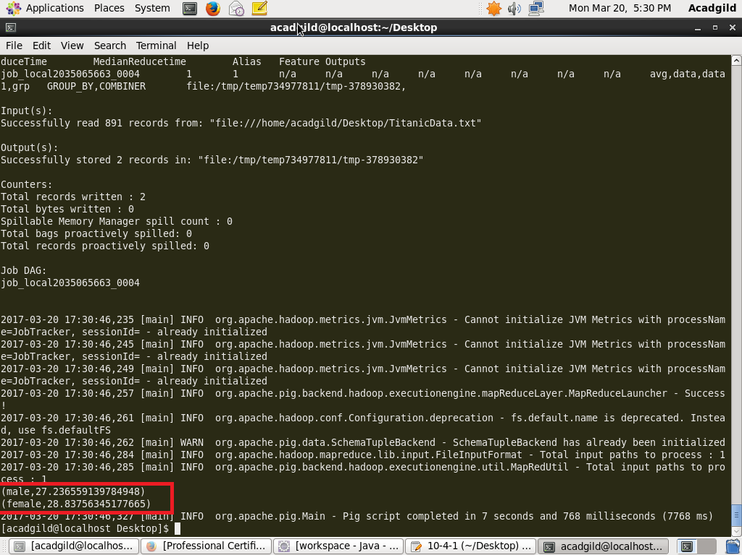

Q2.Write a pig script to find the number of people died and survived in each class.

Program:

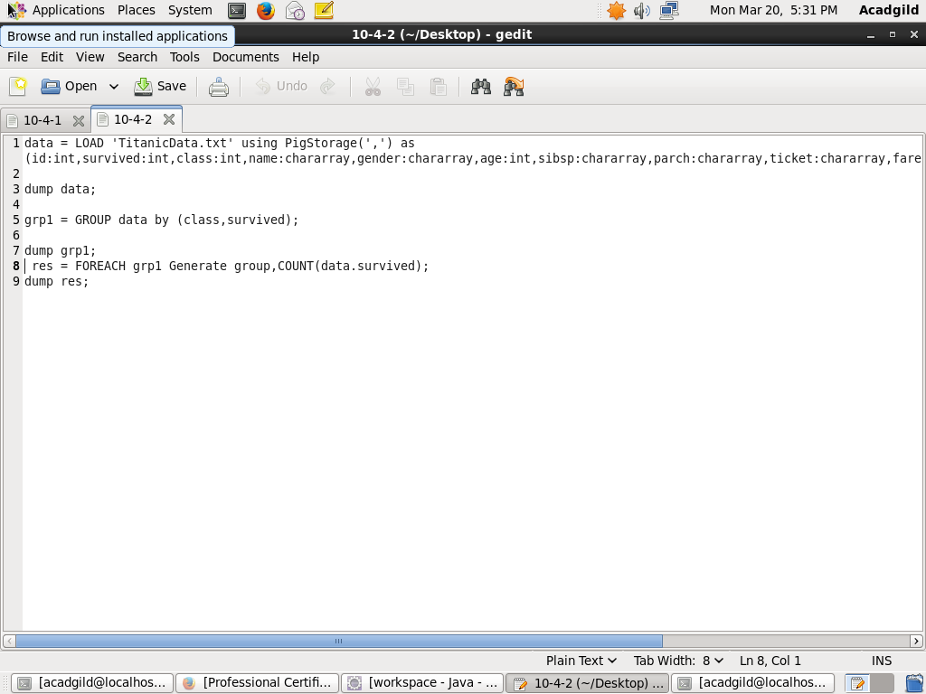

Output:

