**PROBLEM STATEMENT:**

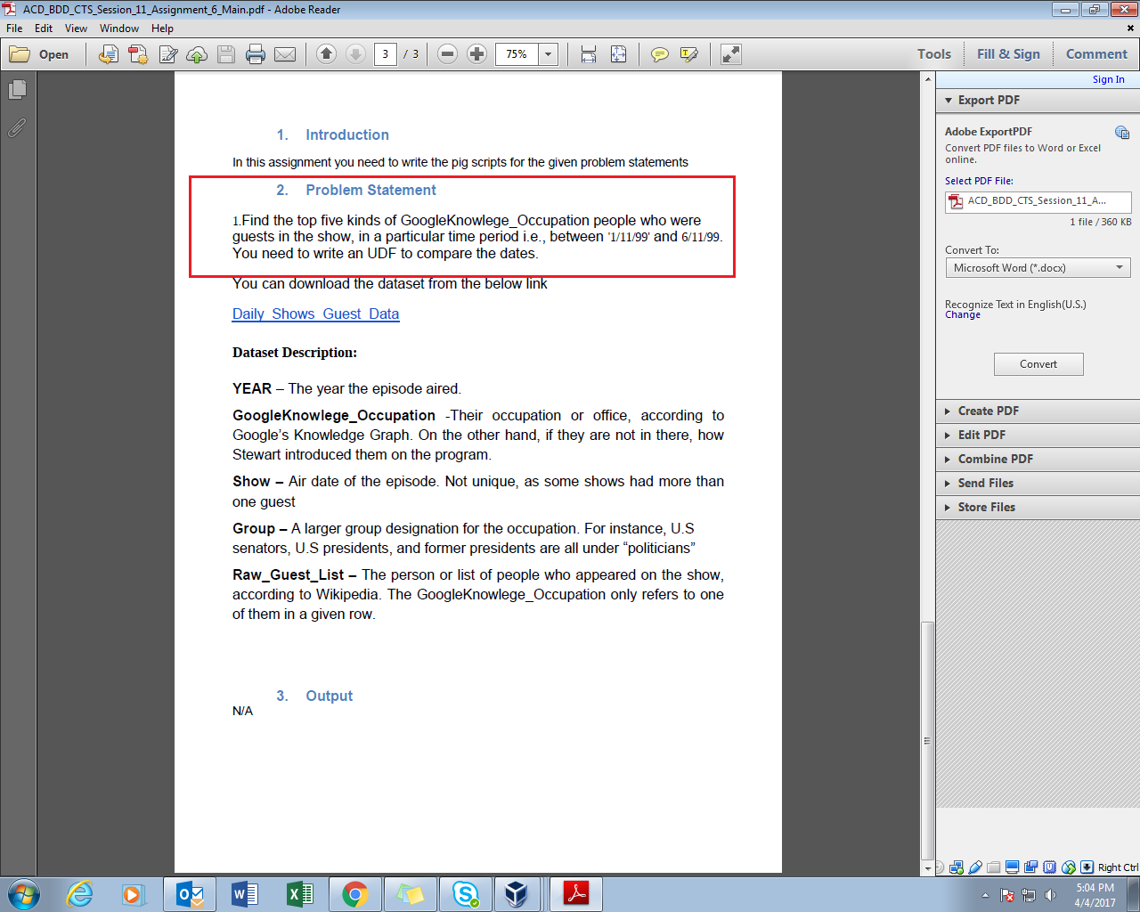

**PROGRAM:**

**UDF(java code)**

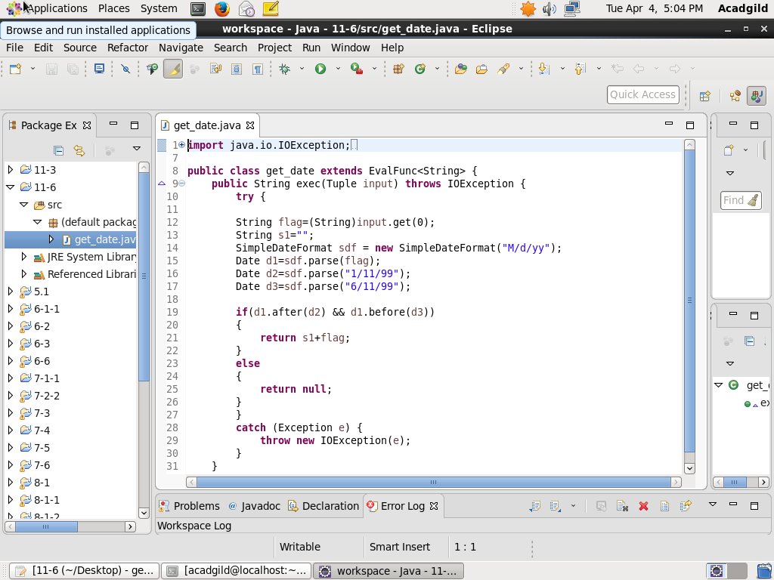

The class get_date extends the EvalFunc class and overrides the exec() method.

The logic for UDF is written in exec() method.

In this code, UDF is used to compare dates.

It is exported as 11-6.jar.

**PIG SCRIPT:**

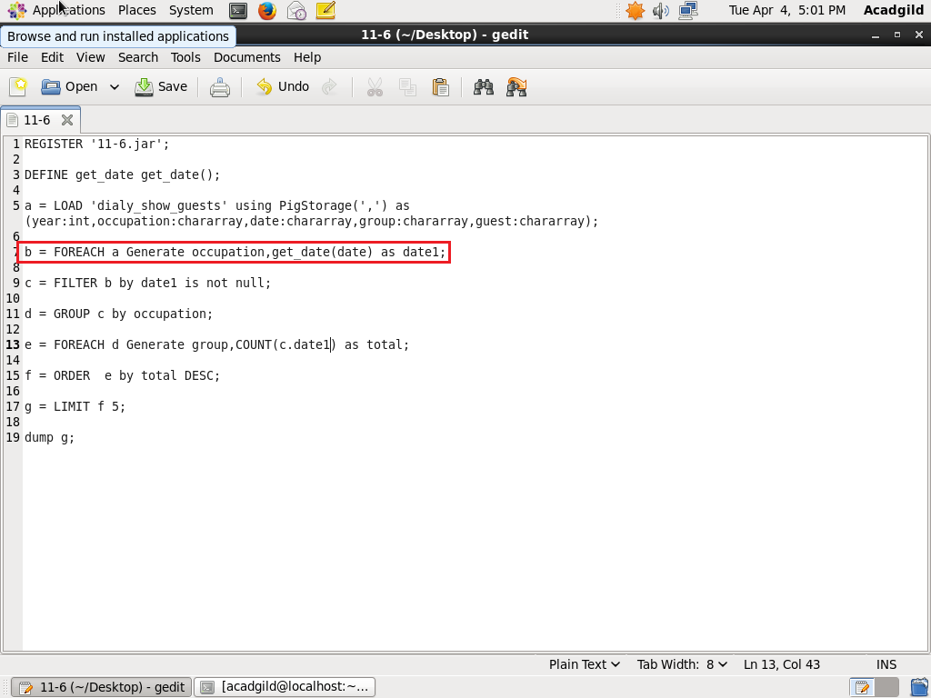

Date tuple is passed as parameter to udf get_date.

It will return the date if the date is between 1/11/99 and 6/11/99 else it will return null.

After getting the result from udf, filter function is used to get rid of null values.

Further group,count,order and limit are used to get the final result.

**OUTPUT:**



