**PROBLEM STATEMENT:**

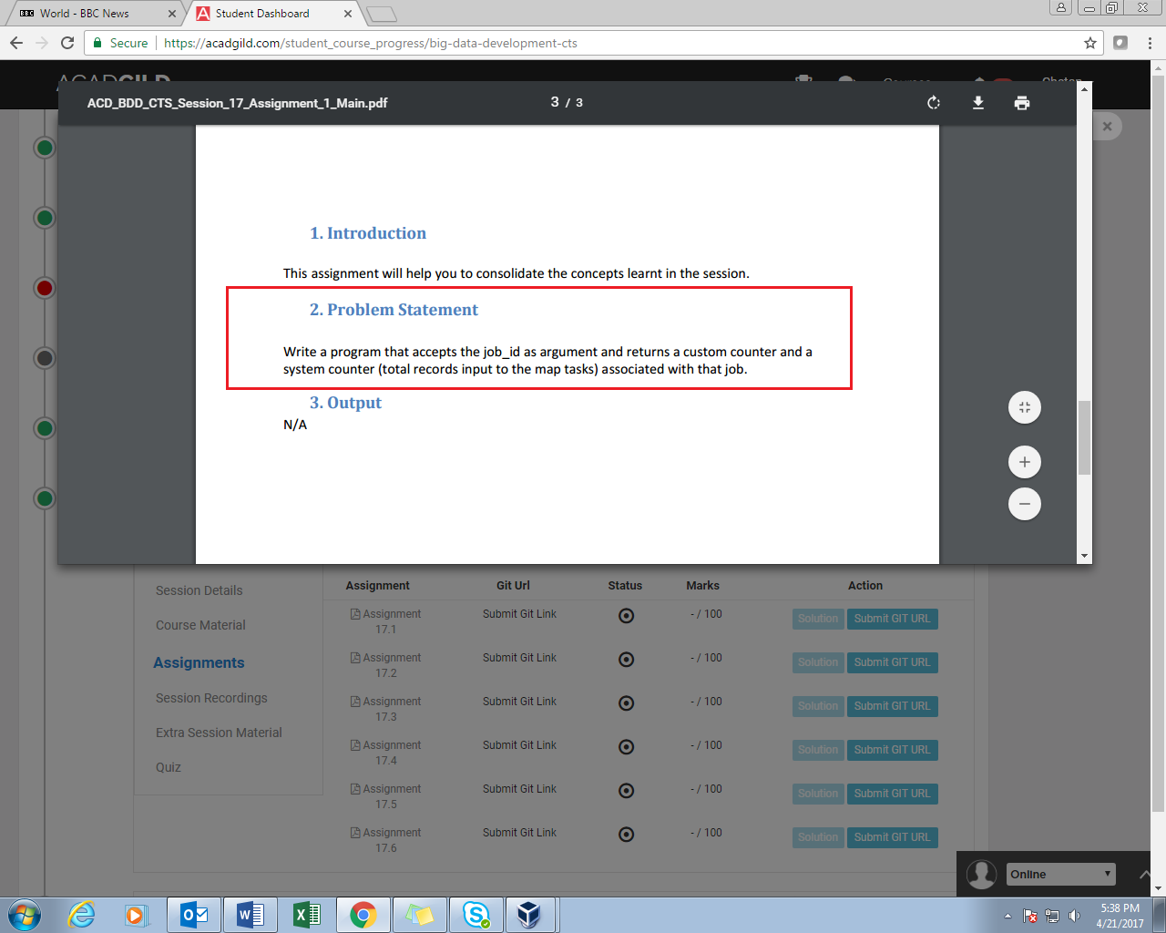

**STEPS:**

1. Initially a regular map reduce job performing word count is created.

2. Three custom counters are created which are as follows:

Less_than_3, equal_to_3 and more_than_3.

3. These counters track the length of words and are incremented when a word of corresponding length is encountered in the mapper.

4. Further this job is executed and its Id is given as input to the next job which will display the values of custom counters and system counters (Map input records).

**PROGRAM:**

//DRIVER CLASS

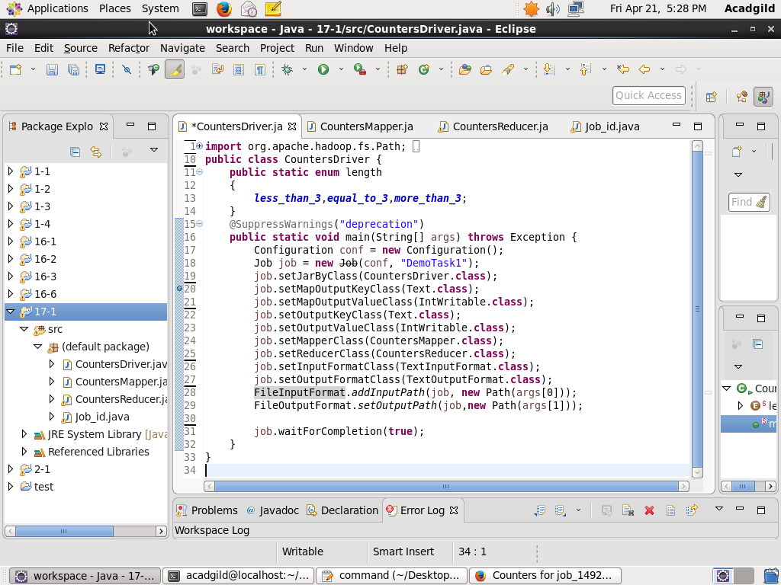

//MAPPER CLASS

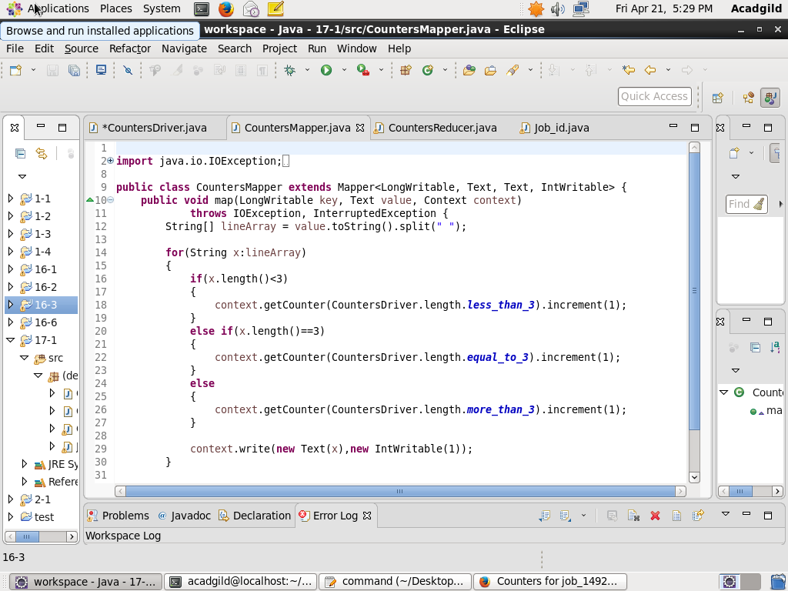

//REDUCER CLASS

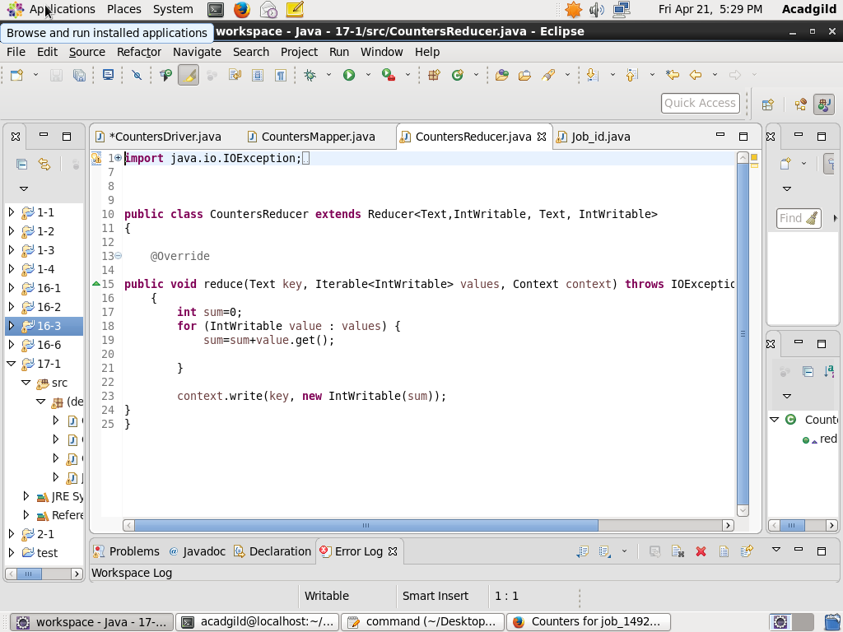

//JOB_ID CLASS

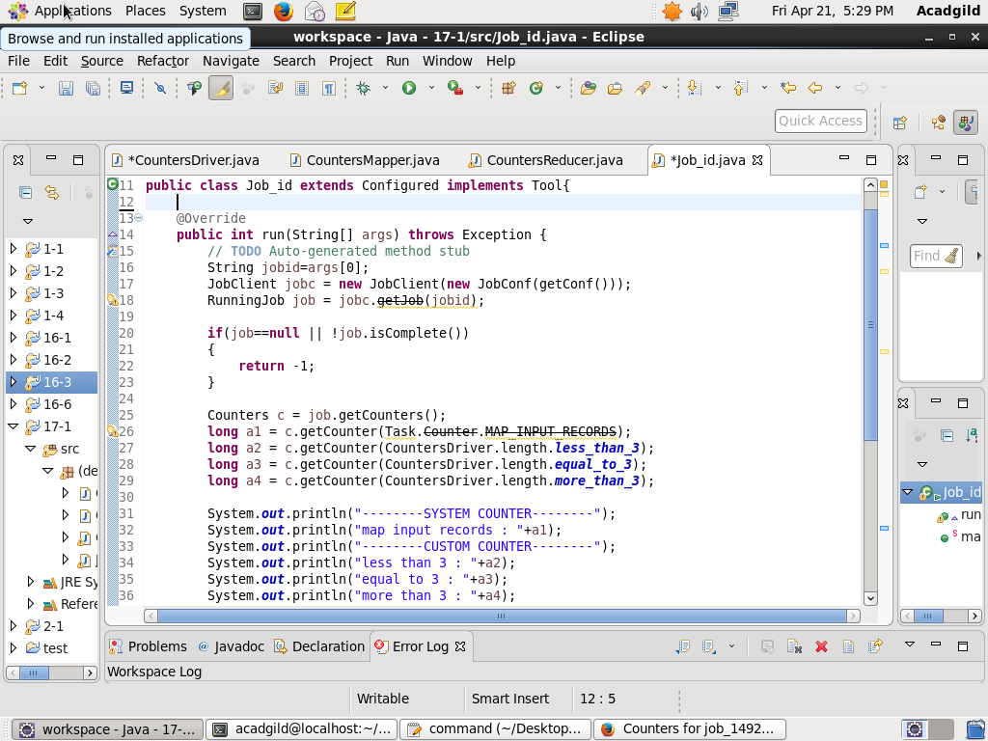

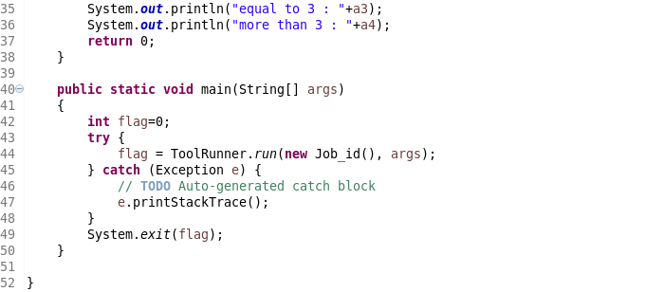

**OUTPUT:**

Executing word count job

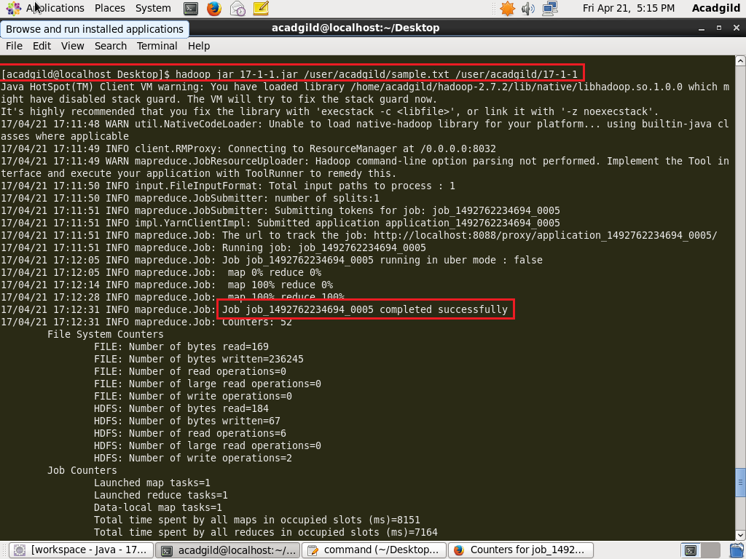

JOB ID is highlighted which is given as input to next job.

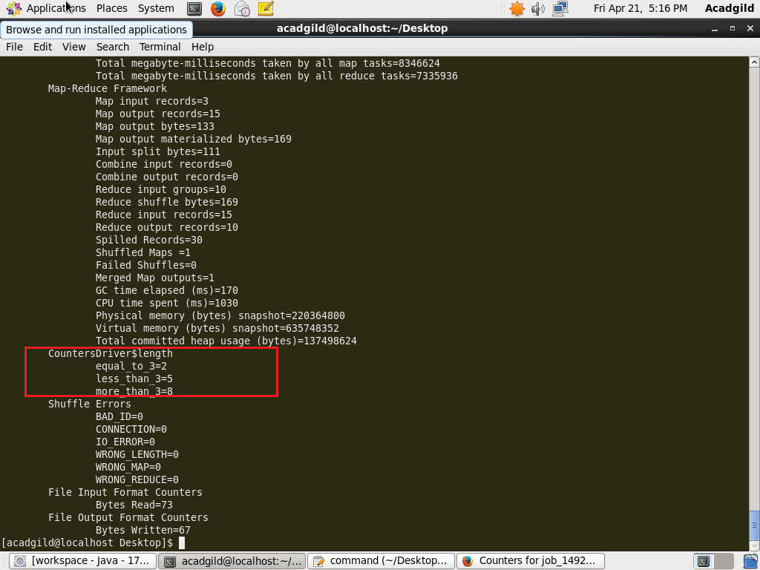

Custom Counters used in the job.

Executing the next job. Job_id of previous job is given as input and custom counters as well as system counters(map input records) are displayed as output.

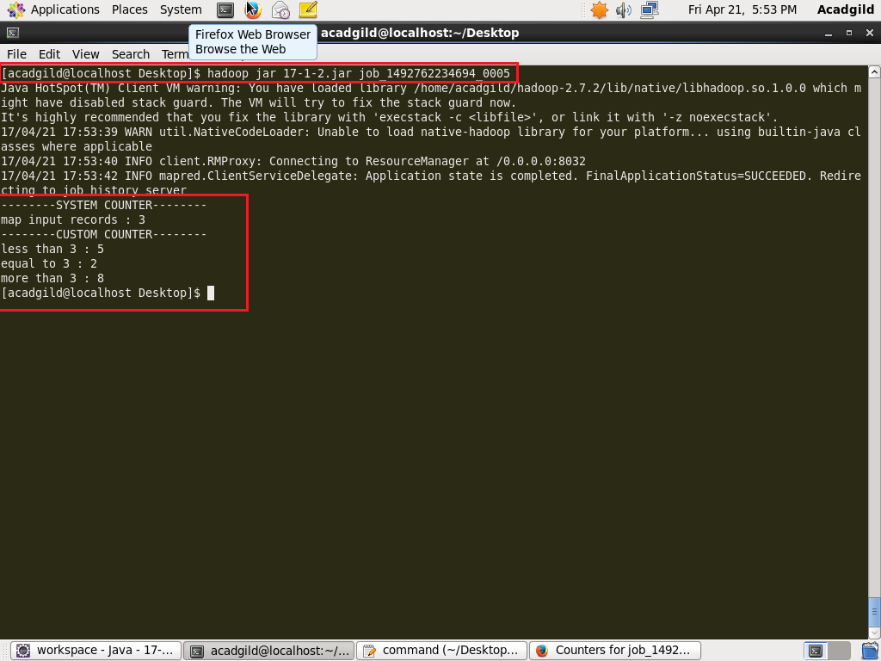

As a proof a snap of job history server is attached to verify the values of counters.

