**PROBLEM STATEMENT:**

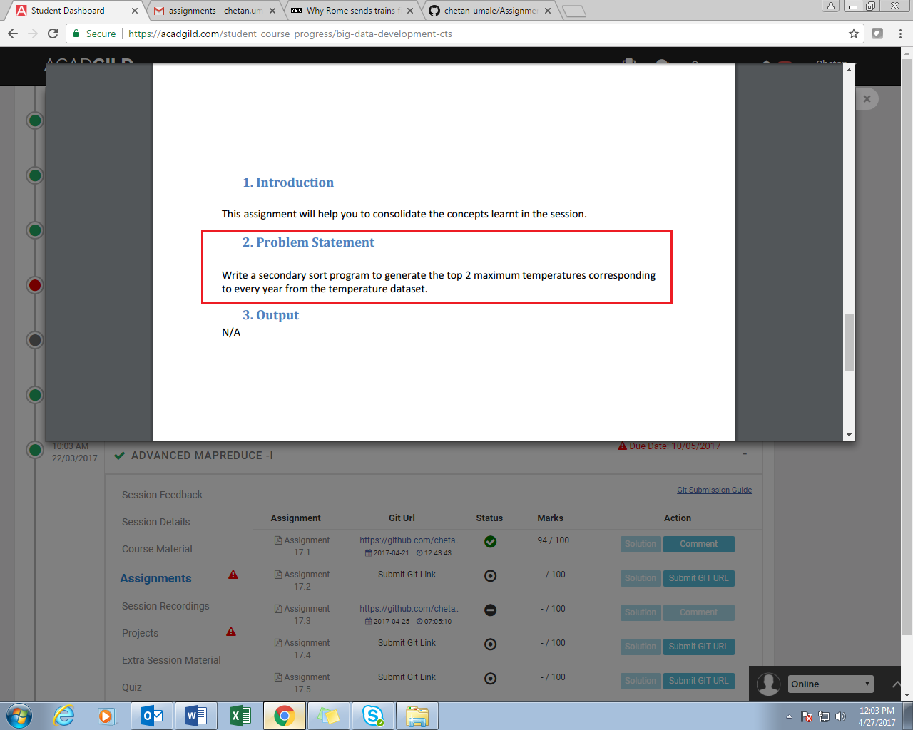

**SOLUTION:**

**PROGRAM:**

//DRIVER CLASS

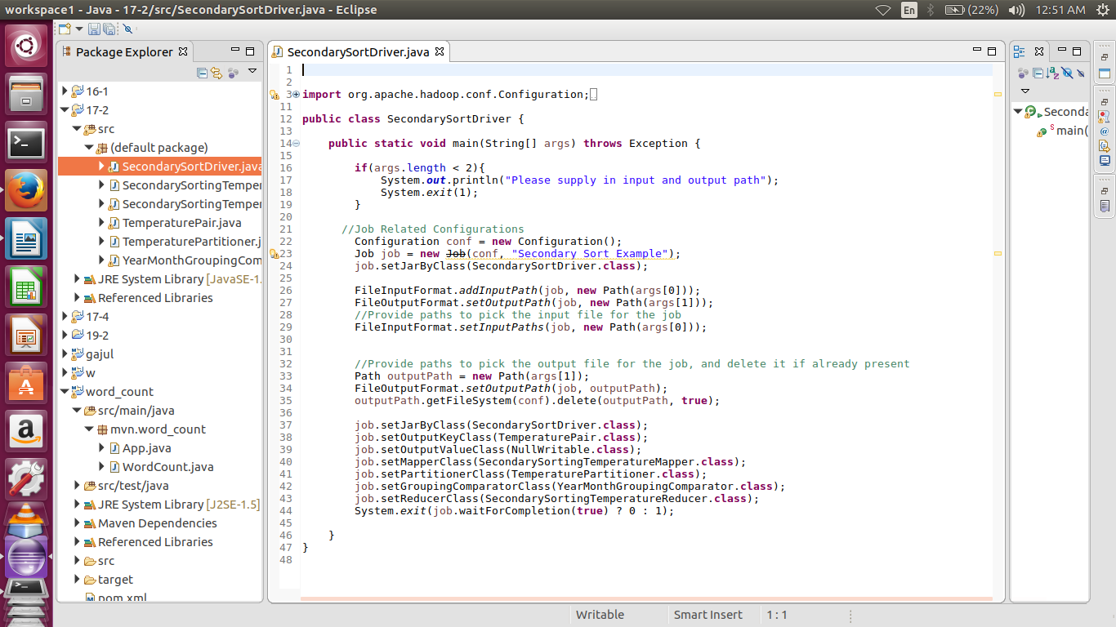

//MAPPER CLASS

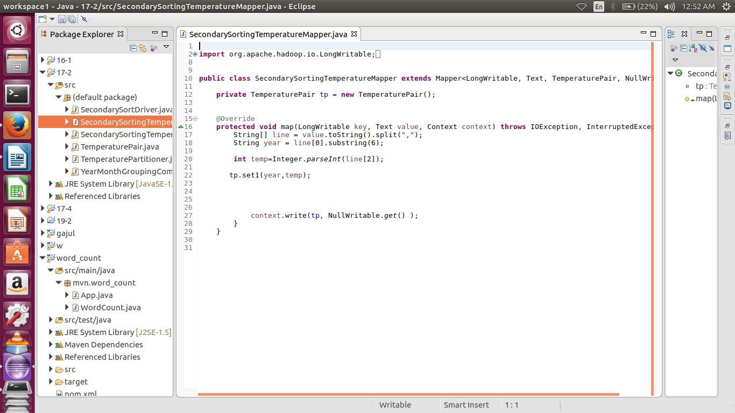

//TEMPERATUTE_PAIR CLASS (EXTENDS WRITABLECOMPARABLE)

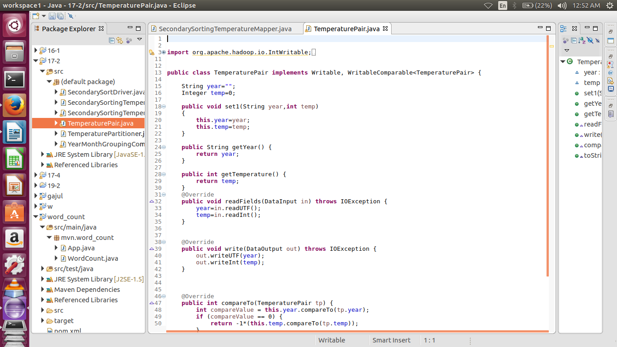

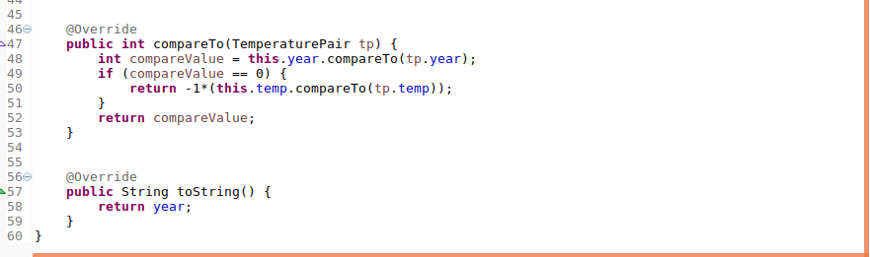

//PARTITIONER CLASS

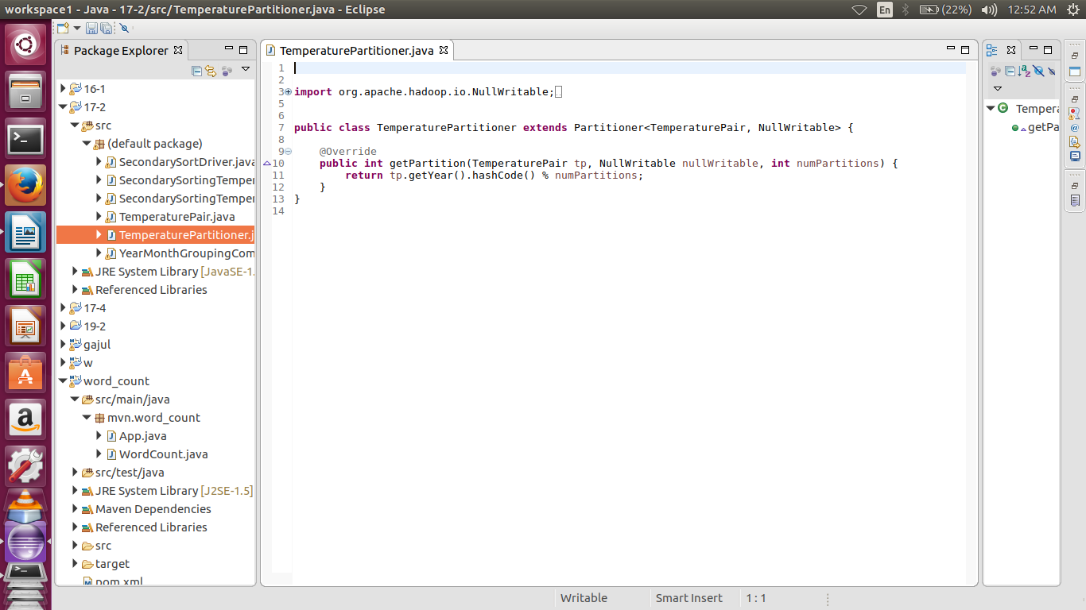

//GROUPCOMPARATOR CLASS

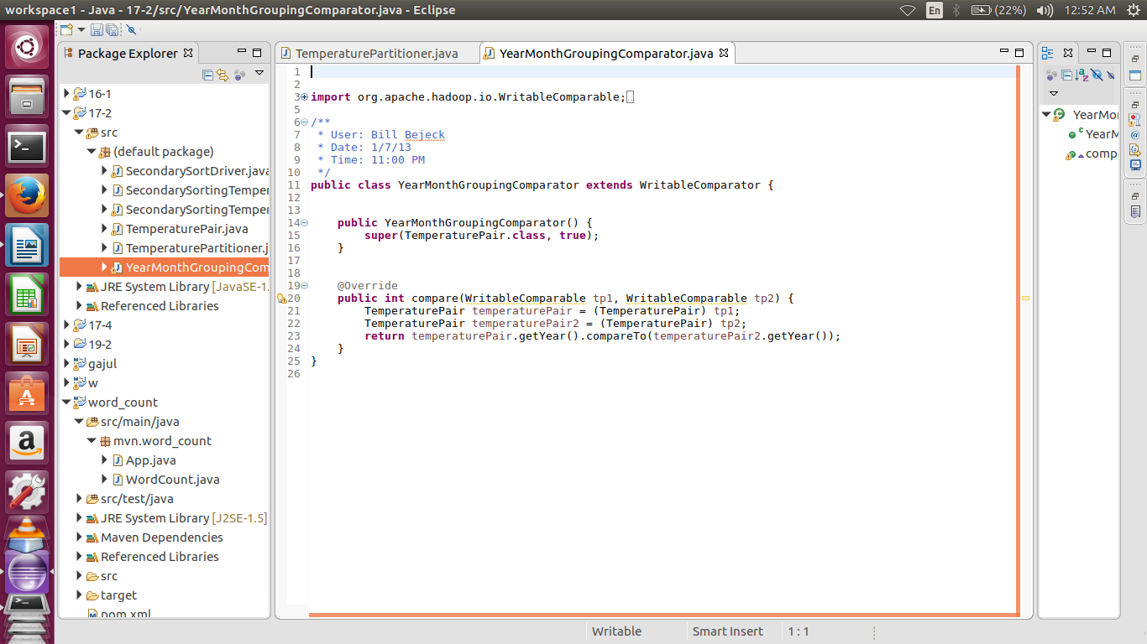

//REDUCER CLASS

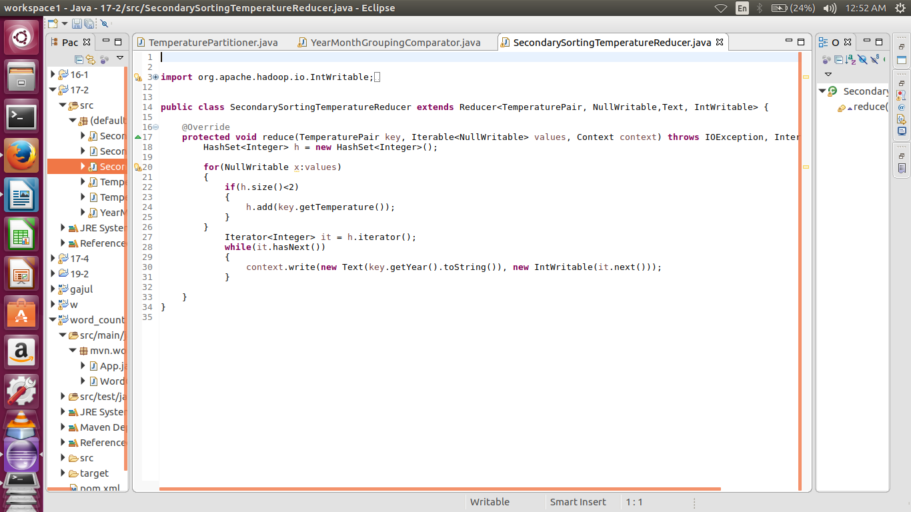

**EXECUTION COMMAND:**

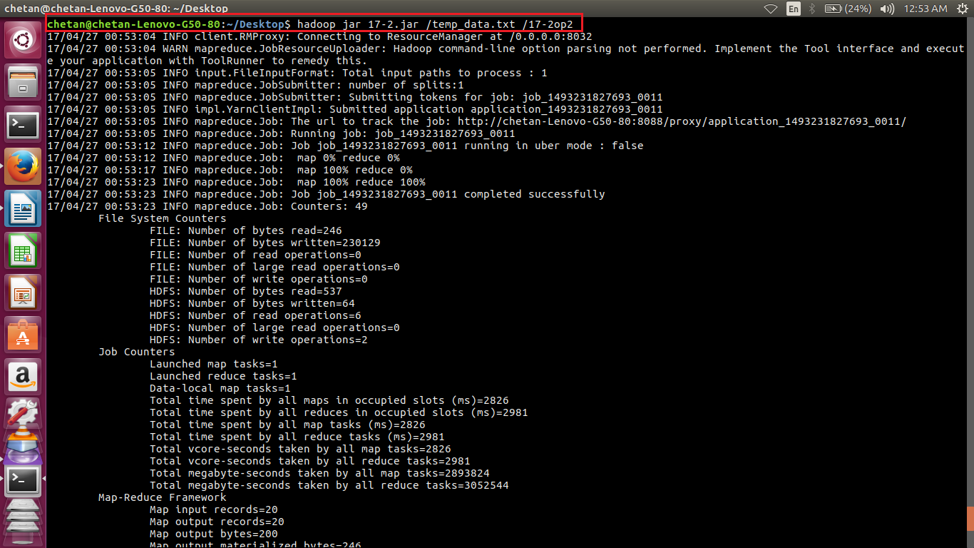

**OUTPUT:**

